Multivariate Meta-Analysis for Longevity and Reproduction

Daniel Noble & Fay Frost

# Multivariate meta-analysis and meta-regression

Reproductive traits were more strongly impacted by temperature changes than longevity when controlling for temperature (contrast = -1.04, 95% CI: -1.31 to -0.76, df = 396, *p*-value = < 0.0001). At 25C, longevity was reduced by -0.22 SD units relative to the control (95% CI: -0.41 to -0.04, df = 396, *p*-value = 0.02). In contrast, reproduction was significantly reduced by -1.26 SD units relative to the control (95% CI: -1.52 to -1, df = 396, *p*-value = < 0.0001). However, there was high heterogeneity in both traits with prediction intervals spanning -6.35 to 4.12 (Figure 1).

Mean effects changed in complicated ways with changes in temperaure, with significant non-linear patterns that depended on the effect outcome (**?@tbl-tbl1**), with effect magnitude and direction changing non-linearly with temperature increases (FAY, MAYBE ADD FIG). Interestingly, studies that observed larger changes in reprodcution also observed correlated changes in longevity (between study correlation = 0.37), however, at the within study-level there was a much weaker correlation (within-study correlation = 0.17, Figure 2).

|  |
| --- |
| Figure 1- Orchard plot with the overall meta-analytic mean (central dots) for reproduction and longevity traits. Thick bars are the 95 confidence intervals and thin bars are the 95 prediction intervals. Data are weighted by their precision (inverse sampling error). Plot is truncated for ease of visualisation. k is the number of effect sizes and n the number of studies. Given we limited our analysis to studies with both reproduction and longevity the samples sizes are the same for both trait types. |

| Parameters | Est. | L 95% CI | U 95% CI | df | p-value |
| --- | --- | --- | --- | --- | --- |
| Longevity (mean) | -0.0903 | -0.3092 | 0.1286 | 392 | 0.42 |
| Reproduction (mean) | -0.4837 | -0.7943 | -0.1732 | 392 | < 0.01 |
| Linear Treatment Temperature (centered) - Longevity | -0.2581 | -0.2875 | -0.2288 | 1,576 | < 0.0001 |
| Linear Treatment Temperature (centered) - Reproduction | -0.0660 | -0.0978 | -0.0342 | 1,576 | < 0.0001 |
| Quadratic Treatment Temperature (centered) - Longevity | -0.0022 | -0.0042 | -0.0002 | 1,576 | 0.03 |
| Quadratic Treatment Temperature (centered) - Reproduction | -0.0123 | -0.0146 | -0.0099 | 1,576 | < 0.0001 |
| Cubic Treatment Temperature (centered) - Longevity | 0.0005 | 0.0003 | 0.0006 | 1,576 | < 0.0001 |
| Cubic Treatment Temperature (centered) - Reproduction | -0.0001 | -0.0002 | 0.0001 | 1,576 | 0.42 |

**?(caption)**

|  |
| --- |
| Figure 2- Between study correlation for reproduction and longevity |

|  |
| --- |
| Figure 3- Zoomed Between study correlation for reproduction and longevity |

# Sensitivity Analysis

This removes the smallest and largest 5% effect sizes (so 10% of the data in total). The plot above shows only the experiments that have outlying effect sizes not the specific effect size itself.

When removing the 10% largest and smallest effect sizes, the following effect sizes are removed.

[1] "HUM109A.-8" "HUM148A.-10" "HUM148A.-4"   
 [4] "HUM148A.-7" "HUM22B.-10" "HUM22B.-5"   
 [7] "HUM22B.-7.5" "HUM256A.-10" "HUM256A.-15"   
 [10] "HUM256A.-5" "HUM264A.-10" "HUM264A.-5"   
 [13] "HUM298_A.-10" "HUM298_A.-5" "HUM298_A.-7.5"   
 [16] "HUM29A.-5" "HUM29A.-8" "HUM302A.-10"   
 [19] "HUM302A.-5" "HUM316_A.-4" "HUM317A.-4"   
 [22] "HUM317A.-8" "HUM319A.-10" "HUM319A.-5"   
 [25] "HUM329A.-4" "HUM329A.-8" "HUM33B.-2.5"   
 [28] "HUM33B.-5" "HUM54A.-5" "HUM55B.-7"   
 [31] "HUM71_A.-2" "HUM71_A.-5" "OSM149A.-6"   
 [34] "PH197_A.-15" "PH197_A.-7.5" "TEMP1001A.-4"   
 [37] "TEMP1001A.-8" "TEMP1020A.-2" "TEMP1053_A.-10"   
 [40] "TEMP1053_A.-15" "TEMP1053_A.-5" "TEMP1054A.-10"   
 [43] "TEMP1054A.-15" "TEMP1054A.-19" "TEMP1054A.-5"   
 [46] "TEMP109_A.-5" "TEMP109_B.-5" "TEMP1098_A.-10"   
 [49] "TEMP1098_A.-15" "TEMP1098_A.-17" "TEMP1098_A.-19"   
 [52] "TEMP1098_A.-5" "TEMP1103_A.-5" "TEMP1107A.-4"   
 [55] "TEMP1107A.-8" "TEMP1108A.-0.6" "TEMP1108A.-3.7"   
 [58] "TEMP1108A.-6" "TEMP1116A.-10" "TEMP111A.-12"   
 [61] "TEMP111A.-4" "TEMP111A.-8" "TEMP1131A.-5"   
 [64] "TEMP1137A.-4" "TEMP1137A.-8" "TEMP1138A.-10"   
 [67] "TEMP1138A.-5" "TEMP1161_A.-3" "TEMP1161_A.-6"   
 [70] "TEMP1161_A.-9" "TEMP1161_B.-3" "TEMP1161_B.-6"   
 [73] "TEMP1161_B.-9" "TEMP1165_B.6" "TEMP1168_A.-10"   
 [76] "TEMP1168_A.-5" "TEMP1168_B.-10" "TEMP1168_B.-5"   
 [79] "TEMP122A.-3" "TEMP122A.-6" "TEMP125A.-2"   
 [82] "TEMP125A.-5" "TEMP125A.-7" "TEMP1267_A.-5"   
 [85] "TEMP1267_B.-5" "TEMP1267_C.-5" "TEMP1275A.-5"   
 [88] "TEMP1275A.-7.5" "TEMP1313A.-10" "TEMP1313A.-3"   
 [91] "TEMP1313A.-7" "TEMP131A.-4" "TEMP131A.-8"   
 [94] "TEMP1361A.-3" "TEMP1456A.-10" "TEMP1456A.-5"   
 [97] "TEMP1456B.-10" "TEMP1456B.-5" "TEMP1457A.-2.5"   
[100] "TEMP1457A.-5" "TEMP1457A.-7.5" "TEMP1472A.-7"   
[103] "TEMP1492A.-10" "TEMP1492A.-15" "TEMP1492A.-5"   
[106] "TEMP1503A.-2.5" "TEMP1503A.-5" "TEMP1503A.-7.5"   
[109] "TEMP1506A.-10" "TEMP1506A.-5" "TEMP1515A.-2.5"   
[112] "TEMP1515A.-5" "TEMP1515A.-7.5" "TEMP1515B.-2.5"   
[115] "TEMP1515B.-5" "TEMP1515B.-7.5" "TEMP1525A.-5"   
[118] "TEMP1525A.-7.5" "TEMP1526A.-4" "TEMP1526A.-8"   
[121] "TEMP1526B.-4" "TEMP1526B.-8" "TEMP1526B.4"   
[124] "TEMP1526C.-4" "TEMP1526C.-8" "TEMP1526D.-4"   
[127] "TEMP1526D.-8" "TEMP1535A.-5" "TEMP1535A.-8"   
[130] "TEMP1540A.-10" "TEMP1540A.-5" "TEMP1541A.-10"   
[133] "TEMP1541A.-15" "TEMP1541A.-5" "TEMP1548A.-2.5"   
[136] "TEMP1548A.-6.1" "TEMP1567A.-5" "TEMP1567B.-5"   
[139] "TEMP1567C.-5" "TEMP1604A.-10" "TEMP1604A.-5"   
[142] "TEMP1605A.-10" "TEMP1605A.-5" "TEMP1635A.-5"   
[145] "TEMP1663A.-5.5" "TEMP1663B.-5.5" "TEMP1669A.-3"   
[148] "TEMP1669A.-6" "TEMP1670A.-3" "TEMP1670A.-6"   
[151] "TEMP1682_A.-7.5" "TEMP1683A.-7.5" "TEMP1690A.-10"   
[154] "TEMP1690A.-5" "TEMP1700A.-5" "TEMP170A.-2.5"   
[157] "TEMP170A.-5" "TEMP170A.-7.5" "TEMP170B.-2.5"   
[160] "TEMP170B.-5" "TEMP170B.-7.5" "TEMP1713A.-13"   
[163] "TEMP1713A.-17" "TEMP1713A.-5" "TEMP1713A.-9"   
[166] "TEMP1713B.-13" "TEMP1713B.-17" "TEMP1713B.-5"   
[169] "TEMP1713B.-9" "TEMP1727_A.-10" "TEMP1727_A.-15"   
[172] "TEMP1727_A.-5" "TEMP1729.-10" "TEMP1729.-15"   
[175] "TEMP1729.-5" "TEMP1771A.-8" "TEMP179A.-3"   
[178] "TEMP1818A.-5" "TEMP1818B.-5" "TEMP1835A.-5"   
[181] "TEMP1835B.-5" "TEMP1835C.-5" "TEMP1862_A.-5"   
[184] "TEMP1862_B.-5" "TEMP1873_A.-10" "TEMP1873_A.-12.5"  
[187] "TEMP1873_A.-15" "TEMP1873_A.-5" "TEMP1873_A.-7.5"   
[190] "TEMP1893_A.-5" "TEMP1893_B.-5" "TEMP1894_A.-10"   
[193] "TEMP1894_A.-5" "TEMP192_A.-4" "TEMP192_A.-8"   
[196] "TEMP192_B.-4" "TEMP192_B.-8" "TEMP192_C.-4"   
[199] "TEMP192_C.-8" "TEMP1941_A.-10" "TEMP1941_A.-5"   
[202] "TEMP1952_A.-8" "TEMP1954_A.-10" "TEMP1954_A.-5"   
[205] "TEMP1954_B.-10" "TEMP1954_B.-5" "TEMP1954_C.-10"   
[208] "TEMP1954_C.-5" "TEMP1954_D.-10" "TEMP1954_D.-5"   
[211] "TEMP1964A.-10" "TEMP1964A.-5" "TEMP1964A.5"   
[214] "TEMP1964A.7" "TEMP1965A.-9" "TEMP1965B.-9"   
[217] "TEMP1966B.-10" "TEMP1966B.-2.5" "TEMP1966B.-5"   
[220] "TEMP1966B.-7.5" "TEMP1980_A.-4" "TEMP1980_B.-4"   
[223] "TEMP1980_C.-4" "TEMP1980_C.-7" "TEMP1987A.-5"   
[226] "TEMP2034_A.-5" "TEMP2035_A.-10" "TEMP2035_A.-15"   
[229] "TEMP2035_A.-20" "TEMP2035_A.-5" "TEMP2061A.-14"   
[232] "TEMP2061A.-18" "TEMP2061A.-22" "TEMP2063A.-10"   
[235] "TEMP2063A.-5" "TEMP2069A.-4" "TEMP2069A.-8"   
[238] "TEMP2069B.-4" "TEMP2069B.-8" "TEMP2081A.-10"   
[241] "TEMP2081B.-10" "TEMP2081C.-10" "TEMP2081D.-10"   
[244] "TEMP2085A.-10" "TEMP2085A.-5" "TEMP2094A.-10"   
[247] "TEMP2094A.-5" "TEMP2096A.-10" "TEMP2096A.-5"   
[250] "TEMP2102A.-10" "TEMP2102A.-5" "TEMP2103A.-4.6"   
[253] "TEMP2103A.-9.4" "TEMP2116_A.-10" "TEMP2116_A.-5"   
[256] "TEMP2148A.-10" "TEMP2148A.-15" "TEMP2148A.-5"   
[259] "TEMP2149_A.-10" "TEMP2149_A.-15" "TEMP2149_A.-5"   
[262] "TEMP2152A.-6" "TEMP22_A.-5" "TEMP2213A.-10"   
[265] "TEMP2213A.-15" "TEMP2213A.-5" "TEMP2224A.-3"   
[268] "TEMP2224A.-6" "TEMP2224A.-9" "TEMP2236A.-3"   
[271] "TEMP2236A.-6" "TEMP2241A.-5" "TEMP2243_A.-8.6"   
[274] "TEMP2262A.-10" "TEMP2262A.-12.5" "TEMP2262A.-5"   
[277] "TEMP226A.-5" "TEMP2281A.10" "TEMP2290_A.-15"   
[280] "TEMP229A.-10" "TEMP229A.-6" "TEMP229B.-10"   
[283] "TEMP229B.-6" "TEMP2313_A.16" "TEMP2313_A.19"   
[286] "TEMP240_A.-5" "TEMP240_B.-5" "TEMP249A.-3"   
[289] "TEMP268_A.-3" "TEMP268_A.-7.7" "TEMP286_A.-10"   
[292] "TEMP286_A.-15" "TEMP286_A.-5" "TEMP286_B.-10"   
[295] "TEMP286_B.-15" "TEMP286_B.-5" "TEMP293_A.-10"   
[298] "TEMP293_A.-5" "TEMP323_A.-3" "TEMP323_A.-6"   
[301] "TEMP366_A.-4" "TEMP366_A.-8" "TEMP368_A.-10"   
[304] "TEMP368_A.-5" "TEMP369A.-3" "TEMP369A.-6"   
[307] "TEMP370A.-5" "TEMP370A.-9" "TEMP376A.-4"   
[310] "TEMP376A.-8" "TEMP378A.-3" "TEMP378A.-5"   
[313] "TEMP385_A.-10.1" "TEMP385_A.-3.8" "TEMP385_A.-7.7"   
[316] "TEMP386A.-11.4" "TEMP386A.-14.6" "TEMP386A.-4.6"   
[319] "TEMP386A.-9.3" "TEMP390A.-10" "TEMP390A.-5"   
[322] "TEMP419A.-10" "TEMP419B.-15" "TEMP419B.-5"   
[325] "TEMP454A.-1.26" "TEMP454A.-2.5" "TEMP454A.-2.92"   
[328] "TEMP454A.-4.17" "TEMP454A.-5.42" "TEMP480_A.-5"   
[331] "TEMP546_A.-10" "TEMP546_A.-5" "TEMP546_A.10"   
[334] "TEMP555A.-10" "TEMP555A.-5" "TEMP559_A.-10"   
[337] "TEMP559_A.-5" "TEMP559_A.15" "TEMP56_A.-8"   
[340] "TEMP56_B.-8" "TEMP562_A.-3" "TEMP562_A.-6"   
[343] "TEMP562_A.-9" "TEMP573_A.-4" "TEMP574A.-6"   
[346] "TEMP574B.-6" "TEMP575A.-2" "TEMP575A.-7"   
[349] "TEMP575B.-2" "TEMP575B.-7" "TEMP575C.-2"   
[352] "TEMP575C.-7" "TEMP575C.3" "TEMP575D.-2"   
[355] "TEMP575D.-7" "TEMP575E.-2" "TEMP575E.-7"   
[358] "TEMP575F.-2" "TEMP575F.-7" "TEMP575F.3"   
[361] "TEMP585_A.-5" "TEMP587A.-10" "TEMP587A.-5"   
[364] "TEMP589A.-8" "TEMP589B.-8" "TEMP595.-26"   
[367] "TEMP610A.-2.5" "TEMP610A.-5" "TEMP624A.-4"   
[370] "TEMP624A.-8" "TEMP629A.-15" "TEMP629A.-5"   
[373] "TEMP634A.-7" "TEMP653A.-10" "TEMP653A.-5"   
[376] "TEMP653A.-8" "TEMP678_A.-10.3" "TEMP678_A.-15.2"   
[379] "TEMP678_A.-4.8" "TEMP714A.-4" "TEMP714A.-9"   
[382] "TEMP800A.-14" "TEMP800A.-17" "TEMP800A.-22"   
[385] "TEMP800A.-7" "TEMP812A.-10" "TEMP812A.-5"   
[388] "TEMP819A.-5" "TEMP850A.-3" "TEMP878A.-5"   
[391] "TEMP881A.-5" "TEMP912A.-10" "TEMP912A.-5"   
[394] "TEMP915_A.-10" "TEMP954A.-12" "TEMP954A.-4"   
[397] "TEMP954A.-8" "TEMP961A.-5" "TEMP961B.-5"   
[400] "TEMP961C.-5" "TEMP961D.-5" "TEMP965A.-10"   
[403] "TEMP965A.-5" "TEMP966A.-5" "TEMP977A.-6"   
[406] "TEMP987A.-10" "TEMP987A.-5" "TEMP995A.-2.3"

# Splitting analysis: warm versus cool

There was a significant and negative linear effect of temperature on both reproduction and adult lifespan at warmer temperatures (-0.17 and -0.38 respectively, see Table 3 for estimates). However, reproductive traits were more strongly impacted by increased temperature changes than adult lifespan (contrast = -0.21, 95% CI: -0.26 to -0.16, df = 786, *t*-value = -8.59, *p*-value = < 0.0001). Figure 5 shows the predicted linear effects of temperature on reproduction and adult lifespan for observed treatment temperatures warmer than their reference temperature.

Interestingly, Figure 6 shows that studies which observed larger changes in reproduction also observed correlated changes in longevity (between study correlation = 0.65, 95% CI: 0.52 to 0.75), however, at the within study-level there was a much weaker correlation (within-study correlation = 0.5, 95% CI: 0.38 to 0.61)

| Parameters | Est. | L 95% CI | U 95% CI | df | p-value |
| --- | --- | --- | --- | --- | --- |
| Longevity (mean) | -0.53 | -0.89 | -0.18 | 344 | < 0.01 |
| Reproduction (mean) | 0.54 | 0.01 | 1.08 | 344 | 0.05 |
| Linear Treatment Temperature (centered) - Longevity | -0.17 | -0.21 | -0.13 | 786 | < 0.0001 |
| Linear Treatment Temperature (centered) - Reproduction | -0.38 | -0.44 | -0.32 | 786 | < 0.0001 |

**?(caption)**

# cool analysis

For treatment temperatures that were cooler than the reference we found a significant and negative quadratic relationship between temperature and lifespan (est. -0.01, 95% CI: -0.02 to -0.01). Adult lifespan is estimated to increase with cooler temperatures with the optimum predicted lifespan to be approximately 12C cooler than the reference temperature. In contrast, we found a significant linear relationship between temperature and reproduction (est. 0.15, 95% CI: 0.08 to 0.22). However, we found no significant quadratic relationship between temperature and reproduction (see Table 4 for estimates). Figure 7 shows the predicted relationship between temperature and reproduction and adult lifespan for observed treatment temperatures cooler than their reference temperature.

We found that studies that observed larger changes in reproduction also observed correlated changes in longevity (between study correlation = -0.15, 95% CI: -0.31 to 0.09), however, at the within study-level there was a much weaker correlation (within-study correlation = -0.23, 95% CI: -0.36 to -0.09)

| Parameters | Est. | L 95% CI | U 95% CI | df | p-value |
| --- | --- | --- | --- | --- | --- |
| Longevity (mean) | 0.0972 | -0.4646 | 0.6590 | 320 | 0.73 |
| Reproduction (mean) | 0.4945 | -0.1196 | 1.1087 | 320 | 0.11 |
| Linear Treatment Temperature (centered) - Longevity | -0.3271 | -0.3955 | -0.2586 | 790 | < 0.0001 |
| Linear Treatment Temperature (centered) - Reproduction | 0.1484 | 0.0754 | 0.2214 | 790 | < 0.001 |
| Quadratic Treatment Temperature (centered) - Longevity | -0.0146 | -0.0191 | -0.0101 | 790 | < 0.0001 |
| Quadratic Treatment Temperature (centered) - Reproduction | -0.0003 | -0.0052 | 0.0046 | 790 | 0.91 |

**?(caption)**

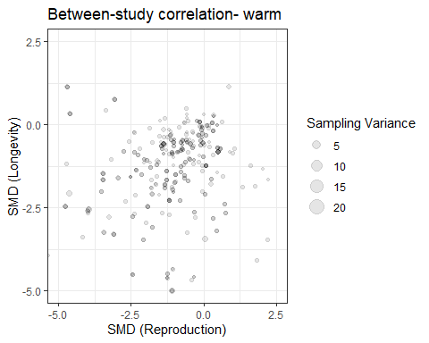{#fig- between-study correlation for reproduction and longevity- split into warm and cool-1}

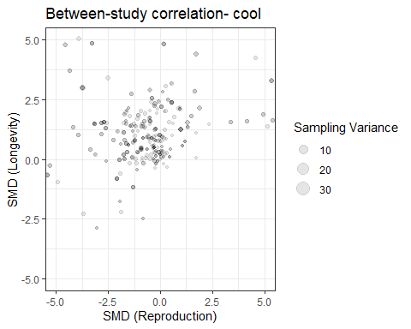{#fig- between-study correlation for reproduction and longevity- split into warm and cool-2}

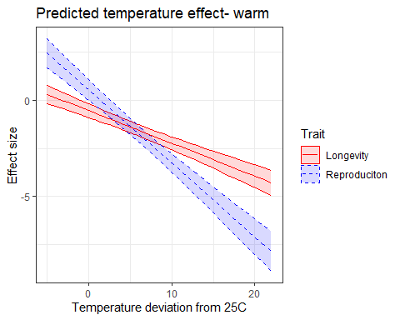{#fig- prediction intervals for mv_mlma split by warm.cool- linear models-1}

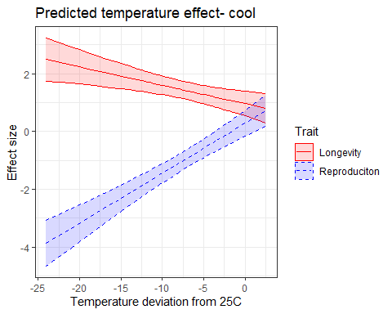{#fig- prediction intervals for mv_mlma split by warm.cool- linear models-2}

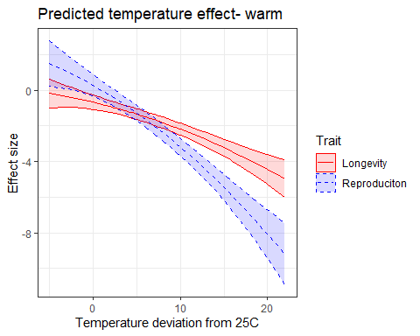{#fig- prediction intervals for mv_mlma split by warm.cool- quadratic models-1}

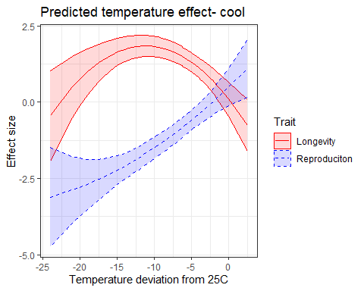{#fig- prediction intervals for mv_mlma split by warm.cool- quadratic models-2}

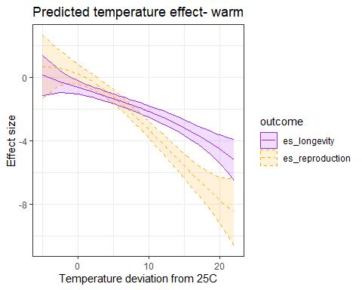{#fig- prediction intervals for mv_mlma split by warm.cool- cubic models-1}

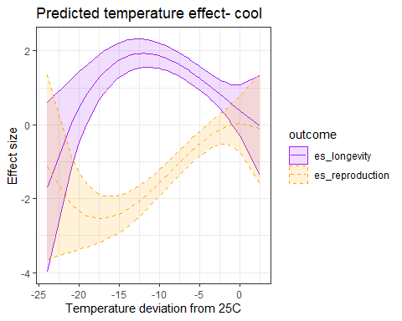{#fig- prediction intervals for mv_mlma split by warm.cool- cubic models-2}

| Parameters | Est. | L 95% CI | U 95% CI | df | p-value |
| --- | --- | --- | --- | --- | --- |
| Longevity (mean) | -0.68 | -0.93 | -0.439 | 329 | < 0.0001 |
| Reproduction (mean) | -0.11 | -0.40 | 0.178 | 329 | 0.45 |
| Linear Treatment Temperature (centered) - Longevity | -0.11 | -0.14 | -0.081 | 706 | < 0.0001 |
| Linear Treatment Temperature (centered) - Reproduction | -0.19 | -0.23 | -0.155 | 706 | < 0.0001 |

**?(caption)**

# Sensitivity warm

We found weaker, but qualitatively similar correlations, after removing outliers (between-study correlation = 0.48, 95% CI: 0.29 to 0.64 within-study correlation= 0.37, 95% CI: 0.21 to 0.51)

| Parameters | Est. | L 95% CI | U 95% CI | df | p-value |
| --- | --- | --- | --- | --- | --- |
| Longevity (mean) | -0.5691 | -0.8516 | -0.2866 | 327 | < 0.001 |
| Reproduction (mean) | 0.0729 | -0.2795 | 0.4253 | 327 | 0.68 |
| Linear Treatment Temperature (centered) - Longevity | -0.2460 | -0.2915 | -0.2004 | 706 | < 0.0001 |
| Linear Treatment Temperature (centered) - Reproduction | -0.2443 | -0.2986 | -0.1900 | 706 | < 0.0001 |
| Quadratic Treatment Temperature (centered) - Longevity | 0.0069 | 0.0035 | 0.0102 | 706 | < 0.001 |
| Quadratic Treatment Temperature (centered) - Reproduction | 0.0041 | -0.0001 | 0.0083 | 706 | 0.05 |

**?(caption)**

# Sensitivity cool (quadratic)

We qualitatively similar correlations, after removing outliers (between-study correlation = 0.35, 95% CI: 0.09 to 0.58 within-study correlation= -0.1, 95% CI: -0.27 to 0.08)

