**Republic Polytechnic - School of Infocomm**

**C328 Intelligent Networks**

AY2024 Semester 1

**Problem Statement**

**LP1: The Company Expansion**

|  |
| --- |
| **Academic Week 1** |

|  |
| --- |
| **Week 1 - Learning Phase 1 – 120 mins** |

|  |
| --- |
| **PART 1 Switching Concepts, VLANs, and InterVLAN Routing - (BASIC DEVICE CONFIGURATION):** |

**Course Name: CCNAv7: Switching, Routing, and Wireless Essentials**

**Class Administration & module introduction – 15 minutes**

1. Please listen for the module briefing from the lecturer. Important module information will be discussed. The slides will be made available in module workbin for your reference.
2. Install the Packet Tracer **8.2.2** program from LEO workbin Module Resources for the file - **CiscoPacketTracer_822_Windows_64bit.exe** )

You may have installed a prior version in C225 or C227. Do uninstall any older versions before proceeding. *(the same copy is available from Netacad website)

To obtain and install your copy of Cisco Packet Tracer follow these steps:

Step 1. Log into your Cisco Networking Academy “I'm Learning” page.  
Step 2. Select Resources.  
Step 3. Select Download Packet Tracer.  
Step 4. Select the **version 8.2.2** of Packet Tracer.  
Step 5. Save the file to your computer.  
Step 6. Launch the Packet Tracer installation program.

**Problem statement presentation (Lecturer facilitated) – 5 minutes**

1. Read out the problem statement, and note down your initial findings in the PDT template.

Use the given template C328_LP1_PDT_Template.docx to write in your notes. It will be used later in the team when you are coming out with a solution to the problem statement.

**Class Discussion (Lecturer facilitated) – 20 minutes**

1. Given a small office/home office environment, one of the main components to get on the Internet is the wireless router as shown below. Circle the wired ports in which you are able to connect PCs? How many wired PCs does this router support?

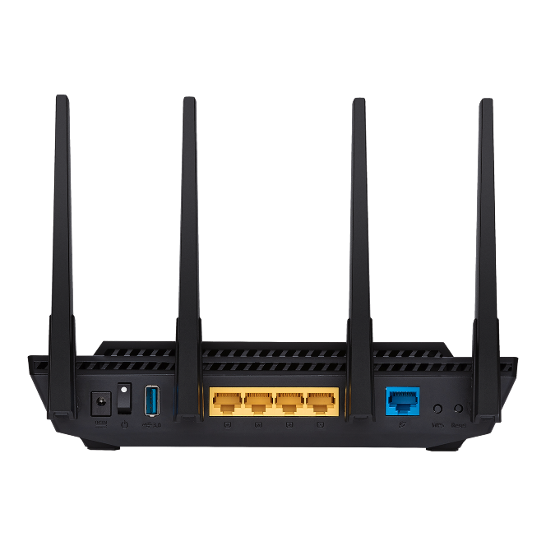 

|  |
| --- |
|  |

1. If now you have 10 PCs to link up using wired mode, what additional device would you need in order to expand the number of ports ?

|  |
| --- |
|  |

1. Compare the 2 switches below? What do you think the differences are and why the difference in prices?

|  |  |
| --- | --- |
| DGS-108 - 8-Port Gigabit Desktop Switch In Metal Casing Singapore  8 port unmanaged gigabit switch: **SGD $60**  **(search on amazon.sg- Dlink DGS-108)** | Cisco Business CBS250-8FP-E-2G Smart Switch | 8 Port GE | Full PoE | Ext PS | 2x1G Combo | Limited Lifetime Protection (CB...  8 port Managed Switch  **SGD $258**  **(search on amazon.sg- Cisco CBS250-8T-E-2G)** |

(For reference : <https://www.cisco.com/c/en/us/products/switches/what-is-a-managed-switch.html> )

|  |
| --- |
|  |

1. For a managed switch, you need to configure it. Without a keyboard/mouse/monitor , you need to use a special cable to perform initial setup. Identify the cable from this video. - [**https://youtu.be/YdC1hQz0YDg?t=60**](https://youtu.be/YdC1hQz0YDg?t=60)

|  |
| --- |
|  |

1. You also need a special program in order access the switch. Identify the program in this video - **https://www.youtube.com/watch?v=x-1znQ5JoRk**

|  |
| --- |
|  |

1. The following slides will describe how to work with a managed switch.

**Class Presentation (Lecturer-Led) – 40 minutes**

|  |
| --- |
| Module 1: Basic Device Configuration   * 1. Configure a Switch with Initial Settings   2. Configure Switch Ports   3. Secure Remote Access |

**PT Activity (Lecturer-Led) - 20 mins**

1. Complete **Packet Tracer - Basic Switch Configuration (**Refer to **1.1.7 Packet Tracer - Basic Switch Configuration - Physical Mode.pka).**

Ensure that you are able to understand the remote management configuration for the switch.

**PT Activity (Self-study) - 20 mins**

1. Complete **Packet Tracer - Configure SSH** (Refer to**1.3.6-packet-tracer---configure-ssh.pka** ) at your own time.   
   Ensure that you are able to understand secure remote management configuration for the switch.
2. From what you had learnt, which are the features applicable to the problem statement? Think of the situation that you will face when you need to support the entire office with only 1 or 2 staff.

|  |
| --- |
|  |

|  |
| --- |
| **Week 1 - Learning Phase 2 – 120 mins** |

**Class Presentation (Lecturer-Led) – 20 minutes**

|  |
| --- |
| Module 1: Basic Device Configuration   * 1. Basic Router Configuration   2. Verify Directly Connected Networks |

**PT Activity (Self-study) – 20 mins**

1. Complete **Packet Tracer - Configure Router Interfaces** (Refer to ***1.4.7 Packet Tracer - Configure Router Interfaces.pka***).

Ensure that you are able to understand how to configure the IPv4 and IPv6 addresses on the interfaces of both routers and PCs.

**Class Discussion – 15 minutes**

1. How is setting the IP address of a device important for remote management of the device?

|  |
| --- |
|  |

1. Why is having the ability to remotely manage a switch so critical?

|  |
| --- |
|  |

1. At what network speeds do you expect to see a half-duplex connection? For copper ports, at what speed is there an impossibility of a duplex mismatch?

|  |
| --- |
|  |

1. Given these 2 remote management protocols, SSH and Telnet, what is the advantage of SSH over telnet ?

|  |
| --- |
|  |

**PT Activity – (Lecturer-Led)**  **– 15 mins**

1. Complete **Packet Tracer - Verify Directly Connected Networks** (Refer to ***1.5.10 Packet Tracer - Verify Directly Connected Networks.pka***).

Ensure that you are able to work through the lab verify the IPv4 and IPv6 addresses on the interfaces of both routers and PCs and are able to troubleshoot errors found.

**Team discussion - Background information - 20 minutes**

1. East building typical floorplan

1. West building typical floorplan. A floor plan of an office building

   Description automatically generated
2. Specification of the buildings

Height – 37 storeys (150m)

Furthest distance between 2 points on a floor = 80m

Distance between both buildings – 100m

Do you need this information? Why?

|  |
| --- |
|  |

1. Do take a look at how the initial office at #18-01 was built out. You should get a sense of the layer 1 connectivity.

<https://www.youtube.com/watch?v=KkIgYbLuA6o>

**Further reading– 30 minutes**

1. Your solution has to be practical and feasible for implementing the network on site.
2. Based on the above information, are there any limitations that come to your mind when wiring up all the different offices?

|  |
| --- |
|  |

1. Look through the equipment list and locate the product data sheet and review the specifications. The common IEEE 802.3 physical standards in use are 1000BaseT(802.3ab) / 1000BaseSX / 1000BaseLX, with references to increasing costs. You need to select the correct physical layer (Recall OSI 7 layer model) for the links. List the type of physical links you would consider for this implementation?

|  |
| --- |
|  |

1. Would the below media convertor product have a role to play in the final solution?

<https://www.youtube.com/watch?v=VYbOudqf6Nw>

|  |
| --- |
|  |

1. How would this below product work with the above product?

<https://www.youtube.com/watch?v=cKCst1wccfo>

|  |
| --- |
|  |

**PDT (Team) – At Your own time**

1. Discuss among your team and come out a team PDT for the problem statement, using all you have learnt so far. You may leave the class when you are done (*Remember to complete the E-learning portion below)

Use the given template C328_LP1_PDT_Template.docx.   
You will need to include this into your team presentation, do reflect the topics and area of research properly.

1. List down your individual PDT contribution below (You will append to the list weekly by filling in the blanks)

Problem Definition Template :

|  |  |  |  |
| --- | --- | --- | --- |
| What I do not know? | What do I need to find out? | Possible answers to solve the problem | Action by: |
|  |  |  |  |

1. Discuss among your team what is your contribution to the team. Are the rest of the members in your team contributing as well? Please mutually work in the team and fill in the figures below and update this table (weekly) into your team presentation in week 7.

|  |  |  |  |
| --- | --- | --- | --- |
| **Member Name** | **Individual Contribution within the team to the solution(s) for the problem statement** | **Details of Contribution to the team’s presentation this week.** | **Details of Contribution to the team’s PKT solution this week.** |
| *Eg - Tan Ah Beng* | *Eg - 20%* | *Eg – Created DHCPv4 slides explaining . . . .* | *Eg – Created DHCPv4 server configuration and verification on router R1* |
| Member 1 | 50% |  |  |
| Member 2 | 30% |  |  |
| Member 3 | 15% |  |  |
| Member 4 | 5% |  |  |
| Member 5 | 0% |  |  |

|  |
| --- |
| **Week 1 - E-Learning Phase – 45 mins** |

**PT Activity – (Self-study)**  **– 30 mins**

1. Complete **Packet Tracer - Implement a Small Network** (Refer to ***1.6.1 Packet Tracer - Implement a Small Network.pka***).

Ensure that you are able to verify the connectivity between the 2 LANs.

**Check Your Understanding (CYU) – 15 minutes**

1. Complete ***1.6.4 Module Quiz – Basic Device Configuration*.**

Take a screenshot of your activity result.

|  |
| --- |
|  |

|  |
| --- |
| **Deliverables for academic week 1 (*ungraded)**   1. Individual Worksheet (completed up to this point) –> individual submission folder in LEO 2.0 by 23:59, uploaded in DOC format.   Do note this Worksheet/PDT submission weekly is for your own progress tracking.  From Week 2 onwards, Module exams will be considered for the 20% AKS component. |

|  |
| --- |
| **Academic Week 2 (E-learning)** |

|  |
| --- |
| **Week 2 - Learning Phase 1 – 120 minutes** |

|  |
| --- |
| **PART 2 Switching Concepts, VLANs, and InterVLAN Routing (SWITCHING CONCEPTS):** |

**Class Presentation (Lecturer-Led) – 45 minutes**

|  |
| --- |
| Module 2: Switching Concepts  2.1 – Frame Forwarding  2.2 – Switching Domains |

**Class Discussion – 30 minutes**

1. Explain the difference between a **Routing table as used by routers** and **MAC address table (or CAM table) as used by switches**.

(A commonly confused point would also be the **ARP table which exists in end-user devices, eg PCs**, which is different from the two above)

|  |
| --- |
|  |

1. Explain the difference in function of a Layer 1 hub, a layer 2 switch and a layer 3 router.

|  |
| --- |
|  |

1. Identify the differences between the following 3 switching methods.
2. Store and forward
3. Modified cut through (or fragment free)
4. Cut through

|  |
| --- |
|  |

1. Which device(s) break up collision domains ?

|  |
| --- |
|  |

1. Which device(s) break up broadcast domains ?

|  |
| --- |
|  |

1. Do you agree with this statement : “A well designed network should have more broadcast domains and more collision domains than a badly designed network of the same size.” (Explain why? How many devices can a broadcast domain handle?)

|  |
| --- |
|  |

**Check Your Understanding (CYU) – 15 minutes**

1. Complete ***2.3.2 Module Quiz – Switching Concepts*.**

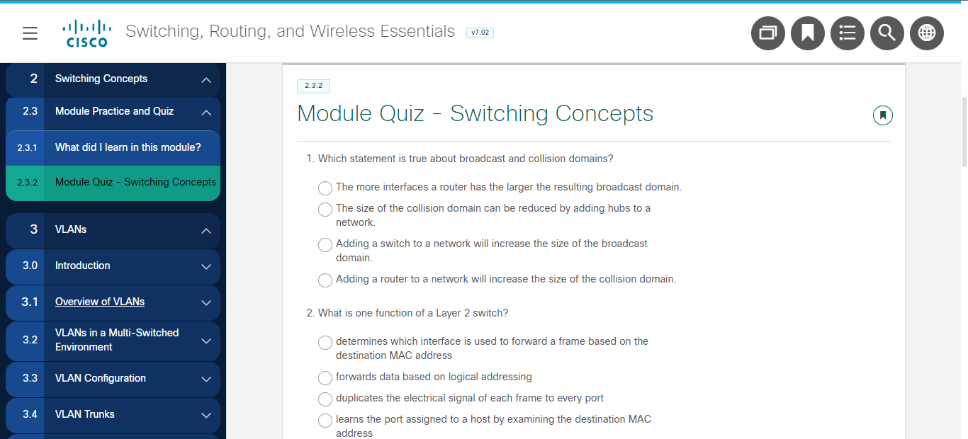

Take a screenshot of your activity result.

|  |
| --- |
|  |

|  |
| --- |
| **PART 3 Switching Concepts, VLANs, and InterVLAN Routing (VLANs):** |

**Class Presentation (Lecturer-Led) – 30 minutes**

|  |
| --- |
| Module 3: VLANs  3.1 – Overview of VLANs  3.2 – VLANs in a Multi-Switched Environment |

|  |
| --- |
| **Week 2 - Learning Phase 2 – 120 minutes** |

**PT Activity (Lecturer-Led) – 15 mins**

1. Complete **Packet Tracer – Who Hears the Broadcast?** (Refer to **3.1.4 Packet Tracer - Who Hears the Broadcast.pka**).

Ensure that you are able to understand how broadcasts propagate throughout the vlans and where it stops.

**PT Activity (Lecturer-Led) –15 mins**

1. Complete **Packet Tracer –Investigate a VLAN Implementation** (Refer to **3.2.8 Packet Tracer - Investigate a VLAN Implementation.pka**).

Ensure that you know how the VLAN implementation works

**Class Presentation (Lecturer-Led) – 60 minutes**

|  |
| --- |
| Module 3: VLANs  3.3 – VLAN Configuration  3.4 – VLAN Trunks  3.5 – Dynamic Trunking Protocol |

**PT Activity (Lecturer-Led)** – **15 minutes**

1. Complete **Packet Tracer – VLAN Configuration** (Refer to***3.3.12 Packet Tracer - VLAN Configuration.pka***).

Ensure that you are able to understand how vlans are configured.

**PT Activity (Lecturer-Led)** – **15 minutes**

1. Complete **Packet Tracer – Configure Trunks** (Refer to***3.4.5 Packet Tracer - Configure Trunks.pka***).

Ensure that you are able to understand how and where Trunk ports are configured.

**PDT (Team) – At Your own time**

1. Discuss among your team and continue working with the team PDT for the problem statement, using all you have learnt so far. You may leave the class when you are done (*Remember to complete the E-learning portion below)

Use the given template C328_LP1_PDT_Template.docx.   
You will need to include this into your team presentation, do reflect the topics and area of research properly.

1. List down your individual PDT contribution below (You will append to the list weekly by filling in the blanks)

Problem Definition Template :

|  |  |  |  |
| --- | --- | --- | --- |
| What I do not know? | What do I need to find out? | Possible answers to solve the problem | Action by: |
|  |  |  |  |

1. Discuss among your team what is your contribution to the team. Are the rest of the members in your team contributing as well? Please mutually work in the team and fill in the figures below and update this table (weekly) into your team presentation in week 7.

|  |  |  |  |
| --- | --- | --- | --- |
| **Member Name** | **Individual Contribution within the team to the solution(s) for the problem statement** | **Details of Contribution to the team’s presentation this week.** | **Details of Contribution to the team’s PKT solution this week.** |
| *Eg - Tan Ah Beng* | *Eg - 20%* | *Eg – Created DHCPv4 slides explaining . . . .* | *Eg – Created DHCPv4 server configuration and verification on router R1* |
| Member 1 | 50% |  |  |
| Member 2 | 30% |  |  |
| Member 3 | 15% |  |  |
| Member 4 | 5% |  |  |
| Member 5 | 0% |  |  |

|  |
| --- |
| **Week 2 - E-Learning Phase – 45 mins** |

**PT Activity (Self Study) – 15 mins**

1. Complete **Packet Tracer – Configure DTP** (Refer to***3.5.5 Packet Tracer - Configure DTP.pka***).

Ensure that you are able to understand how DTP negotiation happens

**PT Activity – (Self-study)**  **– 30 mins**

1. Complete **Packet Tracer - Implement VLANs and Trunking** (Refer to***3.6.1 Packet Tracer - Implement VLANs and Trunking.pka***).

**PT Activity – (Self study- optional)**

1. Complete **Packet Tracer - Configure VLANs and Trunking** (Refer to ***3.4.6 Packet Tracer - Configure VLANs and Trunking - Physical Mode.pka***).

Ensure that you are able to understand how DTP negotiation happens

|  |
| --- |
| **Deliverables for academic week 2**   1. Individual Worksheet (completed up to this point) –> individual submission folder in LEO 2.0 by 23:59, uploaded in DOC format.   Do note this Worksheet/PDT submission weekly is for your own progress tracking.  From Week 2 onwards, Module exams will be considered for the 20% AKS component. |

|  |
| --- |
| **Academic Week 3** |

|  |
| --- |
| **Week 3 - Learning Phase 1 - 120 minutes** |

**Class Discussion (Recap) – 10 minutes**

1. Describe why you think VLANs are useful in an enterprise environment?

|  |
| --- |
|  |

1. Discuss the importance of implementing trunk ports as compared to the legacy way of connecting access ports for each VLAN between the switches.

|  |
| --- |
|  |

**Check Your Understanding (CYU)** – **10 minutes**

1. Complete ***3.6.4 Module Quiz – VLANs.***

Take a screenshot of your activity result.

|  |
| --- |
|  |

|  |
| --- |
| **PART 4 Switching Concepts, VLANs, and InterVLAN Routing (Inter-VLAN Routing):** |

**Class Presentation (Lecturer-Led) –40 minutes**

|  |
| --- |
| Module 4: Inter-VLAN Routing  4.1 – Inter-VLAN Routing Operation  4.2 – Router-on-a-Stick Inter-VLAN Routing |

**PT Activity (Lecturer-Led)** – **20 minutes**

1. Complete Packet Tracer - Configure Router-on-a-Stick Inter-VLAN Routing (Refer to***4.2.7 Packet Tracer - Configure Router-on-a-Stick Inter-VLAN Routing.pka***).

Ensure that you are able to understand how vlans are configured.

**Class Discussion – 10 minutes**

1. Using legacy routing using physical interfaces, if we want to route between 4 networks, How many interfaces does the router need?

|  |
| --- |
|  |

1. Using intervlan routing for routing on a stick, how many physical interfaces are needed?

|  |
| --- |
|  |

1. For a router on a stick configuration, in a single interface router, which mode does the corresponding interface on the switch have to be in, in order to carry multiple vlan traffic?

|  |
| --- |
|  |

1. For that interface on the switch, which vlan traffic is passed through untagged? What is the name of vlan on that interface?

|  |
| --- |
|  |

**Class Presentation (Lecturer-Led) – 30 minutes**

|  |
| --- |
| Module 4: Inter-VLAN Routing  4.3 – Inter-VLAN Routing using Layer 3 Switches  4.4 – Troubleshoot Inter-VLAN Routing |

|  |
| --- |
| **Week 3 - Learning Phase 2 - 120 minutes** |

**Class Discussion – 15 minutes**

1. Compare using a Layer 3 Switch as an Inter-VLAN Router as compared to Router on a stick configuration. Which method is better? (define what do you mean by better?)

|  |
| --- |
|  |

1. What is the impact of the no switchport command on a layer 3 switch? What device would this be connected to for the port when this command is issued?

|  |
| --- |
|  |

1. What do you think is the most common cause of errors in the implementation of Inter-VLAN Routing?

|  |
| --- |
|  |

**PT Activity (Lecturer-Led)** – **20 minutes**

1. Complete **Packet Tracer – Configure Layer 3 Switch and Inter-VLAN Routing** (Refer to***4.3.8 Packet Tracer - Configure Layer 3 Switching and Inter-VLAN Routing.pka***).

Ensure that you are able to understand how L3 inter-vlan routing is configured.

**PT Activity (Lecturer-Led)** – **25 minutes**

1. Complete **Packet Tracer - Troubleshoot Inter-VLAN Routing** (Refer to***4.4.8 Packet Tracer - Troubleshoot Inter-VLAN Routing.pka***)

Ensure that you are able to understand how to troubleshoot problems in intervlan routing

**PT Activity – (Self-study)**  **– 45 mins**

1. Complete Packet Tracer - Packet Tracer - Implement a Small Network (Refer to***4.5.1 Packet Tracer - Inter-VLAN Routing Challenge.pka***).

**Check Your Understanding (CYU) - 15 minutes**

1. Complete ***4.5.4 Module Quiz – Inter-VLAN Routing*.**

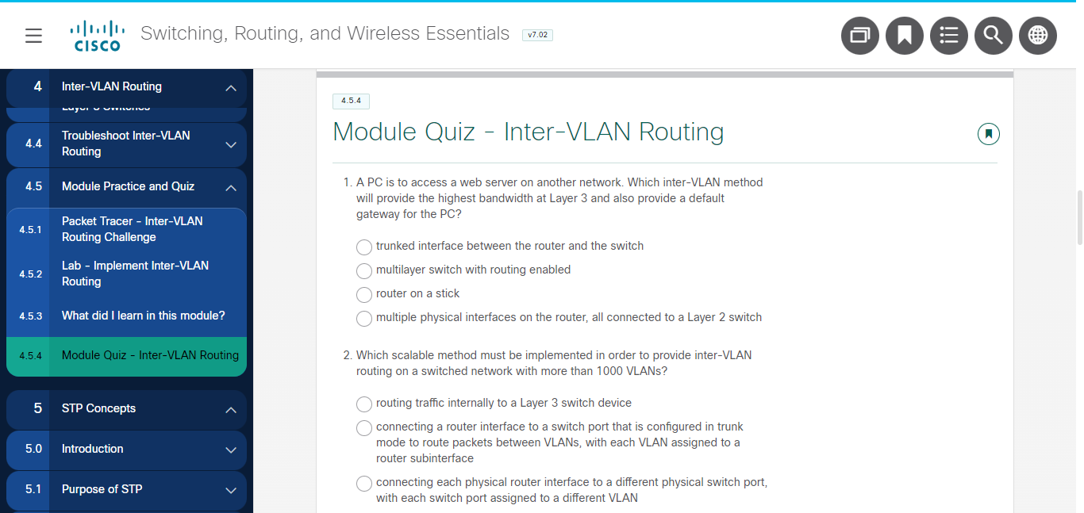

Take a screenshot of your activity result.

|  |
| --- |
|  |

**PDT (Team) – At Your own time**

1. Discuss among your team and continue working with the team PDT for the problem statement, using all you have learnt so far. You may leave the class when you are done (*Remember to complete the E-learning portion below)

Use the given template C328_LP1_PDT_Template.docx.   
You will need to include this into your team presentation, do reflect the topics and area of research properly.

1. List down your individual PDT contribution below (You will append to the list weekly by filling in the blanks)

Problem Definition Template :

|  |  |  |  |
| --- | --- | --- | --- |
| What I do not know? | What do I need to find out? | Possible answers to solve the problem | Action by: |
|  |  |  |  |

1. Discuss among your team what is your contribution to the team. Are the rest of the members in your team contributing as well? Please mutually work in the team and fill in the figures below and update this table (weekly) into your team presentation in week 7.

|  |  |  |  |
| --- | --- | --- | --- |
| **Member Name** | **Individual Contribution within the team to the solution(s) for the problem statement** | **Details of Contribution to the team’s presentation this week.** | **Details of Contribution to the team’s PKT solution this week.** |
| *Eg - Tan Ah Beng* | *Eg - 20%* | *Eg – Created DHCPv4 slides explaining . . . .* | *Eg – Created DHCPv4 server configuration and verification on router R1* |
| Member 1 | 50% |  |  |
| Member 2 | 30% |  |  |
| Member 3 | 15% |  |  |
| Member 4 | 5% |  |  |
| Member 5 | 0% |  |  |

|  |
| --- |
| **Week 3 - E-Learning Phase – 45 mins** |

1. Complete ***Modules 1 - 4: Switching Concepts, VLANs, and InterVLAN Routing Exam*** – **to complete by 23:59**

|  |
| --- |
| **Deliverables for academic week 3**   1. Individual Worksheet (completed up to this point) –> individual submission folder in LEO 2.0 by 23:59, uploaded in DOC format. 2. Complete Module Exam - Modules 1 - 4: Switching Concepts, VLANs, and InterVLAN Routing Exam **(Mandatory )**   Do note this Worksheet/PDT submission weekly is for your own progress tracking.  From Week 2 onwards, Module exams will be considered for the 20% AKS component. |

|  |
| --- |
| **Academic Week 4** |

|  |
| --- |
| **Week 4 - Learning Phase 1 - 120 minutes** |

**Recap (Team) – 30 minutes**

1. Recall East building typical floorplan

1. West building typical floorplan. A floor plan of an office building

   Description automatically generated
2. From the past 3 lessons – List down the network features which you have learnt which you think are applicable to the problem statement.

|  |
| --- |
| a)  b)  c) |

1. Do work on the problem statement and discuss in the team how you would arrange the new equipment to meet the requirements in the PKT.

|  |
| --- |
|  |

1. In the PKT , check that all the PCs are able to reach the web server [www.isp.net](http://www.isp.net).

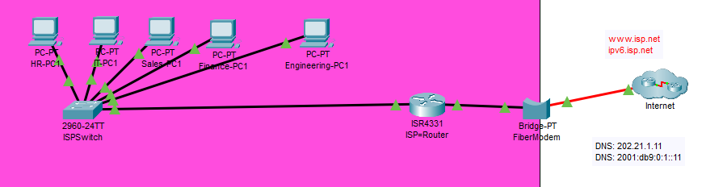

This would show the initial network. Do look at the other devices meant to signify the other floors. How would you fix the network so as to connect all the devices together and also provide Internet for all users?

Note that the router is currently assigning out IP addresses, and the range of permitted IP addresses to access Internet is in the 172.16.0.0/12 block.

Discuss what you would have to do to cater for the rest of the PCs to keep them **logically** separated.

1. In your L3 Do research on the command ip address dhcp. Which device in the problem statement would you put this command at ?

**In-class paper quiz – 30 minutes (Modules 1 – 4)**

(Open-book. Laptop allowed but without Internet, no use of mobile devices)

Please note the PKT

|  |
| --- |
| **PART 5 Redundant Networks):** |

**Course Name: CCNAv7: Switching, Routing, and Wireless Essentials**

**Class Discussion (Lecturer facilitated) – 10 minutes**

1. What do you understand of the term *redundancy*? From an engineering standpoint, is it useful for computer networks? What purpose does redundant hardware serve?

|  |
| --- |
|  |

**Class Presentation (Lecturer-Led) – 30 minutes**

|  |
| --- |
| Module 5: STP Concepts  5.1 Purpose of STP |

**PT Activity (Lecturer-Led) - 20 mins**

1. Complete **Packet Tracer - Investigate STP Loop Prevention** (Refer to**5.1.9-packet-tracer---investigate-stp-loop-prevention.pka** )

Ensure that you are able to understand how layer 2 loops are prevented using STP.

|  |
| --- |
| **Week 4 - Learning Phase 2 – 120 minutes** |

**Class Presentation (Lecturer-Led) – 60 minutes**

|  |
| --- |
| Module 5: STP Concepts  5.2 STP Operations  5.3 Evolution of STP |

**Check Your Understanding (CYU) – 20 minutes**

1. Complete ***5.4.2 Module Quiz – STP***

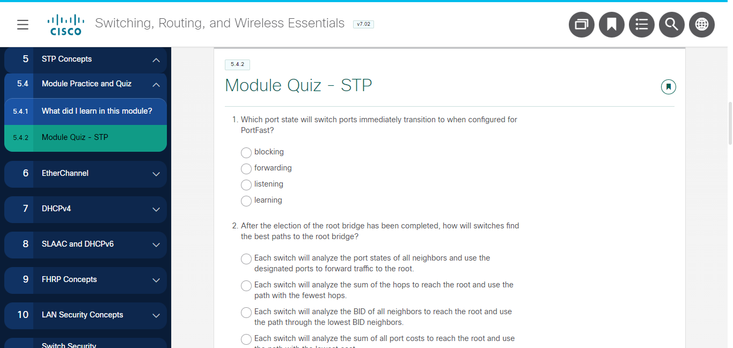

Take a screenshot of your activity result.

|  |
| --- |
|  |

**Class Discussion (Lecturer facilitated) – 40 minutes**

1. Do you think the threat of broadcast storms is still present, given STP’s existence?

|  |
| --- |
|  |

1. How appropriate do you think the standard Spanning Tree timers are for today’s switched networks, eg when a root bridge with a lower priority is introduced ?

|  |
| --- |
|  |

1. From what you have learnt, what significant advantage does RSTP provide over STP?

|  |
| --- |
|  |

1. PortFast allows a port to go into forwarding mode immediately. With reference to the problem statement , which switches are most appropriate for this command to be implemented? In these switches which have end devices waiting for DHCP addresses, how would the portfast command help ?

|  |
| --- |
|  |

**PDT (Team) – At Your own time**

1. Discuss among your team and continue working with the team PDT for the problem statement, using all you have learnt so far. You may leave the class when you are done (*Remember to complete the E-learning portion below)

Use the given template C328_LP1_PDT_Template.docx.   
You will need to include this into your team presentation, do reflect the topics and area of research properly.

1. List down your individual PDT contribution below (You will append to the list weekly by filling in the blanks)

Problem Definition Template :

|  |  |  |  |
| --- | --- | --- | --- |
| What I do not know? | What do I need to find out? | Possible answers to solve the problem | Action by: |
|  |  |  |  |

1. Discuss among your team what is your contribution to the team. Are the rest of the members in your team contributing as well? Please mutually work in the team and fill in the figures below and update this table (weekly) into your team presentation in week 7.

|  |  |  |  |
| --- | --- | --- | --- |
| **Member Name** | **Individual Contribution within the team to the solution(s) for the problem statement** | **Details of Contribution to the team’s presentation this week.** | **Details of Contribution to the team’s PKT solution this week.** |
| *Eg - Tan Ah Beng* | *Eg - 20%* | *Eg – Created DHCPv4 slides explaining . . . .* | *Eg – Created DHCPv4 server configuration and verification on router R1* |
| Member 1 | 50% |  |  |
| Member 2 | 30% |  |  |
| Member 3 | 15% |  |  |
| Member 4 | 5% |  |  |
| Member 5 | 0% |  |  |

|  |
| --- |
| **Week 4 - E-Learning Phase – 30 mins** |

**Activity – (Self-study)**

1. To recap your knowledge about spanning tree protocol, do watch the following videos

STP <https://www.youtube.com/watch?v=japdEY1UKe4>

Portfast / BPDUGuard : <https://www.youtube.com/watch?v=n3en4EcHms0>

Ensure you know the difference between the following 2.

1. Port role Vs Port state
2. Root bridge election process.
3. What is the outcome of mac address table instability on a switch? Specifically, what will happen to the network?

|  |
| --- |
|  |

|  |
| --- |
| **Deliverables for academic week 4**   1. Individual Worksheet (completed up to this point) –> individual submission folder in LEO 2.0 by 23:59, uploaded in DOC format.   Do note this Worksheet/PDT submission weekly is for your own progress tracking.  From Week 2 onwards, Module exams will be considered for the 20% AKS component. |

|  |
| --- |
| **Academic Week 5** |

|  |
| --- |
| **Week 5 - Learning Phase 1 - 120 minutes** |

**Class Presentation (Lecturer-Led) – 40 minutes**

|  |
| --- |
| Module 6: Etherchannel  6.1 Etherchannel Operation  6.2 Configure Etherchannel |

**PT Activity (Lecturer-Led) - 20 mins**

1. Complete **Packet Tracer – Configure Etherchannel (**Refer to **6.2.4 Packet Tracer - Configure EtherChannel.pka).**

Ensure that you are able to understand etherchannel configuration for the switch.

**Class Presentation (Lecturer-Led) – 10 minutes**

|  |
| --- |
| Module 6: Etherchannel  6.3 Verify and Troubleshoot EtherChannel |

**PT Activity (Lecturer-Led) - 20 mins**

1. Complete **Packet Tracer - Troubleshoot EtherChannel** (Refer to**6.3.4 Packet Tracer - Troubleshoot EtherChannel.pka**)

Ensure that you are able to understand how etherchannel troubleshooting is done.

**Class Discussion – 30 minutes**

1. Given 2 links between 2 devices , would you use etherchannel or STP? Explain in terms of reliability and scalability.

|  |
| --- |
|  |

1. What is the purpose behind EtherChannel negotiation protocols?

|  |
| --- |
|  |

1. What is the difference between LACP and PAgP in terms of the number of interfaces that may be bundled into a group?

|  |
| --- |
|  |

1. Why do you think configuration changes must be done under the port-channel interface for existing port-channel groups?

|  |
| --- |
|  |

1. How might the protocols DTP and EtherChannel be confused?

|  |
| --- |
|  |

1. What are some configuration settings that might cause a channel group not to successfully come up?

|  |
| --- |
|  |

|  |
| --- |
| **Week 5 - Learning Phase 2 - 120 minutes** |

**PT Activity – (Self-study)**  **– 30 mins**

1. Complete **Packet Tracer - Implement Etherchannel** (Refer to ***6.4.1 Packet Tracer - Implement Etherchannel.pka***).

|  |
| --- |
| **PART 6 AVAILABLE AND RELIABLE NETWORKS:** |

**Class Presentation (Lecturer-Led) – 30 minutes**

|  |
| --- |
| Module 7: DHCPv4  7.1 – DHCPv4 Concepts  7.2 – Configure a Cisco IOS DHCPv4 Server  7.3 – Configure a DHCPv4 Client |

**Class Discussion – 20 minutes**

1. During the lease procedure, what is the reason for the client sending the DHCPREQUEST as a broadcast packet?

|  |
| --- |
|  |

1. What Layer 2 protocol is peripherally involved during the DHCP process?

|  |
| --- |
|  |

1. What scenarios do you think a router acting as a DHCPv4 server is the best course of action?

|  |
| --- |
|  |

1. If the DHCPv4 server is not configured, does the dhcp service running on the router pose a security risk?

|  |
| --- |
|  |

1. Based on your knowledge of DHCPv4 server configuration options, what options do you think most service providers make sure to provide to home router DHCPv4 clients?

|  |
| --- |
|  |

**PT Activity (Lecturer-Led) - 15 mins**

1. Complete **Packet Tracer – Configure DHCPv4** (Refer to ***7.2.10 Packet Tracer - Configure DHCPv4.pka***).

Ensure that you are able to understand how DHCPv4 client/server configuration is done.

**PT Activity (Lecturer-Led) - 15 mins**

1. Complete **Packet Tracer - Implement DHCPv4** (Refer to ***7.4.1-packet-tracer---implement-dhcpv4.pka***).

Ensure that you are able to understand how DHCPv4 is implemented.

**Check Your Understanding (CYU) – 10 minutes**

1. Complete ***7.4.4 Module Quiz – DHCPv4***

Take a screenshot of your activity result.

|  |
| --- |
|  |

**PDT (Team) – At Your own time**

1. Discuss among your team and continue working with the team PDT for the problem statement, using all you have learnt so far. You may leave the class when you are done (*Remember to complete the E-learning portion below)

Use the given template C328_LP1_PDT_Template.docx.   
You will need to include this into your team presentation, do reflect the topics and area of research properly.

1. List down your individual PDT contribution below (You will append to the list weekly by filling in the blanks)

Problem Definition Template :

|  |  |  |  |
| --- | --- | --- | --- |
| What I do not know? | What do I need to find out? | Possible answers to solve the problem | Action by: |
|  |  |  |  |

1. Discuss among your team what is your contribution to the team. Are the rest of the members in your team contributing as well? Please mutually work in the team and fill in the figures below and update this table (weekly) into your team presentation in week 7.

|  |  |  |  |
| --- | --- | --- | --- |
| **Member Name** | **Individual Contribution within the team to the solution(s) for the problem statement** | **Details of Contribution to the team’s presentation this week.** | **Details of Contribution to the team’s PKT solution this week.** |
| *Eg - Tan Ah Beng* | *Eg - 20%* | *Eg – Created DHCPv4 slides explaining . . . .* | *Eg – Created DHCPv4 server configuration and verification on router R1* |
| Member 1 | 50% |  |  |
| Member 2 | 30% |  |  |
| Member 3 | 15% |  |  |
| Member 4 | 5% |  |  |
| Member 5 | 0% |  |  |

|  |
| --- |
| **Week 5 - E-Learning Phase – 30 mins** |

1. Complete ***Modules 5 - 6: Redundant Networks Exam*** . – **to complete by 23:59**

Take a screenshot of your activity result.

|  |
| --- |
|  |

|  |
| --- |
| **Deliverables for academic week 5**   1. Individual Worksheet (completed up to this point) –> individual submission folder in LEO 2.0 by 23:59, uploaded in DOC format. 2. Complete Module Exam - Modules 5 - 6: Redundant Networks **(Mandatory )**   Do note this Worksheet/PDT submission weekly is for your own progress tracking.  From Week 2 onwards, Module exams will be considered for the 20% AKS component. |

|  |
| --- |
| **Academic Week 6** |

|  |
| --- |
| **Week 6 - Learning Phase 1 – 120 minutes** |

**Class Presentation (Lecturer-Led) – 100 minutes**

|  |
| --- |
| Module 8: SLAAC and IPv6  8.1 – IPv6 GUA Assignment  8.2 – SLAAC  8.3 – DHCPv6  8.4 - Configure DHCPv6 Server |

**Check Your Understanding (CYU) – 20 minutes**

1. Complete **8*.5.3 Module Quiz – SLAAC and DHCPv6***

Take a screenshot of your activity result.

|  |
| --- |
|  |

|  |
| --- |
| **Week 6 - Learning Phase 2 – 120 minutes** |

**Class Discussion – 20 minutes**

1. What parallels can you draw between a IPv6 Link Local Address and an IPv4 APIPA address?

|  |
| --- |
|  |

1. What do you think would happen if the M and A flags were both on in an RA received by a host?

|  |
| --- |
|  |

1. What benefit does the random generation of interface ID by the host provide?

|  |
| --- |
|  |

1. What process would you equate the DAD process to?

|  |
| --- |
|  |

1. What advantage do you think Stateful DHCPv6 has over Stateless DHCPv6?

|  |
| --- |
|  |

1. What is the primary difference between DHCPv4 and DHCPv6 from an operations perspective?

|  |
| --- |
|  |

1. How prevalent do you think the configuration of a DHCPv6 relay agent is within an enterprise network?

|  |
| --- |
|  |

1. In the configuration of a DHCPv6 server, are there any required pool options?

|  |
| --- |
|  |

**Class Presentation (Lecturer-Led) – 60 minutes**

|  |
| --- |
| Module 9: FHRP Concepts  9.1 – First Hop Redundancy Protocols  9.2 – HSRP |

**Check Your Understanding (CYU) – 10 minutes**

1. Complete **9*.3.2 Module Quiz - FHRP Concepts***

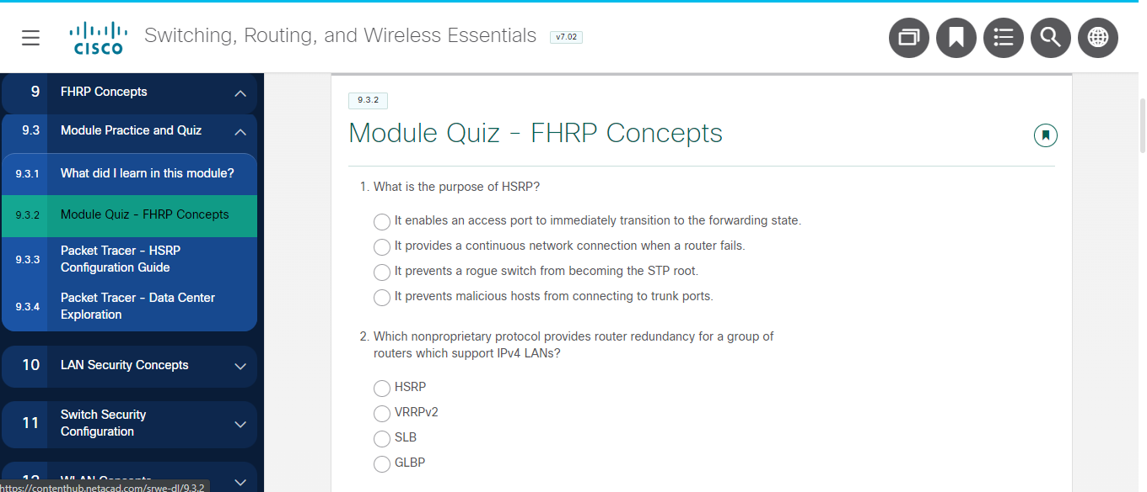

Take a screenshot of your activity result.

|  |
| --- |
|  |

**PT Activity (Lecturer-Led) –10 mins**

1. Complete **Packet Tracer - HSRP Configuration Guide** (Refer to **9.3.3-packet-tracer---hsrp-configuration-guide.pka**).

Ensure that you are able to **appreciate** how HSRP is configured.

**Class Discussion – 10 minutes**

1. What would happen if there were two possible default gateways, but the one your host connected to went down?

|  |
| --- |
|  |

1. How do you think two routers could provide a consistent default gateway to LAN hosts?

|  |
| --- |
|  |

1. How does HSRP operate?

|  |
| --- |
|  |

|  |
| --- |
| **PART 7 Back to Problem Statement:** |

**PDT (Team) – 30 minutes**

1. In the PKT , there is a bug in packet tracer. Implementing IPv6 DHCP nd-other-flag in L3 switches will result in end users not receiving DNS server config. Workaround is to use router.
2. For IPv6 – you do not need to implement IPv6 layer 3 redundancy,

**PDT (Team) – At Your own time**

1. Discuss among your team and continue working with the team PDT for the problem statement, using all you have learnt so far. You may leave the class when you are done (*Remember to complete the E-learning portion below)

Use the given template C328_LP1_PDT_Template.docx.   
You will need to include this into your team presentation, do reflect the topics and area of research properly.

1. List down your individual PDT contribution below (You will append to the list weekly by filling in the blanks)

Problem Definition Template :

|  |  |  |  |
| --- | --- | --- | --- |
| What I do not know? | What do I need to find out? | Possible answers to solve the problem | Action by: |
|  |  |  |  |

1. Discuss among your team what is your contribution to the team. Are the rest of the members in your team contributing as well? Please mutually work in the team and fill in the figures below and update this table (weekly) into your team presentation in week 7.

|  |  |  |  |
| --- | --- | --- | --- |
| **Member Name** | **Individual Contribution within the team to the solution(s) for the problem statement** | **Details of Contribution to the team’s presentation this week.** | **Details of Contribution to the team’s PKT solution this week.** |
| *Eg - Tan Ah Beng* | *Eg - 20%* | *Eg – Created DHCPv4 slides explaining . . . .* | *Eg – Created DHCPv4 server configuration and verification on router R1* |
| Member 1 | 50% |  |  |
| Member 2 | 30% |  |  |
| Member 3 | 15% |  |  |
| Member 4 | 5% |  |  |
| Member 5 | 0% |  |  |

|  |
| --- |
| **Week 6 - E-Learning Phase – 30 mins** |

**PT Activity – (Self-study)**  **– 30 mins**

1. Complete **Packet Tracer - Data Center Exploration - Physical Mode** (Refer to***9.3.4-packet-tracer---data-center-exploration---physical-mode.pka***).

This activity allows you to appreciate the technologies used in data centre configurations.

|  |
| --- |
| **Deliverables for academic week 6**   1. Completed Individual Worksheet and upload –> individual submission folder in LEO 2.0 by 23:59, DOC format. 2. Individual reflection journal -> LEO 2.0 by 23:59.   Do note this Worksheet/PDT submission weekly is for your own progress tracking.  From Week 2 onwards, Module exams will be considered for the 20% AKS component. |

|  |
| --- |
| **Academic Week 7** |

|  |
| --- |
| **Week 7 - Learning Phase 1 – 120 mins** |

**Class Discussion – 30 minutes**

Discuss among your team and prepare for your presentation.

**Team 1 – 30 minutes**

Please follow the instructions of the lecturer in class and follow the timing. Each member is expected to demonstrate an aspect of your practical implementation in the team’s PKT solution.

**Team 2 – 30 minutes**

Please follow the instructions of the lecturer in class and follow the timing. Each member is expected to demonstrate an aspect of your practical implementation in the team’s PKT solution.

**Team 3 – 30 minutes**

Please follow the instructions of the lecturer in class and follow the timing. Each member is expected to demonstrate an aspect of your practical implementation in the team’s PKT solution.

|  |
| --- |
| **Week 7 - Learning Phase 2 – 120 mins** |

**Team 4 – 30 minutes**

Please follow the instructions of the lecturer in class and follow the timing. Each member is expected to demonstrate an aspect of your practical implementation in the team’s PKT solution.

**Team 5 – 30 minutes**

Please follow the instructions of the lecturer in class and follow the timing. Each member is expected to demonstrate an aspect of your practical implementation in the team’s PKT solution.

**6P Presentation** – **30 minutes**

Do take note of the 6P solution. This solution may not be the only answer but it represents a solution from the perspective of an expert in the field.

**In-class paper quiz – 30 minutes**

(Open-book. Laptop allowed but without Internet, no use of mobile devices)

|  |
| --- |
| **Week 7 - E-Learning Phase – 30 mins** |

**PT Activity – (Self-study)**  **– 30 mins**

1. Complete ***Modules 7 - 9: Available and Reliable Networks Exam*** – **to complete by 23:59**

Take a screenshot of your activity result.

|  |
| --- |
|  |

|  |
| --- |
| **Deliverables for academic week 7**   1. Team copy of PKT solution–> team submission folder in LEO 2.0 by 9:45am **SHARP**   **(No SUBMISSION at 9.45am will result in entire team’s presentation component to be NIL)**   1. Team presentation slides –> team submission folder in LEO 2.0 by 9:45am. (To include both contribution percentage & PDT slides)  (NO changes allowed after the submission) 2. Completed Evaluations (Self & Team) 3. Complete Module Exam - Modules 7 - 9: Available and Reliable Networks Exam **(Mandatory )** |