
B.S. Abdur Rahman Crescent Institute of Science and Technology
Deemed to be University u/s 3 of the UGC Act, 1956

PROJECT REPORT
Amizhtha Canteen Website
An Online Food Ordering System for College Canteen
Submitted By
S. FAYAAZ IBRAHIM
RRN : 250181601011
A. MOHAMED SHEIK ALI
RRN : 250181601033
ASLAN SHA
RRN : 250181601021
MOHAMMED ANFAAL
RRN : 250181601038
KEERTHI
RRN : 250181601028
B.TECH CSE (CYBER SECURITY)
For
CSE1203 — JAVA AND INTERNET PROGRAMMING LABORATORY
II SEMESTER
Submitted To
Dr. T. Pandiyavathi
CSE DEPARTMENT

TABLE OF CONTENT
S.NO | TOPIC | PAGE NO
1 | INTRODUCTION | 1
2 | PROJECT OVERVIEW | 1
3 | TOOLS AND TECHNOLOGIES USED | 2
4 | IMPLEMENTATION | 2
5 | RESULTS AND SCREENSHOTS | 3
6 | TEAM CONTRIBUTION | 4
7 | CONCLUSION | 4

INTRODUCTION
The purpose of this project is to design and develop a web-based food ordering system for the Amizhtha Canteen at B.S. Abdur Rahman Crescent Institute of Science and Technology. Students often face the problem of missing classes or wasting time while waiting in long canteen queues. This project aims to solve that problem by providing a simple and efficient online platform where students can browse the menu, add items to their cart, and place orders for delivery directly to their classroom.
The website is built using core web technologies — HTML, CSS, and JavaScript — making it lightweight, fast, and easy to use. It does not require any additional frameworks or backend server, making it ideal for a laboratory project demonstration.

PROJECT OVERVIEW
The Amizhtha Canteen Website is a multi-page frontend web application that simulates a real-world food ordering system. The project consists of four main pages — Home, Menu, Cart, and Order — each serving a specific purpose in the ordering workflow.
Pages and their purpose:
- Home Page (index.html) — Welcomes the user, displays information about the canteen, highlights key features like fast delivery and easy ordering.
- Menu Page (menu.html) — Displays food items categorized into Meals, Snacks, and Drinks. Each item has a name, description, price, and an Add to Cart button.
- Cart Page (cart.html) — Shows all items added by the user, allows removal of items, and displays the total price automatically.
- Order Page (order.html) — Collects student delivery details and confirms the order with a personalized success message.

TOOLS AND TECHNOLOGIES USED
System Details:
- Operating System: Windows
- Editor: Visual Studio Code
- Browser: Google Chrome
- Technologies: HTML5, CSS3, JavaScript (Vanilla)
Technologies Overview:
Technology | Role | Usage in Project
HTML5 | Structure | Building all 4 pages of the website
CSS3 | Styling | Colors, layout, animations, responsiveness
JavaScript | Functionality | Cart logic, form validation, order confirmation
localStorage | Data Storage | Storing cart items across pages

IMPLEMENTATION
The project was implemented as a static multi-page website using HTML, CSS, and JavaScript. All files are stored in a single folder called amizhtha-canteen and are linked together using the anchor tag.
File Structure:
- index.html — Home Page
- menu.html — Menu Page
- cart.html — Cart Page
- order.html — Order Page
- style.css — Stylesheet for all pages
- cart.js — JavaScript for cart functionality
- order.js — JavaScript for order functionality
Procedure:
- Created the folder structure and all HTML files
- Designed the navbar, hero section, about section, features section, and footer in index.html
- Built the menu page with food cards categorized into Meals, Snacks, and Drinks
- Implemented the cart system using JavaScript and localStorage to store and retrieve cart items
- Created the order form with input validation and order confirmation using JavaScript
- Styled all pages using a consistent green color theme with CSS animations and hover effects

RESULTS AND SCREENSHOTS
The website was successfully implemented and tested on Google Chrome. All four pages loaded correctly and the cart and order functionalities worked as expected. The following screenshots show the output of each page.
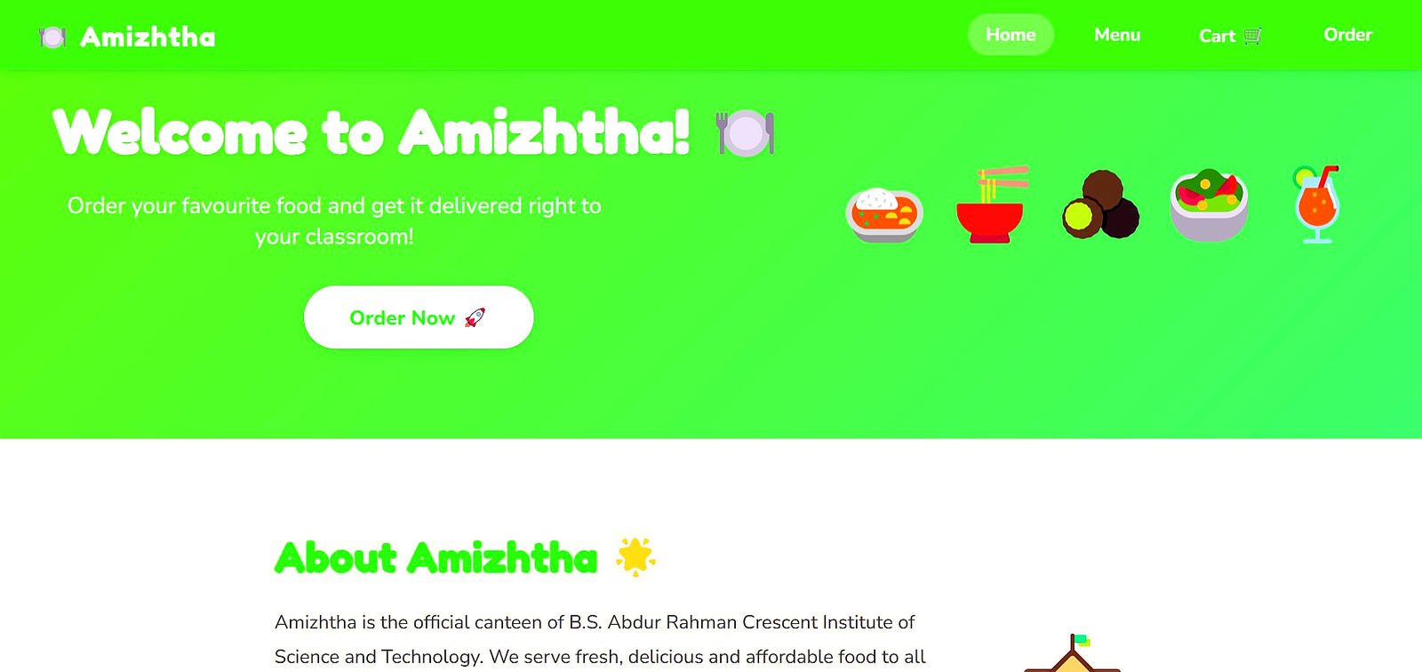
Figure 1: Home Page — Welcome banner and About Amizhtha section
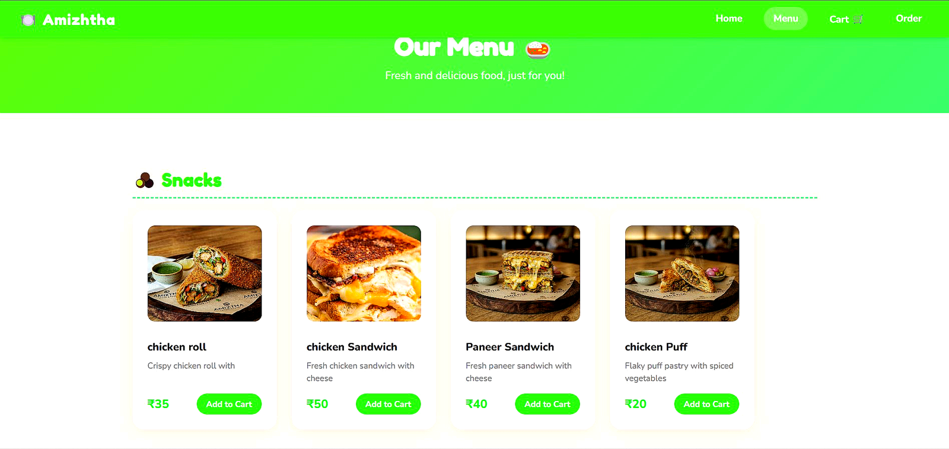
Figure 2: Menu Page — Snacks category with real food images
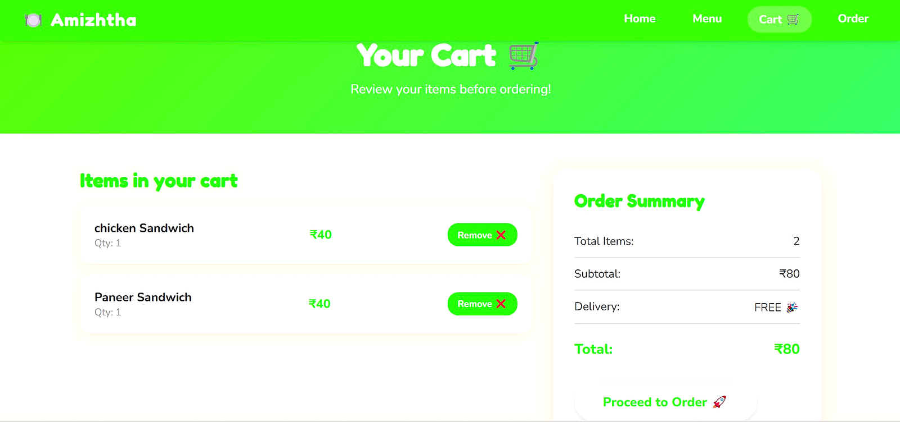
Figure 3: Cart Page — Selected items with order summary and total price
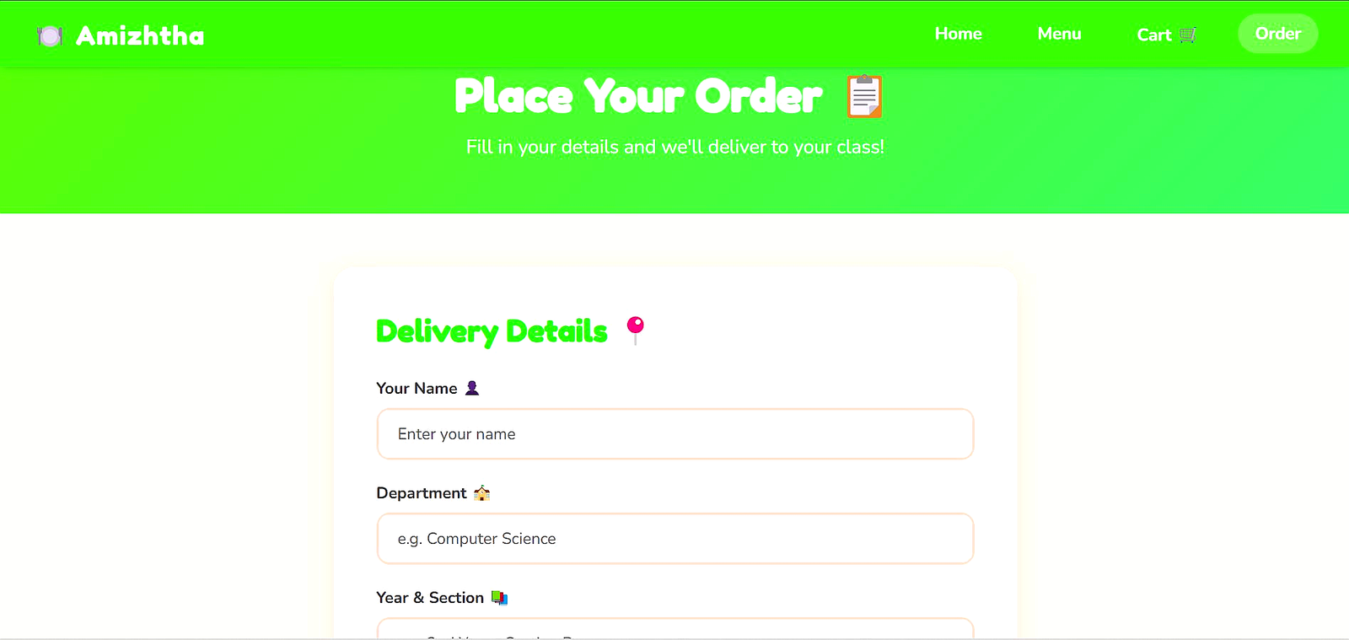
Figure 4: Order Page — Delivery details form for classroom delivery

TEAM CONTRIBUTION
The project was developed collaboratively by a team of five members. Each member was responsible for a specific part of the website as follows:
Name | RRN | Contribution
S. Fayaaz Ibrahim | 250181601011 | Home Page (index.html)
A. Mohamed Sheik Ali | 250181601033 | Menu Page (menu.html)
Aslan Sha | 250181601021 | Cart Page (cart.html + cart.js)
Mohammed Anfaal | 250181601038 | Order Page (order.html + order.js)
Keerthi | 250181601028 | Styling (style.css)

CONCLUSION
This project helped in understanding how HTML, CSS, and JavaScript can be used together to build a complete and functional web application. Through the development of the Amizhtha Canteen Website, the team gained hands-on experience in creating multi-page websites, implementing cart logic using JavaScript, storing data using localStorage, validating user input in forms, and applying CSS styling and animations.
The project also provided practical exposure to real-world web development concepts such as DOM manipulation, event handling, and responsive design. The website successfully demonstrates how a canteen ordering system can be built using only frontend technologies without the need for a backend server.
Overall, the Amizhtha Canteen Website is a practical, real-world inspired project that effectively demonstrates the skills learned in the Java and Internet Programming Laboratory course. It not only solves a common problem faced by college students but also showcases the power of simple web technologies in building meaningful applications.

