Sheet 2 solution

1. outer loop n inner loop
j^2 = 4*n by take square root for both
and 3rd loop k = 3*n
j = 2*n so Over all complexity will be O(n^3)

2. O(n)
3. the step will be 1 , 3, 9 37 …. log(n) base 3
4.O(square root (n)) → O(n)
5. outer loop → n
inner loop → n O(n^2)
6. O(n) → independent loops
7. outer loop n inner loop 0n , 1n ,3n ,4n 5n ...etc n common factor n(1+2+3+5+…)
series of (n(n+1))/2 → O(n^3)
8. outer loop log (n) base 3 inner loop
(3^0 , 3^1,3^2…) 3^n
from geometric series O(n)
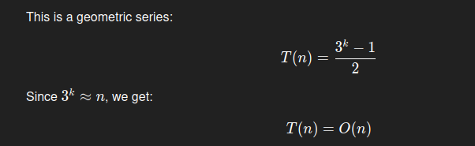

9. outer loop O(n)
2nd loop depend on first 0 ,2 ,4, 9,16 O(n^2)
3rd loop O(n) also depend in outer and second
all O(n^4)
10. n = 5 , k =25
for loop → n^2
while loop will be k also = n^2 but k step /2 so it will be also n so over all O(n^2 log n)
11 . outer loop log(n) base 2
inner loop 0 → ½ , 0 → 2/2 → 1.5 increase by 0.5 every time so if we put 10 in second loop we end up with 20 steps which’s 2n so all O(n)
12.outer n
inner n O(n^2)
13. log(n) base 10
14. outer = n
inner log(n) all O(n log(n))
15. I variable log n base 2 j variable n
all n log(n)
16. 3 loops 1 is n
second = log(n) in p variable so p change with logarithmic rate change in p = log(n)
the 3rd loop change with log(n) at variable p so we ended up = log(log(n))
so when say 2 loops log n + log(log(n))
take log (n) and overall O(n log (n))
17. outer loop n times second loop log(n)
over all O(n log(n))
18. outer loop O(n)
second depend on y and y start from 0 so it will = j so over all O(n^2)
19. O(n^2)

