|  |  |  |  |
| --- | --- | --- | --- |
| **COMP1617 (2020/21)** | **Network Architectures and Services** | **Faculty  Header** | **Contribution 50% of course** |
| **Course Leader Dr Mariusz Pelc** | **COMP1617 Coursework** |  | **Deadline Date:**  **Sunday 29/03/2021** |
| This coursework should take an average student who is up-to-date with tutorial work approximately 30 hours   Feedback and grades are normally made available within 15 working days of the coursework deadline | | | |
| **Learning Outcomes:**  1. Demonstrate in depth knowledge of network communications, OSI and TCP/IP model.  2. Demonstrate a critical understanding of lower level network models with related key protocols, services and applications.  3. Contribute to the analysis, design and development of complex networking systems, recognising the interrelationships among components.  4. Be competent in the use of specialist tools, designed to analyse and simulate network functionality. | | | |

|  |
| --- |
| Plagiarism is presenting somebody else's work as your own. It includes: copying information directly from the Web or books without referencing the material; submitting joint coursework as an individual effort; copying another student's coursework; stealing coursework from another student and submitting it as your own work.  Suspected plagiarism will be investigated and if found to have occurred will be dealt with according to the procedures set down by the University. Please see your student handbook for further details of what is / isn't plagiarism.  **All material copied or amended from any source (e.g. internet, books) must be referenced correctly according to the reference style you are using.   Your work will be submitted for plagiarism checking.  Any attempt to bypass our plagiarism detection systems will be treated as a severe Assessment Offence.** |

#### Coursework Submission Requirements

* An electronic copy of your work for this coursework must be fully uploaded on the Deadline Date of **Sunday 29/03/2021** using the link on the coursework Moodle page for COMP1617.
* For this coursework you must submit a single PDF document.  In general, any text in the document must not be an image (i.e. must not be scanned) and would normally be generated from other documents (e.g. MS Office using "Save As .. PDF"). An exception to this is hand written mathematical notation, but when scanning do ensure the file size is not excessive.
* There are limits on the file size (see the relevant course Moodle page).
* Make sure that any files you upload are virus-free and not protected by a password or corrupted otherwise they will be treated as null submissions.
* Your work will not be printed in colour. Please ensure that any pages with colour are acceptable when printed in Black and White.
* You must NOT submit a paper copy of this coursework.
* All courseworks must be submitted as above. Under no circumstances can they be accepted by academic staff

The University website has details of the current Coursework Regulations, including details of penalties for late submission, procedures for Extenuating Circumstances, and penalties for Assessment Offences.  See <http://www2.gre.ac.uk/current-students/regs>

**Coursework Specification**

This coursework is an **individual** assessment.

The objective of this coursework is to simulate a real IP network and to investigate its performance under different network conditions.

**Use the Riverbed Modeler (OPNET) simulator for this project.**

**Detailed Specification**

Designing a network requires considering several parameters, from reliability, redundancy and security to disaster recovery, performance usability and energy consumption. Predicting network performance and producing energy efficient networks are both open research areas. The performance and energy consumption of a network can be measured, modelled or simulated. In this assignment you are invited to investigate methods for reducing the energy consumption of backbone networks.

**Tasks:**

**Part 1: Literature review on energy efficient backbone networks**

Some examples of techniques for reducing energy in backbone networks include smart sleeping, dynamic adaptation and re-engineering of network devices. There are many more. Before building the network models described below, produce a literature review section on the main energy efficient solutions for backbone networks, their functionality and operation. Ensure you utilise high-quality references from journals to support your literature review, and present them using Harvard Referencing. Some good sources for references are Google Scholar and IEEE Xplore, and specifically reputable publishers would be IEEE, ACM, Elsevier and Springer.

**Part 2: Built a Network model**

Use **Riverbed modeller (OPNET)** to create your model:

* Create a **simplified** version of the IIJ network, which directly links all the company centers to each other, as shown in:

**https://iijamerica.com/wp-content/uploads/2019/10/BBMAP2019-1024x656.png**

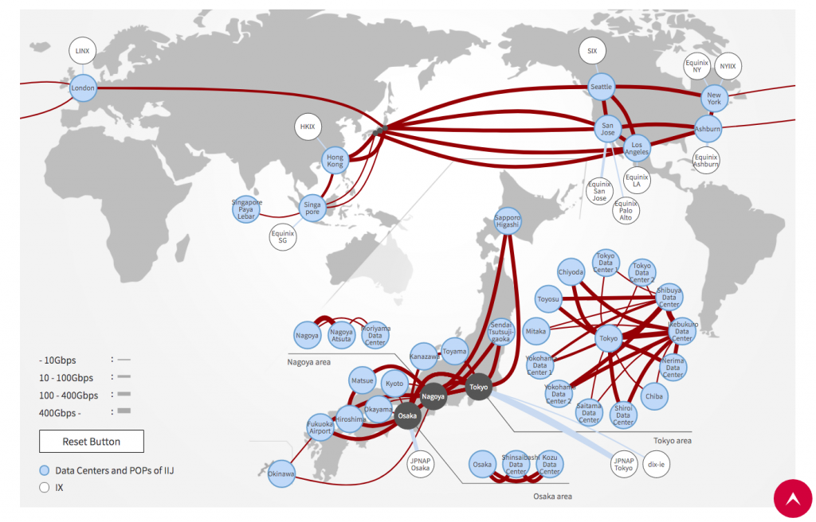

Please describe and justify all the design aspects (links, routers, applications running, traffic generated, etc.) and any assumptions you may decide to make.

* Implement any routing protocol(s) you wish, but do specify which one you would prefer and why.
* Run two scenarios for the routing protocol you have chosen: Scenario 1 should be under “low traffic volume”. Scenario 2 should be under “high traffic volume”.
* Evaluate and investigate the behaviour of the network in terms of energy consumption and performance in the two scenarios. Please note that Riverbed modeler DOES NOT measure energy consumption of wired devices, so you need to find a way to estimate it yourself. Use the research you have conducted in Part 1 of the coursework to identify an energy estimation model that links energy consumption of a network device to traffic metrics (e.g. total *Traffic Sent, Traffic Received,* etc.). Use Global Statistics under OPNET for each routing protocol under both scenarios. You may need to export your data to Excel so that you use them to estimate the energy consumption.

**NOTE: This part will be treated as logbook reflecting all the steps taken to come up with a working solution.**

Deliverables:

A well-structured report needs to include:

* A detailed and critical literature review on energy efficient backbone networks.
* Description of the network models created including scenarios and diagrams.
* Description of each scenario in details including the justification for design and choice of performance parameters.
* Investigation and analysis of all results from all simulations including graphs. Be concise. 4-5 well-chosen graphs with results are usually sufficient.
* Critically evaluate all results. If there is a results figure that is not described well in the text, you know you have done something wrong.
* A conclusion, which is evaluative and reflective.
* You must present your work in a professional manner. You must have a table of contents, page numbers, appropriate sections, headings, graph titles/descriptions. Always check your work for grammatical errors and typos.

**Assessment Criteria**:

1. Literature review 30%

* this should be on the backbone networks, main energy efficient solutions for backbone networks, their functionality and operation
* find a good balance between journal papers / conference papers and technical reports
* include at least in total of 20 references

1. Analysis of the network models and scenarios 10%
2. Justification for design and choice of performance parameters 10%
3. Investigation and analysis of results of the simulations 20%

* this should provide relevant information about: what is being tested, why, test data / settings, results, discussion of the results

1. Conclusions and critical evaluation 20%
2. Presentation 10%

**Marking Conventions**

|  |  |
| --- | --- |
| **Generic Assessment Criteria * %** | |
| 86 – 100 | The work examined is exemplary and provides clear evidence of a complete grasp of the knowledge, understanding and skills appropriate to the Level of the qualification. There is also ample excellent evidence showing that all the learning outcomes and responsibilities appropriate to that Level are fully satisfied. |
| 76 – 85 | The work examined is outstanding and demonstrates comprehensive knowledge, understanding and skills appropriate to the Level of the qualification. There is also excellent evidence showing that all the learning outcomes and responsibilities appropriate to that Level are fully satisfied. |
| 70 – 75 | The work examined is excellent and is evidence of comprehensive knowledge, understanding and skills appropriate to the Level of the qualification. There is also excellent evidence showing that all the learning outcomes and responsibilities appropriate to that Level are satisfied. |
| 65 – 69 | The work examined is very good and is evidence of the knowledge, understanding and skills appropriate to the Level of the qualification. There is also very good evidence showing that all the learning outcomes and responsibilities appropriate to the Level are satisfied. |
| 60 – 64 | The work examined is good and is evidence of the knowledge, understanding and skills appropriate to the Level of the qualification. There is also good evidence showing that all the learning outcomes and responsibilities appropriate to that Level are satisfied. |
| 55 – 59 | The work examined is sound and is evidence of the knowledge, understanding and skills appropriate to the Level of the qualification. There is also sound evidence showing that all the learning outcomes and responsibilities appropriate to that Level are satisfied. |
| 50 - 54 | The work examined is sound but provides limited evidence of the knowledge, understanding and skills appropriate to the Level of the qualification. There is also sound but limited evidence showing that all the learning outcomes and responsibilities to that Level are satisfied. |
| 45 – 49 | The work examined is acceptable but provides significantly restricted evidence of the knowledge, understanding and skills appropriate to the Level of the qualification. There is also acceptable but significantly restricted evidence showing that all the learning outcomes and responsibilities appropriate to that Level are satisfied. |
| 40 – 44 | The work examined is acceptable but provides barely sufficient evidence of the knowledge, understanding and skills appropriate to the Level of the qualification. There is also acceptable but barely sufficient evidence showing that all the learning outcomes and responsibilities appropriate to that Level are satisfied. |
| 35 – 39 | The work examined narrowly fails to provide sufficient evidence of the knowledge, understanding and skills appropriate to the Level of the qualification. There is acceptable evidence showing that the great majority of the learning outcomes and responsibilities appropriate to that Level are satisfied. |
| 30 – 34 | The work examined provides insufficient evidence of the knowledge, understanding and skills appropriate to the Level of the qualification. The evidence provided shows that the majority of the learning outcomes and responsibilities appropriate to that Level are satisfied. |
| 20 – 29 | The work examined is unacceptable and provides little evidence of the knowledge, understanding and skills appropriate to the Level of the qualification. The evidence shows that only some of the learning outcomes and responsibilities appropriate to that Level are satisfied. |
| 10 – 19 | The work examined is unacceptable and provides negligible evidence of the knowledge, understanding and skills appropriate to the Level of the qualification. The evidence shows that few of the learning outcomes and responsibilities appropriate to that Level are satisfied. |
| 0 – 9 | The work examined is unacceptable and provides no evidence of the knowledge, understanding and skills appropriate to the Level of the qualification. The evidence fails to show that any of the learning outcomes and responsibilities appropriate to that Level are satisfied. |