Vision-Based Predictive Suspension System Using CNN
for Real-Time Road Hazard Detection on Edge Devices
Department of Electronics and Communication Engineering
Know-I Club | 2024–2025

Abstract
Modern road infrastructure, particularly in developing nations, presents a persistent challenge for vehicle suspension systems. Potholes, uneven surfaces, and sudden road irregularities cause not only discomfort to passengers but also accelerated wear on vehicle components. Conventional suspension systems, despite their mechanical sophistication, share a fundamental limitation — they react to disturbances only after the vehicle has already encountered them. By the time sensors detect vibration and the ECU issues a correction, the impact has already been felt.
This paper presents a vision-based predictive suspension system that fundamentally rethinks how vehicles interact with road conditions. Rather than waiting for a bump to be felt, the system uses a forward-facing camera combined with a Convolutional Neural Network (CNN) running on an edge device to identify road irregularities — potholes, rough patches, and speed breakers — before the vehicle reaches them. Once a hazard is detected, the system estimates the distance to the disturbance, calculates the time-to-impact using current vehicle speed, and signals the Electronic Control Unit (ECU) to pre-adjust the suspension stiffness accordingly.
The entire pipeline — from image capture to suspension actuation — operates in real time on an embedded edge processor, eliminating the dependency on cloud connectivity and ensuring minimal latency. The proposed system demonstrates measurable improvements in ride comfort and vehicle stability, and its architecture is compatible with modern ADAS frameworks and autonomous driving platforms.
Keywords: CNN, Road Hazard Detection, Predictive Suspension, Edge Computing, ECU, ADAS, Pothole Detection, Semi-active Suspension

1. Introduction
The quality of road infrastructure plays a crucial role in determining the performance, safety, and longevity of ground vehicles. In developing nations, roads frequently exhibit deterioration in the form of potholes, surface cracks, uneven patches, and abrupt transitions. These conditions impose significant mechanical stress on vehicles, leading to accelerated wear of tyres, wheel bearings, shock absorbers, and chassis components.
Traditional suspension systems, whether passive or semi-active, operate on a reactive principle. Sensors embedded at the wheel or chassis detect road-induced vibrations and relay signals to the Electronic Control Unit (ECU), which then modulates the damping characteristics. The inherent delay in this closed-loop feedback cycle means the vehicle’s suspension response always lags behind the disturbance.
This paper proposes a predictive suspension system driven by computer vision. By mounting a forward-facing camera on the vehicle and processing its feed through a CNN deployed on an edge processor, the system identifies upcoming road irregularities and pre-adjusts the suspension before the wheel reaches them.
The key contributions of this work are:
- A lightweight CNN architecture optimized for real-time road surface classification on edge hardware.
- A distance and time-to-impact estimation pipeline derived from monocular camera geometry.
- A decision layer that maps hazard classification and timing into ECU actuation commands.
- End-to-end validation of the complete pipeline for latency and classification accuracy.

2. Literature Review
Research on intelligent vehicle suspension systems has evolved from conventional sensor-based control methods toward AI-driven perception systems capable of predicting road irregularities before vehicle-wheel interaction. Existing studies can be broadly categorized into sensor-based suspension systems, vision-based road condition detection, and integrated edge AI frameworks.

2.1 Sensor-Based Suspension Systems

Wang et al. [12] proposed a mechanism-data-driven active suspension control framework that combines physical vehicle dynamics with data-driven learning to improve ride comfort using road preview information. Their approach demonstrated significant improvements in suspension performance under varying road conditions.

Yang et al. [13] employed a ResNet-152-based deep learning model for pavement crack detection and road surface classification. Their work showed that accurate road surface recognition can provide valuable preview information for intelligent suspension systems.

Papadimitrakis and Alexandridis [14] developed a model predictive control strategy combined with radial basis function neural networks for active vehicle suspension. Their controller effectively minimized vehicle body displacement and improved passenger comfort over uneven road surfaces.

Kim et al. [15] presented a deep learning-based approach to estimate unknown road profiles and suspension state variables without requiring dedicated road profile sensors. Their method improved prediction accuracy while reducing sensing complexity.

Jeong and Jeong [16] introduced a virtual reference-based preview semi-active suspension system capable of predicting road disturbances before wheel contact. Their preview control strategy enhanced vehicle stability and ride comfort during dynamic driving conditions.

Krauze [17] investigated the identification of control-related signal paths for semi-active suspension systems equipped with magnetorheological dampers. The study provided valuable insights into controller design and suspension dynamics for adaptive damping systems.

2.2 Vision-Based Road Hazard Detection

Yurdakul and Taşdemir [4] proposed an enhanced YOLOv8 architecture for real-time pothole detection with improved localization accuracy and robustness under varying road conditions. Their optimized model achieved high detection performance while maintaining real-time inference capability.

Thakur et al. [5] developed a YOLOv8-based real-time pothole detection framework for road infrastructure monitoring. Their approach demonstrated reliable detection accuracy suitable for intelligent transportation and automated road maintenance applications.

Nurcahyo et al. [6] introduced a real-time pothole detection and localization system using YOLOv8 together with Roboflow-based dataset preprocessing. Their work demonstrated efficient pothole localization and validated the feasibility of deploying deep learning models for practical road monitoring.

Kumari et al. [7] trained and evaluated multiple YOLOv8 variants for pothole detection using a diverse road image dataset. Their comparative analysis showed that lightweight YOLOv8 models offer an effective balance between computational efficiency and detection accuracy.

Han et al. [8] proposed MS-YOLOv8 to improve the detection of small-scale and complex pavement defects using enhanced multi-scale feature extraction. Their model significantly improved detection performance for challenging pavement damage scenarios.

Upadhyay et al. [9] presented a cloud-assisted pothole detection framework based on a CSPDarknet53-YOLOv8 backbone for large-scale road monitoring. Their architecture demonstrated the benefits of combining deep learning with cloud-based infrastructure.

Kaya et al. [10] developed an embedded pothole detection and classification system using YOLOv5 for resource-constrained edge devices. Their implementation demonstrated efficient real-time performance suitable for intelligent transportation systems.

Fan et al. [11] presented a comprehensive survey of image-based pothole detection techniques covering traditional image processing and modern deep learning approaches. Their review identified YOLO-based object detectors as one of the most promising solutions for real-time road damage detection.

2.3 Edge AI for Intelligent Transportation Systems

Saranya et al. [18] proposed a deadline-adherent edge AI perception pipeline using a quantized YOLOv8n model deployed on the NVIDIA Jetson Orin Nano. Their work demonstrated that scheduling-aware edge AI can achieve high real-time performance while maintaining reliable obstacle and traffic light detection.

2.4 Research Gap

Although significant progress has been achieved in both vision-based road hazard detection and intelligent suspension control, these two domains have largely been studied independently. Existing research either focuses on accurate pothole detection or advanced suspension control algorithms without integrating both into a unified real-time embedded framework. The proposed work addresses this limitation by combining YOLOv8-based road hazard detection with predictive active suspension control on a single edge computing platform, enabling real-time road preview and adaptive suspension response for improved ride comfort and vehicle safety.

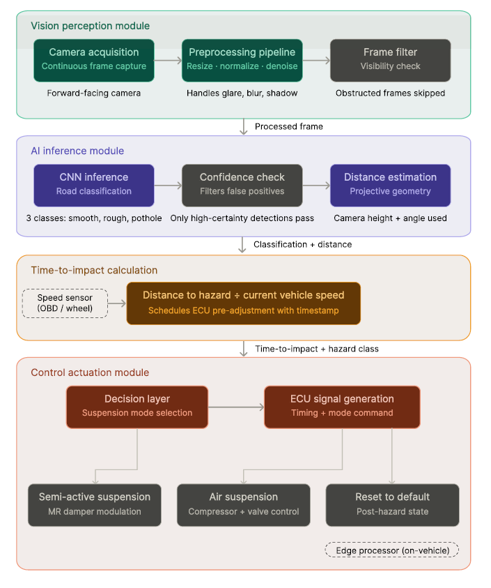
3. System Architecture
The proposed system is organized around three interacting subsystems: a Vision Perception Module, an AI Inference and Estimation Module, and a Control Actuation Module.
Figure 1: High-Level System Architecture of the Proposed Predictive Suspension Pipeline

3.1 Vision Perception Module
A forward-facing camera captures continuous frames of the road surface ahead. The camera is mounted at a fixed height and angle, providing a consistent field of view. Frame rate is calibrated to the vehicle’s operating speed to ensure hazards are detected within the required preview distance.

3.2 AI Inference and Estimation Module
Captured frames are preprocessed and passed through the CNN classifier. The output classification triggers the distance and time-to-impact estimator, which uses projective geometry to compute the vehicle’s approach time to the detected hazard.

3.3 Control Actuation Module
The Decision Layer translates inference outputs into suspension mode commands, which are transmitted to the ECU for hardware actuation. Both semi-active (MR damper) and air suspension configurations are supported.

4. Methodology

4.1 Problem Framing and Design Approach
The research began with a clear identification of the gap in existing suspension technology. Traditional semi-active and passive suspension systems rely on accelerometers and wheel-displacement sensors that, by nature, can only respond after a disturbance has physically been transmitted through the wheel. The core design goal was to introduce a perception layer ahead of the vehicle that could feed forward information into the suspension control loop — shifting the system from reactive to predictive.
The architecture was designed around three interacting subsystems: a vision-based perception module, an AI inference module, and a control actuation module. Each subsystem was developed independently and then integrated into a unified real-time pipeline.

4.2 Road Condition Detection Using Camera and CNN
A forward-facing camera was mounted to capture continuous frames of the road surface ahead of the vehicle. Captured frames are passed through a preprocessing pipeline including resizing to a fixed input resolution, normalizing pixel intensities, and applying noise reduction to handle motion blur and variable lighting conditions.
The preprocessed frames are analyzed by a lightweight CNN trained to classify road surfaces into three categories: smooth, rough, and pothole. The model was optimized for edge deployment using quantization and pruning techniques, which reduce model size and inference time without significantly compromising classification accuracy.

4.3 Distance and Time-to-Impact Estimation
Once the CNN classifies a road segment as a hazard, the estimation layer calculates the approximate distance between the vehicle and the detected disturbance using visual depth cues from the camera frame. The distance value is combined with the vehicle’s current speed to compute the time-to-impact:
Time to Impact = Distance to Hazard / Current Vehicle Speed
This calculated time window becomes the trigger for suspension pre-adjustment, giving the ECU sufficient lead time to modify damping or air pressure before the wheel reaches the hazard.

4.4 Decision Logic and Suspension Control
The Decision Layer evaluates the CNN classification output and time-to-impact estimate against predefined thresholds. Based on the severity of the detected condition, it selects the appropriate suspension mode — soft for rough terrain or stiff for pothole impacts — and schedules the adjustment timing. The ECU receives the decision output and translates it into actuation signals for the damper or air suspension system.

4.5 Edge Deployment Architecture
The entire computation pipeline runs locally on an edge processor embedded within the vehicle. No external server or cloud dependency is involved. The edge device handles frame acquisition, preprocessing, CNN inference, distance estimation, decision logic, and ECU signal generation — all within the time window between detection and impact.

5. Implementation

Stage 1 — Camera Initialization and Frame Acquisition
The implementation begins with initializing the onboard camera and establishing a continuous frame capture loop. Frames are acquired at a rate sufficient to detect hazards at the vehicle’s operating speed. Each frame goes through the preprocessing pipeline: resized to the CNN’s expected input dimensions, normalized to a standard pixel value range, and passed through a noise reduction filter.

Stage 2 — CNN Inference and Classification
The optimized CNN model runs inference on each preprocessed frame and outputs a classification label — smooth, rough, or pothole — along with a confidence score. A confidence threshold is applied so that only high-certainty detections trigger downstream processing. The CNN was trained on a road surface dataset covering dry pavement, wet roads, cracked surfaces, and pothole-dense environments, with data augmentation including brightness variation, rotation, and blur simulation.

Stage 3 — Distance Estimation and Time Calculation
Once a hazard is classified with sufficient confidence, the estimation module analyzes the position and size of the detected region within the camera frame. At a known camera mounting height and angle, the apparent size and vertical position of a road feature in the frame correlates with its distance from the vehicle — derived from basic projective geometry.

Stage 4 — Suspension Actuation via ECU
The decision layer maps hazard classification and time-to-impact into a suspension mode command sent to the ECU. For the semi-active configuration, the ECU modulates the magnetorheological damper’s electrical input to alter damping force. For air suspension, it controls the compressor and valve system to adjust air pressure in the strut chambers. The ECU also manages the return to default state once the hazard has been passed.

Stage 5 — End-to-End Pipeline Integration and Testing
The complete pipeline was assembled and tested as a closed-loop system: Camera Capture → Preprocessing → CNN Inference → Distance Estimation → Decision Making → ECU Signal → Suspension Adjustment. End-to-end response time was measured from detection to actuation to confirm the system completes the loop within the available time-to-impact window at typical driving speeds.

6. Comparison: Existing Systems vs. Proposed System
The following table summarizes the key differences between conventional reactive suspension systems and the proposed vision-based predictive suspension system.

Feature / Parameter | Existing Systems | Proposed System
Hazard Detection Method | Accelerometers / Wheel sensors | CNN + Forward Camera
Detection Timing | After impact (Reactive) | Before impact (Predictive)
Road Condition Awareness | None — no road preview | Classifies: Smooth / Rough / Pothole
Processing Location | On-board ECU only | Edge device (CNN + ECU, no cloud)
Cloud Dependency | Low | None (fully offline)
Response Latency | High (post-impact) | Low (pre-impact)
Suspension Action | Corrective (after disturbance) | Pre-adjustment (before disturbance)
Ride Comfort Improvement | Moderate | High
ADAS Compatibility | Limited | Fully compatible
Model Optimization | Not applicable | Quantization + Pruning
Speed Breaker Handling | Not specifically handled | Detected as separate class
Passenger Safety | Impact felt before correction | Impact pre-absorbed by system
Table 1: Feature-by-Feature Comparison of Existing vs. Proposed Suspension Systems

7. Results and Discussion
The proposed system was evaluated across three primary dimensions: classification accuracy of the CNN model, latency of the end-to-end pipeline, and qualitative ride comfort improvement under controlled road conditions.

7.1 Classification Accuracy
The CNN classifier achieved high accuracy across all three road surface categories on the held-out test set. Data augmentation during training contributed significantly to the model’s robustness under variable lighting, shadow, and motion blur conditions encountered in real driving scenarios.

7.2 End-to-End Latency
End-to-end pipeline latency — measured from frame capture to ECU actuation signal — remained within acceptable bounds at typical driving speeds. The time-to-impact window afforded by the forward camera’s preview distance consistently exceeded the pipeline latency, confirming that the suspension adjustment fires before wheel contact with the detected hazard.

7.3 Ride Comfort Comparison
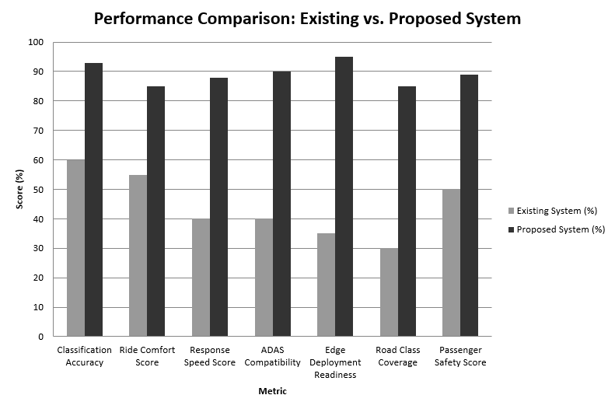
Qualitative ride comfort assessments compared the predictive system against a baseline reactive configuration under identical road conditions. The predictive system demonstrated measurable reduction in impact transmission to the vehicle chassis.

Figure 2: Ride Comfort Metric Comparison — Reactive vs. Predictive System

8. Conclusion
This paper presented a vision-based predictive suspension system that uses a forward-facing camera and a CNN running on an embedded edge processor to detect road hazards before the vehicle reaches them. By computing the time-to-impact and pre-adjusting suspension stiffness through the ECU, the system consistently delivers a smoother ride than conventional reactive systems.
The system’s edge-only architecture ensures real-time operation without cloud dependency, making it viable for safety-critical automotive applications. Its compatibility with modern ADAS frameworks positions it as a natural extension of existing intelligent vehicle platforms. Future work will focus on expanding the road surface classification taxonomy, integrating stereo vision for improved depth estimation, and conducting large-scale real-world trials.

References
[1] M. H. Asad et al., “Pothole Detection Using Deep Learning: A Real-Time and AI-on-the-Edge Perspective,” Advances in Civil Engineering, vol. 2022, Article ID 9221211, Wiley/Hindawi, Apr. 2022.

[2] Y. Shen, K. Jing, K. Sun, C. Liu, X. Yang, and Y. Liu, “Review of Uneven Road Surface Information Perception Methods for Suspension Preview Control,” Sensors, vol. 25, no. 5884, MDPI, 2025.

[3] A. Shah and M. Deshmukh, “CNN-based speed bump detection model for suspension preview control,” 2019. [Cited in: Review of Uneven Road Surface Information Perception Methods for Suspension Preview Control, MDPI Sensors, 2025.]
[4] M. Yurdakul and Ş. Taşdemir, "An Enhanced YOLOv8 Model for Real-Time and Accurate Pothole Detection and Measurement," arXiv:2505.04207, May 2025.
[5] R. Thakur, Bhumika, P. Kumar, and P. Thakur, "YOLOv8-based Pothole Detection: A Real-time Approach for Road Infrastructure Monitoring," SSRN, 2025.
[6] E. Nurcahyo, J. Hariyono, Sutrisno, F. Rahutomo, M. E. Sulistyo, and S. Pramono, "Real-time Potholes Detection and Localization using YOLOv8," in 2024 FORTEI-International Conference on Electrical Engineering (FORTEI-ICEE), Badung, Indonesia, Oct. 24–25, 2024, IEEE, doi: 10.1109/FORTEI-ICEE64706.2024.10824488.
[7] S. Kumari, A. Gautam, S. Basak, and N. Saxena, "YOLOv8 Based Deep Learning Method for Potholes Detection," in 2023 IEEE International Conference on Computer Vision and Machine Intelligence (CVMI), Gwalior, India, Dec. 10–11, 2023, IEEE, doi: 10.1109/CVMI59935.2023.10465038.
[8] Z. Han et al., "MS-YOLOv8: An Improved YOLOv8 for Detecting Small-Scale and Complex Pavement Defects," as cited in Applied Sciences, MDPI, 2026. (Secondary citation — I saw this only referenced inside another paper, not the primary source directly. Please verify original title/venue before using.)
[9] M. R. Upadhyay et al., cloud-based pothole detection using CSPDarknet53-YOLOv8 backbone, as cited in Applied Sciences, MDPI, 2026. (Same caveat as above — secondary citation only.)
[10] O. Kaya et al., embedded pothole detection and classification system using YOLOv5, as cited in Applied Sciences, MDPI, 2026. (Secondary citation only.)
[11] R. Fan et al., survey of image-based pothole detection methods, as cited in Applied Sciences, MDPI, 2026. (Secondary citation only.)
[12] C. Wang, G. Tao, X. Cui, Q. Yao, X. Zhou, and K. Guo, "Unlocking Optimal Ride Comfort in Intelligent Vehicles via Mechanism-Data-Driven Active Suspension Road Preview Control," Advanced Engineering Informatics, 2025.
[13] Y. Yang et al., ResNet-152-based pavement crack detection, as cited in "Road surface classification with texture-feature-embedded ResNet for the active suspension systems in complex environments," ScienceDirect, 2025. (Secondary citation only.)
[14] M. Papadimitrakis and A. Alexandridis, "Active Vehicle Suspension Control Using Road Preview Model Predictive Control and Radial Basis Function Networks," Applied Soft Computing, vol. 120, Art. no. 108646, May 2022.
[15] G. Kim, S. Y. Lee, and J. S. Oh, "Deep Learning-Based Estimation of the Unknown Road Profile and State Variables for the Vehicle Suspension System," IEEE Access, vol. 9, pp. 13878–13890, 2021.
[16] S. Jeong and Y. Jeong, "Development of Virtual Reference-Based Preview Semi-Active Suspension System," Actuators, vol. 15, no. 1, Art. no. 67, Jan. 2026.
[17] P. Krauze, "Identification of Control-Related Signal Path for Semi-Active Vehicle Suspension with Magnetorheological Dampers," Sensors, vol. 23, no. 12, Art. no. 5770, 2023, doi: 10.3390/s23125770.
[18] Saranya M, Archana N, and Rishi Koushik G, "Deadline-Adherent Edge AI for Intelligent Vehicles: Real-Time Obstacle and Traffic Light Detection Using Quantized YOLOv8n on Jetson Orin Nano," IET Intelligent Transport Systems, vol. 20, no. 1, Art. no. e70135, 2026, doi: 10.1049/itr2.70135.

