**CORE JAVA**

## *Introduction:*

**JAVA** was developed by James Gosling at **Sun Microsystems Inc** in the year **1995** and later acquired by Oracle Corporation. JAVA is a high-level, class-based, object-oriented programming language and a **platform**. It is mainly used for application programming i.e., in Windows-based (Standalone applications), web-based, enterprise and mobile app development.

* Java applications are called WORA (Write Once Run Anywhere). This means a programmer can develop Java code on one system and can expect it to run on any other Java-enabled system without any adjustments. This is all possible because of JVM. So, its platform Independent
* Java is not 100% object oriented as it supports primitive datatypes.

**PLATFORM** ---> A platform is a hardware or software environment in which a program runs. JAVA has a platform i.e; JRE

**PATH vs CLASSPATH:**

Path is set for java tools in java programs like java and javac, which are used to compile your code.

CLASSPATH is used by System or Application class loader to locate and load compile Java bytecodes stored in the .class file.

* The **sourcepath** specifies the location of your Java source files (.java files) that the compiler needs to compile Java code.
* The **classpath** is used to specify the location of compiled Java classes and resources that the Java runtime needs to execute a program.
* The **buildpath** specifies the location of dependent libraries (e.g., JAR files), source folders, and other resources that are required to compile the Java source code into executable bytecode. Build path is used by the compiler to resolve dependencies and compile the source code.

**class** Simple{

**public** **static** **void** main(String args[]){

     System.out.println("Hello Java");

    }

}

**System** is the class name, it is declared as final.

**out** is an instance of the System class and is of type PrintStream. Its access specifiers are public and final.

All instances of the PrintStream class have a public method called **println()**, It is responsible for printing the argument and printing a new line.

**Note**: Yes, we can save a Java source file by another name than the class name, if the class is not public.

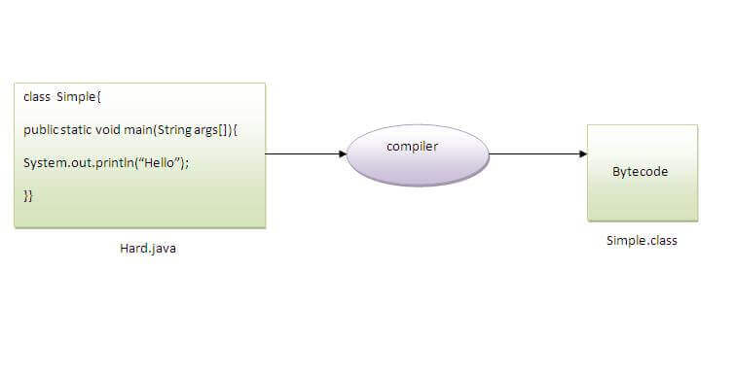

ASCII values

0 to 9 ----> 48 to 57

A to Z ----> 65 to 90

a to b ----> 97 to 122

--->to execute class in terminal:

Compile: javac Simple.java

Run: java Simple //here, we need to give .class name

Packages:

Packages can be defined as the grouping of related/similar types of classes, interfaces etc, providing access to protection and namespace management.

There are various advantages of defining packages in Java.

* Packages avoid name clashes.
* The Package provides easier access control.
* We can also have the hidden classes that are not visible outside and are used by the package.
* It is easier to locate the related classes.

There are two types of packages in Java

* User-defined packages
* Build In packages

--->to execute packages;

Compile: javac -d . Simple.java

Run: java packageName.Simple

// -d means destination & .(dot) means current location/within same directory

**Note:** can two classes have same name in diff packages?

Yes, you can have two classes with the same name in multiple packages. Two classes in different packages may have the same name, and we differentiate between them by using their fully qualified names.

However, you can't import both classes in the same file using two import statements. You'll have to fully qualify one of the class names if you really need to reference both.

//error

import pkg1.SomeClass;

import pkg2.SomeClass;

public class Main {

public static void main(String args[]) {

new SomeClass(); //ambiguty

}

}

//good

import pkg1.SomeClass;

public class Main {

public static void main(String args[]) {

new SomeClass();

new pkg2.SomeClass(); // not imported

}

}

## *Compile & Runtime:*

At compile time, the Java file is compiled by Java Compiler (It does not interact with OS) and converts the **Java code(**source code**)** into **bytecode**(machine code)

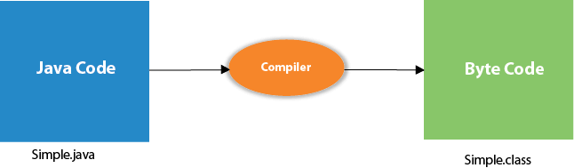

At runtime, the **bytecode**(executable code) is started running by JVM. ie; The interpreter executes this bytecode at runtime and produces output.

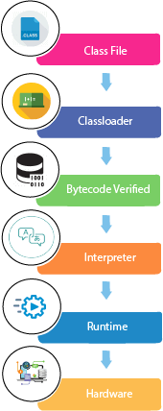

* **Classloader:** It is a part of the Java Runtime Environment (JRE) which is used to load Java classes into the JVM dynamically. It adds security by separating the package for the classes of the local file system from those that are imported from network sources.
* **Bytecode Verifier:** It checks the code fragments for illegal code that can violate access rights to objects.
* **Interpreter:** Read bytecode stream then execute the instructions.

Types OF Classloaders:

1. Bootstrap Class Loader

**Responsibility:** The bootstrap class loader, or primordial class loader, is responsible for loading core Java classes from the bootstrap classpath. This includes classes from rt.jar and other core libraries located in the lib directory of the JRE.

**Implementation**: It is implemented in native code (typically written in C or C++) and is not written in Java. It is part of the JVM implementation itself.

**Parent**: It does not have a parent class loader.

**Examples**: java.lang.String, java.lang.Object, etc.

2. Extensions Class Loader

**Responsibility**: The extensions class loader loads classes from the extensions directories ($JAVA_HOME/lib/ext or any other directory specified by the java.ext.dirs system property).

**Parent**: Its parent is typically the bootstrap class loader.

**Examples**: Classes from third-party libraries added to the extension’s directories.

3. System Class Loader (Application Class Loader)

**Responsibility**: The system class loader loads classes from the system classpath. It is responsible for loading application-specific classes from directories or JAR files specified by the java.class.path system property.

**Parent**: Its parent is typically the extensions class loader.

**Examples**: Classes from your application, third-party libraries, etc.

# *Features of JAVA:*

**1. Platform Independent:**Compiler converts source code to bytecode and then the JVM executes the bytecode generated by the compiler. This bytecode can run on any platform be it Windows, Linux, or macOS (means if we compile a program on Windows, then we can run it on Linux). Any system having JVM can run it irrespective of their operating system. That’s why Java is platform-independent. Byte code is referred to as a Portable code.

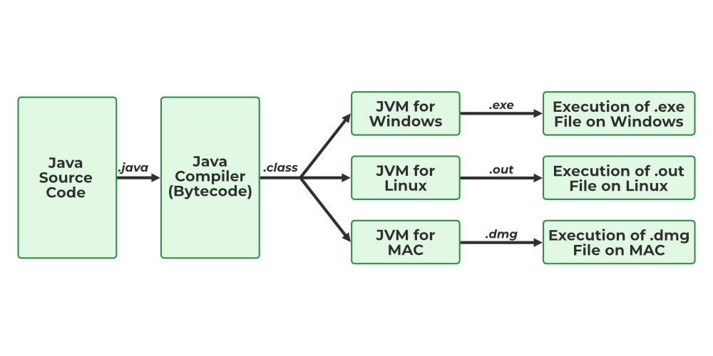

**2. Object-Oriented Programming:**Everything in Java is an object. Object-oriented means we organize our software as a combination of different types of objects that incorporate both data and behavior. The **four** main concepts are:

* Abstraction
* Encapsulation
* Inheritance
* Polymorphism

**3.** **Simple:**Java is one of the simple languages as it does not have complex features like pointers, operator overloading, multiple inheritances, and Explicit memory allocation.

**4.** **Robust:**Java language is robust which means reliable. It is developed in such a way that it puts a lot of effort into checking errors as early as possible, that is why the java compiler can detect even those errors that are not easy to detect by another programming language. The main features of java that make it robust are garbage collection, Exception Handling, and memory allocation.

**5.** **Secure:** Java is best known for its security. With Java, we can develop virus-free systems. we can directly share an application with the user without sharing the actual program makes Java a secure language. Java is secured because:

- No explicit pointer

- Java Programs run inside a **virtual machine sandbox**

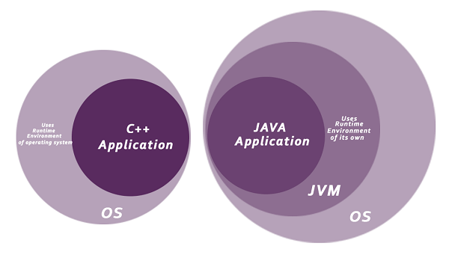

**6.** **Distributed:**We can create distributed applications using the java programming language. Remote Method Invocation and Enterprise Java Beans are used for creating distributed applications in java. The java programs can be easily distributed on one or more systems that are connected to each other through an internet connection.

**7.** **Multithreading:**Java supports multithreading. It is a Java feature that allows concurrent execution of two or more parts of a program for maximum utilization of the CPU.

**8.** **Portable:**Java is portable because it facilitates you to carry the Java bytecode to any platform. It doesn't require any implementation.

**9. High Performance:** Java architecture is defined in such a way that it reduces overhead during the runtime and at sometimes java uses Just In Time (JIT) compiler where the compiler compiles code on-demand basics where it only compiles those methods that are called making applications to execute faster.

Java is an interpreted language that is why it is slower than compiled languages, e.g., C, C++, etc but faster than other traditional interpreted programming languages.

**10. Dynamic flexibility:**Java being completely object-oriented gives us the flexibility to add classes, new methods to existing classes, and even create new classes through sub-classes. Java even supports functions written in other languages such as C, C++ which are referred to as native methods.

# *Constructor:*

It is a special type of method which is used to initialize the object. It is called when an instance of the class is created. At the time of calling constructor, memory for the object is allocated in the memory.

There are two rules defined for the constructor:

1. Constructor name must be the same as its class name.
2. A Constructor must have no explicit return type.
3. A Java constructor **cannot** be abstract, static, final, and synchronized.

There are **two types of constructors** in Java:

Default constructor (no-arg constructor)

Parameterized constructor

**Constructor Overloading in Java:**

In Java, a constructor is just like a method but without return type. It can also be overloaded like Java methods.

Constructor overloading is a technique of having more than one constructor with different parameter lists. They are arranged in a way that each constructor performs a different task. They are differentiated by the compiler by the number of parameters in the list and their types.

# *Keywords:*

Java keywords are known as **reserved words** (predefined words), which hold special meaning. So, you cannot use keywords like int, for, class etc as variable name (or identifiers) as they are part of the Java programming language syntax.

* In programming languages, **Identifiers** are used for identification purposes. In Java, an identifier can be a class name, method name, variable name, or label generated by programmer.
* **Keywords** can’t be used as an identifier.

Ex: int score; //int=keyword, score=identifier

STATIC:

The static keyword in Java is used to declare members (variables, methods, and nested classes) that belong to the class itself, rather than to instances of the class. It is mainly used for memory management (memory efficient/ saves memory).

**Static Variable:**

* static variable can be used to refer to the common property of all objects.
* When you declare a static variable in a class, **memory for that variable is allocated only once, regardless of how many instances of the class are created**. This memory allocation happens in a special area of memory called the "class area" or "static area".
* It cannot be local. These are commonly used to define **constants** that are associated with the class.

**Static Method:**

* A static method belongs to the class rather than the object of a class.
* A static method can be invoked without the need for creating an obj of a class.
* A static method can access static data member and can change the value of it.
* In Java, you can overload static methods, but you cannot override them.

**NOTE**: There are two main restrictions for the static method. They are:

1. Static methods cannot use non-static data member (or) call non-static method directly.
2. this and super cannot be used in static context.

* A static block can throw only a RunTimeException and should not throw any checked exceptions. Because it is not possible to handle these checked exceptions in your source as static methods are class level and objects are not instantiated to handle them with try-catch blocks.

FINAL KEYWORD --> It is used to **restrict** the user, if you make any variable as final, we cannot change the value of final variable (It will be constant).

final methods cannot be overridden.

Final class cannot be inherited.

//uninitialized final variable can be initialized in the constructor only.

this keyword:

this can be used to refer current class instance variable.

this can be used to invoke current class method (implicitly)

this() can be used to invoke current class constructor.

**Ex**: return this; //if used inside method, will return current obj

super Keyword: The **super** keyword is a **reference variable** which is used to refer immediate parent class object.

***USES:***

super can be used to refer immediate parent class instance variable.

super can be used to invoke immediate parent class method.

super() can be used to invoke immediate parent class constructor.

**Note**: both this() & super() can’t be used together because, those keywords have to be first in the constructor. Since both keywords can't be first at the same time, you can't use them together.

# *C++ vs Java:*

|  |  |  |
| --- | --- | --- |
| **Comparison** | **C++** | **Java** |
| **Platform-independent** | C++ is platform-dependent. | Java is platform-independent. |
| **Mainly used**  **for** | C++ is mainly used for **system** programming. | Java is mainly used for **application** programming. |
| **Libraries** | Comparatively available with low-level functionalities | Wide range of classes for various high-level services |
| **Multiple inheritance** | C++ **supports multiple inheritance.** | Java **doesn't support** multiple inheritance through class. It can be achieved by using [interfaces in java](https://www.javatpoint.com/interface-in-java). |
| **Operator Overloading** | C++ supports [operator overloading](https://www.javatpoint.com/cpp-overloading). | Java doesn't support operator overloading. |
| **Pointers** | C++ supports [pointers](https://www.javatpoint.com/cpp-pointers). You can write a pointer program in C++. | Java supports pointers internally. However, you can't write the pointer program, it has restricted pointer support. |
| **Compiler and Interpreter** | C++ uses **compiler** only. C++ is compiled and run using the compiler which converts source code into machine code. so, C++ is platform dependent. | Java uses both **compiler and interpreter**. Java source code is converted into bytecode at compilation time. The interpreter executes this bytecode at runtime and produces output. |
| **Call by Value and Call by reference** | C++ supports both call by value and call by reference. | Java supports call by value only. There is no call by reference in java. |
| **Thread Support** | C++ doesn't have built-in support for threads. It relies on third-party libraries for thread support. | Java has built-in thread support. |
| **Documentation comment** | C++ doesn't support documentation comments. | Java supports documentation comment (/** ... */) to create documentation for java source code. |

# *Diff between JDK, JRE, JVM:*

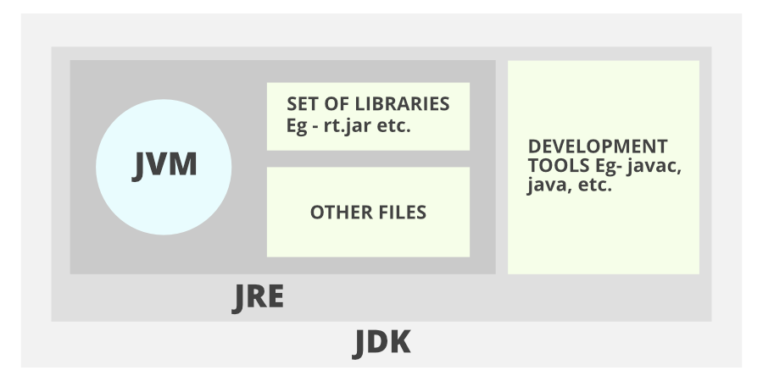

JVM, JRE, and JDK are platform dependent because the configuration of each OS is different from each other.

1. **Java Development Kit (JDK**) stands for Java Development Kit which provides the environment to develop and execute Java programs. JDK is a package that includes **two things** Development Tools (interpreter/loader (Java), a compiler (javac) etc) to provide an environment to develop your Java programs and, JRE to execute Java programs or applications.

It includes the Java Runtime Environment (JRE), an interpreter/loader (Java), a compiler (javac), an archiver (jar), a documentation generator (Javadoc) and other tools needed in Java development.

2.**Java Runtime Environment(JRE)** and also be written as **“Java RTE.”** It is an installation package that provides an environment to **only run** the java program **(not develop)** onto your machine.

It consists of the Java Virtual Machine (JVM), core classes, and supporting files.

3.[**Java Virtual Machine(JVM)**](https://www.geeksforgeeks.org/jvm-works-jvm-architecture/) It acts as a run-time engine to run Java applications.  When you run your Java program (using the **java** command), the JVM loads the bytecode (.class files) and executes it. The JVM interprets the bytecode instructions and translates them into machine-specific instructions for the underlying hardware. JVM is the one that calls the **main** method present in a java code. Whatever Java program you run using JRE or JDK goes into JVM and It is responsible for executing the java program line by line, hence it is also known as an [**i*nterpreter***](https://www.geeksforgeeks.org/compiler-vs-interpreter-2/)**.**

It contains lang **and util base libraries**, **Integration libraries, User interface toolkits etc.**

**Just-In-Time (JIT) compiler**:

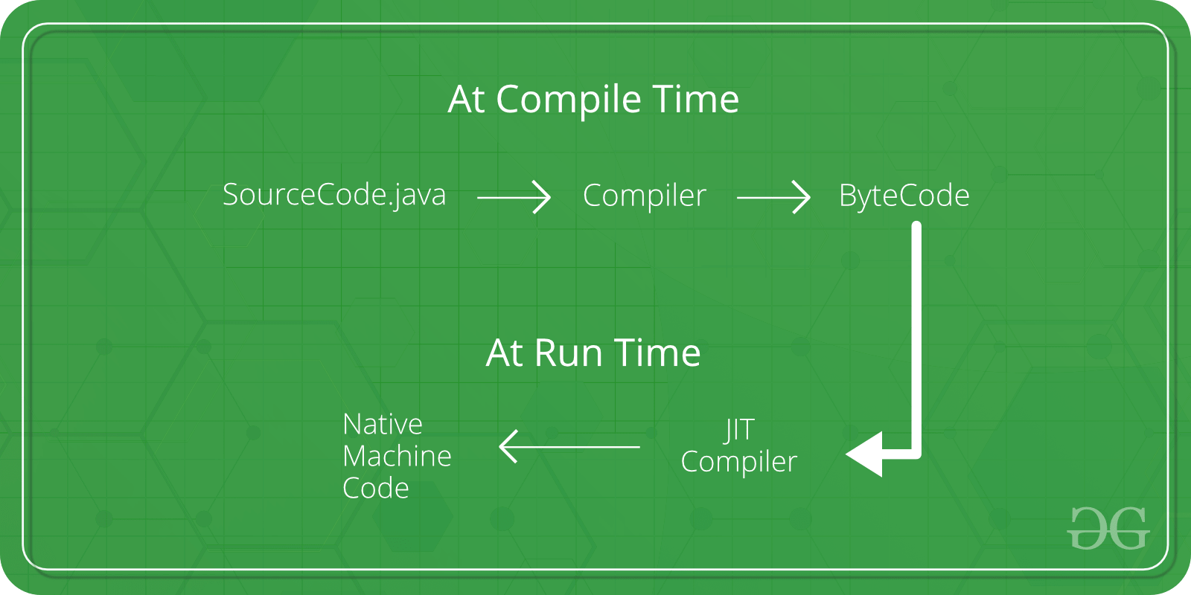

JIT compiler is a part of JVM it is used for better performance of the Java applications during **run-time**. To improve performance, JIT compilers interact with the JVM at run time and compile suitable bytecode sequences into native machine code.

* The JIT compiler is enabled throughout, while it gets activated when a method is invoked. For a compiled method, the JVM directly calls the compiled code, instead of interpreting it.
* As JVM calls the compiled code that increases the performance and speed of the execution.

|  |  |
| --- | --- |
| JVM consists of many other components like stack area, heap area, etc. | JIT is **one of the components of JVM** (It present inside JVM). |
| JVM compiles complete byte code to machine code. | JIT compiles only the reusable byte code to machine code. |

# *Access Modifiers:*

These Access modifiers are used to control the scope of classes and methods.

* **Access Modifiers:** default, public, protected, private.
* **Non-access Modifiers:** final, abstract, static, transient, synchronized, volatile, native.

Private: The access level of a private modifier is only **within the class**. It cannot be accessed from outside the class.

Default: The access level of a default modifier is only **within the package**. It cannot be accessed from outside the package. If you do not specify any access level, it will be the default.

Protected: The access level of a protected modifier is **within the package** and **outside the package through child class** (by extending that class).

Public: The access level of a public modifier is **everywhere**.

# *Operations:*

Operators are the special types of symbols used to perform specific operations on OPERANDS.

**Ex:** a+b ---> a=operand, +=operator

There are multiple types of operators in Java all are mentioned below:

1. Arithmetic Operators (+ - * / %)
2. Unary Operators (- + ! -- ++)
3. Assignment Operator (= += -= *= /= %=)
4. Relational Operators (== != < <= > >=)
5. Logical Operators (&& || !)
6. Ternary Operator (con ? true : false)
7. Bitwise Operators (& | ~ ^)
8. Shift Operators (<< >> >>>)

LEFT SHIFT ---> System.out.println(10<<2); //10*2^2=10*4=40

RIGHT SHIFT ---> System.out.println(30>>3); //30/2^3=30/8=3

1. instance of Operator (return Ture /False)

The  **instanceof** operator is used to check whether the object is an instance of the specified type (class or subclass or interface).

 Simple1 s = **new** Simple1();

  System.out.println(s **instanceof** Simple1); //true

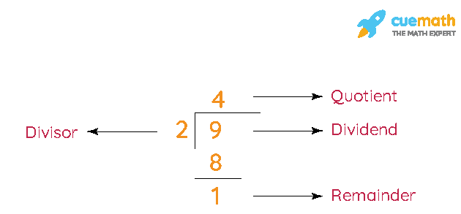

the modulo (%) operator gives the **remainder**, while the division (/) operator gives the **quotient**.

Logical && and Bitwise &

The **logical &&** operator doesn't check the 2nd condition if the 1st condition is false. It checks the second condition only if the first one is true.

The **bitwise &** operator always checks both conditions whether 1st condition is true or false.

Logical || and Bitwise |

The **logical ||** operator doesn't check the 2nd condition if the 1st condition is true. It checks the second condition only if the first one is false.

The **bitwise |** operator always checks both conditions whether 1st condition is true or false.

**--->Java + operator and Operator overloading:**

An operator is said to be overloaded if it can be used to perform more than one functions.

The + operator is overloaded in Java. However, Java does not support user-defined operator overloading.

The + operator can be used to as an arithmetic addition operator to add numbers and can also be used to concatenate strings.

Truth table of the bitwise operators.

| **X** | **Y** | **X & Y (AND)** | **X | Y (OR)** | **X ^ Y (XOR)** |
| --- | --- | --- | --- | --- |
| **0** | **0** | 0 | 0 | 0 |
| **0** | **1** | 0 | 1 | 1 |
| **1** | **0** | 0 | 1 | 1 |
| **1** | **1** | 1 | 1 | 0 |

**Bit Manipulation :**

1. **Get Bit** – fetch the bit present in the given position of a number n **(0101)**

Bit Mask: 1 << i // i is the position of bit we want to perform any action.

Operation: AND //then perform operation btw bitmask and n

2. **Set Bit** – set the bit present in the given pos to 1

Bit Mask: 1 << i

Operation: OR

3. **Clear Bit** – set the bit present in the given pos to 0

Bit Mask: 1 << i

Operation: AND with NOT of BitMask

4. **Update Bit**

To update 1 to 0 (same as clear bit)

Bit Mask: 1 << i

Operation: AND with NOT of BitMask

To update 0 to 1 (same as set bit)

Bit Mask: 1 << i

Operation: OR

# *Datatypes:*

Datatypes specify the type of values that can be stored in the variable.

1. **Primitive Data Type:** Primitive data are only single values and store only numeric data.   Primitives are stored directly in the memory location. There are 8 primitive data types such as boolean, char, int, short, byte, long, float and double.

**//char** stores data in form of 16-bit Unicode character.

1. **Non-Primitive Data Type or Reference Data Types:**

Non-Primitive **Data Types**will contain a memory address of variable values because the reference types won’t store the variable value directly in memory such as String, Array, objects etc.

// nonPrimitives are stored indirectly by referencing a memory location

|  |  |  |  |
| --- | --- | --- | --- |
| **Data Type** | **Default Value** | **Default size** | **Range** |
| boolean | false | 1 bit | -2^7 to 2^7 - 1 (-128 to 127) |
| char | '\u0000' | 2 byte | '\u0000' to '\uffff' (0 to 65,535) |
| byte | 0 | 1 byte | -2^7 to 2^7 - 1 (-128 to 127) |
| short | 0 | 2 byte | -2^15 to 2^15 - 1 (-32,768 to 32,767) |
| int | 0 | 4 byte | -2^31 to 2^31 - 1 (-2,147,483,648 to 2,147,483,647) |
| long | 0L | 8 byte | -2^63 to 2^63 - 1 |
| float | 0.0f | 4 byte | Approximately ±3.40282347E+38F (6-7 significant decimal digits) |
| double | 0.0d | 8 byte | Approximately ±1.7976931348623157E+308 (15 significant decimal digits) |

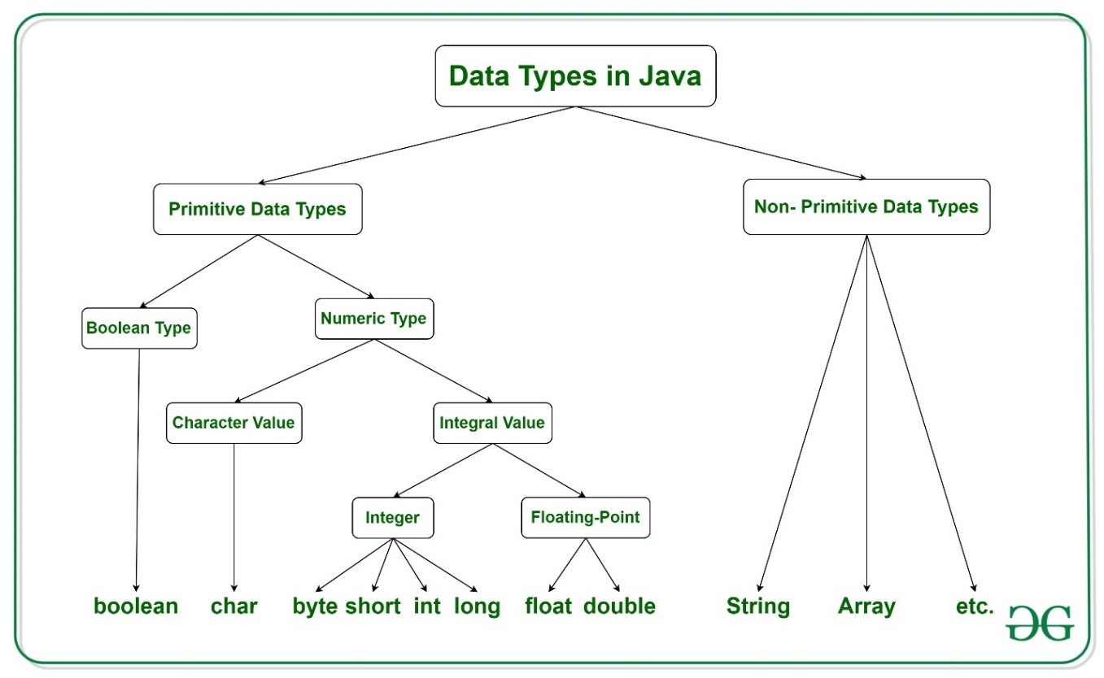

# *Variables:*

VARIABLE is a name of memory location which holds a value. It is the basic unit of storage in a program. All the operations done on the variable affect that memory location. The value stored in a variable can be changed during program execution.

There are three types of variables in java:

1. **Local Variables**

A variable that is defined within a block or method or constructor is called a local variable.

* These variables are created when the block is entered, or the function is called and destroyed after exiting from the block or when the call returns from the function.
* The scope of these variables exists only within the block in which the variables are declared, i.e., we can access these variables only within that block.
* Initialization of the local variable is mandatory before using it in the defined scope.

2. **Instance Variables**

Instance variables are non-static variables and are declared in a class outside of any method, constructor, or block.

* As instance variables are declared in a class, these variables are created **when an object of the class is created** and destroyed when the object is destroyed.
* Unlike local variables, we may use access specifiers for instance variables. If we do not specify any access specifier, then the default access specifier will be used.
* Initialization of an instance variable is not mandatory. Its default value is dependent on the data type of variable. for*float*itis*0.0f,*for*int*it is*0.*for Wrapper classes like String, *Integer* it is *null etc.*
* Instance variables are**serialized***.*
* Instance variables can be accessed only by creating objects.
* We initialize instance variables using constructors while creating an object.

3. **Static Variables**

Static variables are also known as class variables. These are declared similarly to instance variables. The difference is that static variables are declared using the static keyword within a class outside of any method, constructor, or block.

* Unlike instance variables, we can only have one copy of a static variable per class, irrespective of how many objects we create.
* Static variables are created at the start of program execution and destroyed automatically when execution ends.
* static variables are **not serialized**, during deserialization these current values will loaded from class.
* we access a static variable without need of instance of class.
* Static variables cannot be declared locally inside an instance method.
* Static blocks can be used to initialize static variables.

**Time Complexity:** O(1) //for variables – constant time  
**Auxiliary Space:** O(1)

**HEAP** 🡪 Java Heap space is used by java **runtime** to allocate memory to Objects and JRE classes. Whenever we create an object, it’s always created in the Heap space. Garbage Collection runs on the heap memory to free the memory used by objects that don’t have any reference.

**STACK** 🡪 Java Stack memory is used for the execution of a threads. They contain method-specific values that are short-lived and references to other objects in the heap that is getting referred from the method. Stack memory is always referenced in LIFO (Last-In-First-Out) order.

**NOTE**: When the obj is instantiated, **reference variable** will be stored in the stack and the **original object** will be stored in the heap. In general, local variables are stored on the stack. Instance variables are stored on the heap.

**Ex:** All the references to s1, s2, ob1, obj2 and obj3 will be stored in the Stack.

The objects data will be stored in the Heap (and for String, it can be stored in a special constant pool).

[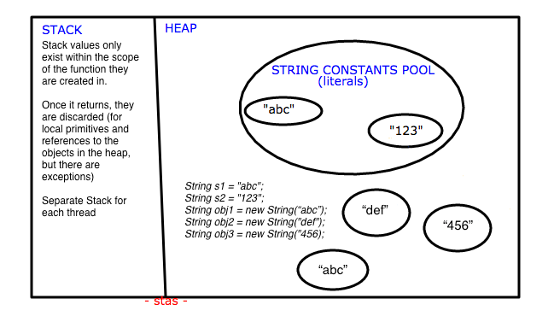](https://i.stack.imgur.com/ZSrf4.png)

The reference variable, which is stored in the stack, contains the memory address (or reference) of the object in the heap. So, when you use the reference variable to access the object, the program looks up the memory address stored in the reference variable and accesses the object's data in the heap.

This separation of reference variables (stored in the stack) and objects (stored in the heap) allows for efficient memory management and enables features like garbage collection, where unused objects in the heap are automatically reclaimed to free up memory.

**Variable Argument (Varargs):**

varrags allows the method to accept zero or muliple arguments. *Varargs* were introduced in *Java 5.* Before that, whenever we wanted to pass a variable number of arguments, we had to pass all arguments in an array or implement N methods (method overloading). *Varargs* help us avoid writing boilerplate code. The varargs uses ellipsis i.e. three dots (…) after the data type. *varargs*are like arrays so we need to work with them just like we’d work with a normal array.

Syntax: public String formatWithVarArgs(String... values) { //code }

Rules for varargs:

- Each method can only have one varargs parameter

- The varargs argument must be the last parameter

void method(String... a, int... b){} //Compile time error

void method(int... a, String b){} //Compile time error

Ex:

class Test1 {

static void fun(int... a){

System.out.println("Number of arguments: "+ a.length);

for (int i : a) // using for each loop to display contents of a

System.out.print(i + " ");

}

public static void main(String args[]){

fun(100); // one parameter

fun(1, 2, 3, 4); // four parameters

fun(); // no parameter

}

}

# *Wrapper classes:*

The wrapper class is an object class that encapsulates the primitive data types (such as int, char, float, etc.) within an object.

wrapper class provides the mechanism to convert primitive data type into object (**Autoboxing**) and object into primitive data type (**Unboxing**).

**Advantages of Wrapper Classes**

1. Collections allowed only object data.
2. On object data we can call multiple methods compareTo(), equals(), toString()
3. Cloning process on objects
4. Object data allows null values.
5. Serialization can allow only object data.

|  |  |
| --- | --- |
| **Primitive Type** | **Wrapper class** |
| boolean | [Boolean](https://www.javatpoint.com/java-boolean) |
| int | Integer |
| char | [Character](https://www.javatpoint.com/post/java-character) |
| byte | [Byte](https://www.javatpoint.com/java-byte) |

# *Flow Controls:*

**1. Decision Making statements:**

* if / if-else

- switch statement -> switch statement is fall-through. It means it executes all statements after the first match if a break statement is not used/present.

**2. Loop statements:**

* do while -> checks the condition at the end of the loop after executing the loop statements. use this when the number of iterations is not known and we have to execute the loop at least once
* while -> used to iterate over the number of statements multiple times. use if we don't know the number of iterations in advance.
* for loop -> It enables us to initialize the loop variable, check the condition, and increment/decrement in a single line of code. We use the for loop only when we exactly know the number of times, we want to execute the block of code.
* for-each loop -> an enhanced for loop to traverse the data structures like array or collection. In the for-each loop, we don't need to update the loop variable.

**3. Jump statements:**

* break statement -> to come out of a loop. In case of inner loop, it breaks only inner loop.
* continue statement -> It continues the current flow of the program and skips the remaining code at the specified condition. In case of an inner loop, it continues the inner loop only.

| **for loop (jdk1)** | **foreach loop (jdk5)** |
| --- | --- |
| In a normal for-loop, we can increase the counter as per our wish by using i=i+x (where x is any constant x=1,2,3…) | In enhanced for loop will execute in a sequential manner i.e counter will always increase by one. |
| In for-loop, we can iterate/print in both decrement or increment order. | In foreach-loop, we can iterate/print only in increment order. |
| In for-loop, we can replace elements at any specific index. | In foreach-loop, we don’t have access to the index, so we cannot replace elements at any specific index. |
| **Ex:**Printing element in a 1D array  int[ ] x={1,2,3};  for(int i=0;i<x.length;i++){  System.out.println(x[i]);  } | **Ex:**Printing element in a 1D array  int[ ] x={1,2,3};  for(int a :  x){  System.out.println(a);  } |
| **Ex:**Printing element in a 2D array  int[ ][ ] x={{1,2,3},{4,5,6}};  for(int i=0;i<x.length;i++) {  for(int j=0; j<x[i].length;j++) {  System.out.println(x[i][j]);  }  } | **Ex:**Printing element in a 2D array  int[ ][ ] x={{1,2,3},{4,5,6}} ;  for(int[ ] x1 :x){  for(int x2 : x1) {  System.out.println(x2);  }  } |

# *OOPS concept:*

Object-oriented programming (OOPs) is a methodology that simplifies software development and maintenance by providing some rules.

Oops concept is to improve code readability and reusability by defining a Java program efficiently. The main principles of object-oriented programming are abstraction, encapsulation, inheritance, and polymorphism.

1. **Object**

An Object can be defined as an instance of a class. It is an entity that has state(data) and behavior(functionality). It can be physical or logical. An object contains an address and takes up some space in memory.

1. **Class**

A class is a template/blueprint from which objects are created. It is a logical entity. Class doesn't consume any space.

// A class is a group of objects which have common properties.

// The **Object class** is the parent class of all the classes in java by default.

The **object cloning** is a way to create exact copy of an object. The clone() method of Object class is used to clone an object. The **java.lang.Cloneable interface** must be implemented by the class, whose object we want to clone. If we don't implement Cloneable interface, clone() method generates **CloneNotSupportedException.**

1. **Inheritance**

It is a mechanism in which one object acquires all the properties and behaviors of a parent object, it is known as inheritance. It provides code reusability & method overriding. The **extends keyword** indicates that you are making a new class that derives from an existing class.

**5 TYPES: (IS-A relationship)**

* When a class inherits another class, it is known as a single inheritance
* When there is a chain of inheritance, it is known as multilevel inheritance
* When two or more classes inherits a single class, it is known as hierarchical inheritance
* When a class inherits two classes, it is known as *multiple inheritance*
* Combination of hierarchical and multiple inheritance, is known as *hybrid inheritance*

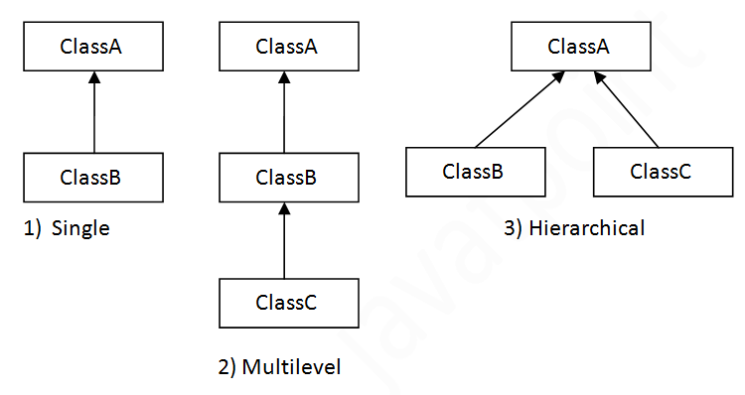

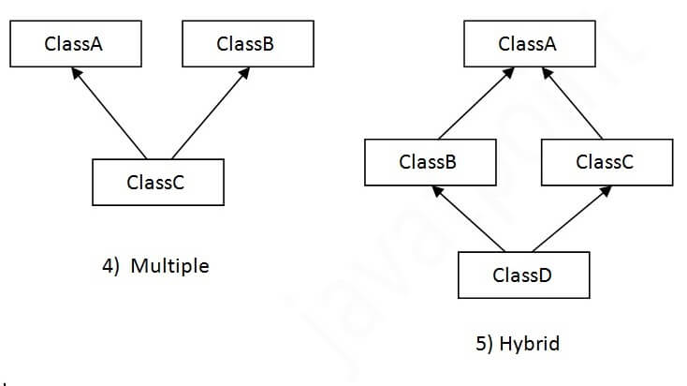

* + multiple and hybrid inheritance is supported through interface only.

**Why multiple inheritance is not supported in java?**

Consider a scenario where A, B, and C are three classes. The C class inherits A and B classes. If A and B classes have the same method and you call it from child class object, there will be **ambiguity** to call the method of A or B class.

Since compile-time errors are better than runtime errors, Java renders **compile-time error** if you inherit 2 classes.

**AGGREGATION:**

If a class have an entity reference, it is known as Aggregation. It represents **HAS-A relationship.**

Consider a situation, Employee object contains many information’s such as id, name, emailId etc. It contains one more object named **address**, which contains its own information such as city, state, country, zip code etc. In such case, Employee has an entity reference **address**, so relationship is Employee HAS-A address.

The real life example of inheritance is child and parents, all the properties of parents are inherited by his son(child).

1. **Polymorphism**

It is a concept by which we can perform a single action in different ways. In other words, polymorphism allows you to define one interface and have multiple implementations.

There are two types of polymorphism in Java:

* compile-time polymorphism
* runtime polymorphism.
* If a class has multiple methods having same name but different in parameters, it is known as Method Overloading (COMPILE TIME POLYMORPHISM)

There are two ways to overload the method in java:

1. By changing number of arguments
2. By changing the data type

**Can we overload java main() method?**

Yes, by method overloading. You can have any number of main methods in a class by method overloading. But JVM calls main() method which receives string array as arguments only. Let's see the simple example:

1. **class** TestOverloading4{
2. **public** **static** **void** main(String[] args){System.out.println("main with String[]");}
3. **public** **static** **void** main(String args){System.out.println("main with String");}
4. **public** **static** **void** main(){System.out.println("main without args");}
5. }

Output: main with String[]

**NOTE**: In Java, Method Overloading is not possible by changing the return type of the method only, we need to change parameters as well. But possible in Method Overriding (covariant return type).

* If a subclass provides the specific implementation of the method that has been declared by one of its parent class, it is known as method overriding (RUN TIME POLYMORPHISM)

// we **canNOT** override java main() method, becoz its a static method.

**Upcasting:** If the reference variable of Parent class refers to the object of Child class, it is known as upcasting. Ex; A a=**new** B();//upcasting

**Note**: Downcasting not possible, it will not give compilation error, but throws **ClassCastException.**

* When **type of the object** is determined at **compiled time** (by the compiler), it is known as static binding.  //static class loading

Dog d1=**new** Dog();

* When **type of the object** is determined at **run-time**, it is known as dynamic binding.  //Dynamic class loading

Animal a=**new** Dog();

**Covariant return type:** The covariant return type specifies that the return type may vary in the same direction as the subclass.

since Java5, it is possible to override method by changing the return type. I.e., subclass **overrides** any method whose return type is **non-Primitive** bychanging its return type to subclass type

class A{

A get(){return this;}

}

class B extends A{

@Override

B get(){return this;}

void message(){System.out.println("welcome to covariant return type");}

public static void main(String args[]){

new B().get().message();

}

}

Real life example of polymorphism: A **person** at the same time can have different characteristics. Like a man at the same time is a father, a husband, an employee. So, the same person possesses different behavior in different situations.

//another ex: **Camera**, we can take pics, record videos, slow motions, paranoma etc.

**Calculator Application:** Consider a calculator application where you want to perform addition with different types of operands. You can have overloaded methods for addition like:

public int add(int num1, int num2);

public double add(double num1, double num2);

public int add(int num1, int num2, int num3);

|  |  |  |  |  |  |
| --- | --- | --- | --- | --- | --- |
| **No.** | | | **Method Overloading** | **Method Overriding** | |
| 1) | Method overloading is used *to increase the readability* of the program. | | | Method overriding is used *to provide the specific implementation* of the method that is already provided by its super class. | |
| 2) | Method overloading is performed ***within class***. | | | Method overriding occurs *in* ***two classes*** that have IS-A (inheritance) relationship. | |
| 3) | In case of method overloading, parameter *must be different*. | | | In case of method overriding, *parameter must be same*. | |
| 4) | Method overloading is the example of *compile time polymorphism*. | | | Method overriding is the example of *run time polymorphism*. | |
| 5) | method overloading can't be performed by changing return type of the method only. *Return type can be same or different* in method overloading, but you must have to change the parameter. | | | *Return type must be same or covariant* in method overriding. | |

1. **Abstraction**

**Abstraction** is a process of hiding the implementation details and showing only functionality to the user.

There are two ways to achieve abstraction in java

1. Abstract class (0 to 100%)
2. Interface (100%)

**Abstract class**

A class which is declared as abstract is known as an **abstract class**. It can have abstract and non-abstract methods. It cannot be instantiated. It can have constructors and static methods also.

A method which is declared as abstract and does not have implementation is known as an abstract method.

abstract class Bike{

abstract void run();

}

class Honda extends Bike{

void run(){System.out.println("running safely");}

public static void main(String args[]){

Bike obj = new Honda();

obj.run();

}

}

**NOTE:** If you are extending an abstract class that has an abstract method, you must either provide the implementation of the method or make this class abstract.

Real life example: ATM machine for cash withdrawal, money transfer, retrieve min-statement, etc in our daily life. But we don't know internally what things are happening inside ATM machine when you insert an ATM card.

**Interface:**

Interface is a mechanism to achieve abstraction (100%). There can be **only** abstract methods in the Java interface. It is used to achieve **abstraction** and **multiple inheritance** in Java (IS-A relationship)

// it can have default and static methods...Static & final variables also

The Java compiler adds public and abstract keywords before the interface method. Moreover, it adds public, static and final keywords before data members.

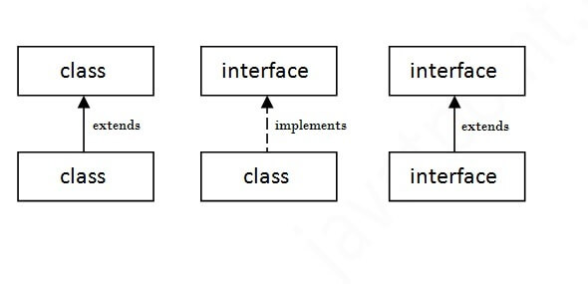

interface printable{

void print();

}

class A implements printable{

public void print(){System.out.println("Hello");}

public static void main(String args[]){

A obj = new A();

obj.print();

}

}

**Multiple inheritance in Java by interface:**

If a class implements multiple interfaces (or) an interface extends multiple interfaces, it is known as multiple inheritance.

// multiple inheritance can be achieved in Interface because, implementation is done in subclass.

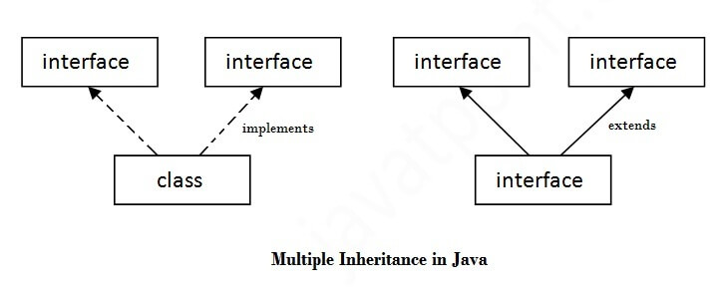

interface Printable{

void print();

}

interface Showable{

void print();

}

class TestInterface3 implements Printable, Showable{

public void print(){System.out.println("Hello");}

public static void main(String args[]){

TestInterface3 obj = new TestInterface3();

obj.print();

}

}

* However, you may wonder which print() method will be called when obj.print() is invoked in the main method. In Java, when a class implements multiple interfaces that contain the same method signature, the implementing class must provide an implementation for that method only once.

In this case, the print() method from the Printable interface is effectively overridden by the print() method from the Showable interface within the TestInterface3 class. So, when **obj.print()** is called, it invokes the **print()** method from the **Showable** interface, and "Hello" will be printed to the console.

|  |  |
| --- | --- |
| **Abstract class** | **Interface** |
| 1) Abstract class can have **abstract and non-abstract** methods. | Interface can have **only abstract** methods. Since Java 8, it can have **default and static methods** also. |
| 2) Abstract class **doesn't support multiple inheritance**. | Interface **supports multiple inheritance**. |
| 3) Abstract class **can have final, non-final, static and non-static variables**. | Interface has **only static and final variables**. |
| 4) Abstract class **can provide the implementation of interface**. | Interface **can't provide the implementation of abstract class**. |
| 5) The **abstract keyword** is used to declare abstract class. | The **interface keyword** is used to declare interface. |
| 6) An **abstract class** can extend another Java class and implement multiple interfaces. | An **interface** can extend another interface only. |
| 7) An **abstract class** can be extended using keyword "extends". | An **interface** can be implemented using keyword "implements". |
| 8) A Java **abstract class** can have class members like private, protected, etc. | Members of a Java interface are public by default. |

**NOTE**: Since Java 8, we can have method body in interface. But we need to make it **default** method.

A Marker interface can be defined as empty interface, having **no data member and functions**, It is called the Marker or **tagged** interface. Ex, Serializable, Cloneable etc

// While Clonable interface doesn't contain any methods, it's used by the **clone()** method in the **Object** class to determine whether cloning is allowed for a particular object or not.

// When a class implements **Serializable**, it's a signal to the Java runtime that the objects of that class can be serialized.

A functional interface has **only one abstract method,** but it can have multiple default & static methods.

**@FunctionalInterface** to make interface as Functional interface. They can have only one functionality to exhibit. From Java 8 onwards, lambda expressions can be used to represent the instance of a functional interface.

A functional interface can have methods of object class like hascode(), toString() etc.

**EX:** Runnable, Comparable, Comparator etc.

//Lambda exp is used to represent the functional interface

NOTE:

* **Static methods** in interfaces are used as helper/utility methods, while **default methods** are used as a default implementation for classes that implements that interface.
* It can extend another interface only when it doesn’t have any abstract method.

* The Consumer Interface accepts a single argument and does not return any result. It is a functional interface defined in java.util.function package. It contains an abstract **accept()** and a default **andThen()** method.

The Consumer interface is often used in scenarios where you need to perform an action on each element of a collection, process data, or perform some side-effect operation. The Consumer interface is part of the Java **Stream API** and is commonly used with functional programming constructs like lambda expressions and method references.

@FunctionalInterface

public interface Consumer<T> {

void accept(T t);

}

Ex:

List<Integer> numbers = new ArrayList<>(Arrays.asList(1, 2, 3, 4, 5));

// Using Consumer to double each element of the list, but it wont print elements

Consumer<Integer> doubleNumber = (num) -> System.out.println(num * 2);

//In forEach each element is applied with consumer obj and prints output.

numbers.forEach(doubleNumber);

**6) Encapsulation**

**It** is *a*process of wrapping code(methods) and data(fields) together into a single unit(class)*,* We can create a fully encapsulated class in Java by making all the data members of the class private. Now we can use setter and getter methods to set and get the data in it.

Real life example: Bluetooth connection, we can send data, but we cannot access other persons data.

🡪 Suppose you go to an automatic cola vending machine and request for a cola. The machine processes your request and gives the cola. Here automatic cola vending machine is a class. It contains both data i.e. Cola-tin & operations i.e. service mechanism and they are wrapped/integrated under a single unit Cola Vending Machine. This is called **Encapsulation**.

You need not know how the machine is working. This is called **Abstraction**.

You can interact with cola tin only through service mechanism. You cannot access the details about internal data like how much tins it contains, mechanism etc. This is **Data Hiding**.

You cannot pick the tin directly. You request for cola through proper instructions and request mechanism (i.e. by paying amount and filling request) and get that cola only through specified channel. This is **message passing**.

The working and data is hidden from you. This is possible because that Vending machine is made (or Encapsulated or integrated) so. Thus, we can say **Encapsulation is a way to implement Abstraction.**

# *Arrays:*

**An Array** is a collection of similar type (homogenous) of elements which has contiguous memory location. We can store only a fixed set of elements in a Java array (fixed size)

Array is index-based, the first element of the array is stored at the 0th index, 2nd element is stored on 1st index and so on.

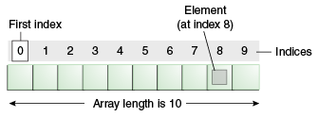

1. **int** a[]={33,3,4,5}; //declaration, instantiation and initialization
2. String [] names = new String[3]; //declaration and instantiation

names[0] = "Abbey"; //initialization

1. **int** arr[][]={{1,2,3},{2,4,5},{4,4,5}};
2. **int**[][] arr=**new** **int**[3][3]; //3 row and 3 column

arr[0][0]=1;

arr[0][1]=2;

1. int[] intArray = new int[]{ 1,2,3,4,5,6,7,8,9,10 };

Advantages

* **Code Optimization:** It makes the code optimized, we can retrieve or sort the data efficiently.
* **Random access:** We can get any data located at an index position.

Disadvantages

* **Size Limit:** We can store only the fixed size of elements in the array. It doesn't grow its size at runtime. To solve this problem, collection framework is used in Java which grows automatically.
* If we are creating **odd number of columns** in a 2D array, it is known as a jagged array. In other words, it is an array of arrays with different number of columns.

//declaring a 2D array with odd columns

int arr[][] = new int[3][];

arr[0] = new int[3];

arr[1] = new int[4];

arr[2] = new int[2];

# *Strings:*

String is an object that represents **sequence of characters**. String objects are stored in a special memory area known as the "string constant pool".

Strings are immutable (cannot be changed), Whenever we change any string, a new instance is created. For mutable strings, you can use StringBuffer and StringBuilder classes.

**char**[] ch = {'j','a','v','a','t','p','o','i','n','t'};

String s = **new** String(ch);   is same as -> String s = "javatpoint";

There are two ways to create String object

**1) By string literal ->** String s="welcome";

Each time you create a string literal, the JVM checks the "string constant pool" first. If the string already exists in the pool, a reference to the pooled instance is returned. If the string doesn't exist in the pool, a new string instance is created and placed in the pool.

EX: String s1="Welcome";

String s2="Welcome"; //It doesn't create a new instance

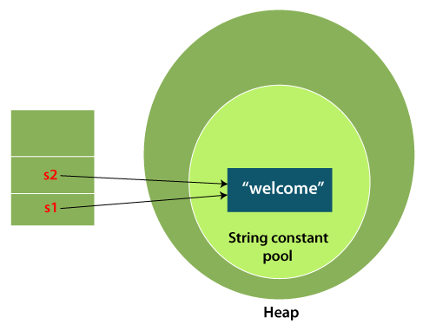

**# Why Java uses the concept of String literal?**

To make Java more memory efficient (because no new objects are created if it exists already in the string constant pool).

* String constant pool is not beneficial/ inefficient in some situations, when there are lot of unique string objects, becoz it will be complex to check each string in pool while creating a new string to pass reference of object.

**2) By new keyword ->** String s = new String("Welcome");

When you create a string using the **new** keyword, it explicitly creates a new instance of the String class, even if an equivalent string already exists in memory. This means that a new memory allocation is made for the string object, regardless of whether the same string already exists in the string pool.

In such case, JVM will create a new string object in normal heap memory, the variable **s** will refer to the object in a heap (non-pool).

**Immutable String:** Since, strings are immutable, we need to explicitly assign it to the reference variable as shown below.

* class Testimmutablestring{

public static void main(String args[]){

String s="Sachin";

s.concat(" Tendulkar");

System.out.println(s);

}

} o/p: Sachin

* class Testimmutablestring1{

public static void main(String args[]){

String s="Sachin";

s=s.concat(" Tendulkar");

System.out.println(s);

}

} o/p: SachinTendulkar

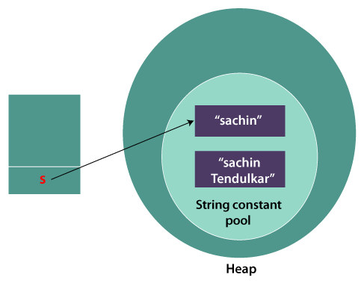

**Why String objects are immutable in Java?**

As Java uses the concept of String literal. Suppose there are 5 reference variables, all refer to one object "Sachin". If one reference variable changes the value of the object, it will be affected by all the reference variables. That is why String objects are **immutable** in Java.

Here's why immutability is emphasized for strings and sometimes other types as well:

1. Thread Safety

Immutable objects, including strings, are inherently thread-safe. Multiple threads can access and use immutable objects concurrently without the risk of data corruption or inconsistency. This simplifies concurrent programming, as developers do not need to synchronize access to immutable objects explicitly.

2. Security

Immutable strings enhance security by preventing unauthorized modification:

**Sensitive Data:** Immutable strings, such as passwords or encryption keys, ensure that once created, their values cannot be changed, reducing the risk of accidental exposure or tampering.

**Class Loading:** In Java, strings are often used in class loading and reflection. Immutable strings prevent attackers from modifying string values to load unauthorized classes or execute malicious code.

3. Performance Optimization

Immutable objects, including strings, enable certain performance optimizations:

**String Pool**: Java maintains a string pool to store literal strings. Immutable strings allow Java to reuse existing strings from the pool, reducing memory consumption and improving performance by avoiding unnecessary object creation.

**Caching:** Immutable objects can be safely cached, as their values do not change. This can improve performance in applications where caching is used extensively.

4. Predictable Behavior

Immutability helps prevent bugs related to unintended state changes:

**Function Arguments:** Immutable objects passed as arguments to methods ensure that their values remain constant throughout the method's execution, reducing the risk of side effects.

**Collections:** Immutable collections, like Collections.unmodifiableList, ensure that the collection's contents cannot be modified after creation, preserving their state and integrity.

5. Simplicity in Design and Debugging

Immutability simplifies software design and debugging:

**Debugging**: Immutable objects are easier to debug because their state does not change. This reduces complexity in identifying and fixing bugs related to unexpected state changes.

**Concurrency**: In concurrent environments, immutability reduces the need for locks and synchronization mechanisms, simplifying concurrent programming and reducing the risk of deadlock or race conditions.

String Compare:

There are three ways to compare String in Java:

1. By Using equals() Method
   * equals() method compares the original content of the string. It compares values of string for equality. String class provides **equals(),** **equalsIgnoreCase() methods.**
2. By Using == Operator
   * The == operator compares references not the values.
3. By compareTo() Method
   * compareTo() method compares values lexicographically and returns an integer value if first string is less than, equal to or greater than second string.

**s1 == s2** : returns 0.

**s1 > s2** : returns a positive value //returns the diff in position of alphabets.

**s1 < s2** : returns a negative value //returns the diff in position of alphabets.

String s1="Sachin";

String s2="Sachin";

String s3="Ratan";

System.out.println(s1.compareTo(s2));//0

System.out.println(s1.compareTo(s3));//1(because s1>s3)

System.out.println(s3.compareTo(s1));//-1(because s3 < s1 )

**Concatenation:** It can be achieve by + and concat() method.

String s=50+30+"Sachin"+40+40;

System.out.println(s); //80Sachin4040

**Note:** After a string literal, all the + will be treated as string concatenation operator.

Split()

This method splits the string against given **regular expression** and returns a char/string array.

--> String[] words=s1.split("\\s+"); //adding + will remove continuous white spaces

**join()** method returns a string combined with a given **delimiter**.

String s=String.join("-","welcome","to","javatpoint");

System.out.println(s); //welcome-to-javatpoint

**Mutable Strings:**

A String that can be modified or changed is known as mutable String. StringBuffer and StringBuilder classes are used for creating mutable strings objects.

For these 2 mutable string classes, we use **append()** method to concatenate the given argument with this String. For regular String we use **concat()** and **+**

Ex: StringBuffer sb=**new** StringBuffer("Hello ");

sb.append("Java"); //now original string is changed

System.out.println(sb); //Hello Java

Available methods are reverse(), insert(int offset, String s), replace(int startIndex, int endIndex, String str), append(String s), capacity() etc.

|  |  |  |
| --- | --- | --- |
| **No.** | **String** | **StringBuffer** |
| 1) | The String class is **immutable**. | The StringBuffer class is **mutable**. |
| 2) | String consumes more memory when we concatenate too many strings because **every time it creates new instance.** | StringBuffer consumes less memory when we concatenate strings. |
| 3) | String class overrides the equals() method of Object class. So you can compare the contents of two strings by equals() method. | StringBuffer class doesn't override the equals() method of Object class. |
| 4) | String class is slower while performing concatenation operation. | StringBuffer class is faster while performing concatenation operation. |
| 5) | String class uses **String constant pool** | StringBuffer uses **Heap memory** |

|  |  |  |
| --- | --- | --- |
| **No.** | **StringBuffer** | **StringBuilder** |
| 1) | StringBuffer is ***synchronized*** i.e. thread safe. It means two threads can't call the methods of StringBuffer simultaneously. | StringBuilder is ***non-synchronized*** i.e. not thread safe. It means two threads can call the methods of StringBuilder simultaneously. |
| 2) | StringBuffer is *less efficient* than StringBuilder. | StringBuilder is *more efficient* than StringBuffer. |

***Mutable/Immutable Objects:***

* The immutable objects are the objects whose value cannot be changed after initialization. Immutable objects have a fixed state, meaning their properties cannot be modified, and any operation that appears to modify the object creates a new object with the updated state. Immutable objects offer several advantages, such as thread safety, ease of caching, and predictable behavior in concurrent environments. **For example**, Wrapper class, String class, etc.
* The mutable objects are the objects whose value can be changed after initialization. When we made a change in existing mutable objects, no new object will be created; instead, it will alter the value of the existing object. **For example**, Arraylist, StringBuilder, StringBuffer, etc.

**How to create Immutable class?**

Immutable class is a class whose instances cannot be modified after they are created. This means that the state of an immutable object remains constant throughout its lifetime. All the wrapper classes and String class are immutable. Advantages of using immutable classes: Thread Safety, Security, Concurrent Programming etc.

how do we define a completely immutable custom class

Declare class as final.

Make all properties as private final.

Do not declare setters. Only getters.

Declare all args constructor.

If there are custom nested/ref objects in the class as properties, implement clone.

If there are other types of nested objects as properties, perform a deep copy.

Ex: final class Employee {

private final String empName; //normal field

private final Address address; //custom ref obj

private final List<String> phoneNumbers; //other nested/ ref obj

public Employee(String name, Address address, List<String> phoneNumbers) {

this.empName = name;

this.address = address;

this.phoneNumbers = phoneNumbers;

}

public String getEmpName() { return empName;}

// clone the address object– impl clone() inside address class

public Address getAddress() throws CloneNotSupportedException {

return (Address) address.clone();

}

// deep copy the list of phone numbers - It will always return initialized objects

public List<String> getPhoneNumbers() {

return new ArrayList<>(phoneNumbers);

}

}

**Java Regex** ---> It is an API to define a pattern for searching or manipulating strings. It is widely used to define the **constraint** on strings such as password and email validation.

s.o.p(Pattern.matches(".s", "as")); //true

s.o.p(Pattern.matches(".s", "amms")); //false (. means any single char)

s.o.p(Pattern.matches("\\d", "4443")); //false (digit but comes more than once)

s.o.p(Pattern.matches("[a-zA-Z0-9]{6}", "arun32")); //true (count is 6 only)

s.o.p(Pattern.matches("[789]{1}\\d{9}", "8853038949")); //true

//Regular expression to validate a password. A password must start with an alphabet and followed by alphanumeric characters; Its length must be in between 8 to 20.

Ans: ^(?=.*[A-Za-z])(?=.*\d)[A-Za-z\d]{8,20}$

**Explanation:**

* ^: Start of the string.
* (?=.*[A-Za-z]): Positive lookahead assertion ensuring that the string contains at least one alphabet (uppercase or lowercase).
* (?=.*\d): Positive lookahead assertion ensuring that the string contains at least one digit.
* [A-Za-z\d]{8,20}: Match between 8 and 20 characters consisting of alphabets (uppercase or lowercase) and digits.
* $: End of the string.

# *Exception Handling:*

Exception is an abnormal condition (event) that disrupts the normal flow of the program.

The **Exception Handling** is a mechanism to handle the runtime errors, so that the normal flow of the application can be maintained.

Types of Java Exceptions

1. **Checked Exception**

The classes that inherit Throwable class instead RuntimeException, Error are known as checked exceptions. Checked exceptions are checked at compile-time. Ex: IOException, classNotFoundException, SQLException etc.

1. **Unchecked Exception**

The classes that inherit RuntimeException are known as unchecked exceptions. Unchecked exceptions are not checked at compile-time but are checked at runtime. Ex: ArithmeticException, NullPointerException, arrayIndexOutOfBoundsException etc

The java.lang.Throwable class is the **root class** of Java Exception hierarchy inherited by two subclasses: Exception and Error. The hierarchy of Java Exception classes is given below:

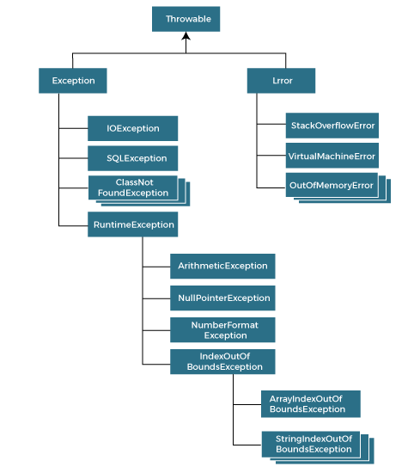

|  |  |  |
| --- | --- | --- |
| **Keyword** | | **Description** |
| try | The "try" keyword is used to specify a block where we should place an exception code. It means we can't use try block alone. The try block must be followed by either catch or finally. | |
| catch | The "catch" block is used to handle the exception. It must be preceded by try block which means we can't use catch block alone. It can be followed by finally block later. | |
| finally | The "finally" block is used to execute the necessary code of the program. It is executed whether an exception is handled or not. | |
| throw | The "throw" keyword is used to throw an exception. | |
| throws | The "throws" keyword is used to declare exceptions. It specifies that there may occur an exception in the method. It doesn't throw an exception. It is always used with method signature. The caller to these methods has to handle the exception using a try-catch block | |

**NOTE:**

The basic difference between final, finally and finalize is that the ***final*** keyword is an access modifier, ***finally*** is the block in Exception Handling and ***finalize*** is the method of object class (used to perform clean up processing just before object is garbage collected).

* If the JVM exits while the try or catch is being executed, then the finally block may not execute. Likewise, if the thread executing the try or catch code is interrupted or killed, the finally block may not execute even though the application as a whole continues. System.exit() will prevent a finally block from executing.
* We can throw exception in finally block. But that is not recommended because we use finally block mostly to close the resource. Not for throwing a new exception. Methods called inside finally block may throw exceptions. We have to handle such exceptions by surrounding them with try-catch.

E.g. if we close FileReader inside finally block, there is a chance for IO exception, which has to be handled.

* Instead of having multiple catch blocks, we can use single catch block with pipe “|“,

To handle multiple exceptions.

**Exception Handling with Method Overriding**

* **If the superclass method does not declare an exception**

If the superclass method does not declare an exception, subclass overridden method cannot declare the checked exception, but it can declare unchecked exception.

* **If the superclass method declares an exception**

If the superclass method declares an exception, subclass overridden method can declare same exception or no exception, but cannot declare parent exception (ie, Exception).

**Custom Exception:**

Creating our own Exception is known as custom exception or user-defined exception. In order to create custom exception, we need to extend Exception class that belongs to java.lang package.

class InvalidAgeException extends Exception {

public InvalidAgeException (String str) {

super(str); // calling the constructor of parent Exception

}

}

public class TestCustomException1 {

static void validate (int age) throws InvalidAgeException {

if(age < 18) {

// throw an object of user defined exception

throw new InvalidAgeException("age is not valid to vote");

} else {

System.out.println("welcome to vote");}

}

public static void main(String args[]) {

try {

validate(13);

} catch (InvalidAgeException ex) {

System.out.println("Caught the exception");

System.out.println("Exception occured: " + ex);

}

System.out.println("rest of the code...");

}

}

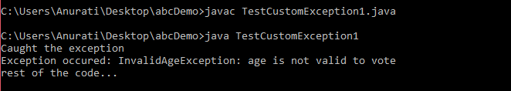

# *Multi-threading:*

Multithreading is a process of **executing multiple threads simultaneously**. A thread is a lightweight sub-process. Each thread run in a separate callstack and uses a shared memory area. They don't allocate separate memory area so saves memory, and context-switching between the threads takes less time than process.

Example is a **web server**. A web server typically has multiple threads running concurrently to serve multiple clients simultaneously.

**Advantages:**

1) It doesn't block the user because threads are **independent**, and you can perform multiple operations at the same time.

2) Since Threads are independent, so it doesn't affect/block other threads if an exception occurs in a single thread.

3)At a time one thread is executed only. If you sleep a thread for the specified time, the thread scheduler picks up another thread and so on.

4) Multithreading is mostly used in games, animation, etc.

**Life cycle of a Thread (Thread States):**

New: When a thread is created but not yet started, it is in the new state. This state occurs when an instance of the Thread class is created, but the start() method has not yet been called to begin its execution.

Runnable: After the start() method is called on a thread, it enters the runnable state. In this state, the thread is eligible to be scheduled for execution by the thread scheduler, but it may not necessarily be running immediately. The thread scheduler determines when to run the thread based on factors such as thread priorities and available CPU resources.

Running: When a thread is actually executing its code, it is in the running state. In this state, the thread's instructions are being executed on the CPU. However, it's important to note that in a multi-threaded environment, multiple threads may be in the running state simultaneously, each taking turns executing their code.

Blocked/Waiting: A thread can enter the blocked or waiting state for various reasons, such as waiting for I/O operations to complete, waiting for synchronization locks, or waiting for other threads to complete their execution. When a thread is in this state, it is temporarily inactive and does not consume CPU resources.

Timed Waiting: This state is similar to the blocked/waiting state, but with a specified time duration. Threads can enter this state when they call methods like sleep() or wait() with a timeout parameter. The thread remains in this state until the specified time elapses or until it receives a notification from another thread.

Terminated: When a thread completes its execution or is explicitly terminated by calling the stop() method, it enters the terminated state. Once a thread is terminated, it cannot be restarted or resumed. However, its resources, such as memory, are released, and it can be garbage collected.

*Difference between Process and Thread:*

| S.NO | **Process** | **Thread** |
| --- | --- | --- |
| 1. | A process is an instance of a program that is being executed | Thread means a segment of a process and is also known as the lightweight sub-process. |
| 2. | The process takes more time for creation & terminate. | The thread takes less time for creation & terminate. |
| 3. | It also takes more time for context switching. | It takes less time for context switching. |
| 4. | Multiprogramming holds the concepts of multi-process. | We don’t need multi programs in action for multiple threads because a single process consists of multiple threads. |
| 5. | The process is isolated and does not share data with each other. | Threads are interdependent and shares memory |
| 6. | The process is called the heavyweight process. | A Thread is lightweight as each thread in a process shares code, data, and resources. |
| 7. | If one process is blocked, then it will not affect the execution of other processes | If a user-level thread is blocked, then all other user-level threads are blocked. |
| 8. | Changes to the parent process do not affect child processes. | Since all threads of the same process share address space and other resources so any changes to the main thread may affect the behavior of the other threads of the process. |

Thread scheduler in java is the part of the JVM that decides which thread should run. The thread scheduler mainly uses preemptive or time slicing scheduling to schedule the threads.

- **preemptive scheduling**, the highest priority task executes until it enters the waiting or dead state or even higher priority task comes into existence.

- **time slicing**, a task executes for a predefined slice of time and then reenters the pool of ready tasks.

**How to create a thread in Java**

There are **two** ways to create a thread:

1. By extending Thread class
2. By implementing Runnable interface.

// If you are not extending the Thread class, your class object would not be treated as a thread object. So, you need to explicitly create Thread class object by passing the object of your class that implements Runnable, so that your class run() method may execute.

* class Multi extends Thread{

public void run(){

System.out.println("thread is running...");

}

public static void main(String args[]){

Multi t1=new Multi();

t1.start();

}

}

* class Multi3 implements Runnable{

public void run(){

System.out.println("thread is running...");

}

public static void main(String args[]){

Multi3 m1=new Multi3();

Thread t1 =new Thread(m1); // Using the constructor Thread(Runnable r)

t1.start();

}

}

Imp: Its better to use **Runnable interface** becoz, if we create a thread object by extending Thread class, we will have a constraint as we can’t extend any other class because java **doesn’t support multiple inheritance.**

**What if we call Java run() method directly instead start() method?**

* Each thread starts in a separate call stack.
* Invoking the run() method from the main thread, the run() method goes onto the current call stack rather than at the beginning of a new call stack. And it will treated as normal overriden run() method and main method itself will execute the run method , means no multi-threading.

**join():** When the join() method is invoked, the current thread stops its execution and goes into the wait state. The current thread remains in the wait state until the thread on which the join() method is invoked has achieved its dead state.

* **Daemon thread:**

Daemon threads in Java are special types of threads that **run in the background** and provide services to other threads or perform tasks that don't require explicit termination. **It** is a **service provider thread** that provides services to the user threads. when all the user threads dies, JVM terminates this thread automatically.

There are many java daemon threads running automatically e.g. gc, finalizer etc.

It is a low priority thread.

t1.setDaemon(**true**); //now t1 is daemon thread

**Note:** If you want to make a user thread as Daemon, it must not be started otherwise it will throw IllegalThreadStateException.

* **Thread pool** represents a group of worker threads that are waiting for the job and reused many times.

In the case of a thread pool, a group of fixed-size threads is created. A thread from the thread pool is pulled out and assigned a job by the service provider. After completion of the job, the thread is contained in the thread pool again.

* **Thread group**, Java provides a convenient way to group multiple threads in a single object. In such a way, we can suspend, resume or interrupt a group of threads by a single method call.

A ThreadGroup represents a set of threads. A thread group can also include the other thread group. The thread group creates a tree in which every thread group except the initial thread group has a parent. A thread is allowed to access information about its own thread group, but it cannot access the information about its thread group's parent thread group or any other thread groups.

ThreadGroup tg1 = new ThreadGroup("Group A");

Thread t1 = new Thread(tg1, new MyRunnable(), "one");

Thread t2 = new Thread(tg1, new MyRunnable(), "two");

Thread t3 = new Thread(tg1, new MyRunnable(), "three");

**Shutdown Hook:**

A shutdown hook is a thread that is registered with the JVM to perform specific actions **when the JVM is shutting down**. These actions could include cleaning up resources, saving data, or performing any necessary cleanup tasks before the program terminates. Common Use Cases:

* Saving unsaved data or state before termination.
* Releasing resources such as closing database connections, file handles, or network sockets.
* Logging shutdown events or performing final cleanup operations.

**Ex:**

public class ShutdownHookExample {

public static void main(String[] args) {

Runtime.getRuntime().addShutdownHook(new Thread(() -> {

// Perform cleanup tasks or save data

System.out.println("Shutdown hook executed");

}));

System.out.println("Application started");

try {

Thread.sleep(5000); // Simulating application running for 5 seconds

} catch (InterruptedException e) {

e.printStackTrace();

}

System.exit(0); // Terminate the application

}

} //op: Shutdown hook executed

**Garbage Collection:** Garbage Collection is process of reclaiming the runtime unused memory automatically. It makes java **memory efficient** because gc() removes the unreferenced objects from heap memory.

Garbage collection is performed by a daemon thread called garbageCollector (gc). This thread calls the finalize() method before object is garbage collected.

In java, garbage means unreferenced objects.

*Ex: System.gc();*

1) By nulling a reference:

1. Employee e=**new** Employee();
2. e=**null**;

2) By assigning a reference to another:

1. Employee e1=**new** Employee();
2. Employee e2=**new** Employee();
3. e1=e2; //now the object referred by e1 is available for garbage collection

3) By anonymous object:

1. **new** Employee();

**NOTE:** The Garbage collector of JVM collects only those objects that are created by new keyword. So, if you have created any object without **new**, you can use **finalize** method to perform cleanup processing (destroying remaining objects).

**Generations in Garbage collection:**

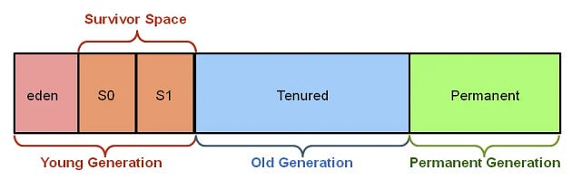

**Young Generation:** Newly created objects are allocated into the young generation. So, we can say that the young generation contains short lived objects.

**Old Generation:** objects which have survived a few GC cycles get promoted to the old gen. If the new object requests for a larger heap space, it gets allocated directly into the old gen. So, to say conclusively: long lived objects house in old generation.

**Permanent Generation:** The permanent generation holds objects that the JVM finds convenient not to have the garbage collector manage, such as objects describing classes and methods, as well as the classes and methods themselves. The permanent generation does not interact with the other two generations.

**ClassNotFoundException vs NoClassDefFoundError:**

ClassNotFoundException

This exception is typically encountered during runtime. It occurs when the Java runtime system tries to load a class at runtime using the Class.forName() method or its equivalents (ClassLoader.loadClass()), but the class definition is not found in the classpath.

**Typical Scenarios:**

* When the class file was not included in the deployment package or classpath.
* When there's a mistake in the fully qualified name of the class being loaded.
* When the class depends on another class that is missing.

**Handling:**

* Ensure that the required JAR files or class files are included in the classpath.
* Verify that the class name and its package name are correctly specified.

NoClassDefFoundError

This error occurs at runtime when the class was present during compilation but not found during execution. Unlike ClassNotFoundException, which indicates a missing class definition during loading, NoClassDefFoundError indicates that the class was found during the compilation, but at runtime, the class definition was not found.

**Typical Scenarios:**

* The class file got deleted or moved after compilation.
* The class file became corrupted.
* A dependency required for the class to load is missing at runtime.

**Handling:**

* Check classpath to ensure all necessary classes and dependencies are available.
* Verify the integrity of the class files and dependencies.

# *Synchronization:*

Synchronization has the capability to control the access of multiple threads to any shared resource. Used to prevent thread interference. synchronization is crucial to prevent race conditions, data inconsistencies.

When two or more threads need access to shared resources, there is some loss of data i.e. data inconsistency. The process by which we can achieve data consistency between multiple threads is called Synchronization.

**Synchronized Method:**

If you declare any method with **synchronized** keyword, it is known as synchronized method.

When you declare a method as synchronized, only one thread can execute that method on the object instance at a time. Other threads that attempt to execute the method will be blocked until the synchronized method is released.

class Table{

synchronized void printTable(int n){ //synchronized method

for(int i=1;i<=5;i++){

System.out.println(n*i);

try{

Thread.sleep(400);

}catch(Exception e){System.out.println(e);}

}

}

}

In synchronization, there are two types of locks on threads:

**Object-level lock:**

An object-level lock is associated with an instance (object) of a class. When a method is declared as synchronized without the static keyword, it acquires an object-level lock.

Each instance of the class has its own object-level lock, and multiple threads can concurrently access synchronized methods of **different instances**. Once method execution completes automatically thread releases the lock.

* Object-level locks are useful when you want to synchronize access to instance variables or instance methods of a class.

public class ClassLevelLockExample {

public void lock() {

synchronized (this) {

//DO your stuff here

}

}

}

--or—

Public synchronized void demoMethod(){

//Do your stuff

}

**Class level lock:**

A class-level lock is associated with the class itself, rather than with any particular instance (object) of the class. When a method is declared as synchronized with static keyword, it acquires a class-level lock. Only one thread can acquire a class-level lock for a particular class at a time. Once method execution completes automatically thread releases the lock.

* Class-level locks are useful when you want to synchronize access to static methods or static variables shared among all instances of the class.

public class ClassLevelLockExample {

public void lock() {

synchronized (ClassLevelLockExample.class) {

//DO your stuff here

}

}

}

--or—

Public synchronized static void demoMethod(){

//Do your stuff

}

**Deadlock in Java:**

Deadlock occurs when two or more threads are blocked indefinitely, waiting for each other to release resources that they need to proceed.

In other words, each thread holds a resource that another thread needs, and they are all waiting for each other, resulting in a circular waiting dependency called Deadlock.

Deadlock can happen due to improper resource allocation and synchronization.



public class TestDeadlockExample1 {

public static void main(String[] args) {

final String resource1 = "ratan jaiswal";

final String resource2 = "vimal jaiswal";

**// t1 tries to lock resource1 then resource2**

Thread t1 = new Thread() {

public void run() {

synchronized (resource1) {

System.out.println("Thread 1: locked resource 1");

try { Thread.sleep(100);} catch (Exception e) {}

synchronized (resource2) {

System.out.println("Thread 1: locked resource 2");

}

}

}

};

**// t2 tries to lock resource2 then resource1**

Thread t2 = new Thread() {

public void run() {

synchronized (resource2) {

System.out.println("Thread 2: locked resource 2");

try { Thread.sleep(100);} catch (Exception e) {}

synchronized (resource1) {

System.out.println("Thread 2: locked resource 1");

}

}

}

};

t1.start();

t2.start();

}

}

**Solution for Deadlock:**

The deadlock occurred as the two threads were acquiring the locks in a different order. If we synchronize the thread in the same order, then we can get rid of deadlock.

How to Avoid Deadlock in Java?

Deadlocks cannot be completely resolved. But we can avoid them by following basic rules mentioned below;

1. Using Thread. join()
2. Using Synchronization Objects
3. Avoid Nested Locks
4. Avoid Using unnecessary Locks When Not Needed
5. Proper Design of Code

* **Livelock** is similar to deadlock, but instead of threads being blocked indefinitely, they are actively responding to each other, but none of them make progress. In a livelock scenario, two or more threads are stuck in a loop of repeatedly trying to resolve a resource conflict, but their attempts are always unsuccessful. These processes are not in the waiting state, and they are running concurrently. This is different from a deadlock because in a deadlock all processes are in the waiting state.

**Inter-thread Communication in Java**

Inter-thread communication or Co-operation is all about allowing **synchronized** threads to communicate with each other.

It is a mechanism in which a synchronized thread is paused running in its critical section and another synchronized thread is allowed to enter (or lock) in the same critical section to be executed. It is implemented by following methods of Object class:

* wait()
* notify()
* notifyAll()

1**) wait() method**

The wait() method causes current thread to release the lock and wait until either another thread invokes the notify() method or the notifyAll() method for this object, or a specified amount of time has elapsed.

**2) notify() method**

The notify() method wakes up a single thread that is waiting on this object's monitor. If any threads are waiting on this object, one of them is chosen to be awakened.

**3) notifyAll() method**

Wakes up all threads that are waiting on this object's monitor.

|  |  |
| --- | --- |
| **wait()** | **sleep()** |
| The wait() method releases the lock. | The sleep() method doesn't release the lock. |
| It is a method of Object class | It is a method of Thread class |
| It is the non-static method | It is the static method |
| It should be notified by notify() or notifyAll() methods | After the specified amount of time, sleep is  completed. |

**Serialization:**

Serialization is a mechanism of writing the state of an object into a byte-stream. It is mainly used in Hibernate, RMI, JPA, EJB and JMS technologies.

The reverse operation of serialization is called deserialization, where byte-stream is converted into an object (the process of reconstructing the object from the serialized state).

* The serialization and deserialization processes are **platform-independent**, it means you can serialize an object on one platform and deserialize it on a different platform.
* For serializing the object, we call the writeObject() method of ObjectOutputStream class, and for deserialization we call the readObject() method of ObjectInputStream class.

Advantages of Java Serialization

* It is mainly used to transfer object's state on the network (that is known as marshalling).

***NOTE***: ***There are some cases of Serialization with respect to inheritance:***

Case 1: If the superclass is serializable, then subclass is automatically serializable

If the parent class is Serializable, by default all the child classes also Serializable. Hence even though child class doesn’t implement Serializable, we can serialize child class object if parent class implements serializable interface.

Case 2: If the superclass is serializable, but we don’t want the subclass to be serialized

There is no direct way to prevent sub-class from serialization in java. One possible way we can achieve this is by implementing the writeObject() and readObject() methods in the subclass and need to throw NotSerializableException from these methods.

Case 3: If a superclass is not serializable, then subclass can still be serialized

If a superclass is not serializable, then the subclass cannot be serialized automatically. attempting to serialize a subclass will result in a java.io.NotSerializableException at runtime. However, you can still serialize a subclass by implementing the Serializable interface in the subclass itself, even if its superclass is not serializable.

**Serializable** is a marker interface (has no data member and method). It is used to "mark" Java classes so that the objects of these classes may get a certain capability.

The **Serializable** interface must be implemented by the class whose object needs to be persisted. String class and all the wrapper classes implement the java.io.Serializable interface by default.

* ***Serialization example***

import java.io.Serializable;

public class Student implements Serializable {

int id;

String name;

public Student(int id, String name) {

this.id = id;

this.name = name;

}

}

class Persist{

public static void main(String args[]){

try{

Student s1 =new Student(211,"ravi");

FileOutputStream fout=new FileOutputStream("f.txt");

ObjectOutputStream out=new ObjectOutputStream(fout);

out.writeObject(s1);

out.close(); //closing the stream

System.out.println("success");

}catch(Exception e){System.out.println(e);}

}

}

* ***Deserialization example***

import java.io.*;

class Depersist{

public static void main(String args[]){

try{

//Creating stream to read the object

ObjectInputStream in=new ObjectInputStream(new FileInputStream("f.txt"));

Student s=(Student)in.readObject();

System.out.println(s.id+" "+s.name);

in.close(); //closing the stream

}

catch(Exception e){System.out.println(e);}

}

}

IMP: During the serialization, when we do not want an object to be serialized, we can use a **transient** keyword.

The transient keyword can be used with the data members of a class to avoid their serialization. For example, if a program accepts a user's login details and password. But we don't want to store the original password in the file. Here, we can use transient keyword and when JVM reads the transient keyword it ignores the original value of the object and instead stores the default value of the object.

Ex;

**int** id;

 String name;

**transient** **int** age; //Now it will not be serialized

 Student s1 =**new** Student(211,"ravi",22);

After deserialization, o/p will be **211 ravi 0**

**SerialVersionUID**:

The serialVersionUID attribute is an identifier that is used to serialize/deserialize an object of a Serializable class. The SerialVersionUID can be used during deserialization to verify that the sender and receiver of a serialized object have loaded classes for that object that are compatible w.r.t serialization. If the deserialization object is different than serialization, then it can throw an InvalidClassException. If the serialVersionUID is not specified, then the runtime will calculate a default serialVersionUID value for that class based on various aspects of the class. The serialVersionUID attributes of different classes are independent. Therefore, it is not necessary for different classes to have unique values.

class Employee implements Serializable {

   private static final long serialVersionUID= 5462223600l;

   int empId;

   String name;

There are also certain problem associations depending on the default SerialVersionUID generated by JVM as listed below:

- Both sender and receiver should use the same JVM with respect to platform and version also. Otherwise, the receiver is unable to deserialize because of different SerialVersionUID.

- Both sender and receiver should use the same ‘.class’ file version. After serialization, if there is any change in the ‘.class’ file at the receiver side then the receiver is unable to deserialize.

# *Collections:*

collections are objects that **group multiple elements** into a single unit. They provide a way to store, retrieve, manipulate, and operate on groups of objects. Java collections framework provides a set of interfaces and classes that offer various implementations of collections, each designed for specific use cases.

The Iterable interface is the root interface for all the collection classes. It belongs to the java.lang package. It represents a data structure that can be iterated over. The Iterable interface provides a method that produces an **Iterator**. All collections in Java implement the Iterable interface.

The Collection interface extends the Iterable interface and therefore all the subclasses of Collection interface also implement the Iterable interface.

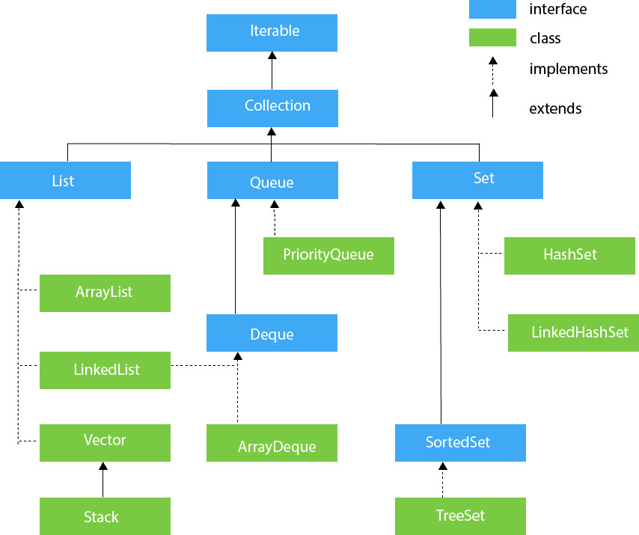

**1)List Interface**

List interface is the child of Collection interface. It represents the ordered set of elements which allow us to store the duplicate items.

* ArrayList class Implements List Interface and uses a dynamic array for storing the elements. It is like an array, but there is **no size limit**. We can add or remove elements anytime.

can have the duplicate elements

maintains the insertion order

It allows to store the null elements (no 2 nulls are same).

It is non-synchronized i.e, not thread safe

allows random access because the array works on an index basis.

Better for storing and accessing data.

manipulation is little bit slower than the LinkedList because a lot of shifting needs to occur if any element is removed from the array list.

ArrayList<**int**> al = ArrayList<**int**>(); // does not work  for primitive types

ArrayList<Integer> al = **new** ArrayList<Integer>(); // works fine

***NOTE*:** generic collection allows you to have only one type of object in a collection. Now it is type-safe, so typecasting is not required at runtime. In Parameter type we cannot use primitives like ‘int’, ’char’ or ‘double’ it gives compile-time error.

* Arrays stores and checks type information at runtime. Generics, check for type errors at compile-time and [don’t have type information at runtime.](https://www.baeldung.com/java-generics#type-erasure) That’s why Java does not allow us to create arrays of generic types.

**ArrayList methods:** add(), addAll(), remove(), removeAll(), removeIf(), size(), get(), set(), isEmpty(), clear() etc

**//Traversing list through Iterator**

Iterator interface provides a way to iterate over a collection in a forward direction only. It Helps to traverse **Map, List and Set**. It cannot add, modify or replace elements present in Collection; it throws ConcurrentModificationException. This interface allows us to retrieve or remove elements from a collection during the iteration. It provides hasNext(), next() and remove() methods.

Iterator itr=list.iterator();

while(itr.hasNext()){ //check if iterator has the elements

System.out.println(itr.next()); //printing the element and move to next

}

**//Here, element iterates in reverse order**

ListIterator interface extends Iterator interface and provides bidirectional traversal I.e., It allows iterating both forward and backward through a list. It Helps to traverse **List only.** It can add, modify or replace elements present in Collection. It has methods like add(E e), hasNext(), hasPrevious(), next(), nextIndex(), previous(), previousIndex(), remove(), set(E e).

ListIterator<String> list1=list.listIterator(list.size());

while(list1.hasPrevious()) {

System.out.println(list1.previous());

}

**---or----** Iterator i=list.descendingIterator();

while(i.hasNext()) {

System.out.println(i.next());

}

* LinkedList class Implements List & Deque Interfaces and uses a doubly linked list (add on both sides) to store the elements (A linked list is a linear data structure, in which the elements are not stored at contiguous memory location).

can contain duplicate elements.

maintains insertion order

Allows null elements

It is not synchronized (not thread safe)

manipulation is fast because no shifting needs to occur.

Better for data manipulation

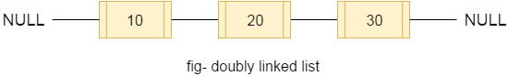

**LinkedList Methods:** add(), addAll(), addFirst(), addLast(), remove(), removeAll(), removeFirst(), removeLast(), peek(), poll(), pop(), clear(), get(), set() etc

|  |  |
| --- | --- |
| **ArrayList** | **LinkedList** |
| 1) ArrayList internally uses a **dynamic array** to store the elements. | LinkedList internally uses a **doubly linked list** to store the elements. |
| 2) Manipulation with ArrayList is **slow** because it internally uses an array. If any element is removed from the array, all the other elements are shifted in memory. | Manipulation with LinkedList is **faster** than ArrayList because it uses a doubly linked list, so no bit shifting is required in memory. |
| 3) An ArrayList class can **act as a list** only because it implements List only. | LinkedList class can **act as a list** and **queue** both because it implements List and Deque interfaces. |
| 4) ArrayList is **better for storing and accessing** data. | LinkedList is **better for manipulating** data. |
| 5) The memory location for the elements of an ArrayList is **contiguous**. | The location for the elements of a linked list is **not contagious (**allnodes can be scattered throughout the memory**)** |
| 6) Generally, when an ArrayList is initialized, a default capacity of 10 is assigned to the ArrayList. | There is no case of default capacity in a LinkedList. In LinkedList, an empty list is created when a LinkedList is initialized. |

* Vector uses a dynamic array to store the data elements. It is like ArrayList. However, It is **synchronized** (thread safe) and contains many methods that are not the part of Collection framework. It is recommended to use the Vector class in the thread-safe implementation only. If you don't need to use the thread-safe implementation, you should use the ArrayList, it will perform better in such case.
* The stack is the subclass of Vector. The **stack** is a linear data structure that is used to store the collection of objects based on **Last-In-First-Out** (LIFO) manner. The stack contains all of the methods of Vector class and also provides its methods like boolean push(), boolean peek(), boolean push(object o), which defines its properties.

|  |  |
| --- | --- |
| **ArrayList** | **Vector** |
| 1) ArrayList is **not synchronized**. | Vector is **synchronized**. |
| 2) ArrayList **increments 50%** of current array size if the number of elements exceeds from its capacity. | Vector **increments 100%** (doubles the array size) if the total number of elements exceeds than its capacity. |
| 3) ArrayList is **not a legacy** class. It is introduced in JDK 1.2 | Vector is a **legacy** class (It is available since Java 1.0) |
| 4) ArrayList is **fast** because it is non-synchronized. | Vector is **slow** because it is synchronized. |
| 5) ArrayList uses the **Iterator** interface to traverse the elements. | A Vector can use the **Iterator** interface or **Enumeration** interface to traverse the elements. |

**2)Queue/Deque Interface**

- Priority Queue implements the Queue interface and uses QUEUE to store and orders the element in FIFO(First In First Out) manner. In FIFO, first element is removed first and last element is removed at last. It is an ordered list of objects, where insertion of elements occurs at the end of the list, and removal of elements occur at the beginning of the list.

doesn't maintain the insertion order (sorts based on priority)

Null values are not accepted

Not Syncronized (not thread safe)

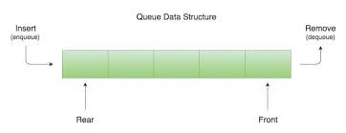

**PriorityQueue Methods:** add(), addAll(), offer(), remove(), removeAll(), peek(), poll(), element(), clear() etc

offer() - It is used to insert the specified element into this queue.

Poll() - It is used to retrieves and removes the head of this queue, or returns null if this queue is empty.

Peek() - It is used to retrieves, but does not remove the head of this queue, or returns null if this queue is empty.

Element() - It is used to retrieves, but does not remove the head of this queue.

* Array Deque Implements the Deque interface and uses DEQUE which supports element insertion and removal at both ends Therefore, a deque can be used as a stack or queue. Deque is an acronym for "**double ended queue**".

-> STACK - LIFO, QUEUE - FIFO

Null elements are not allowed

maintains the insertion order

faster than ArrayList, Stack and has no capacity restrictions.

Not Syncronized (not thread safe)

**ArrayDeque Methods:** add(), addAll(), offer(), offerFirst(), offerLast(), remove(), removeAll(), peek(), peekFirst(), peekLast(), poll(), element(), clear() etc

**3)Set Interface**

Set Interface extends the Collection interface. It represents the unordered set of elements which doesn't allow us to store the duplicate items.

* HashSet class implements Set Interface and uses a **hash table** for storage. When we create an object of HashSet, it internally creates an instance of HashMap with default initial capacity 16.

HashSet stores the elements by using a mechanism called **hashing**.

contains unique elements only.

doesn't maintain the insertion order (Elements are inserted based on their hashcode)

allows atmost one null value.

It is non synchronized (not thread safe)

better for search operations.

The initial default capacity of HashSet is 16, and load factor is 0.75 (load factor refers to the threshold at which the HashSet will resize its internal array to accommodate more elements.)

**HashSet methods:** add(), addAll(), remove(), removeAll(), removeIf(), clear() etc

* LinkedHashSet class implements Set interface. It internally uses a **hash table** and a **linked list** to store elements.

contains unique elements only.

maintains insertion order

It is non synchronized (not thread safe)

Doesn’t allows null value

Iterating over a LinkedHashSet is generally **slower** than iterating over a HashSet because of the additional linked list maintenance overhead.

**LinkedHashSet methods:** add(), addAll(), remove(), removeAll(), removeIf(), clear() etc

- TreeSet class implements the Set interface and uses a tree for storing elements.

contains unique elements only

doesn’t maintains insertion order //ascending order.

doesn't allow null element.

It is non synchronized (not thread safe)

TreeSet class access and retrieval times are quiet fast.

TreeSet is being implemented using a binary search tree, which is self-balancing tree just like a **Red-Black Tree**. Therefore, operations such as a search, remove, and add consume O(log(N)) time. It is there to ensure that the tree height never exceeds O(log(N)) for all the mentioned operations. Therefore, it is one of the efficient data structures to keep the large data that is sorted and also to do operations on it.

**Treeset Methods:** add(), addAll(), remove(), removeAll(), ceiling(), floor(), higher(), lower(), first(), last(), pollFirst(), polllast(), isEmpty(), size(), clear() etc

Ceiling() - It returns the equal or closest greatest element of the specified element from the set, or null there is no such element.

Floor() - It returns the equal or closest least element of the specified element from the set, or null there is no such element.

Higher() - It returns the closest greatest element of the specified element from the set, or null there is no such element.

Lower() - It returns the closest least element of the specified element from the set, or null there is no such element.

# *MAP:*

Map is not a direct descendant of Collection interface. However, both Map and Collection are part of the Java Collections Framework and are used for managing groups of objects.

Map

+-- HashMap

+-- TreeMap

+-- LinkedHashMap

+-- ConcurrentHashMap

+-- Hashtable

* HashMap class implements the Map interface and uses an **Array of LinkedList** data structure internally to store elements in key-value pair, where keys should be unique. Each key and value pair are known as an **entry.**

It allows one null key and multiple null values (Hash code of null Key is 0)

contains unique keys only (if you try to store same key with another value, it will replace the existing value)

maintains no order (hashcode decides the index location)

it is not synchronized (not Thread-safe)

Default Hashmap size is 16 with a load factor of 0.75 (When the load factor threshold is reached, the capacity of the HashMap is doubled, and all elements are rehashed and redistributed into the new larger array)

**Hashmap methods:** put(), putAll(), putIfAbsent(), containsKey(), containsValue(), remove(), removeAll(), entrySet(), replace(), size(), isEmpty(), clear() etc

for(Map.Entry<String, Integer> m : map.entrySet()){ //Converting to Set to traverse

System.out.println(m.getKey()+" "+m.getValue());

}

map.entrySet()  //Returns a Set view of the mappings

.stream()

.sorted(Map.Entry.comparingByKey()) //sorts based on key

.forEach(System.out::println);

map.entrySet()

.stream()

.sorted(Map.Entry.comparingByValue()) //sorts based on value

.forEach(System.out::println);

**Internal working of HashMap:**

Hashing is the process of converting an **object into an integer** value. The integer value helps in indexing and faster searches.

hashing is used to index and retrieve information from a database because it helps accelerate the process; it is much easier to find an item using its shorter hashed key than its original value.

hashCode() 🡪 This is the method of the object class. It returns the memory reference of the object in integer form. The value received from the method is used as the bucket number, which is the index/ address of the element inside the map.

equals() 🡪  It checks the equality of two objects. It checks that both Keys are equal or not. If Keys are same, replace the value with the current value. Otherwise, connect this node object to the existing node object through the LinkedList.

Buckets 🡪 Array of the node is called buckets. Each node has a data structure like a LinkedList. More than one node can share the same bucket. It may be different in capacity.

Bucket

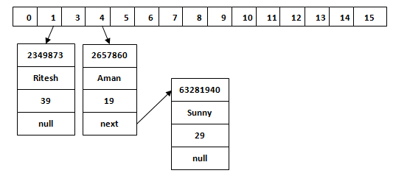

**Overriding both equals(Object) and hashCode() method:**

You must override hashCode() in every class that overrides equals(). Failure to do so will result in a violation of the general contract for Object.hashCode(), which will prevent your class from functioning properly in conjunction with all hash-based collections, including HashMap, HashSet, and Hashtable.

***General Contracts for hashCode() in Java***

1) If two objects are equal by the equals() method then their hashcode returned by the hashCode() method must be the same.

2) Whenever the hashCode() method is invoked on the same object more than once within a single execution of the application, hashCode() must return the same integer (provided no information or fields used in equals and hashcode is modified)

3) If two objects are not equaled by the equals() method it is not required that their hashcode must be different.

**Ex:**

public class Employee {

String name;

int age;

public Employee(String name, int age) {

this.name = name;

this.age = age;

}

//getters and setters

@Override

public boolean equals(Object obj) {

if (obj == this) return true;

if (!(obj instanceof Employee)) return false;

Employee employee = (Employee) obj;

return employee.getAge() == this.getAge()

&& employee.getName() == this.getName();

}

@Override

public int hashCode() {

return Objects.hash(name, age);

}

}

public class ClientTest {

public static void main(String[] args) {

Employee emp = new Employee("rajeev", 24);

Employee emp1 = new Employee("yash", 25);

Employee emp2 = new Employee("rajeev", 24);

HashSet<Employee> employees = new HashSet<Employee>();

employees.add(emp);

employees.add(emp1);

employees.add(emp2);

System.out.println("employee.hashCode(): " + emp.hashCode() + "\n" +

" employee1.hashCode():" + emp1.hashCode() + "\n" +

" employee2.hashCode():" + emp2.hashCode());

//since emp and emp2 are same, equals() override its previous value

employees.stream().forEach(e -> System.out.println(e.getName() + "-" + e.getAge()));

}

}

|  |  |
| --- | --- |
| **HashMap** | **Hashtable** |
| 1) HashMap is **non synchronized**. It is not-thread safe and can't be shared between many threads without proper synchronization code. | Hashtable is **synchronized**. It is thread-safe and can be shared with many threads. |
| 2) HashMap **allows one null key and multiple null values**. | Hashtable **doesn't allow any null key or value**. |
| 3) HashMap is a **new class introduced in JDK 1.2**. | Hashtable is a **legacy class**. (java 1.0) |
| 4) HashMap is **fast**. | Hashtable is **slow**. |
| 5) We can make the HashMap as synchronized by calling this code Map map = Collections.synchronizedMap(hashMap); | Hashtable is internally synchronized and can't be unsynchronized. |
| 6) HashMap is **traversed by Iterator**. | Hashtable is traversed by **Enumerator** and **Iterator**. |
| 7) Iterator in HashMap is **fail-fast**. | Enumerator in Hashtable is **not fail-fast**. |
| 8) HashMap inherits **AbstractMap** class | Hashtable inherits **Dictionary** class. |

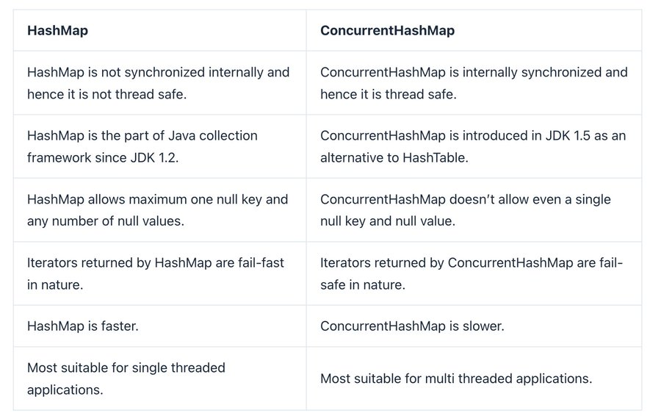

IMP:

* Hashtable and SynchronizedMap both acquires lock on entire Map object which provides thread-safety, but not good performance as at a time only one thread can access that Map instance.
* To overcome this issue, ConcurrentHashMap was introduced in Java 5 along with other concurrent classes like CountDownLatch, CyclicBarrier, CopyOnWriteArrayList, BlockingQueue within java.util.Concurrent package. More than one threads can read and write concurrently in ConcurrentHashMap and still it provides thread-safety.

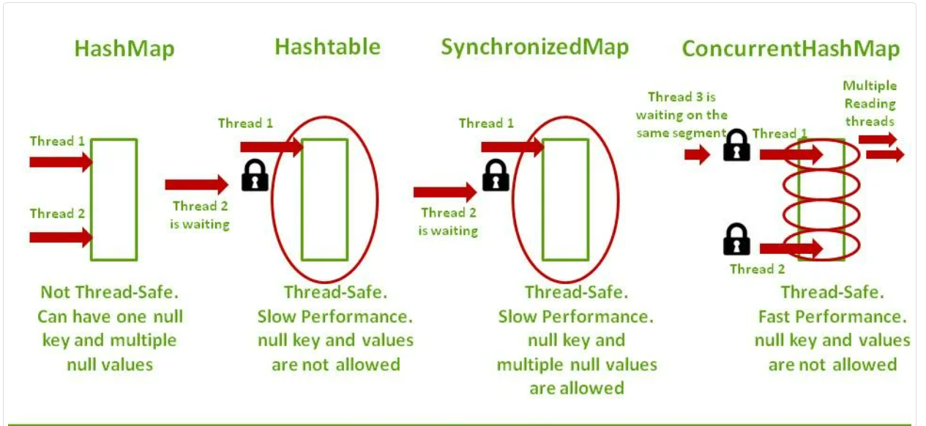

* LinkedHashMap class inherits HashMap and implements the Map interface. It uses **Hash Table** and **doubly Linked List** DS to store elements.

contains unique elements.

may have one null key and multiple null values.

maintains insertion order.

It is non synchronized (not thread safe)

initial default capacity of HashMap class is 16, load factor is 0.75

map.keySet() – fetches only keys in map

map.values() – fetches the values

* TreeMap class implements the NavigableMap interface, which in turn extends the SortedMap interface, and the SortedMap interface extends the Map interface. It uses red-black tree (balanced BST). It provides an efficient means of storing key-value pairs in sorted order.

contains unique elements.

cannot contain any null key but can have multiple null values.

maintains ascending order.

It is non synchronized (not thread safe)

It is way slower than HashMap because it runs sorting operations with each insertion, update, and removal.

|  |  |
| --- | --- |
| **HashMap** | **TreeMap** |
| 1) HashMap can contain one null key. | TreeMap doesnt contain any null key. |
| 2) HashMap maintains no order. | TreeMap maintains ascending order. |
| 3) It implements Map interface | It implements NavigableMap interface and extends AbstractMap class. |

**ConcurrentHashMap:**

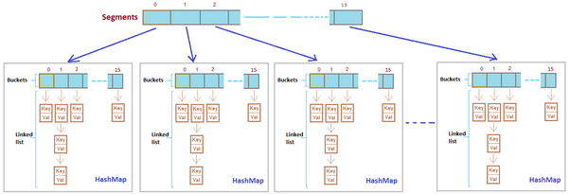

**Internal working of concurrent Hasmmap(CHM):**

* The underlined data structure for ConcurrentHashMap is Hashtable.
* ConcurrentHashMap class is thread-safe i.e. multiple threads can operate on a single object without any complications.
* At a time any number of threads are applicable for a read operation without locking the ConcurrentHashMap object which is not there in HashMap.
* In ConcurrentHashMap, the Object is divided into a number of segments according to the concurrency level.
* The default concurrency-level of ConcurrentHashMap is 16.
* In ConcurrentHashMap, at a time any number of threads can perform retrieval operation but for updating the object, the thread must lock the particular segment in which the thread wants to operate. This type of locking mechanism is known as Segment locking or bucket locking. Hence at a time, 16 update operations can be performed by threads.
* Inserting null objects is not possible in ConcurrentHashMap as a key or value.

As opposed to the HashTables where every read/write operation needs to acquire the lock, there is no locking at the object level in CHM and locking is much granular at a hashmap bucket level.

CHM never locks the whole Map, instead, it divides the map into segments and locking is done on these segments. CHM is separated into different regions(default-16) and locks are applied to them. When setting data in a particular segment, the lock for that segment is obtained. This means that two updates can still simultaneously execute safely if they each affect separate buckets, thus minimizing lock contention and so maximizing performance. First call is to lock(), since it is a write/update operation on a bucket of same segment we need a lock. If you recollect Segment class it extends ReentrantLock so each segment is a lock. So you can call lock() and unlock() directly in Segment class. Next it's like a normal HashMap. You find the index of the Entry table where your elements hash falls and add it there as linked list. Finally once operation is complete it calls unlock() so that other threads can continue update.

**Constructors of ConcurrentHashMap:**

Concurrency-Level: It is the number of threads concurrently updating the map. The implementation performs internal sizing to try to accommodate this many threads.

Load-Factor: It’s a threshold, used to control resizing.

Initial Capacity: Accommodation of a certain number of elements initially provided by the implementation. if the capacity of this map is 10. It means that it can store 10 entries.

// Creates a new, empty map with a default initial capacity (16), load factor (0.75) and concurrencyLevel (16).

ConcurrentHashMap<K, V> chm = new ConcurrentHashMap<>();

//Creates a new, empty map with the specified initial capacity, load factor, and concurrency level. we have constructors to set req values as per our req.

ConcurrentHashMap<K, V> chm = new ConcurrentHashMap<>(int initialCapacity, float loadFactor, int concurrencyLevel);

**Sorting in collections:**

**Collections** class provides static methods for sorting the elements of a collection. If collection elements are of a Set type, we can use TreeSet. However, we cannot sort the elements of List.

Collections.sort(list); //**sort()** is used to sort the elements of List, but List elements must be of the Comparable type.

 Collections.sort(list, Collections.reverseOrder()); //reverse order

**Note**: String class and Wrapper classes implement the Comparable interface. So, if you store the objects of string or wrapper classes, it will be Comparable.

Comparable & Comparator:

**1)Comparable** --> Comparable interfaces are used to sort the objects of the user-defined/custom classes.It provides single sorted sequence i.e; you can sort the elements based on single data member only. It have compareTo() method only.

import java.util.*;

import java.io.*;

class Student implements Comparable<Student> {

int rollno;

String name;

int age;

Student(int rollno,String name,int age) {

this.rollno=rollno;

this.name=name;

this.age=age;

}

public int compareTo(Student st){

if(age==st.age)

return 0;

else if(age>st.age) //use < for reverse order

return 1;

else

return -1;

}

}

public class TestSort3{

public static void main(String args[]){

ArrayList<Student> al=new ArrayList<Student>();

al.add(new Student(101,"Vijay",23));

al.add(new Student(106,"Ajay",27));

al.add(new Student(105,"Jai",21));

Collections.sort(al);

for(Student st : al){

System.out.println(st.rollno+" "+st.name+" "+st.age);

}

}

}

**2)Comparator** ---> Comparator interfaces are used to sort the objects of the user-defined/custom classes.It provides multiple sorted sequences i.e., you can sort the elements on the basis of any/multiple data members. it have compare() method.

class Student{

int rollno;

String name;

int age;

Student(int rollno,String name,int age){

this.rollno=rollno;

this.name=name;

this.age=age;

}

}

class AgeComparator implements Comparator<Student>{ //age comparator

public int compare(Student s1, Student s2){

if(s1.age==s2.age)

return 0;

else if(s1.age>s2.age)

return 1;

else

return -1;

}

}

class NameComparator implements Comparator<Student>{ //Name comparator

public int compare(Student s1,Student s2){

return s1.name.compareTo(s2.name);

}

}

class TestComparator {

public static void main(String args[]) {

ArrayList<Student> al=new ArrayList<Student>();

al.add(new Student(101,"Vijay",23));

al.add(new Student(106,"Ajay",27));

al.add(new Student(105,"Jai",21));

System.out.println("Sorting by Name");

Collections.sort(al, new NameComparator());

for(Student st : al){

System.out.println(st.rollno+" "+st.name+" "+st.age);

}

System.out.println("sorting by Age");

Collections.sort(al, new AgeComparator());

for(Student st : al){

System.out.println(st.rollno+" "+st.name+" "+st.age);

}

} }

**Note:** Java 8 Comparator interface is a functional interface that contains only one abstract method.

|  |  |
| --- | --- |
| **Comparable** | **Comparator** |
| 1) Comparable provides a **single sorting sequence**. In other words, we can sort the collection on the basis of a single element such as id, name, and price. | The Comparator provides **multiple sorting sequences**. In other words, we can sort the collection on the basis of multiple elements such as id, name, and price etc. |
| 2) Comparable **affects the original class**, i.e., the actual class is modified. | Comparator **doesn't affect the original class**, i.e., the actual class is not modified. |
| 3) Comparable provides **compareTo()** method | Comparator provides **compare()** method |
| 4) Comparable is present in **java.lang** package. | A Comparator is present in the **java.util** package. |
| 5) We can sort the list elements of Comparable type by **Collections.sort(List)** method. | We can sort the list elements of Comparator type by **Collections.sort(List, Comparator)** method. |

# *Features of Java 8:*

1) **Functional Interface**

An Interface that contains only one abstract method is known as functional interface. It can have any number of default and static methods.

2) **Lambda Expressions**

A lambda expression is a short block of code which takes in parameters and returns a value. Lambda expressions are like methods, but they do not need a name and they can be implemented right in the body of a method.

parameter -> expression

*(*parameter1*,* parameter2*)* -> { code block }

3) **forEach() method**

Java provides a new method forEach() to iterate the collection elements. A new, concise and interesting way to iterate over a collection. This method takes a single parameter which is a functional interface. So, you can pass lambda expression as an argument.

**EX:** namesMap.forEach((key, value) -> System.out.println(key + " " + value));

list.forEach(name -> System.out.println(name));

|  |  |
| --- | --- |
| **foreach() loop** | **foreach() method** |
| 1. used to access arrays and collections | 1. Can access collections only |
| 2. Lambda operators is not used | 2. Lambda operators is used |
| 3. The return or control statements work within the loop | 3. The return or control statements are not allowed within the loop but the function calls are very easy to call |
| 4. Example  for (String str : arr) {  System.out.print(str);  } | 4. Example  list.stream().forEach(s->{  System.out.print(s);  }; // list.forEach(System.out::println); |

4) Java has introduced a new **Date and Time API** since Java 8. The java.time package contains Java 8 Date and Time classes

New date-time package is introduced to overcome drawbacks of old package (java.util.Date and java.util.Calender);

* New API are Immutable and thread-safe.
* Included many date/time operations in new package.
* Mainly used API are LocalDate, LocalTime, LocalDateTime etc

5) **Default Methods**

Methods which are defined inside the **interface** and tagged with default keyword are known as default methods. These methods are non-abstract methods and can have method body.

* Default methods in interfaces were introduced in Java 8 to provide a way to add new methods to existing interfaces without breaking backward compatibility with classes that **already** implement those interfaces.
* Yes, default methods in interfaces can be overridden by classes that implement those interfaces.

When a class implements an interface that contains a default method, it has the option to override that default method with its own implementation. If the class does not provide an override for the default method, it will inherit the default implementation from the interface.

6) **Streams Api**

Java provides a new additional package in Java 8 called java.util.stream. Stream API is used to process collections of objects & allows you to perform operations on the elements like filtering, mapping, reducing, sorting etc with concise and readable code.

**Features**:

* Stream does not store elements. It simply conveys elements from a source such as a data structure, array, or an I/O channel through a pipeline of computational operations.
* Operations performed on a stream does not modify it's source. For example, filtering a Stream obtained from a collection **produces a new Stream** without the filtered elements, rather than removing elements from the source collection.
* Stream operations are evaluated lazily.
* The elements of a stream are only visited once during the life of a stream. Like an Iterator, a new stream must be generated to revisit the same elements of the source.

List<String> filteredNames = names.stream()

.filter(name -> name.startsWith("A"))

.map(String::toUpperCase)

.collect(Collectors.toList());

Intermediate And Terminal Operations :

1) The main difference between intermediate and terminal operations is that **intermediate operations return a stream as a result** and **terminal operations return non-stream values like primitive or object or collection or may not return anything**.

2) Intermediate operations can be chained together to form a pipeline of operations, but there has to be only one terminal operation, that too at the end of pipeline.

3) Intermediate operations are lazily loaded. When you call intermediate operations, they are actually not executed. They are just stored in the memory and executed when the terminal operation is called on the stream.

4) As the names suggest, intermediate operations doesn’t give end result. They just transform one stream to another stream. On the other hand, terminal operations give end result.

5) **Intermediate Operations:**

map(), filter(), distinct(), sorted(), limit(), skip()

**Terminal Operations:**

forEach(), toArray(), reduce(), collect(), min(), max(), count(), anyMatch(), allMatch(), noneMatch(), findFirst(), findAny()

7) **Base64 encode and decode**

Java provides a class Base64 to deal with **encryption**. You can encrypt and decrypt your data by using provided methods. You need to import java.util.Base64 in your source file to use its methods.

8) In java8, there are some changes in Hashmap which will convert internal DS from **LinkedList** to **Tree** after some threshold to improve performance of Hashmap.

9) Optional is a container object that **may or may not contain a value**. It was introduced in Java 8 to address the problem of dealing with potentially null values in a safer and more expressive manner. Optional class is part of java.util package

Here are some key points about Optional:

* Avoiding NullPointerException
* provides various methods for working with the contained value, such as isPresent(), map(), flatMap(), filter(), orElse() and orElseThrow() etc, to perform operations on the value only if it is present.
* Optional is immutable, meaning that once created, its contents cannot be changed. This helps ensure thread safety and prevents accidental modification of the contained value.

# *Java File I/O:*

Java uses the concept of a stream to make I/O operation fast. The java.io package contains all the classes required for input and output operations.

We can perform **file handling in Java** by Java I/O API.

Java IO

**OutputStream:**

Java application uses an output stream to write data to a destination, it may be a file, an array, peripheral device or socket.

Java output stream hierarchy

import java.io.FileOutputStream;

public class FileOutputStreamExample {

public static void main(String args[]){

try{

FileOutputStream fout=new FileOutputStream("D:\\testout.txt");

String s="Welcome to javaTpoint";

byte b[]=s.getBytes(); //converting string into byte array

fout.write(b);

fout.close();

System.out.println("success...");

}catch(Exception e){System.out.println(e);}

}

}

**InputStream**

Java application uses an input stream to read data from a source; it may be a file, an array, peripheral device or socket.

Java input stream hierarchy

import java.io.FileInputStream;

public class DataStreamExample {

public static void main(String args[]){

try{

FileInputStream fin=new FileInputStream("D:\\testout.txt");

int i=fin.read();

System.out.print((char)i);

fin.close();

}catch(Exception e){System.out.println(e);}

}

}

**FileWriter / FileReader:**

Java FileWriter class is used to write **character-oriented data** to a file. It is character-oriented class which is used for file handling in java.

Unlike FileOutputStream class, you don't need to convert string into byte array because it provides method to write string directly.

package com.javatpoint;

import java.io.FileWriter;

public class FileWriterExample {

public static void main(String args[]){

try{

FileWriter fw=new FileWriter("D:\\testout.txt");

fw.write("Welcome to javaTpoint.");

fw.close();

}catch(Exception e){System.out.println(e);}

System.out.println("Success...");

}

}

Java FileReader class is used to read data from the file. It returns data in byte format like FileInputStream class. It is character-oriented class which is used for file handling in java.

package com.javatpoint;

import java.io.FileReader;

public class FileReaderExample {

public static void main(String args[])throws Exception{

FileReader fr=new FileReader("D:\\testout.txt");

int i;

while((i=fr.read())!=-1)

System.out.print((char)i);

fr.close();

}

}

# *Time/space complexity:*

* **Time complexity** is defined as the amount of time taken by an algorithm to run, as a function of the length of the input. It measures the time taken to execute each statement of code in an algorithm. Note that the time to run is a function of the length of the input and not the actual execution time of the machine on which the algorithm is running on.

There are different types of time complexities used, let’s see one by one:

**1. Constant time – O (1)**

**2. Linear time – O (n)**

**3. Logarithmic time – O (log n)**

**4. Quadratic time – O (n^2)**

**5. Cubic time – O (n^3)**

* **O(N log N)** – linearithmic time complexity. The time required to run the algorithm increases linearly with the size of the input, multiplied by the logarithm of the input size.
* **O(2^N)** – exponential time complexity. The time required to run the algorithm increases exponentially with the size of the input.

1. The addition of two scalar numbers requires one addition operation. the time complexity of this algorithm is constant: O(1)

2. Time complexity of a simple **loop** when the loop variable is **incremented or decremented** by a constant amount: O(n)

3. Time complexity of a **loop** when the loop variable is **divided or multiplied** by a constant amount: O(logn)

4. Time complexity of a **nested loop**: O(n^2)

5. Time complexities of different loops: O(m) + O(n)

* **Space complexity** is the amount of memory required by the algorithm (no. of variables stored etc) to solve a problem. Lesser the space, faster the algorithm executes. It is also important to know that time and space complexity are not related to each other.

Note: Time complexity affects how fast or slow an algorithm performs, which is crucial for **time-sensitive applications**. On the other hand, space complexity affects how much memory an algorithm uses, which is critical for applications running on **memory-constrained devices**. Therefore, choosing the best solution depends on requirement.

# *Imp Questions-1:*

1.map() vs flatMap():

***map()*** operation is used to transform each element of a stream into a new stream using a given function. It returns the transformed elements in the same order as the original stream. This transformation is one-to-one, meaning each input element produces exactly one output element.

List<String> fruits = Arrays.asList("apple", "banana", "cherry");

List<Integer> lengths = fruits.stream()

.map(String::length)

.collect(Collectors.toList()); //op = lengths: [5, 6, 6]

List number = Arrays.asList(2,3,4,5);

List square = number.stream().map(x->x*x).collect(Collectors.toList());

**flatMap()** operation is used when each element in the stream is transformed into multiple elements, often in the form of another collection or stream. The resulting elements are then flattened into a single stream. This transformation is one-to-many, meaning an input element produces multiple output elements, later all flattened into a single Stream. ie;  flatMap() operation is a two-step process i.e. map() + flattening means, it helps convert Collection<Collection<Item>> to Collection<Item>.

List<List<Integer>> listOfLists = Arrays.asList(

Arrays.asList(1, 2, 3),

Arrays.asList(4, 5),

Arrays.asList(6, 7, 8));

List<Integer> flattenedList = listOfLists.stream()

.flatMap(list -> list.stream()).toList(); //op= [1, 2, 3, 4, 5, 6, 7, 8]

2.Design patterns:Design patterns are reusable solutions to common problems encountered in software design and development. They provide templates or blueprints for solving recurring design problems in a structured and efficient manner. Design patterns are not specific implementations or pieces of code, but rather general guidelines or best practices that can be applied to various scenarios.

- Types of Design patterns

1) Creational Design patterns: These patterns are designed for class instantiation or object creation based on the situation – Singleton, Prototype, Factory Method, Abstract Factory, Builder, Object Pool.

2) Structural Design patterns: These patterns are about organizing different classes and objects to form larger structures and provide new functionality. The main goal of most of these patterns is to increase the functionality of the class(es) involved, without changing much of its composition - Adapter, Bridge, Composite, Decorator, Facade, Flyweight, Private Class Data and Proxy.

3) Behavioral Design patterns: These patterns are concerned with the interaction between objects, focusing on how objects communicate with each other – Observer, Command, Interpreter, Iterator, Mediator, Memento, Null Object, State, Strategy, Template method, Visitor.

3.CAP theorem, also known as Brewer's theorem

**Consistency**: Consistency means that all clients should see the same data at the same time, no matter which node they connect to. For this to happen, whenever data is written to one node, it must be instantly forwarded or replicated to all the other nodes in the system before the write is deemed ‘successful.’

Ex: US bank balance and Ind bank bal should be same even if we withdraw at US

**Availability**: Availability means that any client making a request for data gets a response, even if one or more nodes are down.

Ex: Both indian and US can be able to view balance

**Partition Tolerance**: A partition is a communications break within a distributed system - a lost or temporarily delayed connection between two nodes. Partition tolerance means that the cluster must continue to work despite any number of communication breakdowns between nodes in the system.

Ex: Even if Us and Ind network didn't communicate, still services will work.

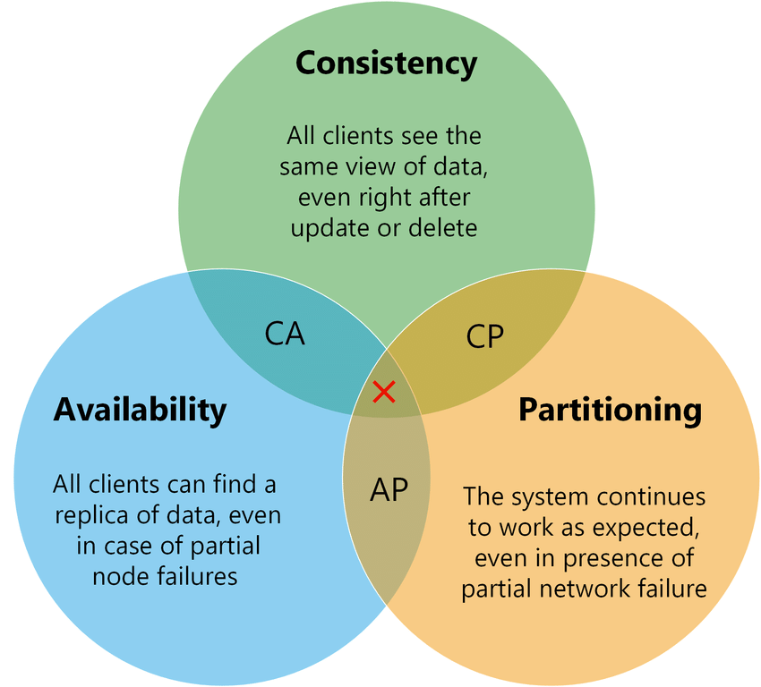

A distributed system can deliver atmost two of these three desired characteristics: consistency, availability, and partition tolerance.

4. **SOLID principles** -> The SOLID principle helps in reducing tight coupling.

Single Responsibility Principle

* This principle states that “a class should have only one reason to change” which means every class should have a **single responsibility** or single job or single purpose.

Open-Closed Principle

* This principle states that “software entities (classes, modules, functions, etc.) should be open for extension, but closed for modification” which means you should be able to extend a class behavior, without modifying it.

Liskov’s Substitution Principle

* This principle states that “Derived or child classes must be substitutable for their base or parent classes” which means that any class that is the child of a parent class should be usable in place of its parent without any unexpected behavior.

Interface Segregation Principle

* This principle states that “do not force any client to implement an interface which is irrelevant to them”, which means larger interfaces should be split into smaller ones. By doing so, we can ensure that implementing classes only need to be concerned about the methods that are of interest to them.

Dependency Inversion Principle

* This principle refers to the “decoupling of software modules”. This way, instead of high-level modules depending on low-level modules, both will depend on abstractions. The main motive of this principle is decoupling the dependencies so if class A changes, class B doesn’t need to care or know about the changes.
* Ex: Suppose we have a **NotificationService** class responsible for sending notifications to users via email. Initially, the **NotificationService** directly depends on an **EmailSender** class to send emails. This creates a tight coupling between **NotificationService** and **EmailSender**, violating DIP.

To avoid this create a new interface **MessageSender**, now **NotificationService** class depends on the **MessageSender** interface instead of the **EmailSender** class directly, which is decoupled from the specific implementation of message sending, adhering to the DIP. With this design, we can easily switch the message sending mechanism by providing a different implementation of the **MessageSender** interface without modifying the **NotificationService** class.

5. RLock in RWMutex package vs Lock in mutex package

Lock: It will allow only single thread to lock and allows it to read or write.

RLock: It will allow multiple threads to lock but only to read the data and not to write anything.

6. JSON Web Token (JWT) is an open standard that defines a compact and self-contained way for securely transmitting information between parties as a JSON object. The beauty of JWTs lies in their self-contained nature, meaning the token itself holds all necessary information/ claims about user or client, which is verified through digital signatures.

Here are some scenarios where JSON Web Tokens are useful:

* **Authorization & Authorization**: This is the most common scenario for using JWT. Once the user is logged in, each subsequent request will include the JWT, allowing the user to access routes, services, and resources that are permitted with that token.
* **Information Exchange**: JSON Web Tokens are a good way of securely transmitting information between parties.

In its compact form, JWT consist of **three** parts separated by dots (.) - (xxxxx.yyyyy.zzzzz)

* Header
* Payload
* Signature

1)Header, It typically consists of two parts: 1) type of the token, which is JWT. 2) signing algorithm being used, such as HMAC SHA256 or RSA.

{

"alg": "HS256",

"typ": "JWT"

}

Then, this JSON is **Base64Url** encoded to form the first part of the JWT.

2) payload, which contains the claims. Claims are statements about an entity(user) and additional data. There are three types of claims: registered, public, private claims.

{

"sub": "1234567890",

"name": "John Doe",

"admin": true

}

Then, this JSON is **Base64Url** encoded to form the SECOND part of the JWT.

3)Signature To create the signature part, you must take the encoded header, the encoded payload, a secret - the algorithm specified in the header, and sign that.

HMACSHA256(base64UrlEncode(header) + "." + base64UrlEncode(payload), secret)

The signature is used to verify that the message wasn't changed along the way, and, in the case of tokens signed with a private key, it can also verify that the sender of the JWT is who it says it is.

Whenever the user wants to access a protected route or resource, the user agent should send the JWT, typically in the **Authorization** header using the **Bearer** schema.

Authorization: Bearer <token>

7. **static synchronization wrappers**

The method returns a thread-safe view of the **List**:

List<Integer> syncList = Collections.synchronizedList(new ArrayList<>());

The method returns a thread-safe view of the **Map**:

Map<Integer, String> syncMap = Collections.synchronizedMap(new HashMap<>());

The method returns a thread-safe view of the **SortedMap**:

Map<Integer, String> syncSortedMap = Collections.synchronizedSortedMap(new TreeMap<>());

The method returns a thread-safe view of the **Set**:

Set<Integer> syncSet = Collections.synchronizedSet(new HashSet<>());

The method returns a thread-safe view of the **SortedSet**:

SortedSet<Integer> syncSortedSet = Collections.synchronizedSortedSet(new TreeSet<>());

8. Sealed classes/Interfaces

A sealed class/Interface is a class that **explicitly specifies** which other classes are allowed to extend it. So, Add the “**sealed**” keyword to the class and specify which classes are permitted to inherit it by using the “**permits**” keyword.

*public* ***sealed*** *class Animal* ***permits*** *Dog, Cat, Bird {*

*//Class implementation*

*}*

In this example, the Animal class is declared as sealed and permits three subclasses: Dog, Cat and Bird. Any attempt to create a new subclass of Animal outside of this list will result in a **compilation error.**

9. **Difference between Btree and B+ tree:**

B-tree is known as a self-balancing tree (Binary Search Tree) as its nodes are sorted in the specific order, with the lowest value on the left and the highest value on the right. All the leaf nodes of the B-tree must be at the **same level**.

B+ tree is also known as an advanced self-balanced tree and eliminates the drawback of B-tree , where indexing by storing data pointers only at the leaf nodes of the tree. B+ tree is used to store the records very efficiently by storing the records in an indexed manner using the B+ tree indexed structure. Due to the multi-level indexing, the data accessing becomes faster and easier.

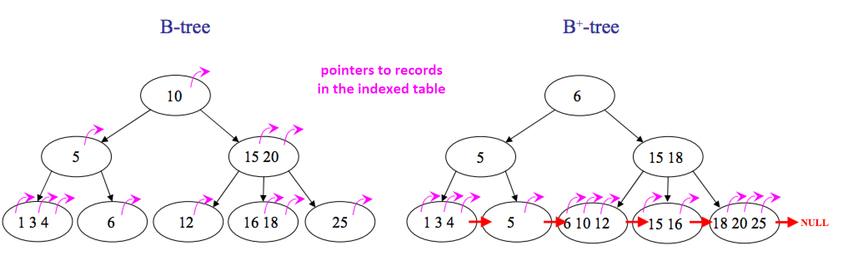

| **Comparison** | **B tree** | **B+ tree** |
| --- | --- | --- |
| **Pointers** | All internal and leaf nodes have data pointers | Only leaf nodes have data pointers |
| **Search** | Since all keys are not available at leaf, search often takes more time. | All keys are at leaf nodes, hence search is faster and more accurate. |
| **Redundant Keys** | No duplicate of keys is maintained | Duplicate of keys are maintained |
| **Insertion** | Insertion takes more time, and it is not predictable sometimes. | Insertion is easier and the results are always the same. |
| **Deletion** | Deletion of the internal node is very complex, and the tree must undergo a lot of transformations. | Deletion of any node is easy because all nodes are found at leaf. |
| **Leaf Nodes** | Leaf nodes are not stored as structural linked list. | Leaf nodes are stored as structural linked list. |
| **Height** | For a particular number of nodes height is larger | Height is lesser than B tree for the same number of nodes |
| **Application** | B-Trees used in Databases, Search engines | B+ Trees used in Multilevel Indexing, Database indexing |
| **Number of Nodes** | Number of nodes at any intermediary level **‘n’ is 2n** | Each intermediary node can have **n/2 to n** children. |

10. **CountDownLatch  vs CyclicBarrier**

**CountDownLatch** is a thread waiting for multiple threads to finish or calling countDown(). When all threads have called countDown(), the awaiting thread continues to execute. (This is needed when we might need to start our application only when a particular set of tasks are completed)

Ex: We can think of this like a dish at a restaurant that is being prepared. No matter which cook prepares however many of the n items, the waiter must wait until all the items are on the plate. If a plate takes n items, any cook will count down on the latch for each item she puts on the plate.

In **CyclicBarrier** a group of threads waits together until all the threads arrive at a barrier. At that point, the barrier is broken, and action can optionally be taken.

Ex: We can think of this like a group of friends. Every time they plan to eat at a restaurant, they decide a common point where they can meet. They wait for each other there, and only when everyone arrives can they go to the restaurant to eat together.

11**. Volatile keyword**

The volatile keyword in Java is used to indicate that a variable's value may be modified by multiple threads simultaneously. It ensures that changes made to a variable by one thread are visible to other threads immediately. It ensures that the variable is always read from and written to the main memory, rather than from thread-specific caches, ensuring visibility across threads. Volatile keyword is applicable with both primitive types and objects. When declared volatile, a variable does not cache its value and always reads from the main memory.

Ex: static **volatile** int sharedVar = 6; // volatile keyword here makes sure that the changes made in one thread are immediately reflect in other thread

12**. Enums**

An enum is a special "class" that represents a group of constants (unchangeable variables, like final variables).

To create an enum, use the enum keyword and separate the constants with a comma. Note that they should be in **uppercase** letters:

enum Level {

LOW,

MEDIUM,

HIGH

}

Level myVar = Level.MEDIUM; //access enum constants with the **dot** syntax

public enum MarketTypeEnum {

RETAIL("Retail"),

WHOLESALE("Wholesale");

private String marketType;

MarketTypeEnum(String marketType) {

this.marketType = marketType;

}

public String getMarketType(){ return marketType;}

}

**Note:** Enum declaration can be done outside a Class or inside a Class but not inside a Method.

* We can use ENUM in switch
* Loop through enum -> .values() gives all constant values as Array

13. Shallow copy vs Deep copy

Shallow Copy (default): In a shallow copy, a new object is created, but instead of copying the elements themselves, **references** to the original elements are copied. This means that changes made to the elements of the copied object will be reflected in the original object and vice versa.

In essence, a shallow copy creates a new collection or object, but it does not create copies of the elements within the collection; it simply copies the references to those elements.

Deep Copy: In a deep copy, both the object itself and all the objects contained within it are duplicated. This means that changes made to the elements of the copied object will not affect the original object, and vice versa. They are completely independent.

Deep copy creates entirely new instances of the objects and recursively copies all objects within the original object, ensuring that there are no shared references between the original and copied objects.

* To achieve this, made changes in clone() method of cloneable interface, by manually creating objects by copying all members.

Choosing between shallow and deep copy:

* If your objects contain only **immutable objects**, a shallow copy is sufficient.
* If your objects contain **mutable objects** or you want to completely detach the copied object from the original, a deep copy is necessary.

14. Memory leak:

A Memory Leak is a situation where there are objects present in the **heap** that are no longer used, but the garbage collector is unable to remove them from memory, and therefore, they’re unnecessarily maintained. A memory leak is bad because it blocks memory resources and degrades system performance over time. If not dealt with, the application will eventually exhaust its resources, finally terminating with a fatal java.lang.OutOfMemoryError.

The GC implicitly takes care of allocating and freeing up memory, and thus is capable of handling the majority of memory leak issues. While the GC effectively handles a good portion of memory, it doesn’t guarantee a foolproof solution to memory leaking. The GC is smart, but not flawless. Memory leaks can still sneak up, even in the applications of a conscientious developer.

**how to fix:**

1) Minimize the use of static variables, becoz can remain in memory for the duration of the application’s life if not managed carefully.

2) When using singletons, rely upon an implementation that lazily loads the object, instead of eagerly loading.

3) Through Unclosed Resources - Always use **finally block** to close resources (especially in scenarios where exceptions might occur, finally block is guaranteed to execute whether an exception is thrown or not, making it suitable for resource cleanup.)

4) Using Heap Dump: It is a technique to solve the memory leak problem. It is a snapshot of all objects that reside in the memory at a certain time. It also optimizes memory usage in a Java application.

* jmap is a built-in tool that comes with the JDK. It allows you to print memory statistics for a running JVM process.
* To capture a heap dump using jmap, run the following command:

jmap -dump:[live],format=b,file=/path/to/dump.hprof <pid>

5) Enable Profiling: Java profilers are tools that monitor and diagnose the memory leaks through the application. They analyze what’s going on internally in our application, like how we allocate memory.

The Java heap size is determined by two JVM attributes, which can be set when launching Java:

-Xms to set the initial heap size

-Xmx to set the maximum heap size

Preventing Memory Leak:

Do not create unnecessary objects.

Avoid String Concatenation, Use String Builder.

Do not store a large amount of data in the session.

Time out the session when no longer used.

Do not use the System.gc() method.

Avoid the use of static objects. Because they live for the entire life of the application, by default. So, it is better to set the reference to null, explicitly.

Always close the ResultSet, Statements, and Connection objects in the finally block.

15. ExecutorService

The Java ExecutorService is the interface which allows us to execute tasks on threads asynchronously. The Java ExecutorService interface is present in the java.util.concurrent package. It helps in maintaining a pool of threads and assigns them tasks. It also provides the facility to queue up tasks until there is a free thread available if the number of tasks is more than the threads available.

Instantiating ExecutorService:

ExecutorService executorService1 = Executors.newSingleThreadExecutor(); //Creates a ExecutorService object having a single thread.

ExecutorService executorService2 = Executors.newFixedThreadPool(10); //Creates a ExecutorService object having a pool of 10 threads.

ExecutorService executorService3 = Executors.newScheduledThreadPool(10); //Creates a scheduled thread pool with 10 threads. In scheduled thread pool, we can schedule tasks of the threads.

Assigning tasks to ExecutorServices:

1. execute(Runnable task) //takes a java.lang.Runnable object and executes it asynchronously, doesnt returns a Future object

2. submit(Runnable task) //It also takes a Runnable obj, returns a Future object

3. submit(Callable<T> task) //It takes a Callable object, returns a Future object

4. invokeAny(Collection<? extends Callable<T>> tasks) //takes a collection of Callable objects, does not return a Future, but returns the result of any one of the Callable objects thats finished. If one of the tasks complete (or throws an exception), the rest of the Callable's are cancelled.

5. invokeAll(Collection<? extends Callable<T>> tasks) //invokes all of the Callable objects you pass to it, returns a list of Future objects via which you can obtain the results of the executions of each Callable.

**EX:**

public class ExecutorServiceExample {

public static void main(String[] args) {

ExecutorService executorService = Executors.newSingleThreadExecutor();

executorService.execute(new Runnable() { //execute

@Override

public void run() {

System.out.println("ExecutorService");

}

});

Future future = executorService.submit(new Runnable() { //submit

public void run() {

System.out.println("Asynchronous task");

}

});

Future future = executorService.submit(new Callable(){ //submit

public Object call() throws Exception {

System.out.println("Asynchronous Callable");

return "Callable Result";

}

});

System.out.println("future.get() = " + future.get()); //returns null if the task has finished correctly.

Set<Callable<String>> callables = new HashSet<Callable<String>>();

callables.add(new Callable<String>() { //invokeAll & invokeAny

public String call() throws Exception {

return "Task 1";

}

});

callables.add(new Callable<String>() {

public String call() throws Exception {

return "Task 2";

}

});

String result = executorService.invokeAny(callables);

List<Future<String>> futures = executorService.invokeAll(callables);

executorService.shutdown(); //To terminate the threads inside the ExecutorService

}

}

16. Consumer, Predicate, Supplier and Function:

Consumer

A Consumer is an in-build functional interface in the java.util.function package, consumer **takes an input value and returns nothing**. The consumer interface is;

@FunctionalInterface

public interface Consumer<T> {

void accept(T t);

//It also contains some other default and static methods.

}

**Usage** in forEach(Consumer) method: .forEach(x -> System.out.println(x));

Ex: Consumer<String> printConsumer= city-> System.out.println(city);

cities.forEach(printConsumer);

Predicate

A Predicate is a functional interface, which **accepts an argument and returns a boolean**. Usually, it is used to apply in a filter for a collection of objects.

@FunctionalInterface

public interface Predicate<T> {

boolean test(T t);

//It also contains some other default and static methods.

}

**Usage** in filter(Predicate) method: .filter(x -> x%2 == 0)

Ex: Predicate<Integer> predicate= x -> x % 2 == 0;

System.out.println(predicate.test(5)); //op: false

Function

A Function is another in-build functional interface in java.util.function package, the function **takes an input value and returns a value**. The function interface is;

@FunctionalInterface

public interface Function<T, R> {

R apply(T t);

//It also contains some other default and static methods.

}

**Usage** in map(Function) method: .map(x -> x*x)

Ex: Function<Integer,Integer> function= x -> x * x;

System.out.println(function.apply(5)); //op: 25

Supplier

The Supplier Interface is a part of the java.util.function package. It represents a function that **does not take in any argument but produces a value of type T**. It contains only one method ie, get()

@FunctionalInterface

public interface Supplier<T> {

T get();

}

Ex: int max=intList.stream().max((x,y) -> x - y).get();

# *Imp Questions-2:*

1) Secure API Authentication Methods

1.**Use HTTPS (SSL/TLS)**: Always use HTTPS to encrypt the data transmitted between the client and the server. This prevents eavesdropping and man-in-the-middle attacks.

2.**Authentication**: Implement authentication mechanisms to verify the identity of clients accessing the API. Common authentication methods include:

• Token-based authentication (JWT, OAuth)

• Basic authentication (username/password)

• API keys

3.**Authorization**: Once the client is authenticated, implement authorization to control what actions the authenticated user can perform. This ensures that users can only access resources they are authorized to access.

4.**Input Validation**: Validate and sanitize all input received from clients to prevent common security vulnerabilities such as SQL injection, Cross-Site Scripting (XSS), and Cross-Site Request Forgery (CSRF).

5.**Rate Limiting**: Implement rate limiting to prevent abuse of the API by limiting the number of requests a client can make within a specific time period.

6.**Error Handling**: Implement proper error handling and avoid leaking sensitive information in error messages. Provide informative error messages to the client without exposing implementation details.

2) Distributed Tracing

Distributed tracing is a technique used to track and observe application requests as they move through distributed systems or microservices.

There are two possible outcomes: 1) all operations successfully complete, or 2) none of the operations are performed at all due to a failure somewhere in the system.

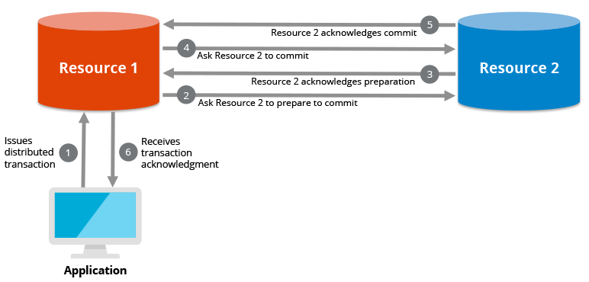

**Distributed transactions** are often done in two phases to safeguard against partial updates that might occur when a failure is encountered. The first phase involves acknowledging an intent to commit, or a “**prepare-to-commit**” phase. After all resources acknowledge, they are then asked to run a final **commit**, and then the transaction is completed.

For a distributed transaction to occur, transaction managers coordinate the resources (either multiple databases or multiple nodes of a single database). The transaction manager decides whether to commit a successful transaction or rollback an unsuccessful transaction, the latter of which leaves the database unchanged.

* Let’s say one or more of the **resources become unavailable** during the prepare-to-commit phase. When the request times out, the transaction manager tells each resource to delete the **prepare-to-commit** status, and all data will be reset to its original state. If instead, any of the resources become unavailable during the **commit** phase, then the transaction manager will tell the other resources that successfully committed their portion of the transaction to undo or “rollback” that transaction, and once again, the data is back to its original state. It is then up to the application to retry the transaction to make sure it gets completed.

Note: One of the most widely used design patterns for handling distributed transactions in microservices is the saga pattern. The saga pattern is based on the idea of breaking a long-running transaction into a series of local transactions, each executed by a different service, and compensating for any failures along the way.

There are two main types of saga patterns:

Choreography-based Saga: In this type of saga, each service involved in the transaction manages its own local transaction and emits events to notify other services about the state changes. Each service listens to these events and reacts accordingly, either by committing or compensating its local transaction. There is **no centralized coordinator** in choreography-based sagas. Services communicate directly through event propagation.

Orchestration-based Saga: In an orchestration-based saga, there is a **central orchestrator or coordinator** responsible for managing the overall transaction. The orchestrator coordinates the execution of local transactions across multiple services. It decides which services to invoke, in what order, and how to handle any failures that may occur during the transaction. The orchestrator often follows a predefined workflow or saga definition to guide the transaction through various steps.

3) **ACID Properties in DBMS**

A [**transaction**](https://www.geeksforgeeks.org/sql-transactions/) is a single logical unit of work that accesses and possibly modifies the contents of a database. Transactions access data using read and write operations.   
To **maintain consistency** in a database, before and after the transaction, certain properties are followed. These are called **ACID** properties.

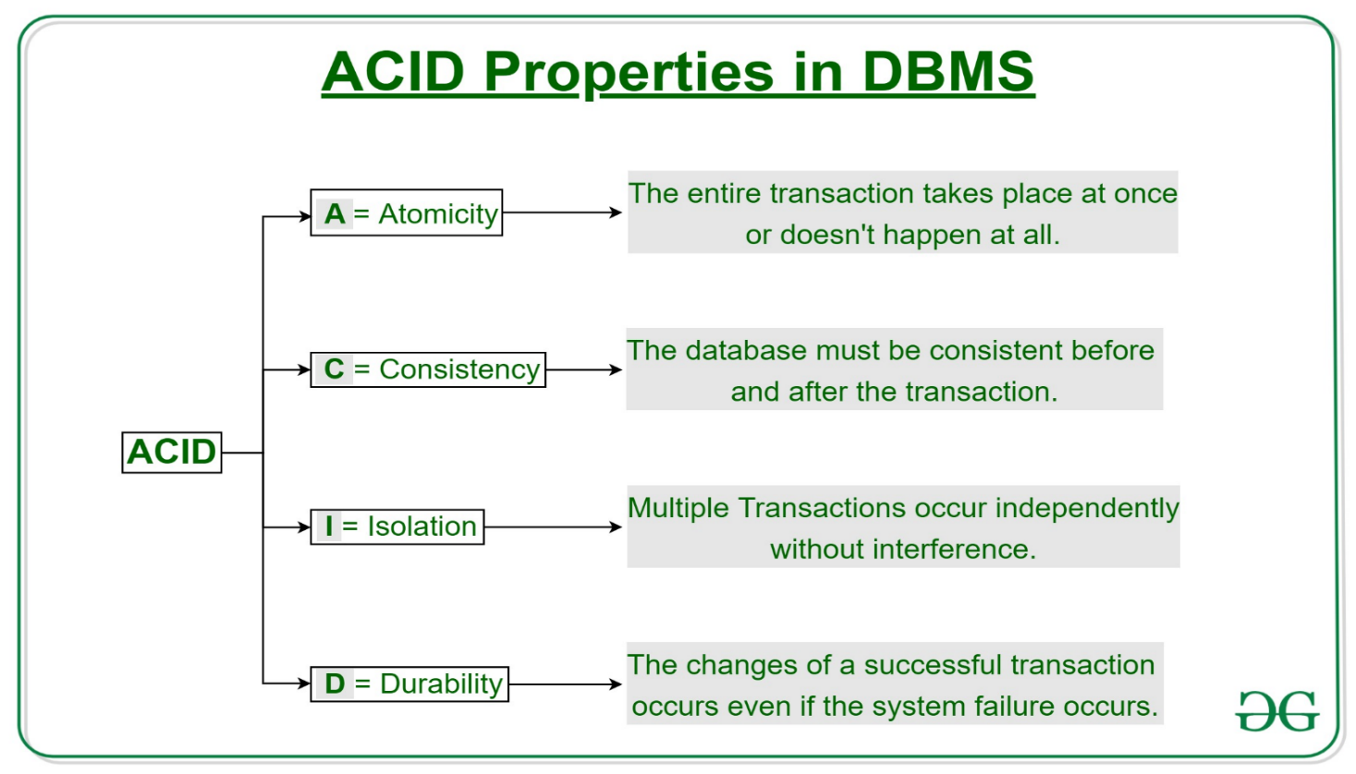

4) put vs patch

PUT and PATCH are both HTTP methods used in RESTful APIs for updating resources, but they have different semantics and use cases.

**PUT:**

* The PUT method is used to update a resource completely or replace it with a new representation.
* When you send a PUT request to a resource URL, you're essentially saying, "Here is the full representation of the resource, please replace the existing resource with this one."
* If the resource doesn't exist at the specified URL, PUT **creates a new resource** with the provided representation.
* PUT requests are **idempotent**, meaning that making the same request multiple times will have the **same effect** as making it once.

Example: Updating a user's profile information with all fields, where the entire user object is sent in the request body.

**PATCH:**

* The PATCH method is used to apply partial modifications to a resource.
* When you send a PATCH request to a resource URL, you're providing a set of instructions on how to modify the resource, rather than sending the entire updated representation.
* PATCH requests are typically used when you only need to update certain fields or properties of a resource, rather than the entire resource.
* PATCH requests are **not necessarily idempotent**; making the same request multiple times may have different effects.

Example: Updating a user's profile information with only the fields that have changed, where the request body contains only the modified fields.

5) **Idempotent methods**

* HTTP methods that, when applied multiple times, have the same effect as applying them once. This means that repeating the same request with the same parameters will not result in a different outcome or change in the server's state. GET, HEAD, PUT, DELETE, OPTIONS, and TRACE are **idempotent** methods, meaning they are safe to be retried or executed multiple times without causing unintended side effects.
* In contrast, POST and PATCH are generally considered **non-idempotent**, as their outcomes may vary with each request.

6) Reflection in Java:

Reflection is an API that is used to examine or modify the behavior of methods, classes, and interfaces at runtime. This particularly comes in handy when we **don’t know their names** at compile time. The required classes for reflection are provided under java.lang.reflect package. Through reflection, we can invoke methods at runtime **irrespective of the access specifier** used with them.

Reflection can be used to get information about class, constructors, and methods as depicted below in tabular format as shown:

|  |  |
| --- | --- |
| **Class** | The getClass() method is used to get the name of the class to which an object belongs. |
| **Constructors** | The getConstructors() method is used to get the public constructors of the class to which an object belongs. |
| **Methods** | The getMethods() method is used to get the public methods of the class to which an object belongs. |

We can invoke a method through reflection if we know its name and parameter types. We use two methods for this purpose as described below before moving ahead;

1. getDeclaredMethod()
2. invoke()

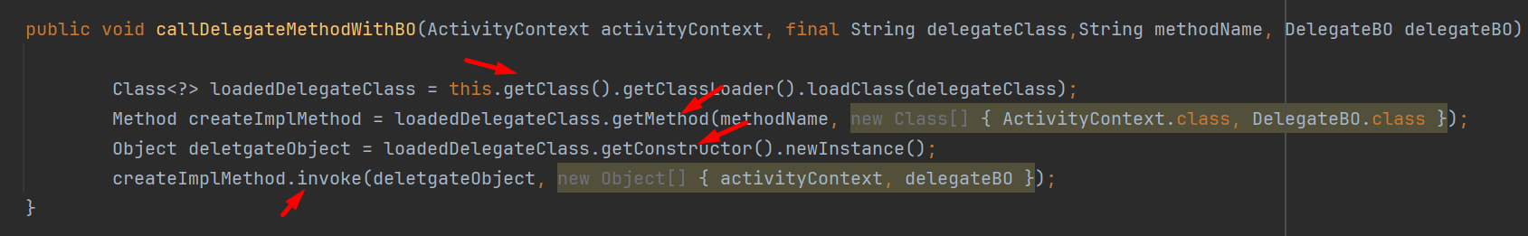

7) try-with-resources

The try-with-resources statement, introduced in Java 7, allows us to declare resources to be used in a try block with the assurance that the **resources will be closed after the execution of that block**. The resources declared need to implement the AutoCloseable interface.

* Ex:

try (FileOutputStream fileOutputStream = new FileOutputStream("/path/to/file.txt")) {

String msg = "Hello, World!";

byte[] byteArray = msg.getBytes();

fileOutputStream.write(byteArray);

System.out.println("Message written to file successfully!");

} catch (Exception e) {

System.out.println(e);

}

* You can also use multiple resources in a try-with-resources statement;

try (FileInputStream fileInputStream = new FileInputStream("/path/to/input.txt");

FileOutputStream fileOutputStream = new FileOutputStream("/path/to/output.txt")) {

// Use fileInputStream and fileOutputStream

} catch (IOException e) {

// Handle exception

}

Both FileInputStream and FileOutputStream are resources that are automatically closed at the end of the statement. The simple & obvious way to use the try-with-resources functionality is to replace the traditional try-catch-finally block.

8) Parallel vs Sequential Stream in Java

**Sequential Stream**: A sequential stream uses a single thread to process the data. It performs operations one by one on a single core. This means it doesn’t take advantage of multi-core systems even if the underlying system supports parallel execution. The stream() method returns a sequential stream.

list.stream().forEach(System.out::print); //op: Hello GEEKS!

**Parallel Stream**: A parallel stream divides the provided task into many and runs them in different threads, utilizing multiple cores of the computer. This increases its performance, especially with large data sets and computationally intensive tasks. However, the order of execution is not under our control and can give us unpredictably unordered results.  If we run this code multiple times then we can also see that each time we are getting a different order of output. You can obtain a parallel stream by invoking the parallelStream() method of the Collection interface or the parallel() method of the BaseStream interface on a sequential stream.

list.parallelStream().forEach(System.out::print); //op: ES!KGEHello

listOfBooks.stream().parallel().forEach(System.out::print);

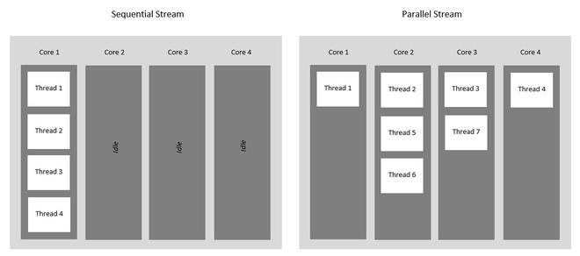

9) Diff types of garbage collectors:

Garbage collection is a mechanism that provides automatic memory management.

**Types of Garbage Collector**: There are four types.

1. Serial Garbage Collector

This is the simplest GC implementation, well-matched for single-threaded environments. It freezes all other running threads of application until garbage collection operations have concluded. If we use Serial Garbage Collector as our default GC, then the application throughput will decrease, and application pause time will increase.

2. Parallel Garbage Collector

It is the default garbage collector in Java 8. It is also known as Throughput collector. Parallel GC is same as Serial GC because Parallel GC also freezes the running threads of the application while performing the garbage collection. But the difference is, Parallel Garbage Collector uses multiple threads to perform cleaning of unused heap area.

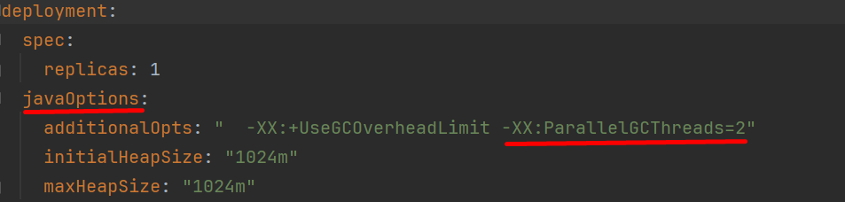

3. Concurrent Mark Sweep (CMS) Garbage Collector

This GC uses multiple threads to scan the heap memory consistently to mark objects that are unused and then sweep the marked objects. It does not freeze the application's threads during the garbage collection. GC threads concurrently execute with the application's threads. For this reason, it uses more CPU in comparison to other GC. If we compare CMS collector with Parallel garbage collector, CMS collector uses more CPU to ensure better application throughput.

4. Garbage First (G1) Garbage Collector

G1 Garbage Collector is the default garbage collection of Java 9. G1 collector replaced the CMS collector since it’s more performance efficient. Unlike other collectors, It partitions the heap space into multiple equal-sized chunks and then performs the parallel garbage collection on that chunks based on the priority. Basically, it is mainly designed for an application having heap size greater than 4GB.

10) Production code is slower than development env code how would you fix it?

- check server/pod logs for any potential issues

- check database call time/traffic

- check any communication lags/breaks between multiple services

- Then decide better approach to fix it either by impl caching, reducing DB calls, scaling etc.

11) OAUTH:

OAuth 2.0 is not a token format but an authorization framework. It defines a series of flows or 'grant types,' which enable a client application to access resources on behalf of a user. OAuth involves obtaining an 'access token,' which the client uses to authenticate requests to a resource server. OAuth is a great choice if you want to allow users to delegate access to their resources to 3rd party applications without sharing their credentials.

**JWT Vs OAuth:**

- OAuth is used for authorization, while JWT is used for authentication and exchanging information.

- JWT defines a token format, while OAuth deals in defining authorization protocols.

- JWT is simple and easy to learn from the initial stage while OAuth is complex.

- OAuth uses both client-side and server-side storage while JWT must use only client-side storage.

- JWT is stateless, meaning it doesn’t rely on an external source to validate claims, It does not require a centralized server or database to store the tokens. OAuth is stateful, meaning it requires a connection to the authorization server to obtain and verify tokens.

- JWT is suitable for stateless applications. OAuth maintains a session state on the server.

JWT and OAuth can **work together** effectively. In many OAuth implementations, the access tokens issued are, in fact, JWTs. This combination leverages both technologies' strengths: OAuth's robust authorization framework and JWT's ability to encode user information and claims securely.

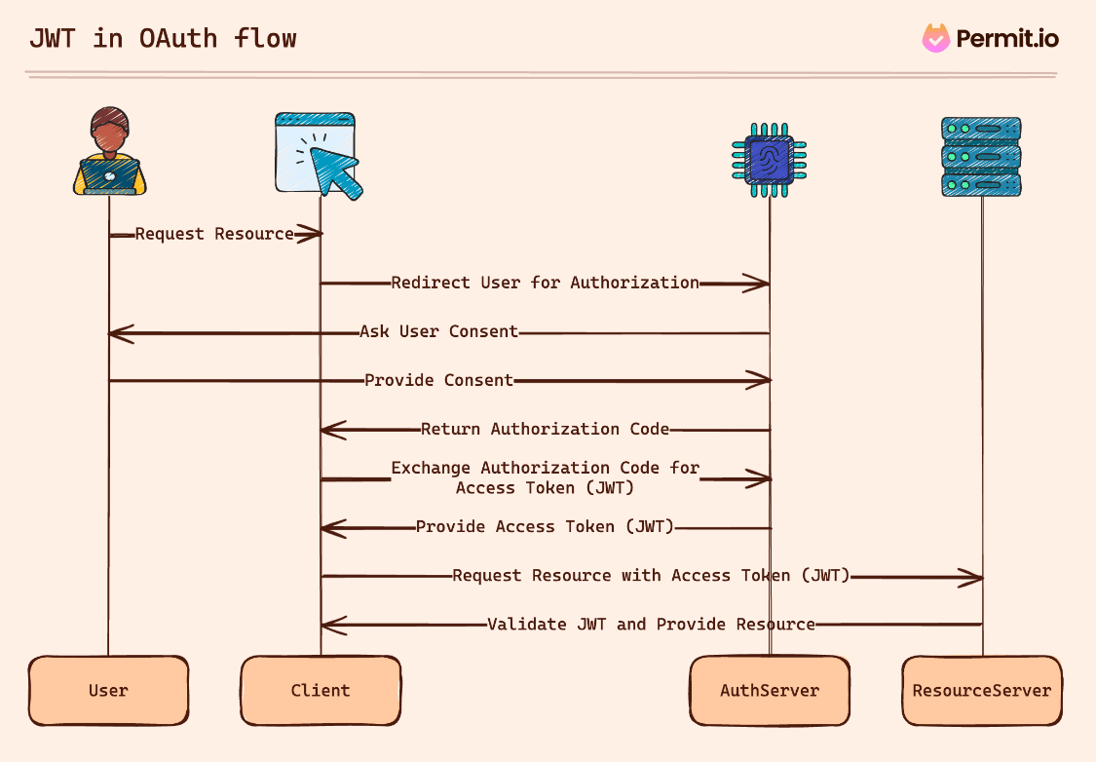

12) Collections.singletonList():

The singletonList() method of java.util.Collections class is used to return an immutable list i,e. both structural and non-structural changes aren’t allowed to be made on the list. This list will always contain only one element thus the name singleton list. When we try to add/remove an element on the returned singleton list, it would give **UnsupportedOperationException**. The returned list is serializable.

Ex: List<String> list = Collections.singletonList("E");

If compared with **Arrays.asList();**

the Arrays.asList() method returns a fixed-size list. Any structural changes will throw UnsupportedOperationException, for example, adding new elements to the list or removing elements from the list. But we can change the elements in the list using the set() method. list.set(0, "new string");

String[] theArray = new String[] { "ONE", "TWO" };

List<String> theList = Arrays.asList(theArray);

//changing the list, the array is changed too

theList.set(0, "ONE [changed in list]");

assertThat(theArray[0]).isEqualTo("ONE [changed in list]");

//changing the array, the list is changed too

theArray[1] = "TWO [changed in array]";

assertThat(theList.get(1)).isEqualTo("TWO [changed in array]");

13) Callable Interface:

There are two ways of creating threads – one by extending the Thread class and other by creating a thread with a Runnable. However, one imp feature lacking in Runnable is that we cannot make a thread return result when it completes its execution, i.e. when run() completes. For supporting this feature, the Callable interface is introduced. It has call() method with return type object.

public Object call() throws Exception;

|  |  |  |
| --- | --- | --- |
| **Callable** |  | **Runnable** |
| It is mandatory to define call() method if we are dealing with the Callable interface. | | It is mandatory to define the run() method if we are dealing with the Runnable interface. |
| The return type of the call() method of the interface is an Object. Hence, the call() method returns an Object. | | The return type of the run() method of the interface is void. Hence, the run() method returns void. |
| The call() method can throw an exception. | | The run() method cannot throw an exception. |
| A thread cannot be created using the Callable interface. | | A thread can be created using the Runnable interface. |

When the call() method terminates, the returned object must be stored in the main thread. It is important because the main thread must know the result generated in the call() method. To accomplish the same, a Future object is used. A Future object holds the result obtained from the different thread, which is sent from the call() method.

Just like Callable, Future is also an interface. Therefore, to use it, its implementation is a must. However, we do not have to take the pain to implement the Future interface. The Java library already has the class called, FutureTask that implements the **Runnable** as well as the **Future** interfaces. The get() method is used to receive the returned object obtained from the different threads to the main thread. The get() method is declared in the Future interface and implemented in the FutureTask class.

14) Event-Driven Architecture:

Event-driven architecture is a software design pattern that allows decoupled applications to asynchronously publish and subscribe to events through an event broker (Message broker). The EDA enables loose coupling of applications by introducing a middleman known as an event broker, often referred to as “asynchronous” communication means that the sender and recipient don’t have to wait for each other to move onto their next task. This pattern replaces the traditional “**request/response**” architecture where services would have to wait for a reply before they could move onto the next task.

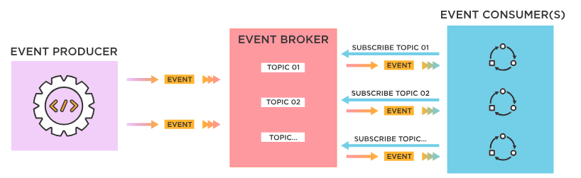

15) Servlet:

Servlets are the Java programs that run on the Java web server or application server. They are used to **handle the request** obtained from the web server, process the request, produce the response, and then send a response back to the web server. Servlet technology is used to create a web application (resides at server side and generates a **dynamic web page**).

Execution of Servlets.

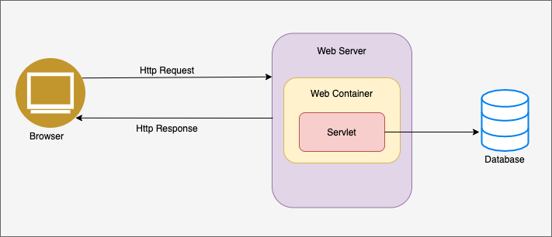

GenericServlet vs HttpServlet:

GenericServlet:

- GenericServlet is an abstract class that implements the Servlet interface.

- It provides a generic, protocol-independent servlet that can **handle any type of request of any protocol**.

- GenericServlet is suitable for developing servlets that need to handle different protocols, such as HTTP, FTP(File Transfer Protocol), or SMTP.

HttpServlet:

- HttpServlet is an abstract subclass of GenericServlet, specifically designed to handle HTTP requests.

- HttpServlet is a specialized servlet class specifically designed **to handle HTTP requests.**

- It extends GenericServlet and provides additional methods for handling HTTP-specific operations, such as doGet, doPost, doPut, doDelete, etc.

- HttpServlet simplifies the development of web applications by providing convenient methods for handling different HTTP request types.

16) Atomic Variables:

Java provides atomic classes such as AtomicInteger, AtomicLong, AtomicBoolean and AtomicReference. Objects of these classes represent the atomic variable of int, long, boolean, and object reference respectively. These classes contain the following methods.

set(int value): Sets to the given value

get(): Gets the current value

lazySet(int value): Eventually sets to the given value

compareAndSet(int expect, int update): Atomically sets the value to the given updated value if the current value == the expected value

addAndGet(int delta): Atomically adds the given value to the current value

decrementAndGet(): Atomically decrements by one the current value

Need for Atomic Variable in a multithreaded environment, which may lead to inconsistent results due to concurrency, which can be avoided by using locks ie, synchronization - but it compromises time efficiency or performance. So, Its good using Atomic variables for atomic operations.

- **AtomicInteger** is a class that allows you to update an integer value atomically. It’s particularly useful for managing shared mutable state in concurrent environments without using locks

# *Rest Api:*

API is an Interface btw two systems to exchange info securely over the internet.

REST (**Representational State Transfer**) is a software architecture that imposes conditions on how an API should work.  REST APIs are **stateless**, meaning no client information is stored between requests and each request is separate and unconnected. REST APIs communicate through HTTP requests to perform standard database functions like creating, reading, updating and deleting records (CRUD) within a resource.

Any API (Application Programming Interface) that follows the REST architectural style/ design principle is said to be RESTful API/web service.

REST API design best practices:

1. Versioning

2. Documentation

3. filtering, sorting and pagination

4. maintain stateless

5. proper exception handling (with more info about error)

6. caching

7. security (https://mysite.com/posts runs on SSL, http://mysite.com/posts does not run on SSL)

8. Use Nouns Instead of Verbs in endpoints

Can we make REST stateful?

Yes, in monolithic app.

No, in MS -> as we dont know in which pod/replicas resource state is going to be saved, so we cant achieve stateful for rest apis in MS.

Tips for Improving API Performance

Cache When You Can.

Limit Payloads.

Simplify/reduce Database Queries.

Rate Limit to Avoid Abuse.

Implement Pagination.

Use PATCH When Possible.

Route optimization – You should identify the fastest route to the origin

Versioning:

Versioning in RESTful APIs refers to the practice of managing different versions of an API to accommodate changes & updates while maintaining **backward-compatibility** for existing clients.

There are several approaches to versioning REST APIs:

1. URL-Based Versioning -> https://api.example.com/v1/resource

2. Header-Based Versioning -> Accept: application/vnd.example.v2+json

3. Query Parameter-Based Versioning -> https://api.example.com/resource?version=v1

we can gradually phase out old endpoints instead of forcing everyone to move to the new API at the same time. The v1 endpoint can stay active for people who don’t want to change, while the v2, with its shiny new features, can serve those who are ready to upgrade. This is especially important if our API is public. We should version them so that we won't break third party apps that use our APIs.

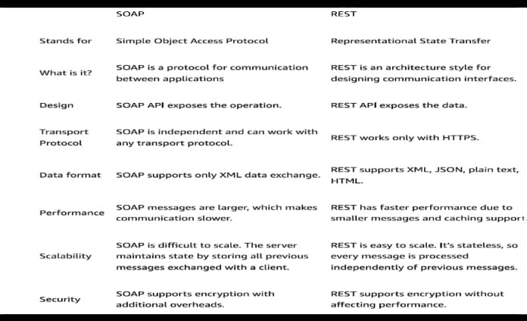

Pagination:

Pagination is a technique used in web development and other digital platforms to divide content into discrete pages. It's particularly useful when dealing with large datasets or lengthy content, allowing users to navigate through content in manageable chunks.

Pagination helps improve user experience by:

- Faster Loading Times

- Improved Navigation

- Better Performance

- Reduced Cognitive Load

* Limit/Offset Paging would look like GET /items?limit=20&offset=100. This query would return the 20 rows starting with the 100th row.

Richardson Maturity Model – RESTful API:

The Richardson Maturity Model (RMM), proposed by Leonard Richardson, is a model used to assess the maturity of a RESTful API based on its implementation levels. It consists of **four levels**, each representing a stage of maturity in the design and implementation of RESTful principles.

REST services are divided into maturity levels according to the Richardson Maturity Model.

Level 0: The Swamp of POX (Plain Old XML)

**Characteristics**:

Uses HTTP as a transport protocol but doesn’t leverage its features.

Often relies on a single endpoint (e.g., POST /api) for all operations.

Treats HTTP as a tunnel for remote procedure calls (RPC).

Doesn’t follow resource-oriented architecture.

**Key Issues:**

Lack of resource-based URLs.

No use of HTTP methods like GET, POST, PUT, DELETE.

Absence of hypermedia controls.

Level 1: Resources

**Characteristics**:

Introduces the concept of resources as the key abstraction.

Resources are exposed as individual URLs (e.g., /users, /products).

Utilizes HTTP methods (GET, POST, PUT, DELETE) to perform operations on resources.

Uses different URLs for different operations (e.g., POST /users to create, GET /users/:id to read).

**Key Issues:**

May not use HTTP methods correctly (e.g., using only POST for all operations).

Does not leverage hypermedia controls.

Level 2: HTTP Verbs

**Characteristics**:

Adheres to proper usage of HTTP methods (GET, POST, PUT, DELETE).

Uses HTTP headers (e.g., Content-Type, Accept) for negotiation and metadata.

Each HTTP method has a specific role in manipulating resources (e.g., GET for retrieval, PUT for update).

Leverages status codes (e.g., 200 OK, 404 Not Found) to convey operation results.

**Key Advancements:**

Enhances API consistency and predictability.

Facilitates better understanding and debugging of API interactions.

Enables caching and optimization based on HTTP features.

Level 3: Hypermedia Controls (HATEOAS)

**Characteristics**:

Represents the highest level of RESTful maturity.

Integrates hypermedia controls within API responses (e.g., links, actions).

Allows clients to navigate the API dynamically without prior knowledge of all endpoints.

Responses include links to related resources and actions that clients can perform next.

**Key Advantages:**

Improves API discoverability and usability.

Reduces client coupling to API structure, promoting flexibility and evolution.

Enables server-driven application state (clients follow links to discover and interact with resources).

What are HTTP and HTTPS protocols?

HyperText Transfer Protocol (HTTP) is an application layer protocol that is used to access and transfer data (text, images, video, multimedia, etc) over WWW.

HTTP is a client-server protocol that runs on top of the TCP/IP family of protocols and uses the request/response protocol. It uses port number 80.

In HTTP, the client sends a request message to the server. After the client responds, HTTP establishes a TCP connection between the client and the server. HTTP delivers a request to the server, which collects the data that was requested. After the server sends data to the client, the connection will be terminated.

Hypertext Transfer Protocol Secure (HTTPS) is a secure extension or version of HTTP that is used for providing security to the data sent over the world wide web. This protocol allows transferring the data in an encrypted form which is particularly important when users transmit sensitive data such as login credentials. To encrypt communications HTTPS uses an encryption protocol called Transport Layer Security (TLS), formerly known as Secure Sockets Layer (SSL).

HTTPS protocol uses the port 443 for communicating the data.

***Features of HTTP/HTTPS:***

**HTTP is connectionless:** After serving a single HTTP request, the client-server connection is closed and that same connection is never used again.

**HTTP is media independent:** It means that HTTP can send any sort of data as long as both the client and the server understand how to process the data.

**HTTP is stateless:** The client and server only know about each other during the current request, and when the connection is disconnected, both the client and the server forget about each other.

# *JUnit & Mockito:*

***JUnit5:***

* @BeforeEach – denotes that the annotated method will be executed before each test method (previously @Before)
* @AfterEach – denotes that the annotated method will be executed after each test method (previously @After)
* @BeforeAll – denotes that the annotated method will be executed before all test methods in the current class (previously @BeforeClass), needs to be static
* @AfterAll – denotes that the annotated method will be executed after all test methods in the current class (previously @AfterClass), needs to be static
* @Disabled – disables a test class or method (previously @Ignore)
* @Test - Marks a method as a test method.
* @ParameterizedTest - used to test a Test case with different parameters
* @TestFactory – denotes a method that’s a test factory for dynamic tests
* @DisplayName – defines a custom display name for a test class or a test method
* @Nested – denotes that the annotated class is a nested, non-static test class
* @Tag – declares tags for filtering/categorize tests ex: @Tag("integration")
* @ExtendWith – registers custom extensions

***Mockito:***

* @Mock annotation is used to create mock object of the class.
* @InjectMocks annotation is used to inject mock objects into the class being tested. It helps to automatically inject all the mocks marked with @Mock or @Spy into the tested object.
* @Spy annotation is used to create a spy of a real object. Spies allow partial mocking, where you can mock some methods while using real implementations for others.
* @ExtendWith - It initializes Mockito annotations for a test class

Ex: @ExtendWith(MockitoExtension.class), it’s a class level annotation

* @Captor annotation is used to create an argument captor, which captures argument values passed to mocked methods.

Methods:

* mock() method is used to create mock objects for unit testing or we can do with annotations as well

Ex: UserRepository userRepository = mock(UserRepository.class);

* when() method is used to specify the behavior of mock objects. It is part of the stubbing mechanism in Mockito, allowing you to define what should happen when a specific method on a mock object is called.

Ex: when(calculatorRepository.add(10, 20)).thenReturn(30);

* verify() method is used to check if certain methods on mock objects were called with specific arguments. This is particularly useful for verifying interactions and ensuring that the code under test is correctly interacting with its dependencies.

Ex: verify(userRepository).saveUser(new User(name, email));

verify(userRepository).findUserByEmail(email);

* inOrder() method is used to verify that interactions with mock objects occur in a specific sequence. This is particularly useful when the order of method calls is important.

Ex: InOrder inOrder = inOrder(inventoryService, paymentService);

inOrder.verify(inventoryService).checkStock("product123", 2);

inOrder.verify(paymentService).processPayment(100.0);

* doNothing() method is used to specify that a method call on a mock object should do nothing. This is useful for stubbing void methods

ex: doNothing().when(notificationService).save(anyString());

* times() method is used to specify the number of times a method should be called on a mock object.

Ex: verify(messageRepository, times(1)).saveMessage(new Message(content));

* never() method in Mockito is used to verify that a certain method on a mock object was never called.

Ex: verify(emailService, never()).sendEmail(any(Email.class));

* timeout() method is used to verify that a specific method call on a mock object occurs within a given time frame. This is particularly useful when testing asynchronous code or ensuring that certain operations complete within an expected duration.

Ex: verify(emailService, timeout(1000)).sendEmail(any(Email.class));

* any() method is used to match any value passed to a method.

ex: verify(userRepository).findUserByEmail(anyString());

verify(userRepository).saveUser(any(User.class));

* verifyNoMoreInteractions() is used to make sure that nothing else was invoked on the mocks. ie to check unverified interactions.

Ex: verifyNoMoreInteractions(bookRepository);

* thenThrow() method is used to specify that a method call on a mock object should throw an exception. This is particularly useful when you want to test how your code handles exceptions from dependencies //for non-void methods

ex: when(calculatorRepository.add(10, 20)).thenThrow(SQLException.class);

* doReturn() method is used to stub a method call with a specific return value. It is particularly useful when you want to stub methods that cannot be stubbed with when(), such as void methods or when chaining method calls

Ex: doReturn(book).when(bookRepository).findBookByTitle(title);

* doThrow() method in Mockito is used to specify that a method call on a mock object should throw an exception. //for void methods

Ex: doThrow(SQLException.class)

.when(bankRepository).save(accountNumber);

doThrow(new IllegalArgumentException("Invalid payment amount"))

.when(paymentRepository).savePayment(payment);

BDDMockito:

* given(): It is used to set up mock objects with predefined behaviors, making the tests more readable and expressive.
  + method configures the mock BookRepository to return a specific Book object when the findBookByTitle method is called with the specified title.

Ex: given(bookRepository.findBookByTitle(title)).willReturn(book);

* then(): It is used to verify interactions with mock objects in a more readable and expressive way.
  + method verifies that the saveBook method was called on the BookRepository with any Book object.

Ex: then(bookRepository).should().saveBook(any(Book.class));

then(bookRepository).shouldHaveNoInteractions();

# *Code practice:*

https://github.com/fayaz-224/Java.git

* <https://takeuforward.org/interviews/strivers-sde-sheet-top-coding-interview-problems/>
* <https://takeuforward.org/strivers-a2z-dsa-course/strivers-a2z-dsa-course-sheet-2/>
* <https://takeuforward.org/system-design/complete-system-design-roadmap-with-videos-for-sdes/>