Contact No: +8801715463647.
Address: Road 7, Block E, Bashundhara R/A, Dhaka.
Email: fayazabrar2000@gmail.com
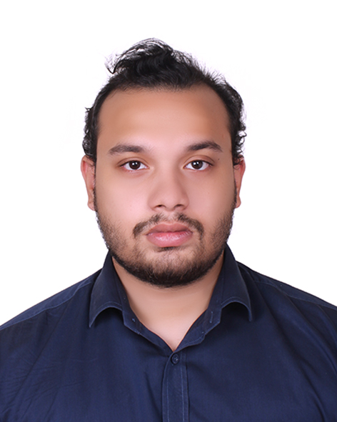

Fayaz Abrar

SOFTWARE & SKILLS
- C, C++, Java, PHP, JavaScript, Python, CSS, HTML, jQuery, Ajax, Bootstrap, Next.js
- My SOL, ORACLE, MS SQL
- Webpage Development, Form Development, Software Development

EDUCATIONAL QUALIFICATION
- Bachelor of science in Computer Science & Engineering 2023-Present
American International University-Bangladesh (AIUB)
CGPA: 3.9 (Out of 4.00)
- Higher Secondary Certificate 2022
Rajshahi University School & College
Science | GPA: 4.92 (Out of 5.00)
- Secondary School Certificate 2020
Rajshahi University School & College
Science | GPA: 4.83 (Out of 5.00)

EMPLOYMENT HISTORY
Full Stack Developer, ADEVS 2024-present
- Worked as an intern alongside completing studies.
- Gained experience in writing efficient, maintainable, and secure code.

PERSONAL STATEMENT
I am always willing to work in an organization with a professional environment where I can utilize and apply my potential, knowledge, and leadership skills to grow while fulfilling organizational and personal goals.

Theotonius Gomes
Assistant Professor
Department Of English
American International University Bangladesh
Email : gomes.theo@aiub.edu

Anika Tasnim
Lead Support Engineer
Qvantel
Email : anika.tasnim@qvantel.com
INTERESET
- Chess
- Reading
- Traveling

AWARD
- Dean’s List Honors - fall 2024-2025

REFERENCE

PROJECT
- Flight Management System
- Security Providing Software
- Hotel Management System
- Tic-tac-toe game

