Documentation following ‘The Equalizer’*, the CM2208 Coursework set to make an Audio Player/Organizer.
*I know equaliser is generally spelt with an ‘s’ rather than a ‘z’ in the UK. This program was named after the Denzel Washington movie ‘The Equalizer’ to add some dramatic effect and in hopes who evert reads this may appreciate it.

Contents:
- Basic Requirements
- Advanced (optional) Requirements
- How Requirements were met & how the program works
- Limitations which could be addressed in further releases

Basic Requirements:
The basic program requirements were to create an Audio Player/Organiser in MATLAB. One which could take inspiration from iTunes, Windows Media Player and such existing programs and had the following basic features:
- Load and play audio of types wav, aiff, mp3, mp4/aac and ogg, with basic functionality
- An appropriate GUI was developed,
- A means of organising the audio was included,
- Basic way of altering the audio files also included (playback volume and treble/bass controls),
Advanced (optional) Requirements:
Some advanced features were also suggested that could be implemented to achieve higher marks. This included, but was not limited to:
- Advanced playback of files (e.g.: repeat, shuffle, random selection),
- Advanced GUI layout / elements to control audio processing/editing/organising and sorting,
- Advanced media organisation (e.g. using tags, song title or artist),
- Advanced tone processing (e.g.: a multi band graphic equaliser rather than bass/treble controls).

How requirements were met & how the program works:
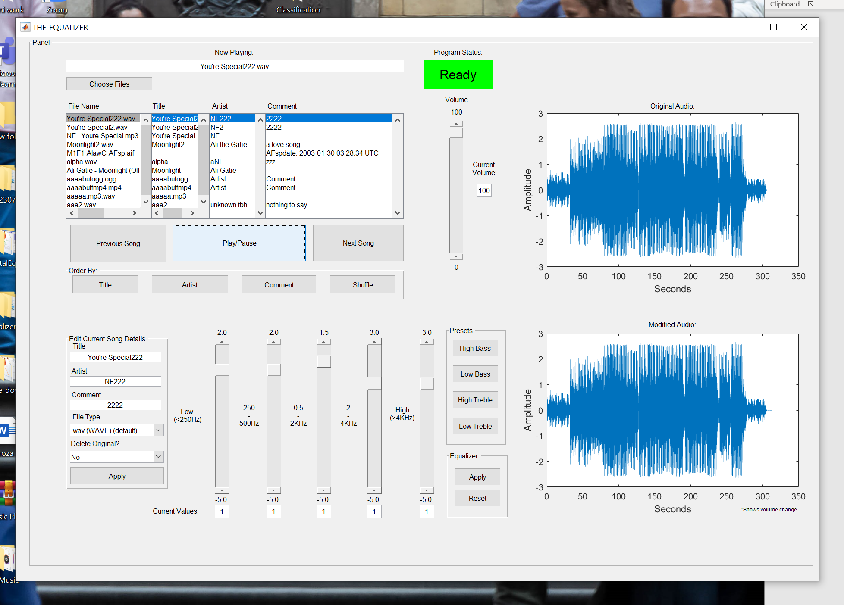
A
B
C
D
E
F
G
H
I
J

Requirements 1 and 2 are likely the most important as they are required to implement most of the other functionalities in a way that is easy for the user to understand. This is because using a graphics equaliser and volume control is easy using a GUI (graphical user interface) but manually typing the instructions would be too advanced for most users. Clicking the button highlighted at A, ‘Choose Files’, opens up a window UI box which allows you to choose multiple files which you would like to add to the playlist (list box), E.
This is done using ‘uigetfile’ and the file types, where you can choose between all supported audio types, more than just specified in the first requirement as it includes support for .au, .aifc and .flac. The files can be chosen all together or by specific types (I.E. all supported files, or only MP3 files or only WAVE files and so on). The files, once imported are all displayed in the list box, E. Showing the achievement of support for all required music types.
Basic functionality is achieved as C highlights the ability to play/pause the current song, shown at B, load the previous song or the next song. The songs are played according to how they are imported and shown on the list box. This can be modified, which will be detailed later. The functions ‘resume()’ and ‘pause()’ were chosen instead of ‘play()’ and ‘stop()’ as it allows for paused songs to be resumes from where they were paused.
Further achieving requirement 4 (for basic functionality), the GUI includes volume and tone control, as highlighted at D. A volume slider is used which is applied to any song that is currently playing. This is done by modifying y ([y, Fs] = audioread(a)) (by a multiple of 1/100th). Each time the volume is changed, y is reset before applying the new volume, to ensure the volume selected is a factor of the original audios volume (rather than just always getting quieter). The variable volume is initially set to 100 (the original level of the audio). This is because the player reads the volume before starting each song, and the volume is only otherwise declared when the volume slider is used. Therefore, if it is not declared when initialising the application, it will raise an error, where it does not know how to apply the volume to y.
Bass and treble control have been included but built in as a multi-band graphic equaliser. Hence this feature has not mentioned when discussing the 4th requirement but will be discussed later on.
The 3rd requirement was to have some way of organising the audio. This was provided using the 4 buttons highlighted at F. The buttons, when clicked, organises the audio in alphabetical order, by Title, Artist and Comment. This was achieved by reading the tags from the audio files using AudioInfo, then sorting the files using the sort function. If the files were already sorted, then flipping the order in the list box so it is sorted via reverse alphabetical order.
Above, details all basic requirements being met. The 4th button at F, the ‘Shuffle’ button, also partially achieves the 5th and 7th advanced requirement by having the songs sorted randomly. This is done by having an advanced GUI layout which allows for elements to be sorted and organised multiple different ways which then means the songs will be played in more than just the standard order of imported files.
One of the two advanced features, beyond basic requirement, that was fully incorporated was the multi-band graphic equaliser. For simplicity and to demonstrate the ability to incorporate a more complex version of this equaliser, only 5 bands were used. This allowed for a more spaced out user interface which was not as cluttered and a greater level of testing to find the best maximum multiplier settings. This is shown as each of the sliders have their own maximum values that can be applied to them.
Changing the levels on the multi-band equaliser does not take immediate effect until the apply button is clicked. When the apply button is clicked, the function belonging to the push button, pulls the variables containing the current value of each of the sliders then applies it to the relevant frequencies in the audio track.
Additionally, for those who did not feel confident enough to change the equaliser settings manually, there are pre-sets available next to the sliders, in the button group, named ‘Presets’, also highlighted in G. These apply the moment they are clicked and adjust the sliders respectfully. The user can still click the reset button, whether custom settings are applied, or a pre-set is used. Once again, the reset button would set these all to the default (1) and apply immediately.
When a song is loaded, the current song will have its original graph shown on the top right of the GUI, highlighted in H. This is what the audio file looks like when it has just been imported. The bottom graph on the right shows the audio file when its been modified. This includes volume modifications which reduce the amplitude of the overall audio file.
The second main advanced feature that has been incorporated is the ability to edit tags and save this as a new file, optionally deleting the old file or keeping the old file, providing they are named differently. This feature works as each time a new song is chosen, the details of the song are extracted using AudioInfo and if not blank, are displayed in the ‘Edit Current Song Details’ grouping highlighted in I.
The user can then choose to enter their own strings in-place to replace what currently exists, choosing the type of file they want to save the audio as and whether or not the old file should be saved or deleted. Then click ‘Apply’ to create the new audio file, which is automatically added to the list box. This is done using audiowrite, which allows us to specify the audio, the tags, file path and more.
A few additional, minor features include: the ability to change the song by double clicking either the ‘File Name’ list box or the ‘Title’ list box. This will start the process to load the song clicked. The GUI can also be resized to fit your screen. Furthermore, one greater feature included is a process indicator which tells you the program status, highlighted in J. What this means is, it will tell you whether or not the program is currently loading something or if its ready to receive its next instruction.
Limitations which could be addressed in further releases:
Whilst designing this program, it may have been a good idea to include a try-catch design, where if an invalid set of instructions is given, a pop-up box tells the user what they have done wrong. Whilst this feature is useful, in this type of program, its very close to redundant. This is because, so long as the audio files have already been imported, every other button should be able to run without any errors arising.
Another short coming of this application is the initial graph plot. Whilst it would have been easy to code the original graph plot directly from the audio sauce, I decided to plot the graph after its been divided into the same frequency bands as the second graph (showing the modified audio track), before any changes are applied to it. This is done to ensure that at a time where nothing has been done to modify the outcoming audio, both graphs look identical.
One major limitation of this application is the inability to change the volume, apply any equaliser changes or pre-sets and do other actions without causing the current song that’s playing to start from the beginning. This is because when the audio is change (volume = Y, frequencies = FS), the audioplayer code used has to be redeclared to encompass those changes, which clears the current audioplayer. One way to over come this may have been to split the music into samples and simply apply the changes to the remaining samples, only temporarily pausing whilst this is done. However, given the time limitations, this seemed like the best solution.
Another limitation is the status indicator. Whilst the feature itself, is extremely useful, its very slow in taking effect. This means it may take a few seconds before the status changes from ‘Ready’ to ‘Loading’ in which time the user may have repeatedly pressed a button. This, however, may be because the program is running directly from MATLAB rather than having been compiled then run. Therefore, this may not actually be an issue.
One issue which may be addressed, using a couple of if-statements is the size of the audio files created each time the ‘Apply’ button is clicked. This is because the bitrate and sample rate is not specified (as not all file types support those options), therefore a file, maybe 10 times bigger than the original is created. This is not a major bug as it can, to some extent, be resolved.
Conclusion:
Whilst this application has its clear limitations, highlighted above. It has met the basic requirements set out by the client and gone above and beyond in incorporating advanced features, in a way which allows users who aren’t so tech-savvy to use it too.

