Typing Race Simulator
EC414U
Fayaz Miah 250349418

Part 1

Task 1
Encapsulation is used to prevent direct access to fields and methods of a class / object, by applying restrictive modifiers such as private or protected.
In the typing race simulator, I used encapsulation by setting the fields of the Typist class to private, so that they can only be modified by methods given within the class.
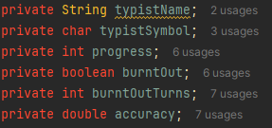
Here are the field attributes set privately.
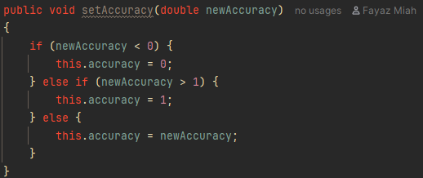
Here is an exemplary setAccuracy methods that modified the accuracy attribute in a specific way rather than directly, ensuring the value is always clamped between 0 and 1.
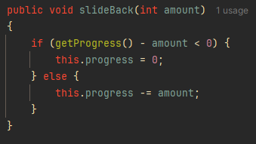
This method slideBack() sets the lower bound of progress to zero, ensuring there is no other way of editing the progress variable, it must be through this method (expect from typing method).
List of Accessor Methods:
- getAccuracy()
- getProgress()
- getName()
- getSymbol()
- getBurnoutTurnsRemaining()
- isBurntOut()

List of Setter Methods:
- setAccuracy()
- setSymbol()

Testing:
◦ That progress cannot go below zero after calling slideBack()
◦ That burnout correctly counts down turn by turn and clears at zero
◦ That resetToStart() clears both progress and burnout state
◦ That accuracy cannot be set outside the 0.0–1.0 range
◦ Normal forward movement via typeCharacter()
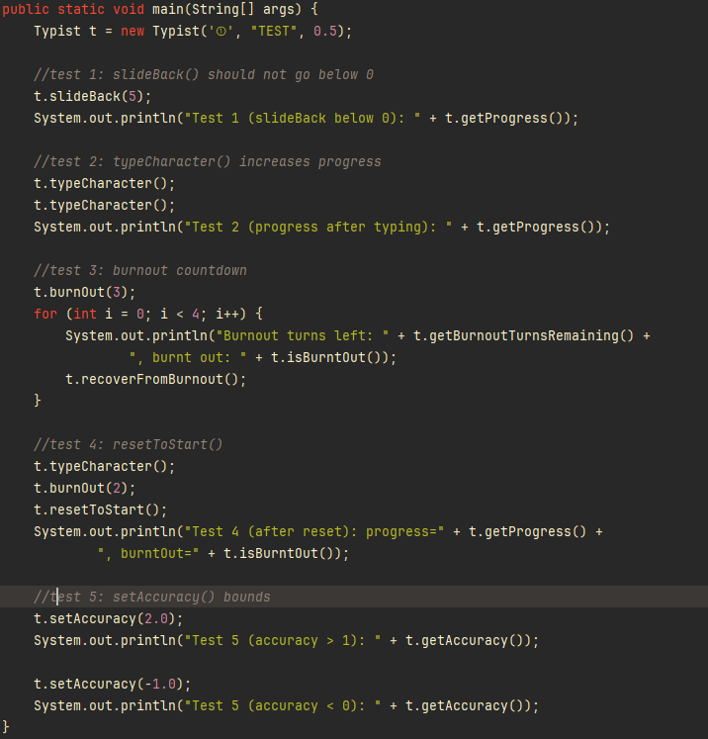
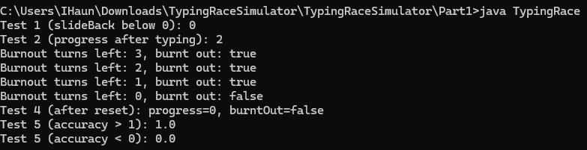
All results returned as expected.
Test 1 shows that the slideBack method prevents the progress attribute from going below zero.
Test 2 shows that typeCharacter() method increases progress by 1 after each call.
Test 3 shows that after each iteration of the burnout, it decrements the counter until its zero, and when it is zero it sets the flag to false.
Test 4 shows that the reset sets progress back to 0 and sets the burntOut flag to false.
Test 5 shows that accuracy is clamped between 0 and 1 inclusively, the arguments in this case were given as -1 and 2 respectively.

Task 2

5a).
This problem required keeping tracking of the winner Typist instance.

To do this, I defined a winner variable of type Typist to be overwritten by the winner decided later in runtime.

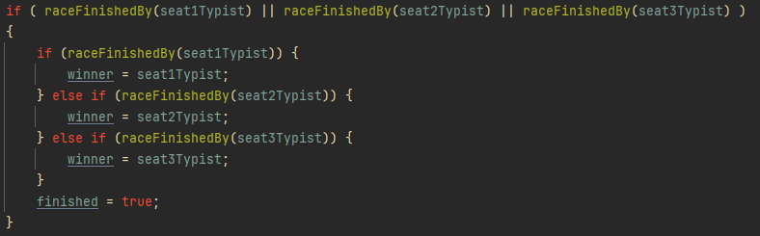
This code block sets the winner variable to the correct winner instance.

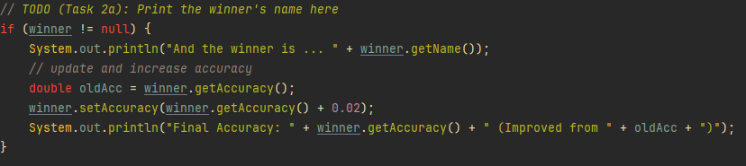
This code block outputs the winners name, and their accuracy. It also improves and shows the new accuracy as the specification image shows.
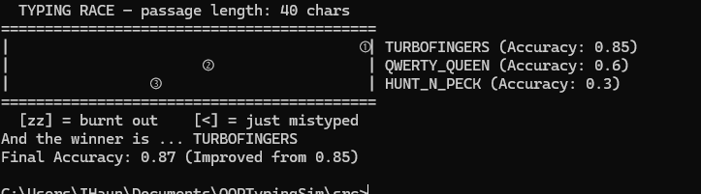
Added final print output showing winners name and the final accuracy.

6b)

Change 1
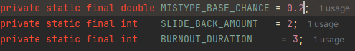
Ty used numbers that “felt right”. This change was made to these constants to change the game modifiers to make it more reasonably scaled.
Mistype chance being too low prevents them from generally happening, whilst being too high causes frequent occurrences and prevents progress.
Slide back amount being too high can wipe out progress too easily preventing game completion, whilst being too low causes the simulation to run too easily.
Burnout duration being too high can simply just cut the typist out the game entirely, whilst the alternative of it being too low completely renders the mechanic as useless.

Change 2
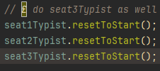
Ty forgot to add the 3rd typist when resetting the Typist instance, and so I have also made sure to include this. If this change was not made, the typist in this seat could have an unfair advantage due to inconsistent starting progress on each simulation. It could also result in disadvantages such as initially being placed in a burnout, causing the unfair loss of progression. The simulation would simply be unreliable.

Change 3
Ty had made a logical error in this conditional statement. It is defined as the more accuracy the Typist instance has, the larger the probability there is to call slideBack(). This would create the complete opposite functionality of what was expected as typists with lower accuracy would have less mistypes, whilst higher accuracy typists would slide back more frequently.

This is the change I have made to Ty’s code, so that it is inversely proportional to accuracy rather than being directly proportional to it. By this inverse proportionality, it would behave as expected as high accuracy typists would have lower probability of mistypes.

Change 4
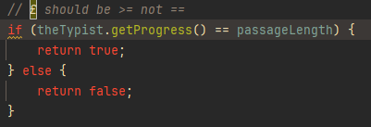
Ty had made the mistake of checking if the Typist instances progress is equivalent to the passageLength. This is incorrect as there may be cases where progression can go beyond the expected threshold value of the passageLength due to multiple updates in a single turn. This error causes incorrect output for the simulation and the winner may be decided incorrectly.
And so, it is better practice to replace Ty’s code with the >= operator rather than the == operator. This is better as it can account for all winning states rather than the single winning state of when progress is equal to the passage length.
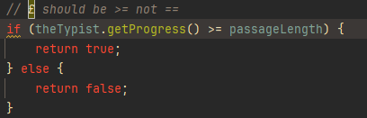

Change 5
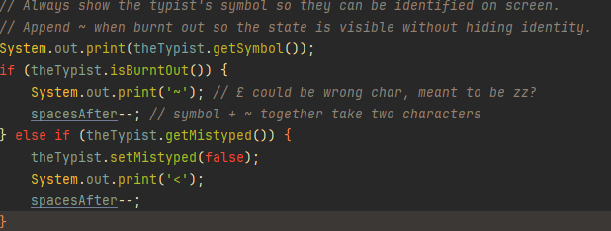
This code block corrects the mistake where mistypes could not be identified during runtime for a user, creating an unreliable simulation. This is poor game design as when watching the simulation back, the typist may seem as if they are glitching back with no valid reason as they cannot be able to tell that a mistype or slide back has occurred.
To fix this, mistypes are now given by a < symbol to the right of the Typist’s symbol. This was done by creating a boolean flag on the Typist class with a variable name of “mistyped” with 2 new methods of get and set. This flag allows for the mistype to be detected during runtime so that the < can be printed to the terminal.
The slideBack() method in the Typist class has also been edited to set the flag to true after a mistype, confirming a mistype has just occurred.
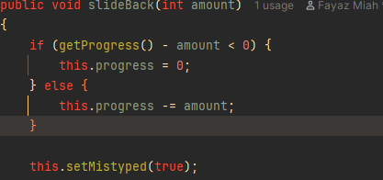
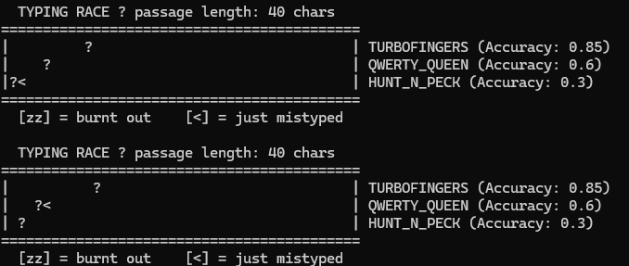
(ignore the ?, it is an encoding problem in windows terminal)

