**CO5 program**

**1.Write a python program to read a file line by line and store it into a list.**

**f1=open("secfile.txt","w")**

**f1.write("This is my first file in python.\nwant to work with files \n This is my third line")**

**f1.close()**

**f1=open("secfile.txt","r")**

**print("name of file",f1.name)**

**print("close of file",f1.close)**

**print("mode of file",f1.mode)**

**print(f1.read())**

**print("---------")**

**f1.seek(0,0)**

**ff=f1.readlines()**

**print(ff)**

**print("no of lines:",len(ff))**

**output:**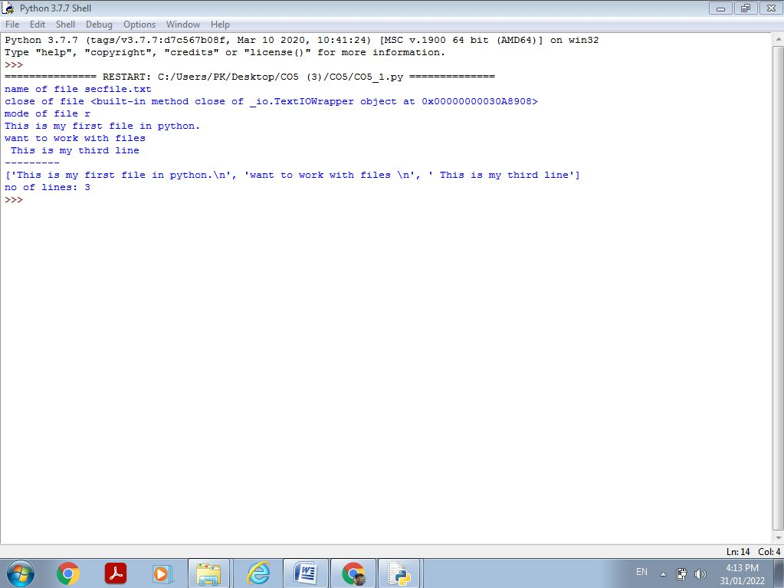

**2.Python program to copy odd lines of one file to other.**

f1 = open("secfile.txt","r")

for x in f1:

print(x)

print("---------------")

f1.seek(0,0)

ff=f1.readlines()

print("Looping through the file using Readline\n")

print("---------------")

for x in range(0,len(ff)):

if(x%2==0):

print(ff[x])

print("---------------")

output:

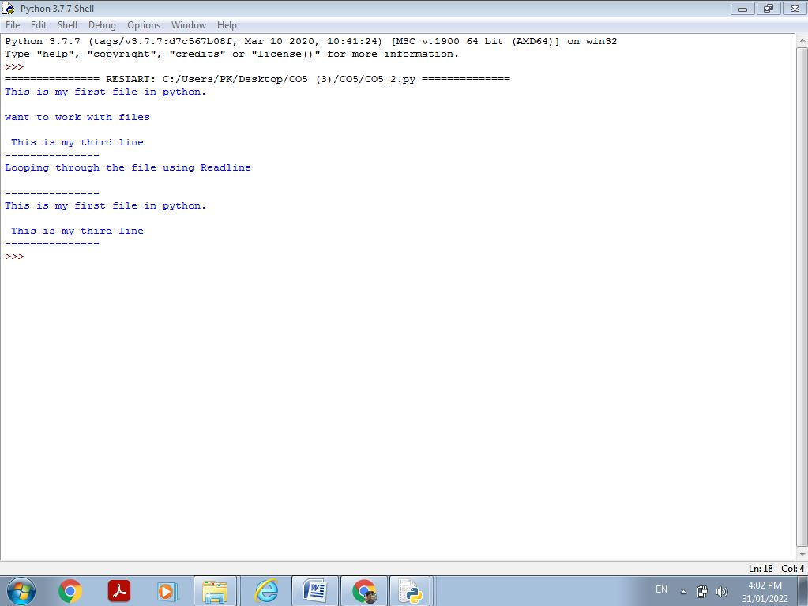

3.

import csv

filename = "username.csv"

rows = []

cf=open(filename, 'r')

csvreader = csv.reader(cf)

for r in csvreader:

rows.append(r)

print(rows)

cf.close()

OUTPUT:

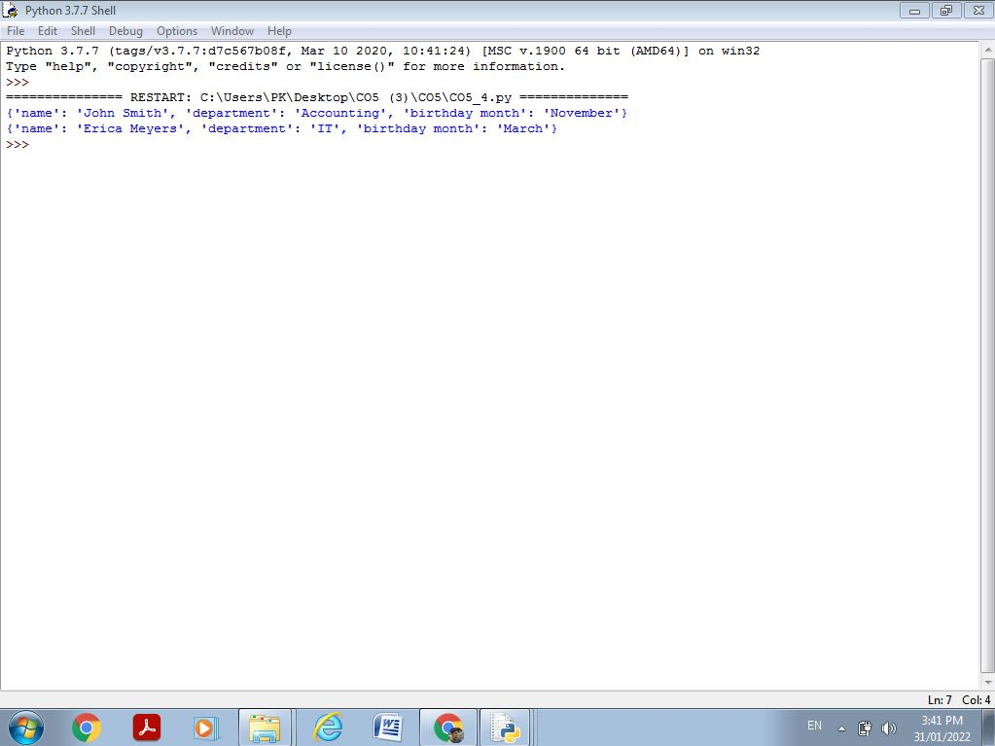

4.

import csv

filename = "emp.txt"

fields = []

rows = []

cf=open(filename, 'r')

csvreader = csv.DictReader(cf)

for r in csvreader:

print(dict(r))

OUTPUT:

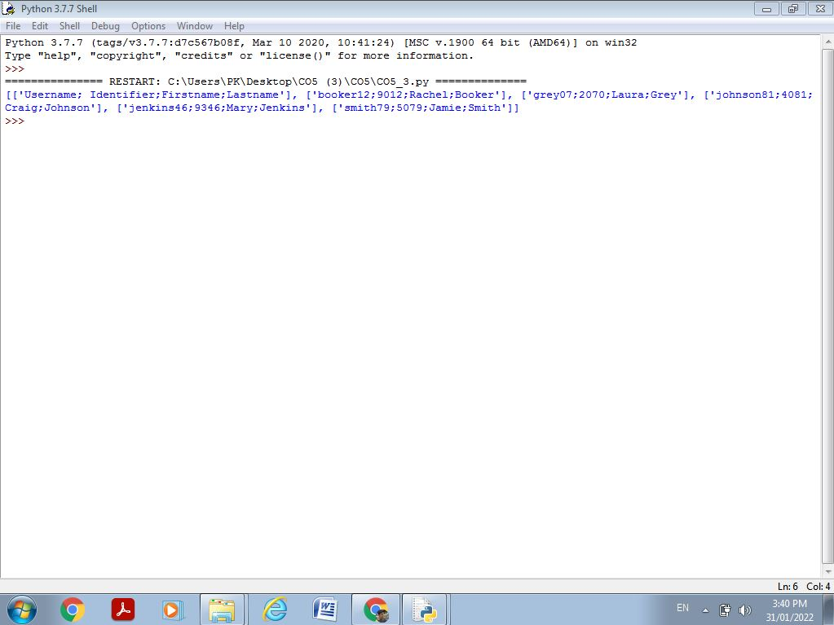

5.

import csv

field_names = ['No', 'Company', 'Car Model']

cars = [

{'No': 1, 'Company': 'Ferrari', 'Car Model': '488 GTB'},

{'No': 2, 'Company': 'Porsche', 'Car Model': '918 Spyder'},

{'No': 3, 'Company': 'Bugatti', 'Car Model': 'La Voiture Noire'},

{'No': 4, 'Company': 'Rolls Royce', 'Car Model': 'Phantom'},

{'No': 5, 'Company': 'BMW', 'Car Model': 'BMW X7'},

]

with open('Names1.csv', 'w') as csvfile:

writer = csv.DictWriter(csvfile, fieldnames = field_names)

writer.writeheader()

writer.writerows(cars)

filename = "names1.csv"

cf=open("names1.csv", 'r')

rows=[]

csvreader = csv.reader(cf)

for r in csvreader:

rows.append(r)

for r in rows:

print(*r)

OUTPUT: