***CO2***

**Program to find the factorial of a number**

n=int(input('Enter a number : '))

f=1

for i in range(1,n+1):

f=f*i

print ('Factorial of',n, '=',f)

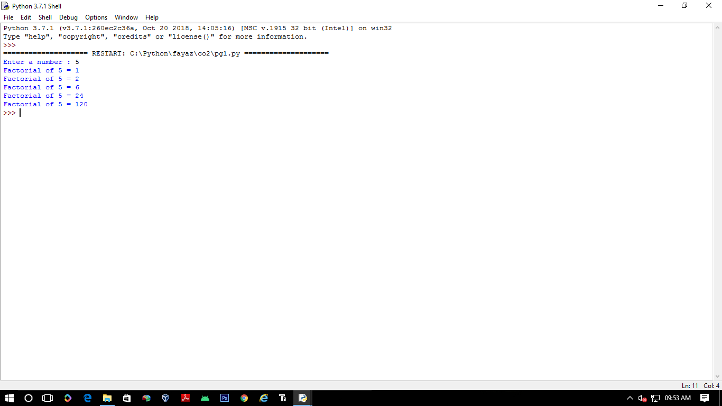

**Generate Fibonacci series of N terms**

n = int(input("Enter the limit : "))

a = 0

b = 1

sum = 0

count = 1

print("Fibonacci Series :",end= " ")

while(count<= n):

print(sum, end = " ")

count = count+1

a = b

b = sum

sum = a + b

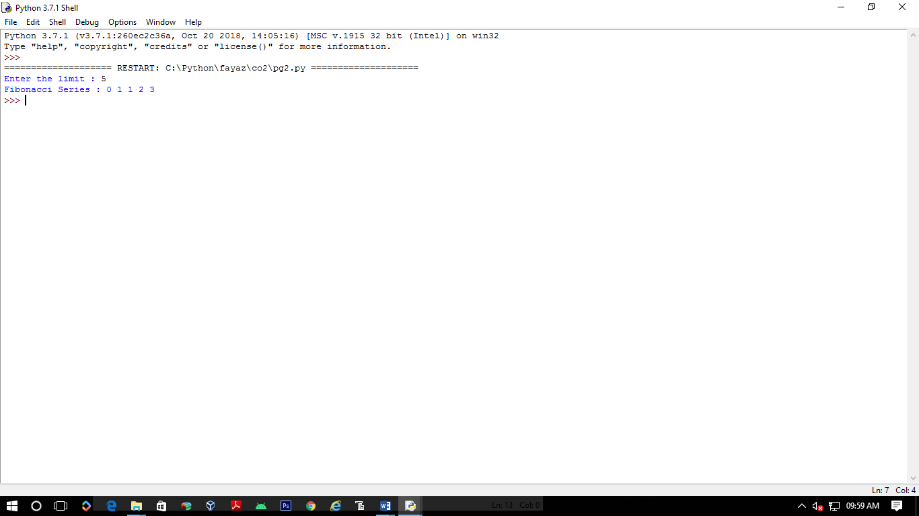

**Find the sum of all items in a list**

list1 = [1, 5, 2, 6,2 ]

total = sum(list1)

print("Sum of list : ",total)

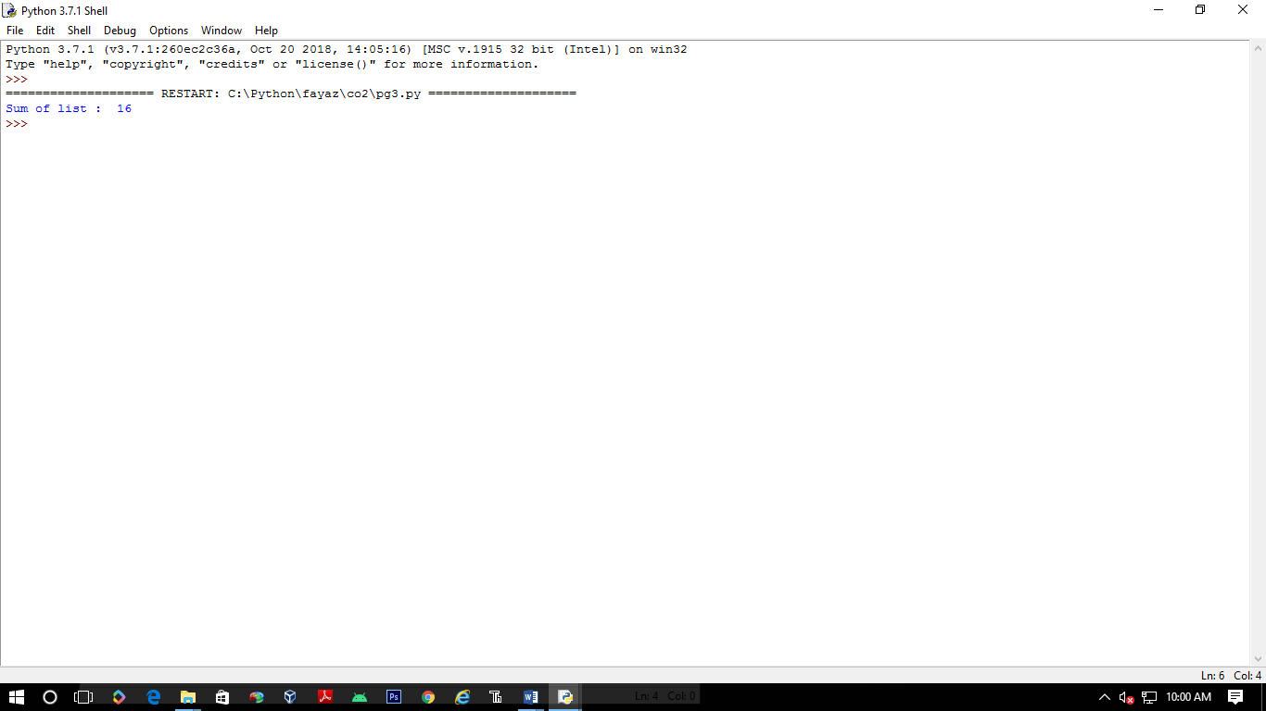

**Generate a list of four digit numbers in a given range with all their digits even and the number is a perfect square.**

from math import sqrt as s

for i in range(1000,10000):

if s(i)==int(s(i)) and i%2==0:

print(i,end=" ")

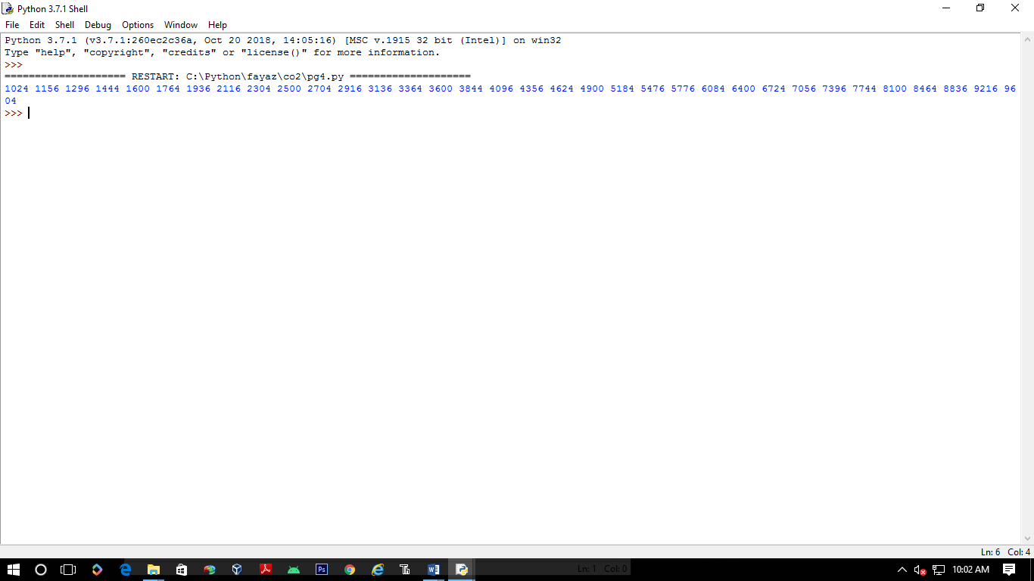

**Display the given pyramid with step number accepted from user.**

rows = int(input("Enter the number of rows: "))

for i in range(1, rows+1):

for j in range(1,i+1):

print(i * j, end=' ')

print()

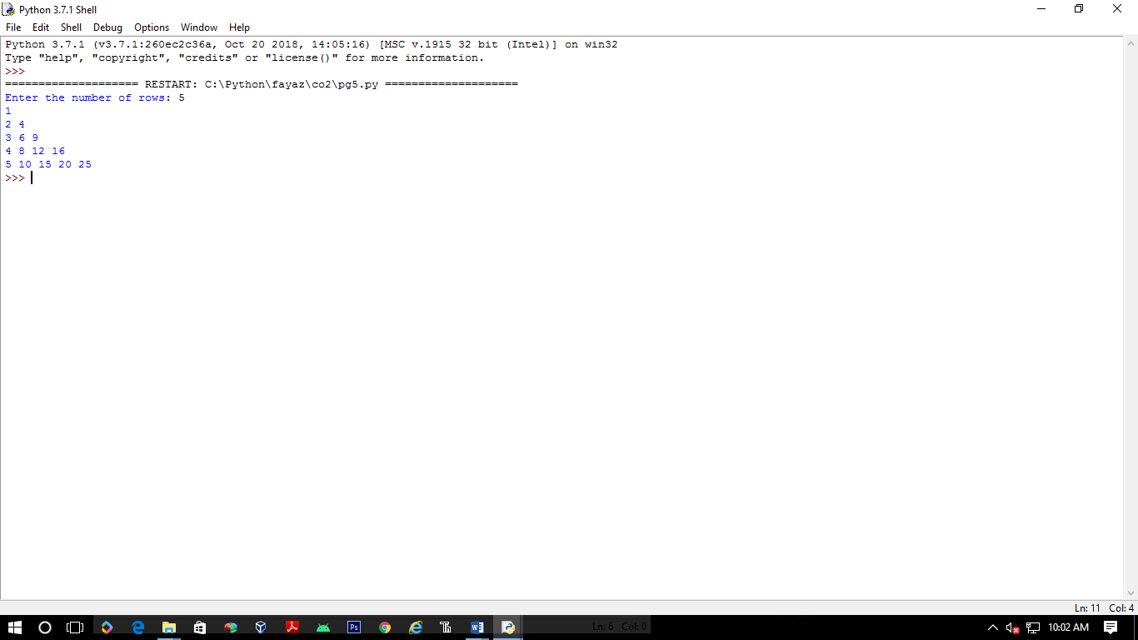

**Count the number of characters (character frequency) in a string.**

**test_str=str(input("Enter the string : "))**

**freq = {}**

**for i in test_str:**

**if i in freq:**

**freq[i] += 1**

**else:**

**freq[i] = 1**

**print ("Count of all characters : "+ str(freq))**

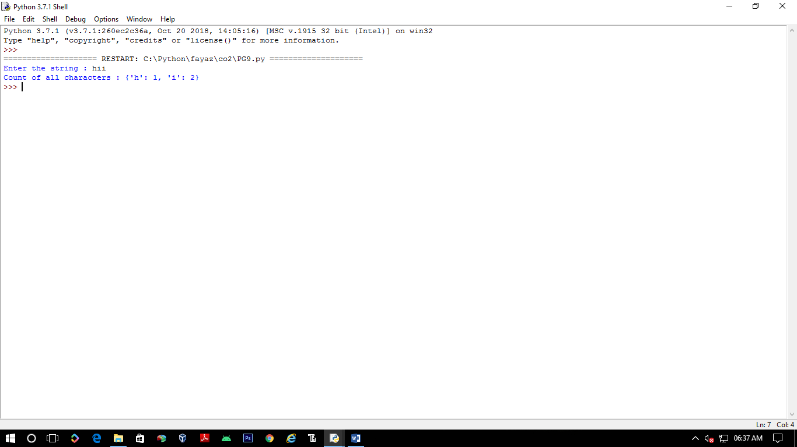

**Add ‘ing’ at the end of a given string. If it already ends with ‘ing’, then add ‘ly’**

**str=input("enter a string:")**

**print("inputed string is:",str)**

**if(str.endswith("ing")):**

**str=str+'ly'**

**else:**

**str=str+'ing'**

**print("the formated string is:",str)**

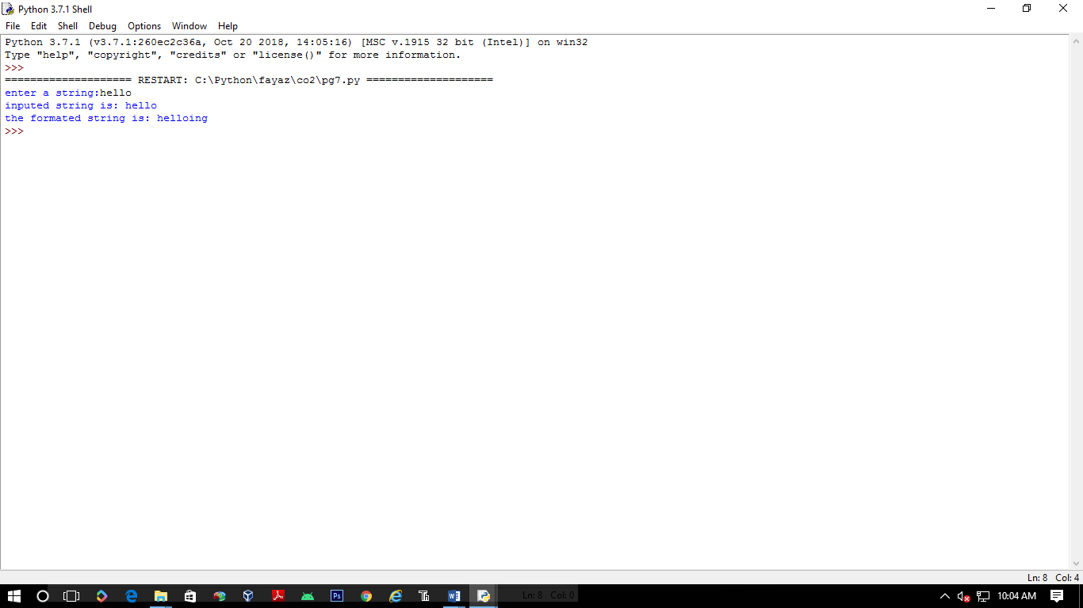

**Accept a list of words and return length of longest word.**

**a=[]**

**n= int(input("Enter the number of elements in list:"))**

**for x in range(0,n):**

**element=input("Enter element "+ str(x+1) )**

**a.append(element)**

**max1=len(a[0])**

**temp=a[0]**

**for i in a:**

**if(len(i)>max1):**

**max1=len(i)**

**temp=i**

**print("Longest Word:",temp)**

**print("Length of longest word :",max1)**

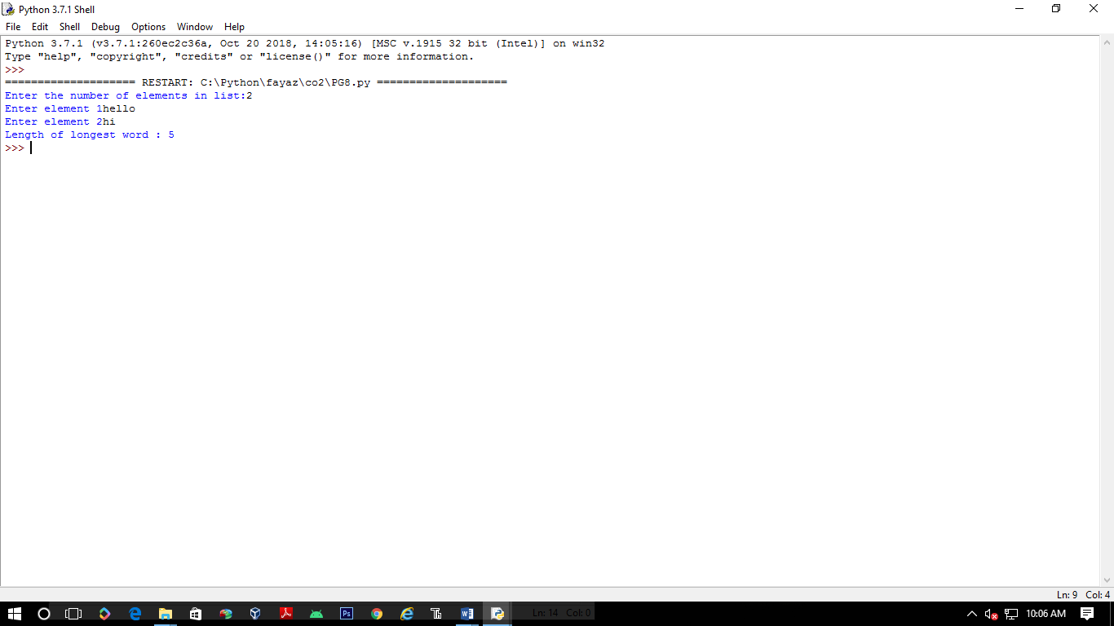

Construct following pattern using nested loop

**n= int(input("Enter the limit:"))**

**for i in range(n):**

**for j in range(i):**

**print ('* ', end="")**

**print('')**

**for i in range(n,0,-1):**

**for j in range(i):**

**print('* ', end="")**

**print('')**

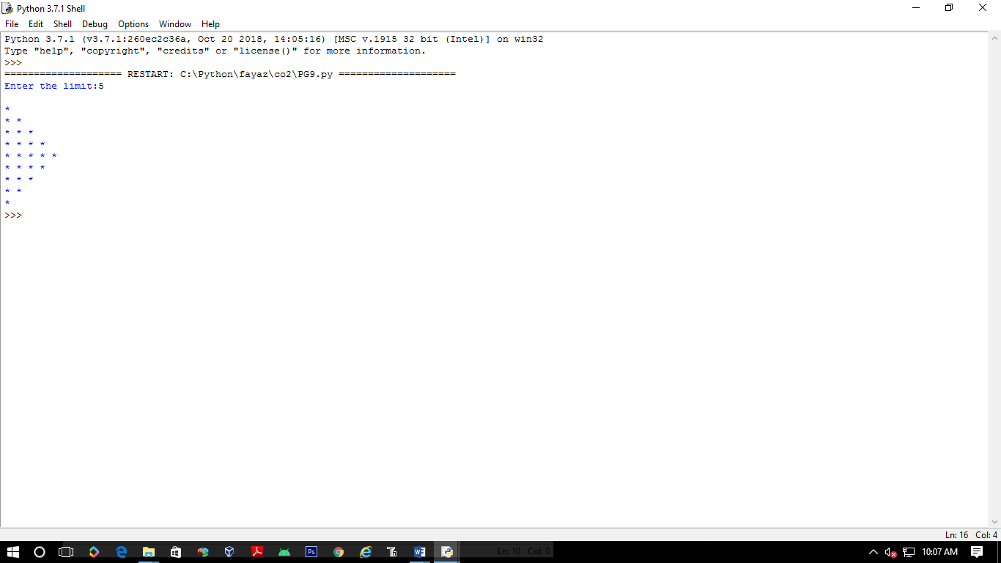

**Generate all factors of a number. def print_factors(x):**

**def factors(x):**

**print("The factors of",x,"are:")**

**for i in range(1, x + 1):**

**if x % i == 0:**

**print(i)**

**n=int(input("Enter a number:"))**

**factors(n)**

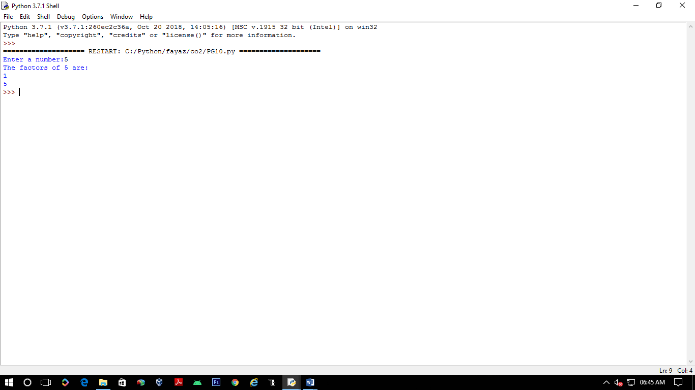

**Write lambda functions to find area of square, rectangle and triangle.**

**import math**

**t_area = lambda b,h :1/2*b*h**

**r_area = lambda l,b :l*b**

**s_area = lambda a : a*a**

**print("Area of Triangle :", t_area(120,20))**

**print("Area of Rectangle:", r_area(31,20))**

**print("Area of Square :", s_area(10))**

