**Chef Client**

Default value of log_location is STDOUT. You can give /path/to/log_location in place of this. You can locate this client.rb file in C:\chef\client.rb or /etc/chef/client.rb directories.

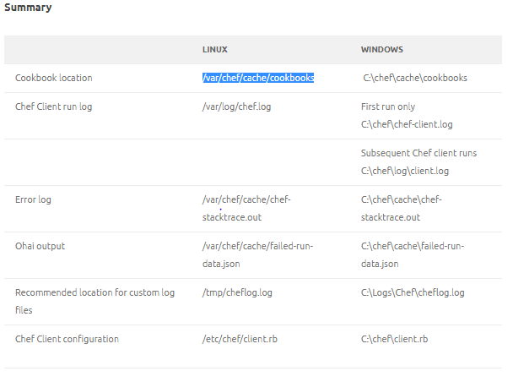

**When you test your cookbook in Test Kitchen**

