**Labo2-3 Résultats**

Validation:

Il s'agit de la procédure de vérification pour entrer dans le système, si le fichier de données de la compagnie aérienne (CompanyName.txt) existe déjà, le message de confirmation du troisième diagramme n'apparaîtra pas et vous passerez directement du deuxième diagramme au menu principal.

Menu:

L’option 1 (liste des vols):

L’option 2 (Ajout d’un vol):

L’option 3 (Retrait d’un vol):

L’option 4 (Modification de la date de départ):

L’option 5 (Réservation d’un vol) :

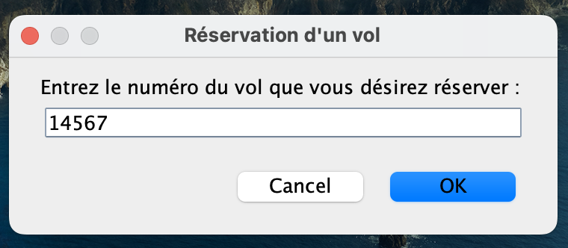

L’option 0 (Terminer) :

