FayrouzCryptoTOOL

Done by : Fayrouz Islam Khoder
412200053

Please click on the link below to view my code on GitHub :
https://github.com/Fayrouzislam/Crypto_tool/blob/main/Fayrouz_CryptoTool.py

Firstly, we will talk about the Main interface
The application features a tabbed interface for organizing cryptographic operations.
The main window includes:
- Tabs: Four primary tabs for distinct cryptographic functions.
- Status Bar: Real-time operation feedback at the bottom.
- Exit Button: Terminates the application.

Symmetric Encryption Tab
Block Ciphers Sub-Tab

Purpose: Encrypt/decrypt data using AES, DES and their variations .
Components:
Algorithm Selection: Toggle between AES and DES variants.
Key Management:
- AES: Generate/input keys (128/192/256-bit) and IV (for decryption).
- DES: Generate/input single, double, or triple keys.
- Operation Mode: Choose Encrypt or Decrypt.
- Input/Output Fields: Text areas for plaintext/ciphertext with file upload support.
- Action Buttons: Execute operation, save output.

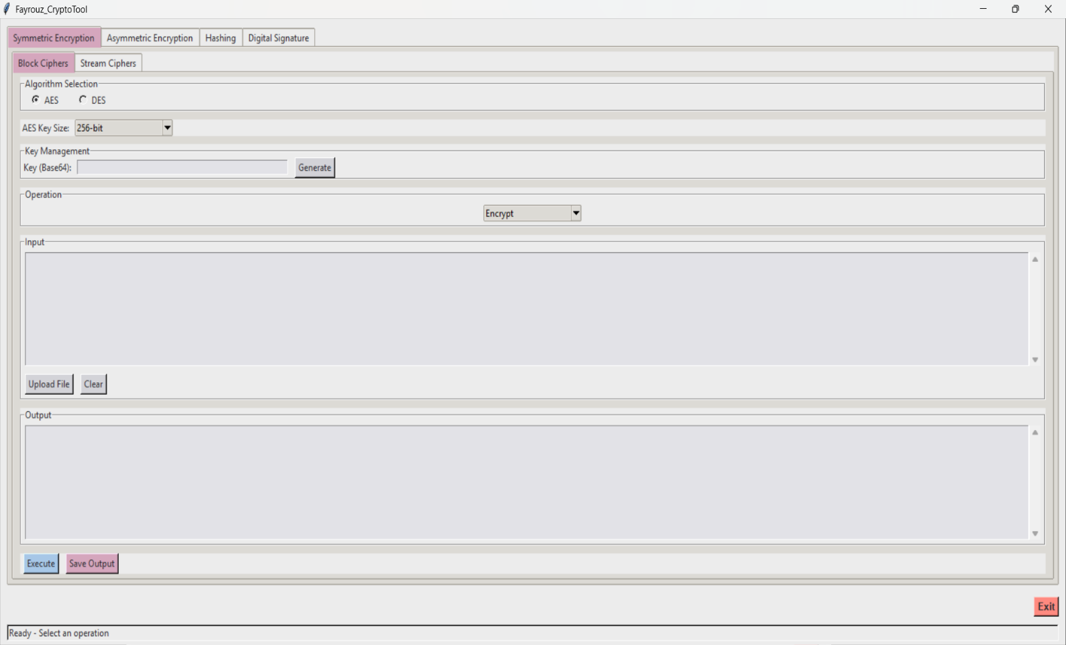
Stream Ciphers Sub-Tab
Purpose: Encrypt/decrypt data using classical encryption techniques
Components:
Algorithm Selection: Toggle between Ceaser /Vigenère
Parameters:
- Ceaser shift : choose value from 1~25
- Vigenère: keyword is letters only
- Operation Mode: Choose Encrypt or Decrypt.
- Input/Output Fields: Text areas for plaintext/ciphertext with file upload support.
- Action Buttons: Execute operation, save output.
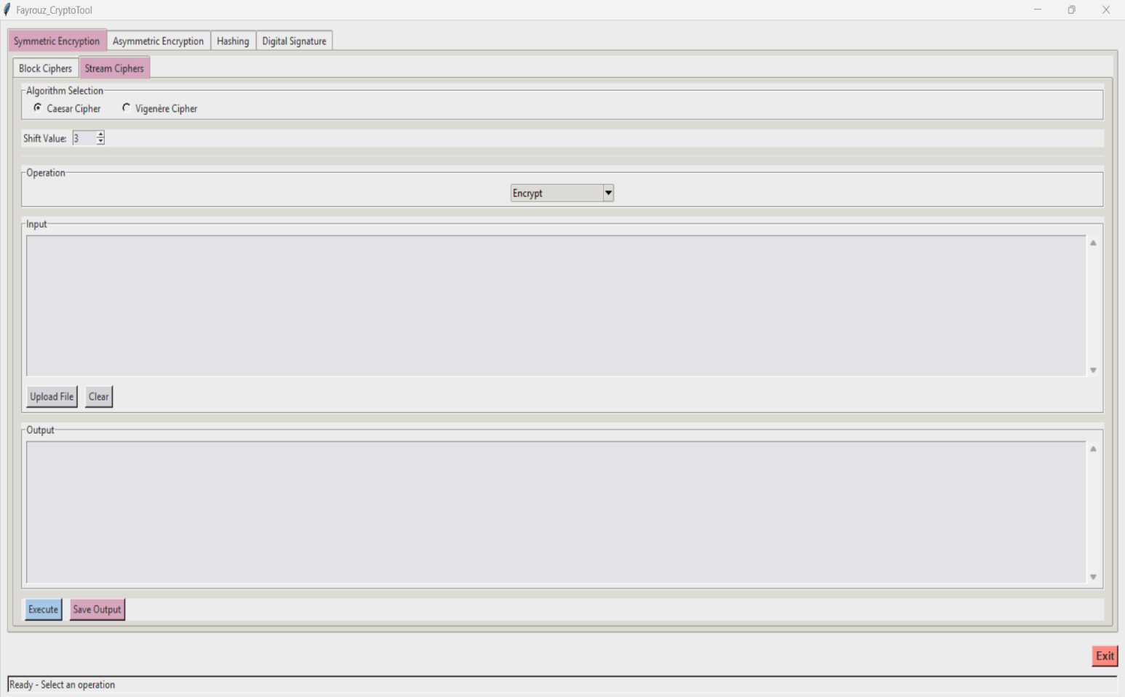

Asymmetric Encryption Tab
Purpose: RSA-based encryption/decryption and key management.
Components:
- Key Generation: Generate 2048-bit RSA key pairs.
- Key Import/Export: Load/save public and private keys
- Operation Mode: Encrypt (public key) or decrypt (private key).
- Input/Output Fields: Text areas for messages/ciphertext.
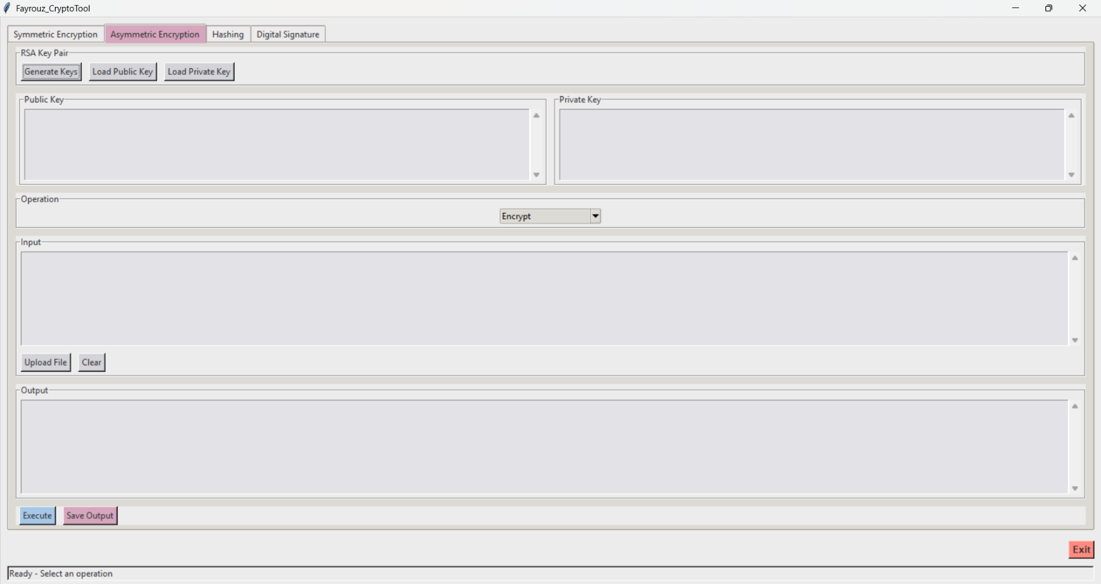
- Action Buttons: Execute operation, save output.
Hashing Tab
Purpose: Generate message digests using cryptographic hash functions.
Components:
- Algorithm Selection: MD5, SHA1, SHA224, SHA256, SHA512.
- Input Field: Text or file input (auto-converted to Base64 for binaries).
- Output Field: Hexadecimal hash result.
- Action Buttons: Generate hash, save output.
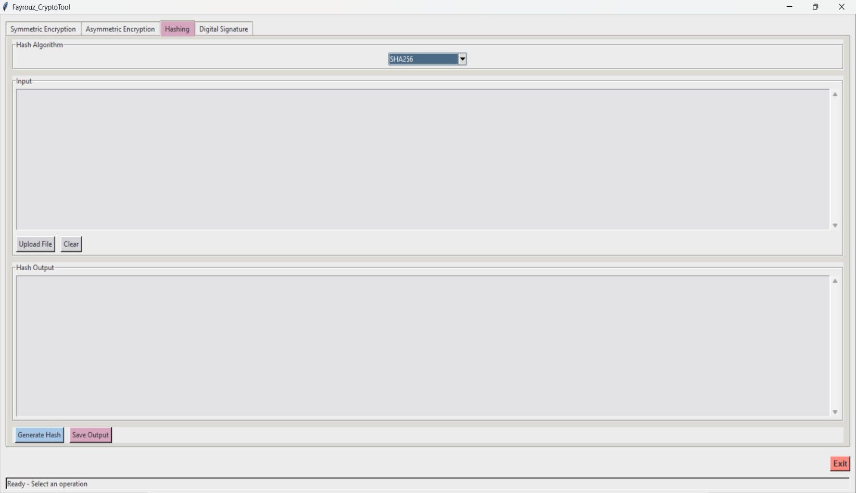
Digital Signature Tab
Purpose: Sign/verify messages using RSA-based signatures.
Components:
Signature Type: Standard or blind signatures.
Key Input: Load public/private keys.
Message Field: Input text or file for signing/verification.
Signature Field: Input/display Base64-encoded signatures (for verification).
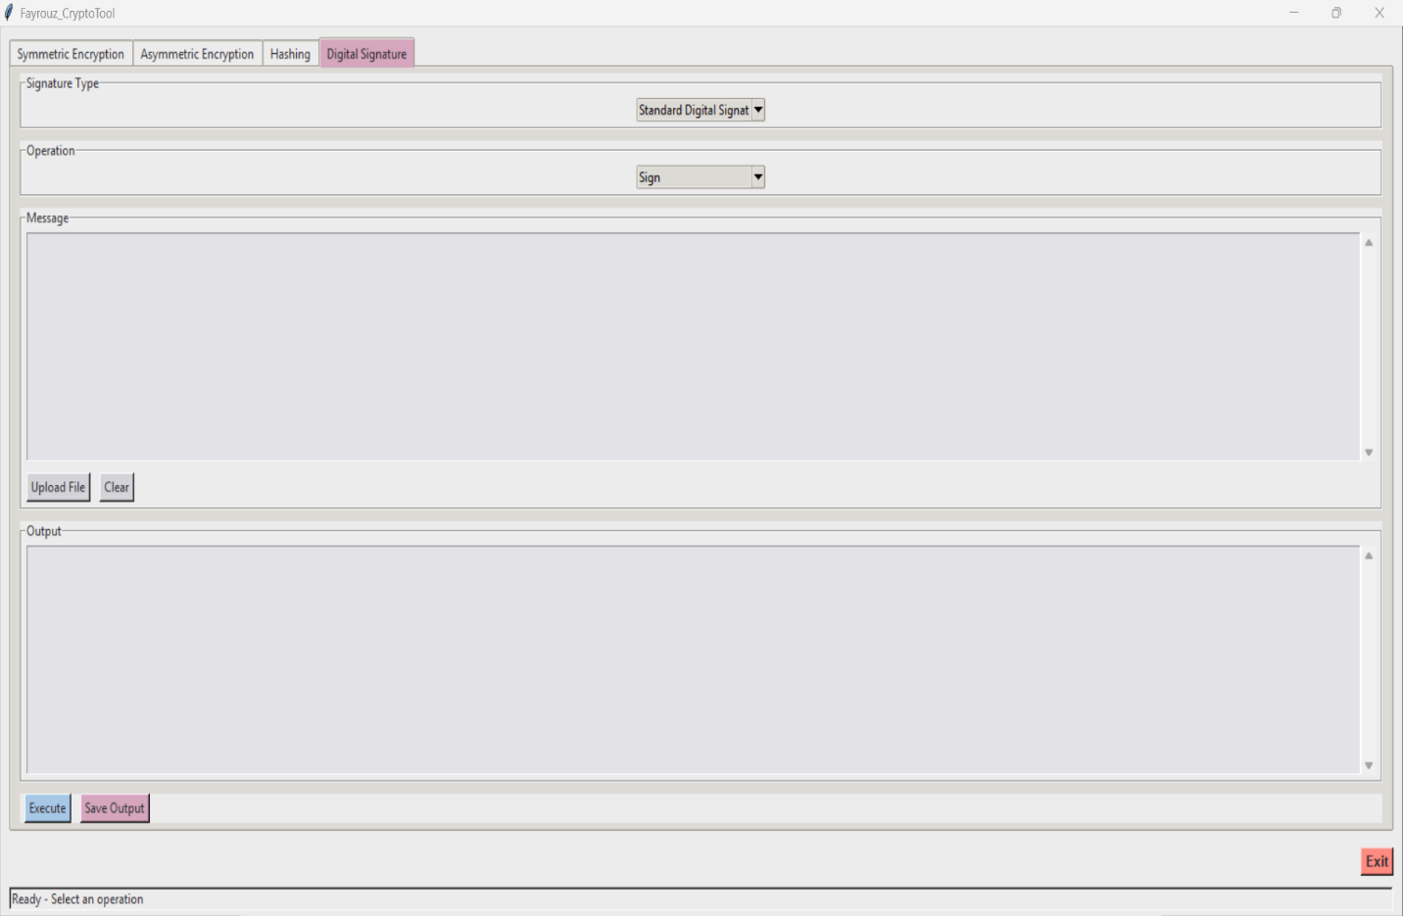
Action Buttons: Execute signing/verification, save output.

Common UI Elements

- File Upload/Download buttons: Supported in all tabs for text/binary data. As you can write text to work on it or upload any file you choose and the result is presented on the output screen or you can save the output and download it as a file

- Status Bar: Displays operation success/errors and current status (e.g., "AES encryption successful" ,”Ready, select an operation”).

- Key Generation: Auto-populates keys in Base64 for easy reuse.

- Exit button: to quit the program any time you want easily

- Drop down list : for selecting desired operation from available options

