Lab Activity: Creation of Elastic IP.

Step 1: Creation of Elastic IP

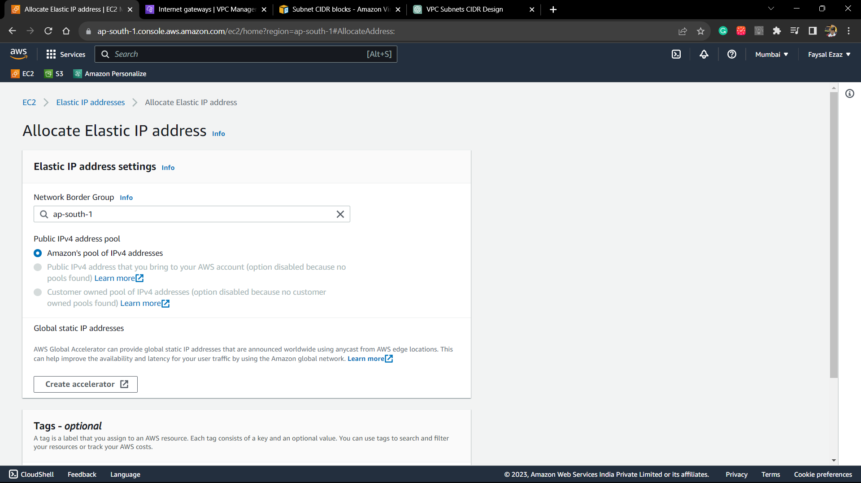

Step 2: Elastic IP Created

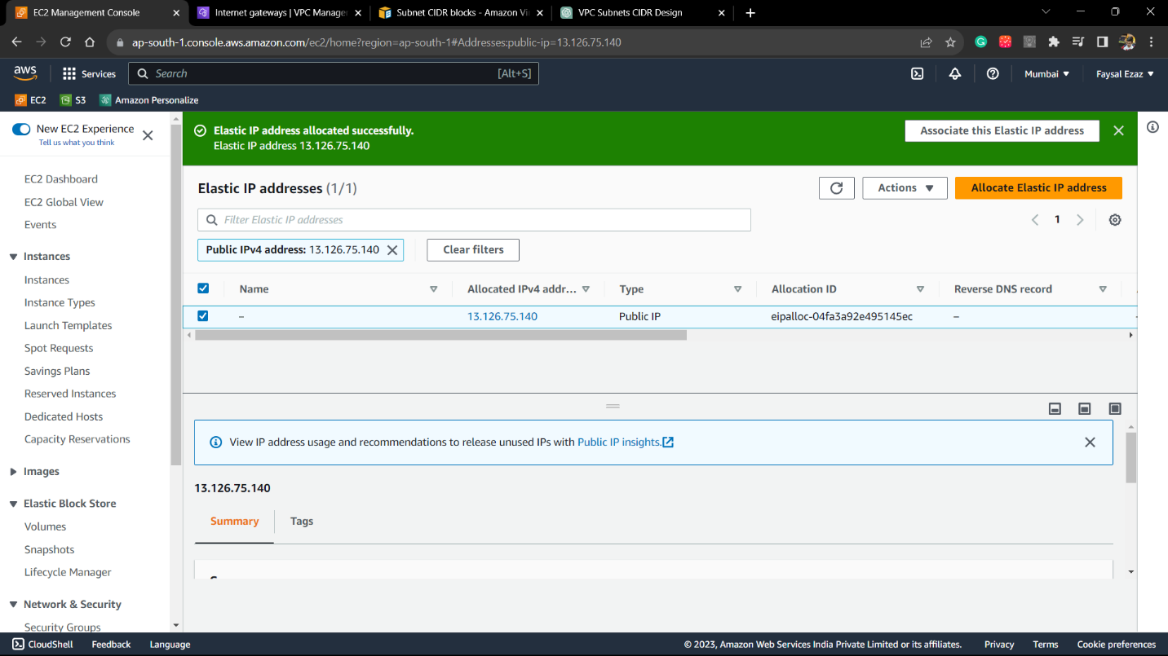

Step 3: Associate the IP address with a running instance.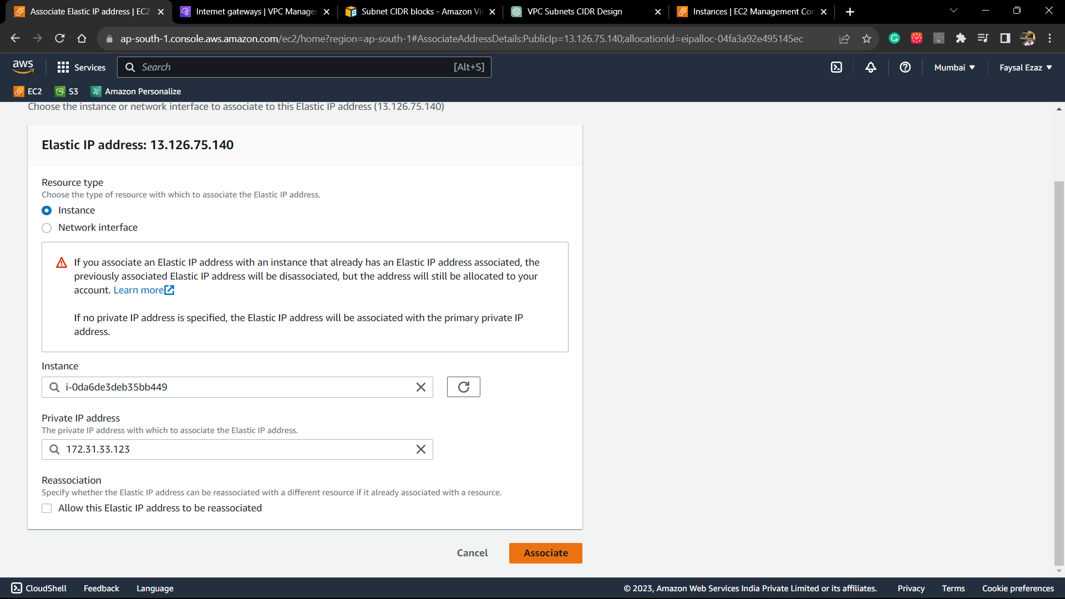

Step 4: Now The Elastic IP is associated with the instance

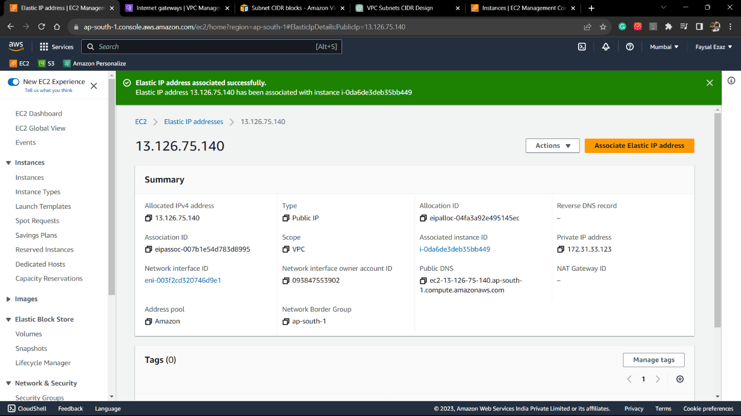

Step 5: Now we can see our Elastic IP is fully functional, since the Static website on the instance is loaded with our newly created Ip.

Now, we will create a Snapshot

Step 1: Creation of snapshot and select the specific volume of which you want to create the snapshot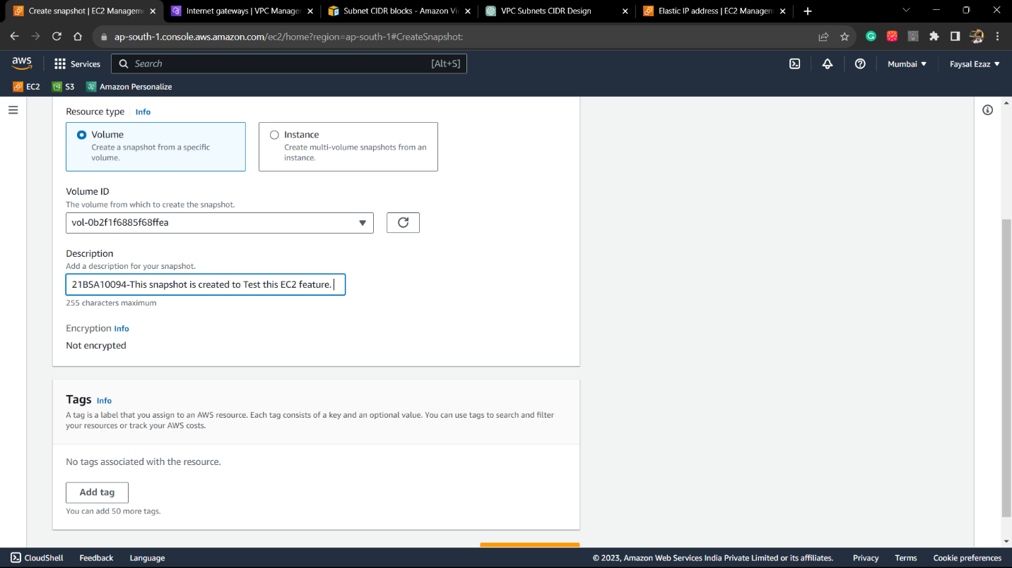

Step 2: Successfully created the snapshot.

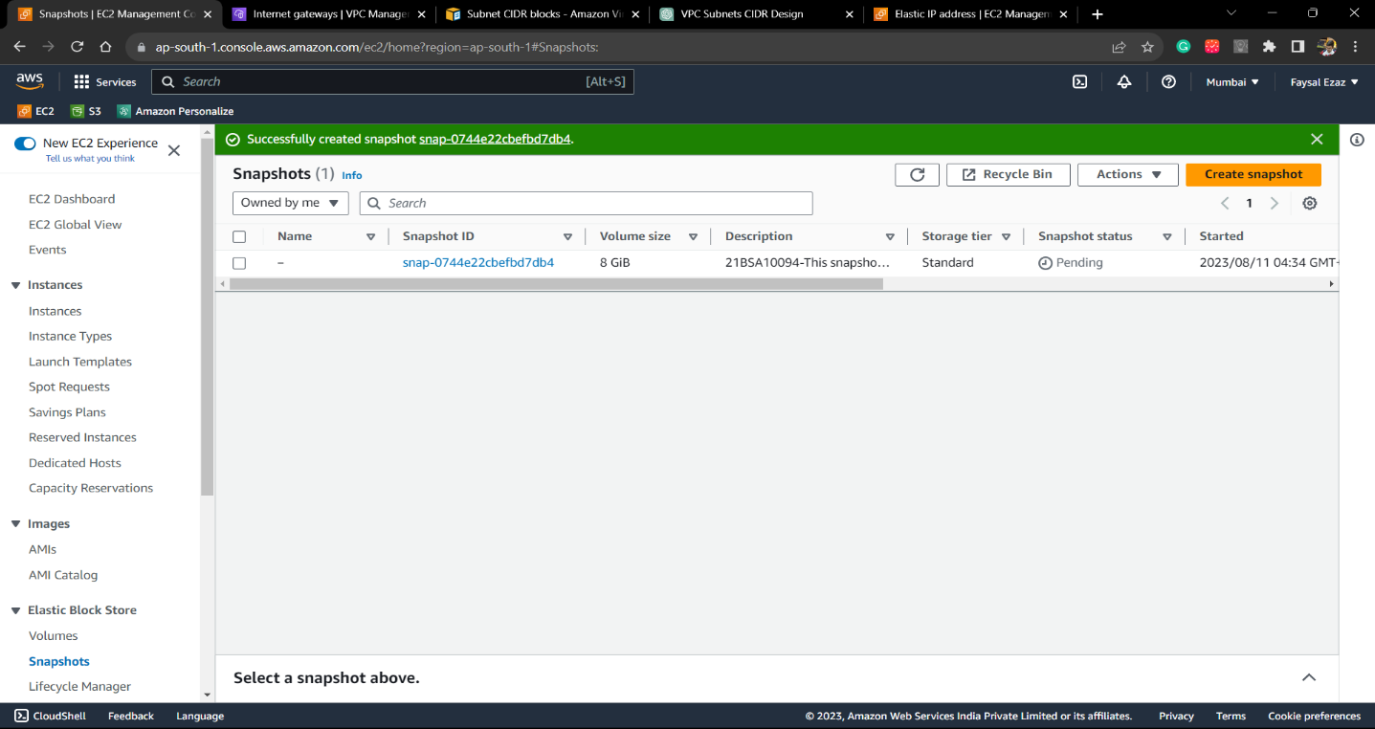

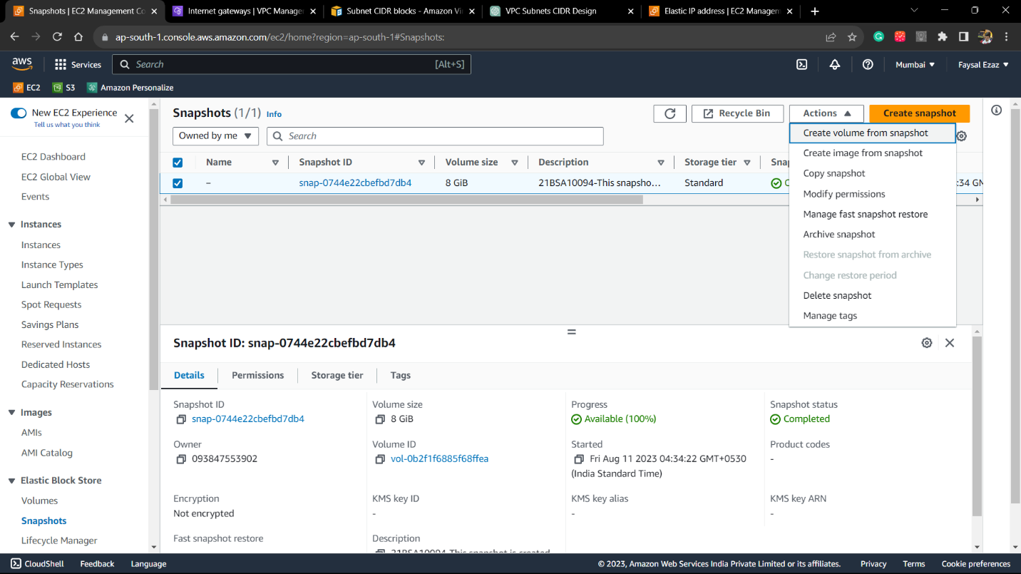

Step 3: choose the ‘Type’ of volume and then, choose the availability zone.

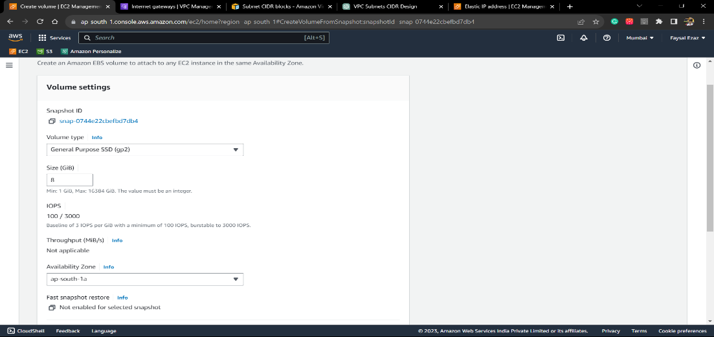

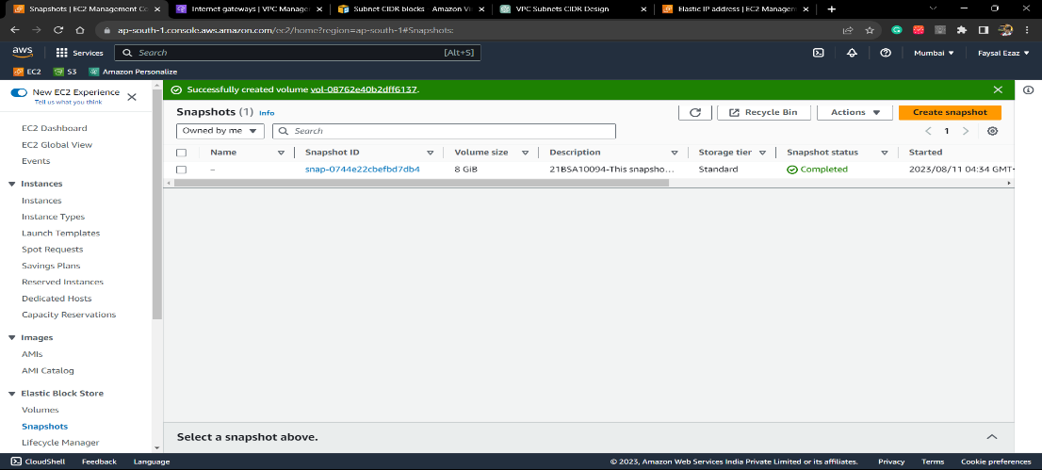

Now we attach a “Volume” (EBS) to an ec2 instance.

Step1: we will use the previously created volume to attach it to the instance

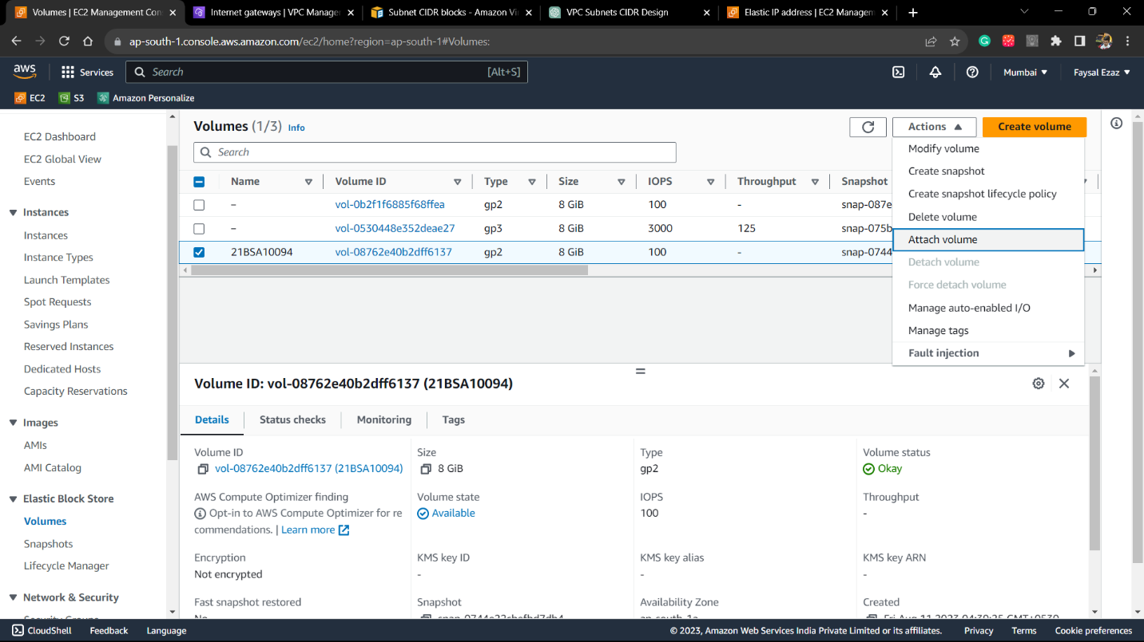

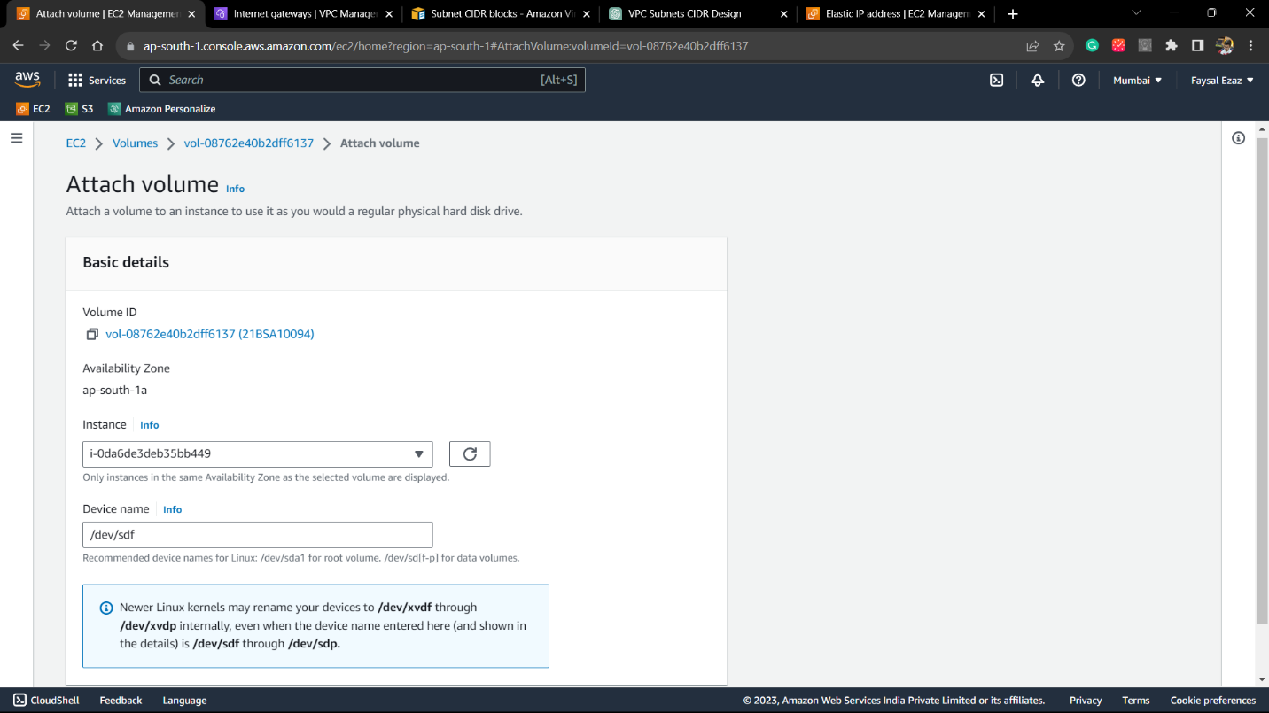

Step 2: Volume is now attached to the instance now we have to mount it in the os.

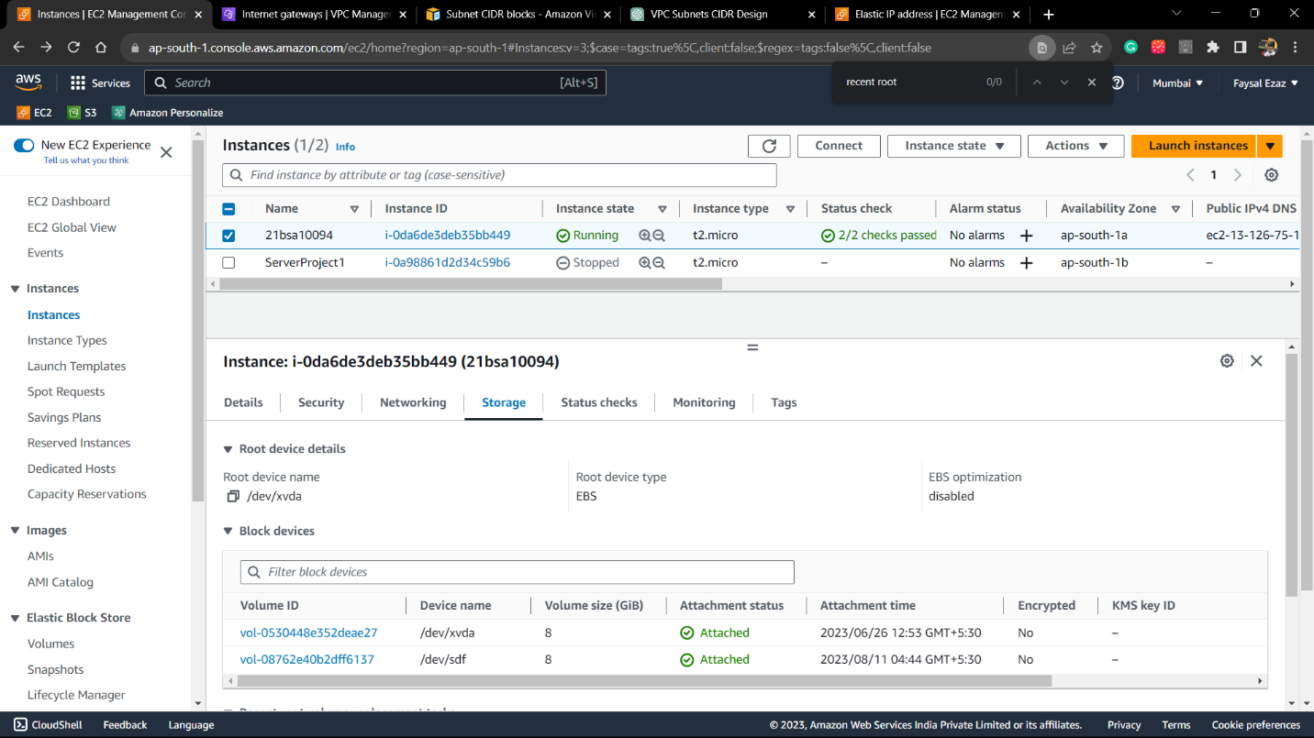

Step 3: Open the console on aws and connect to the ec2 instance connect.

type command df -h (to check the current storage of instance and volumes mounted.)

lsblk list all the block devices in the linux machine

file -s /dev/xvda (Shows the file system ) , currently there seems to be file existing already

mkfs -t xfs -f /dev/xvdf (to make a new filesystem)

Use mkdir -p /app/volume (to Create directory) and mount /dev/xvdf /app/volume ( to mount the volume onto it).

Creation of an Instance using the Amazon Machine Image.

Step 1: Create the image by selecting an instance and choosing create image from action panel.

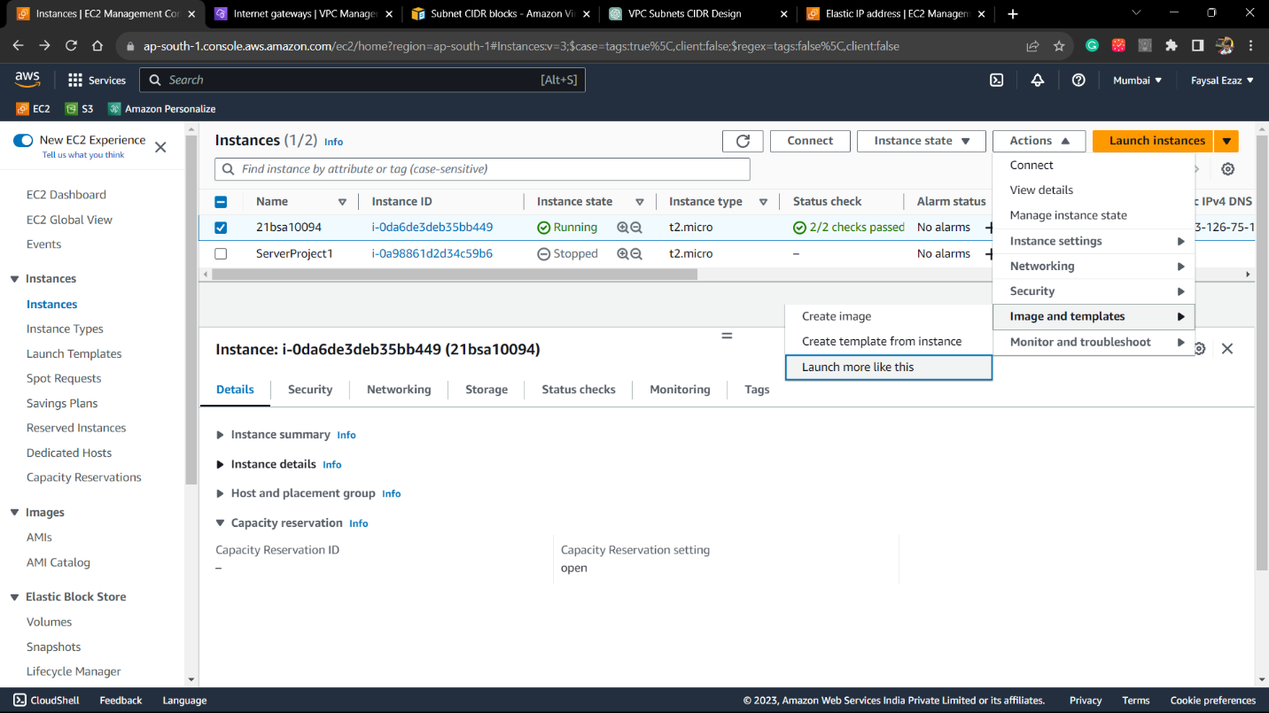

Step 2 : Type the image name and create the imsge

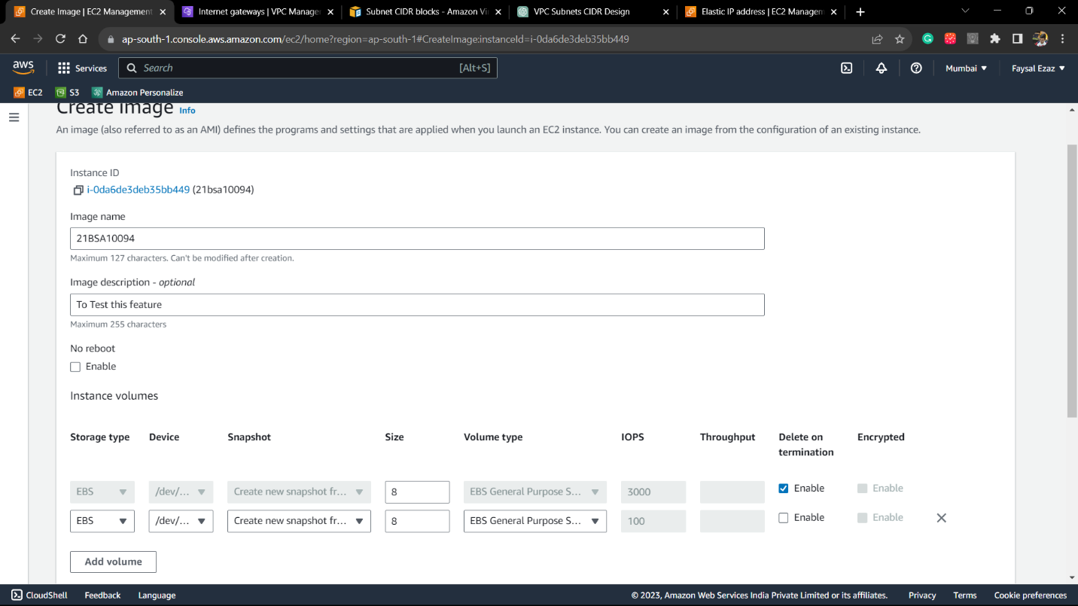

Step 3 :Now the AMI is created and we will be launching an instance using the image.

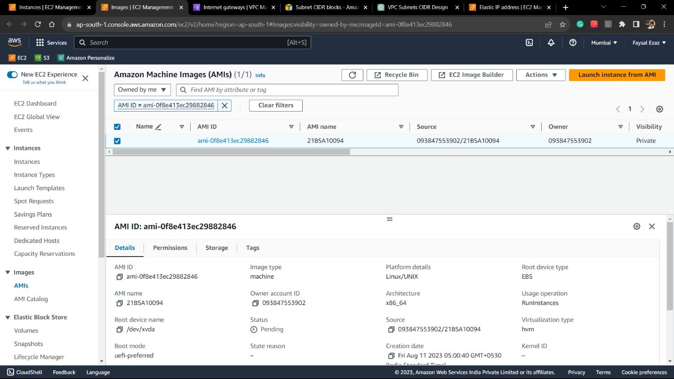

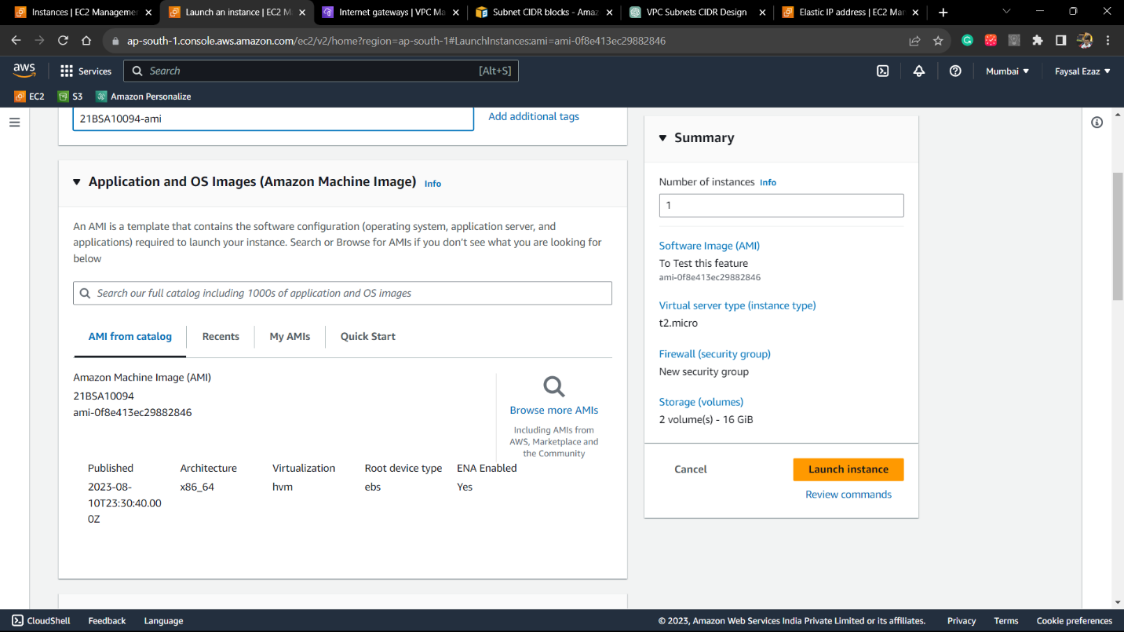

Step 4 :Select Key pair, choose Security rules and launch the instance

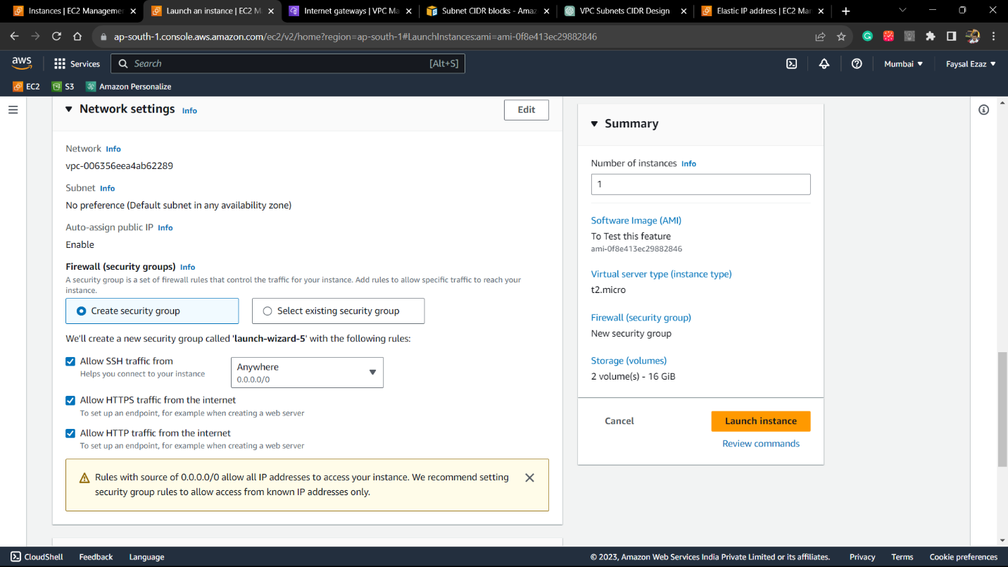

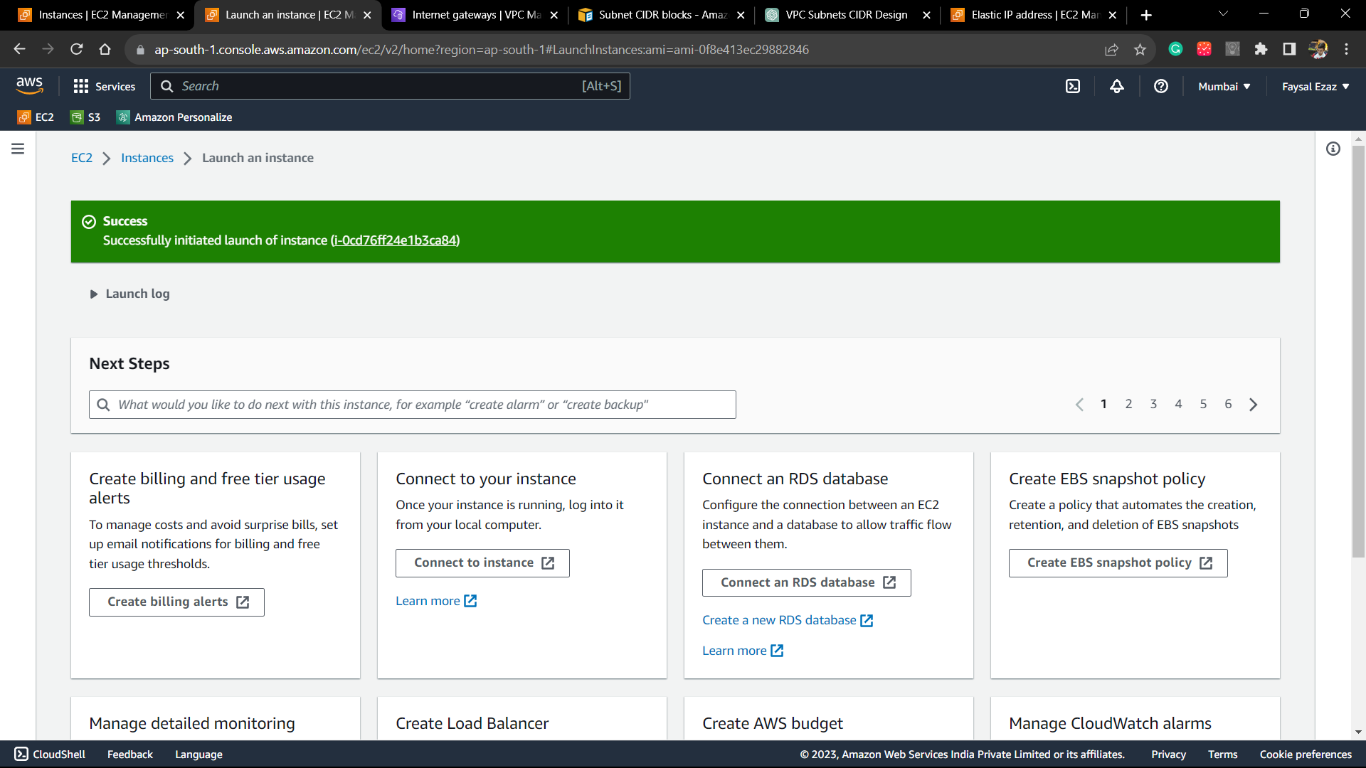

Step 5: Since this instance is a total copy of the the instance from which it was created, it should be able load the website which was contained in it.

Step 6: Start The apache/httpd server

Step 7: Website Succesfully Loads.