Lab 3: Creating an S3 bucket and uploading files to it.

1. In the AWS console we click on S3.
2. From the S3 dashboard we have to click on bucket and then follow the steps accordingly:

Step1) Click on “Create bucket”, enter a unique lowercase name and also “enable ACL’s” to provide access to a specific group of IP address users. 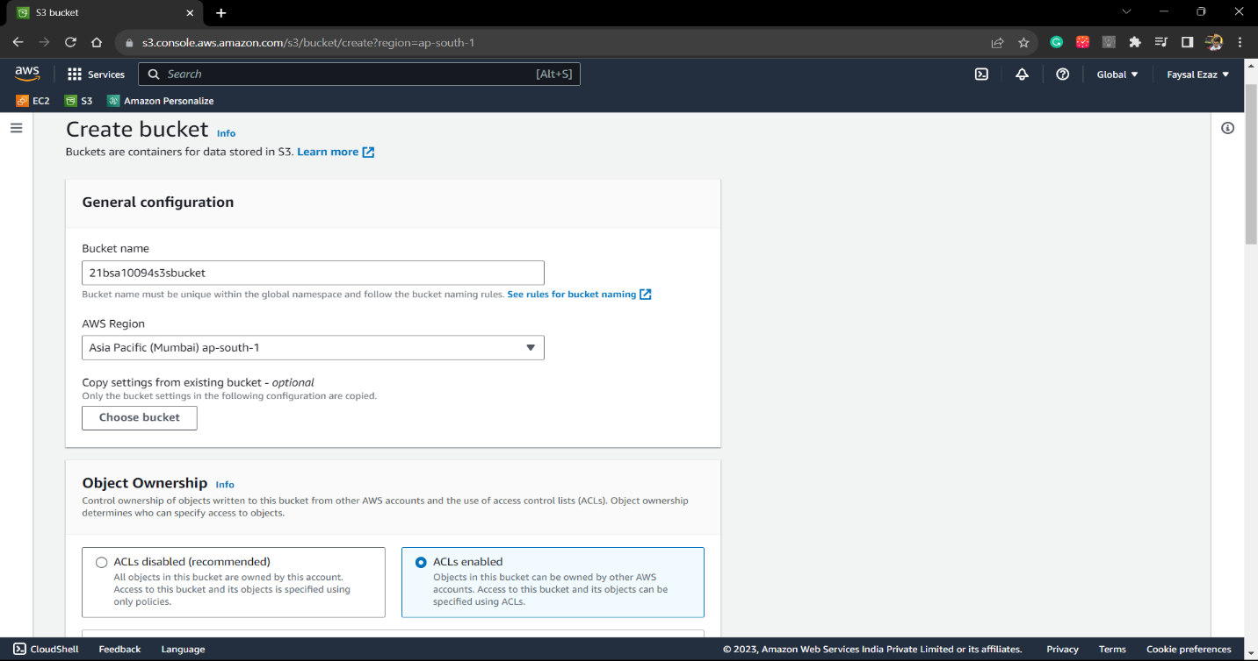

Step2) Disable the “Block Public Access settings for this bucket”. To allow other users to access the bucket.

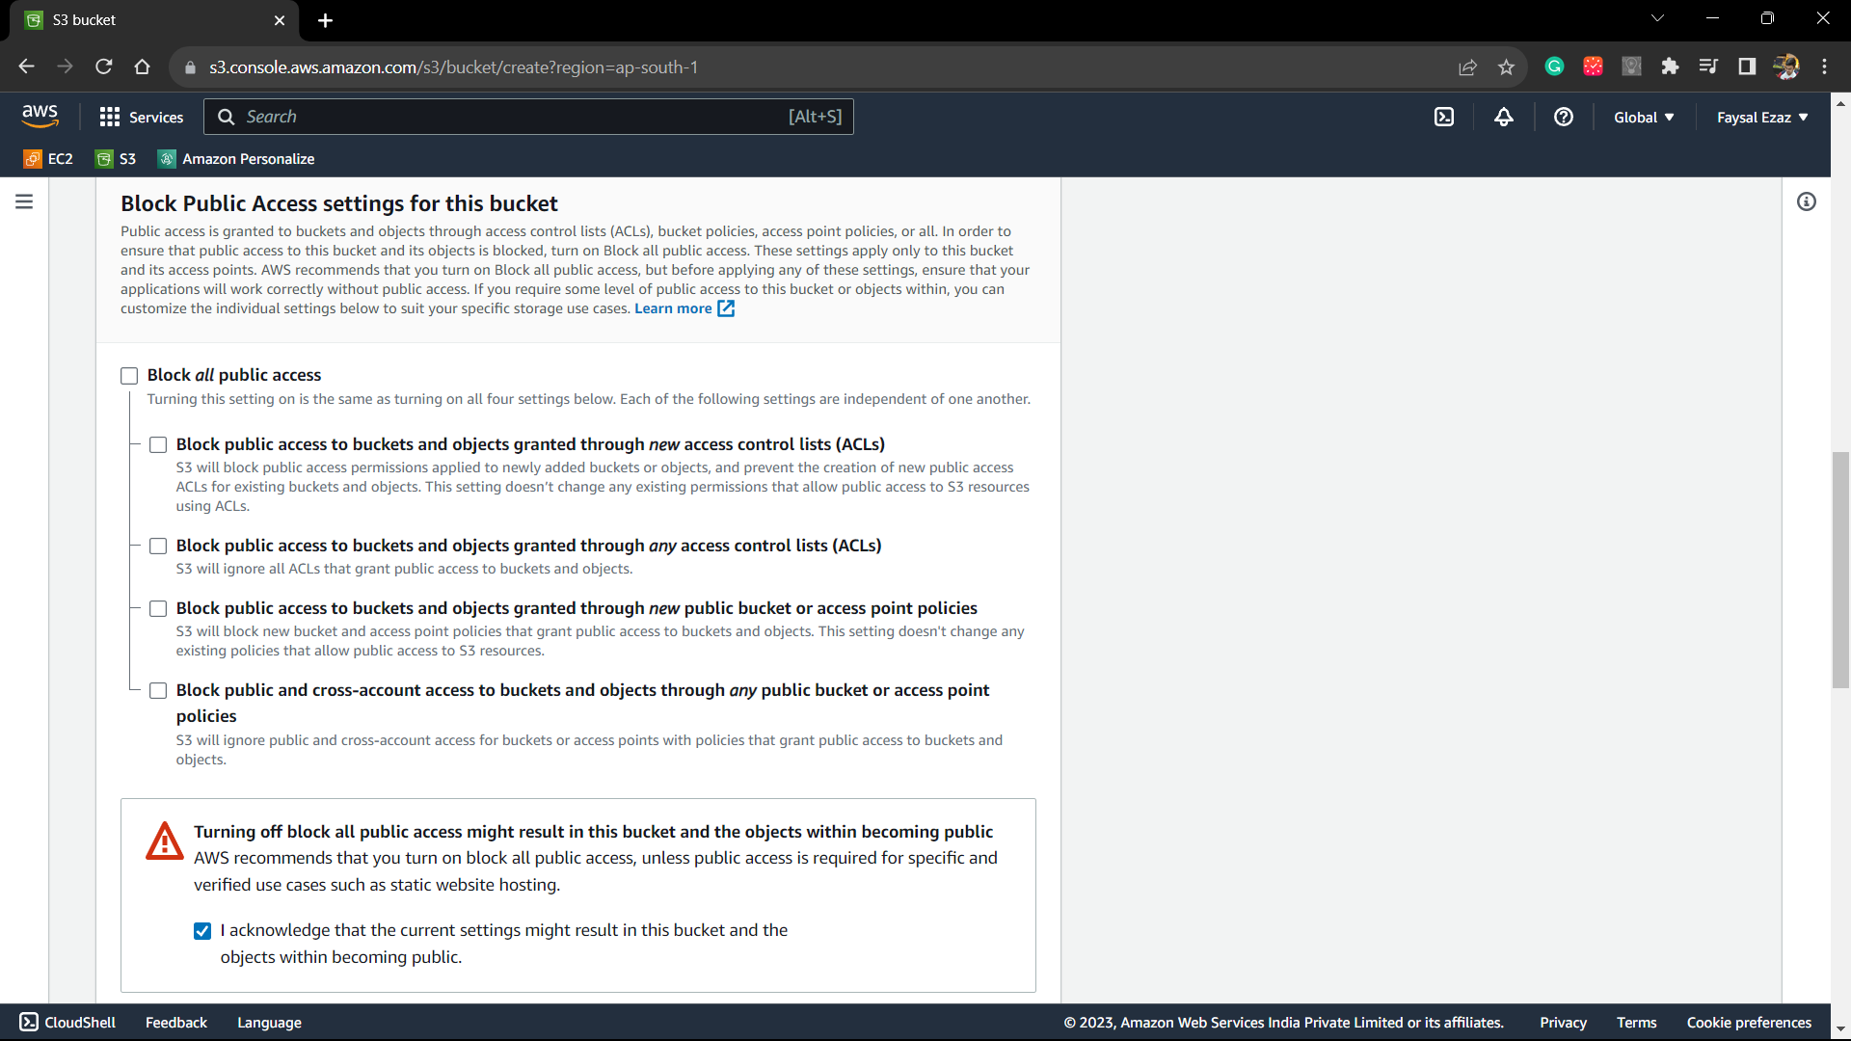

Step3) Enable “Bucket Versioning” to track the logs of files. And we click on “create bucket”.

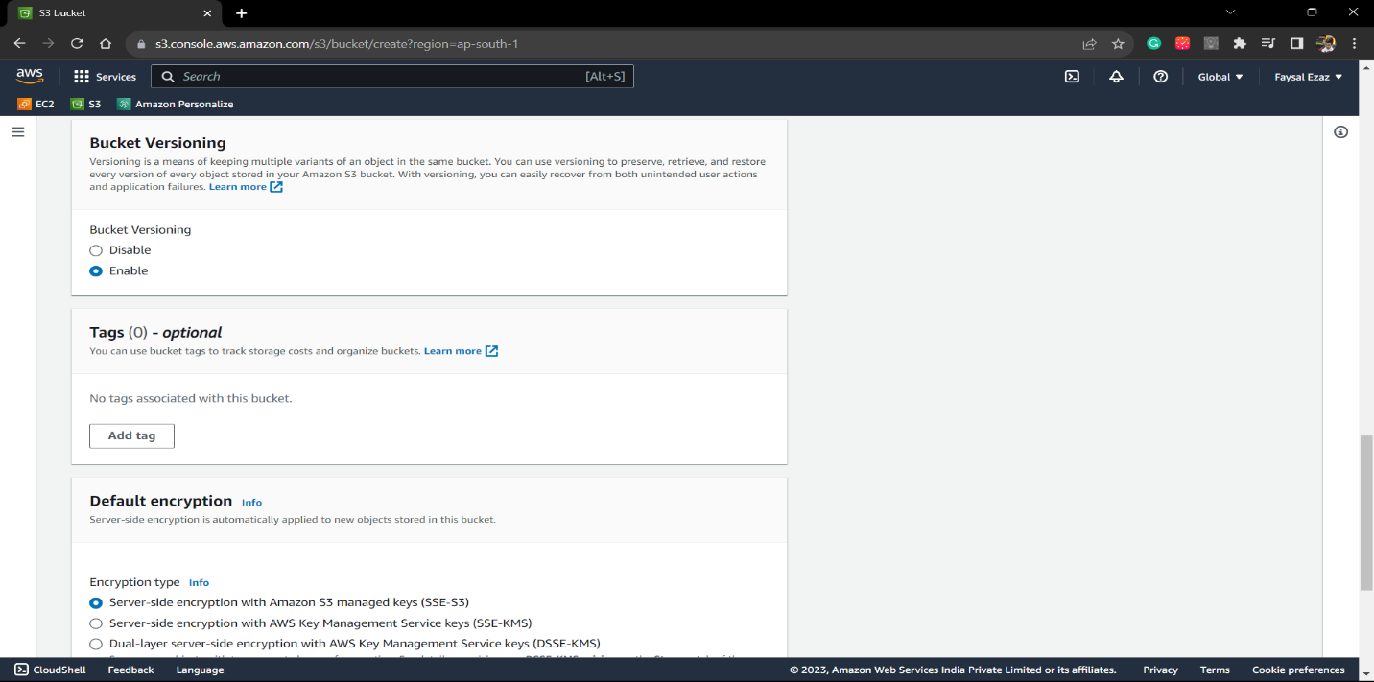

Step4) Now we upload files to the bucket by clicking on “Add Files/Folder” or using the drag and drop method.

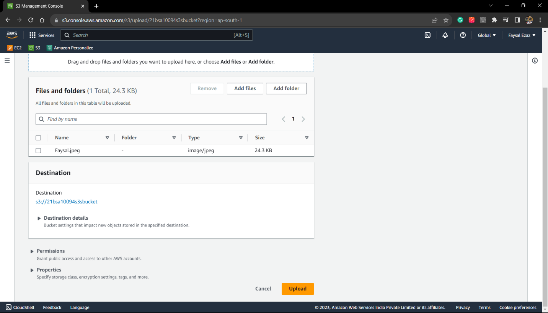

Step5: Files are Uploaded.

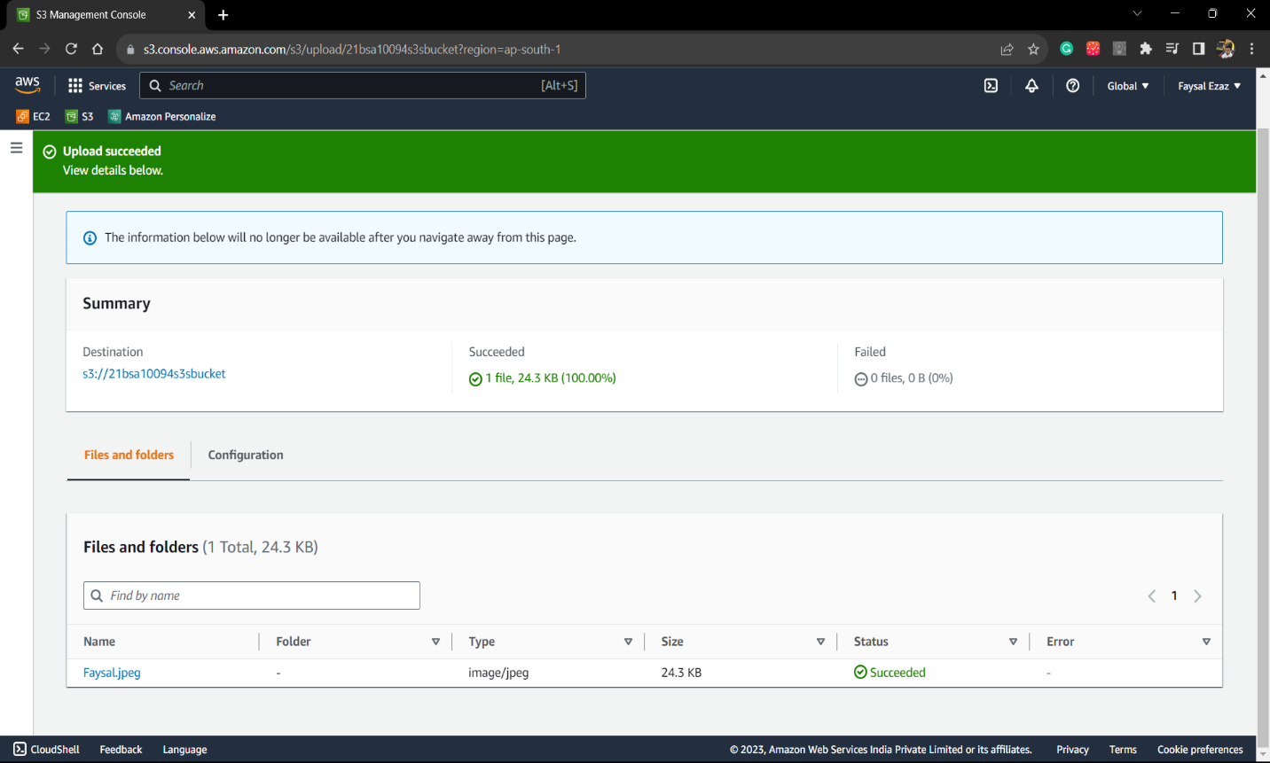

Step 6: We have to click on Version’s slider button to see all the versions of the files uploaded.

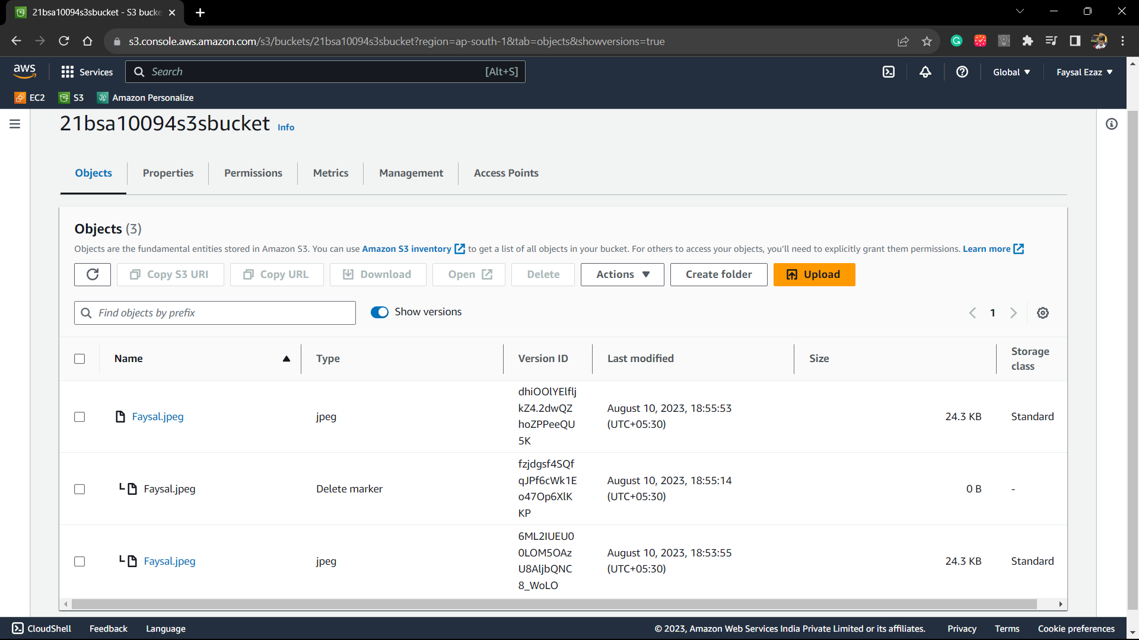

1. Now we will create a Pre-defined URL (so anyone can access the file over a certain time period).

Step 1) We click on the file that we want to share and click on “Action” button and then click on “share with a pre-signed url”.

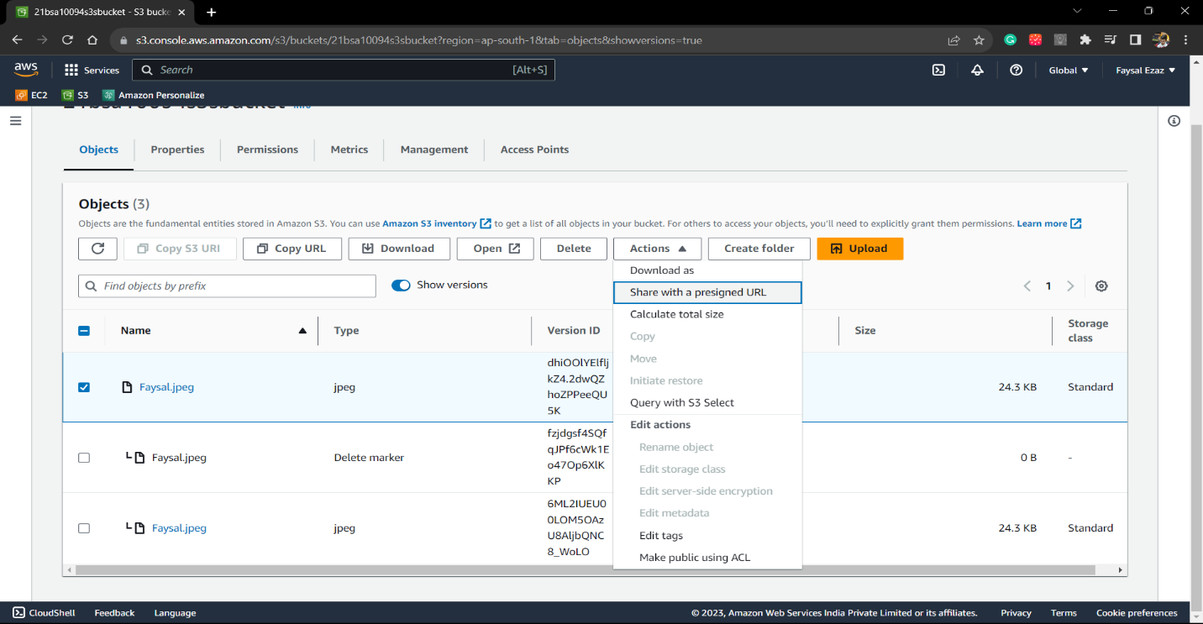

Step 2) Then we assign the amount of time

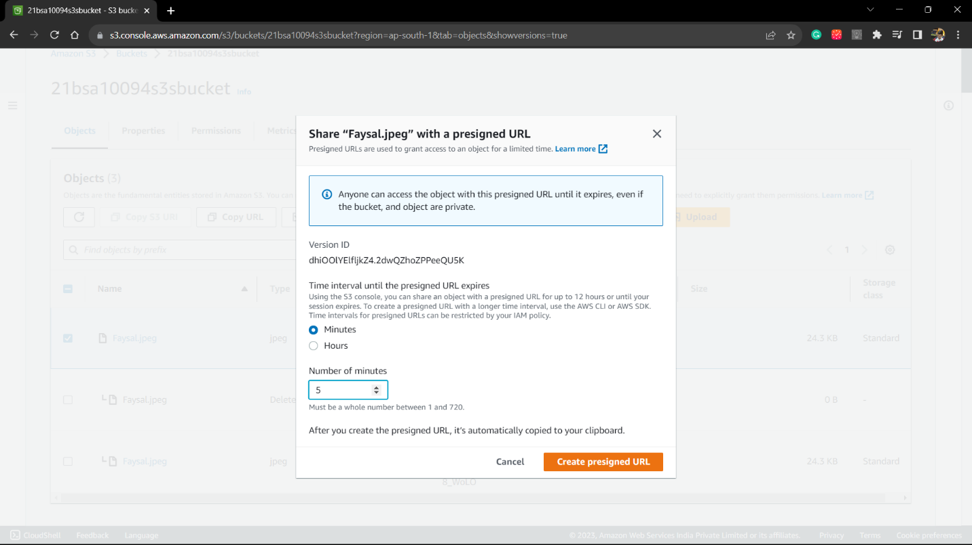

Step3) Now the url is active for 5 minutes:

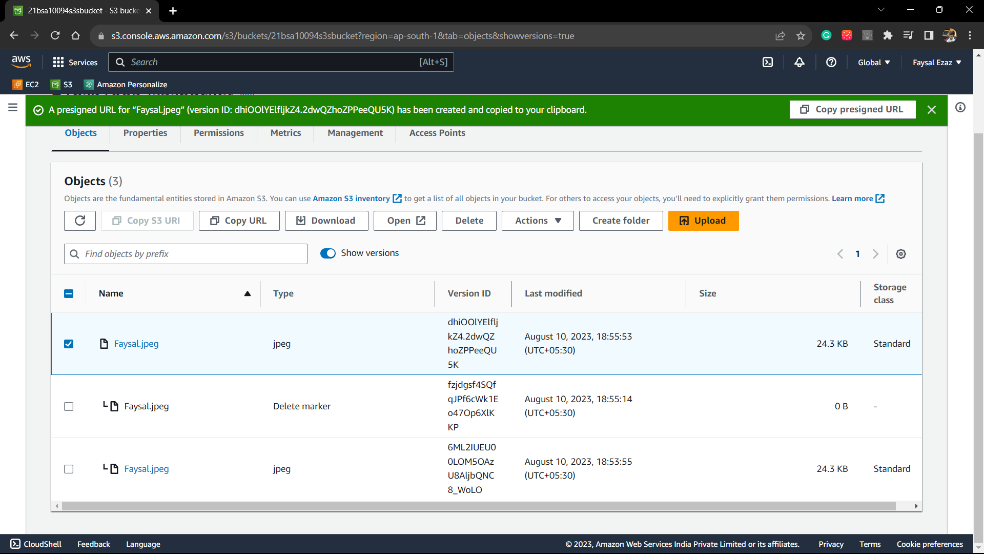

Step 4) Now we past the presigned URL:

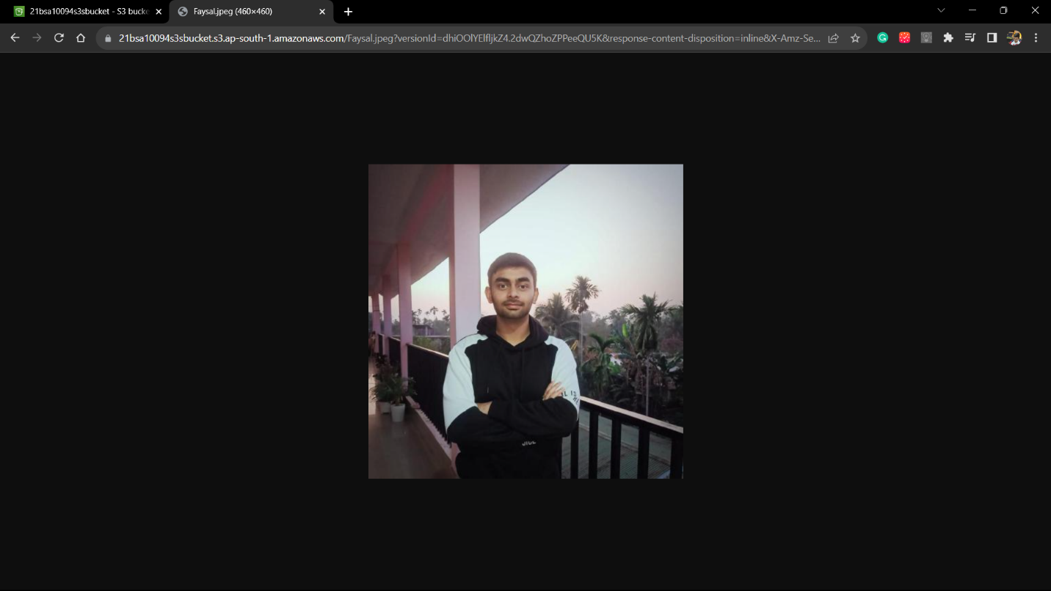

1. Now we configure the lifecycle configuration for the S3 bucket.

Step1) We go to the Management tab of the concerned S3 bucket and find lifecycle rules.

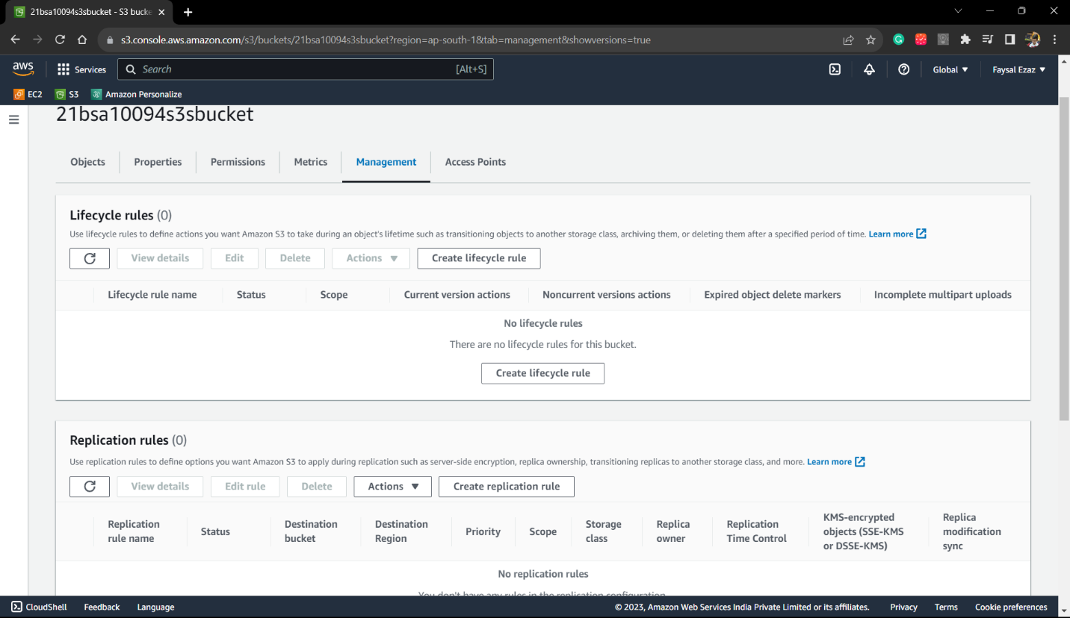

Step2) Create a lifecycle rule, give the name to the rule ,choose the scope of the rule.

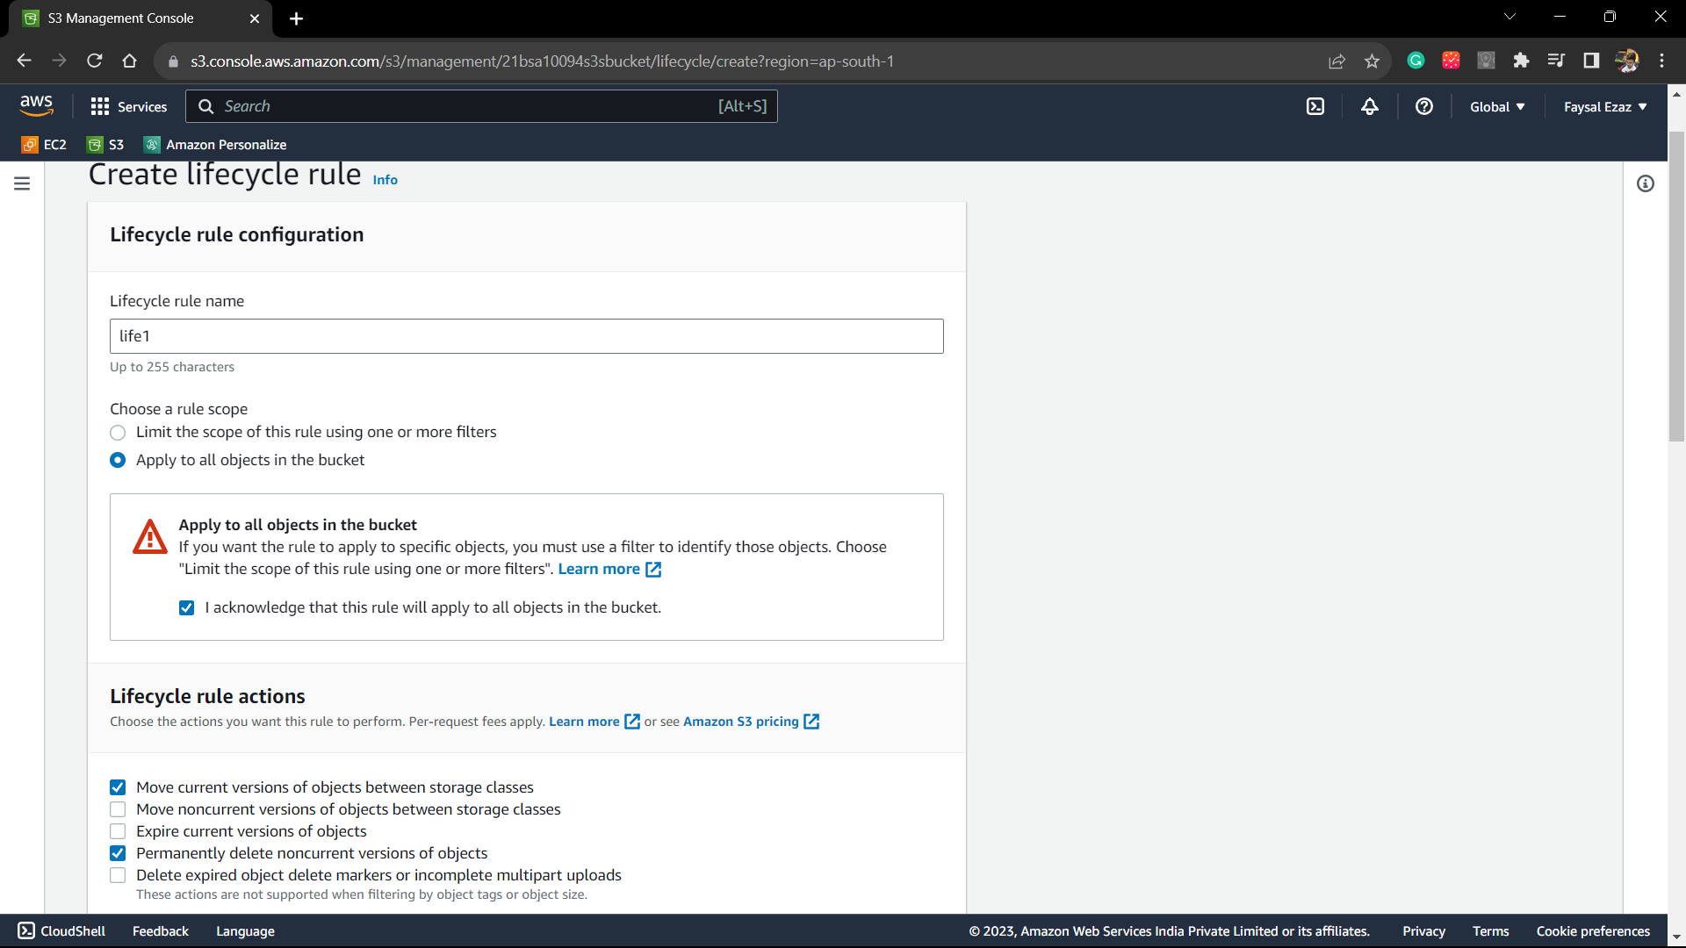

Step3) Choose the storage class transition after certain number of days.

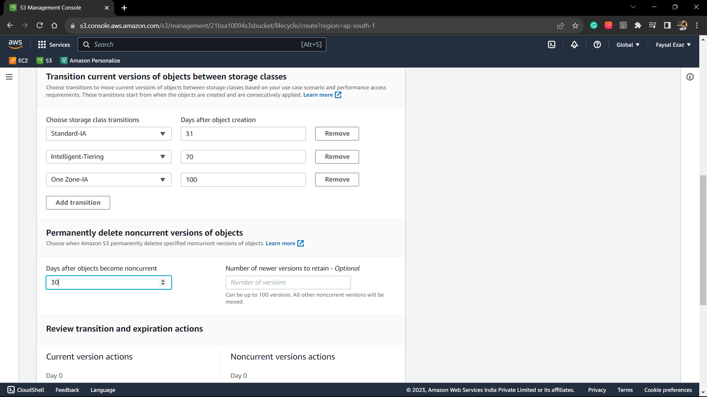

Step 4: Final review the transition you have made and create rule.

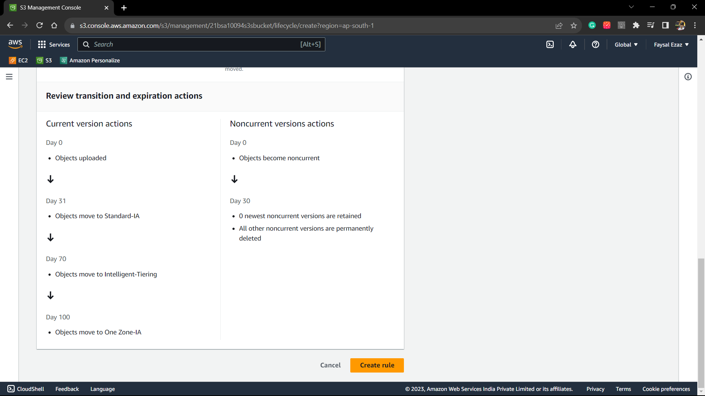

Step 5: Rule has been created for the S3 bucket.

