**CISCO PACKET TRACER 21BSA10094**

1. **PACKAGE TRACING USING HUB**
   1. Select a hub from the available options in the networking devices section, I have selected the HUB-PT
   2. From the end devices section select PC and add 6 PCs to our workplace
   3. Connect the 6 PCs to the hub using the copper straight through wire from eth 0 of the PC to ethernet 1 of the hub and so on
   4. Next click on the PC and under the desktop option click on the IP configuration option, after that enter the IPV4 address for the PC 1 as 10.0.0.1 then for PC 2 as 10.0.0.2 and so on till the 6th PC
   5. Next click on the simulation option and click on add simple PDU
   6. Add the PDU on the PCs you want to send the package to, here I am sending from PC 1 to PC 3
   7. Click on the play button and you will witness how the packet transfer occurs

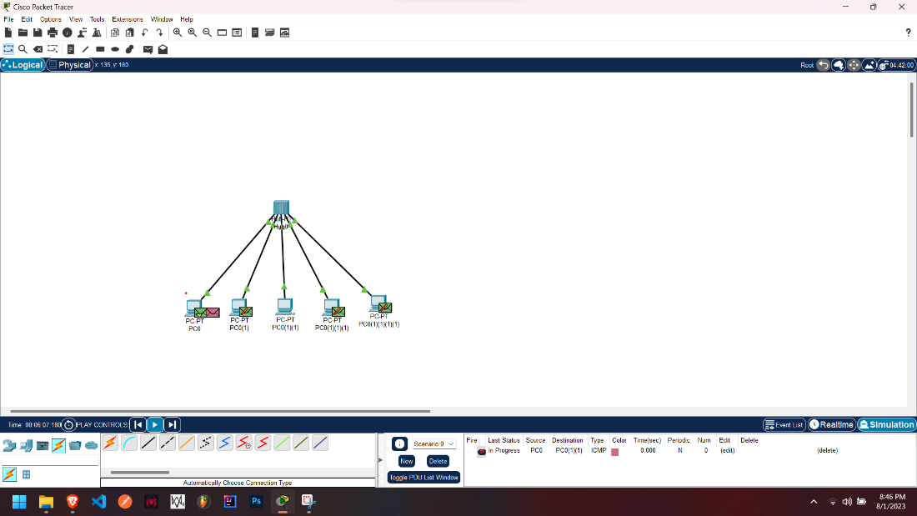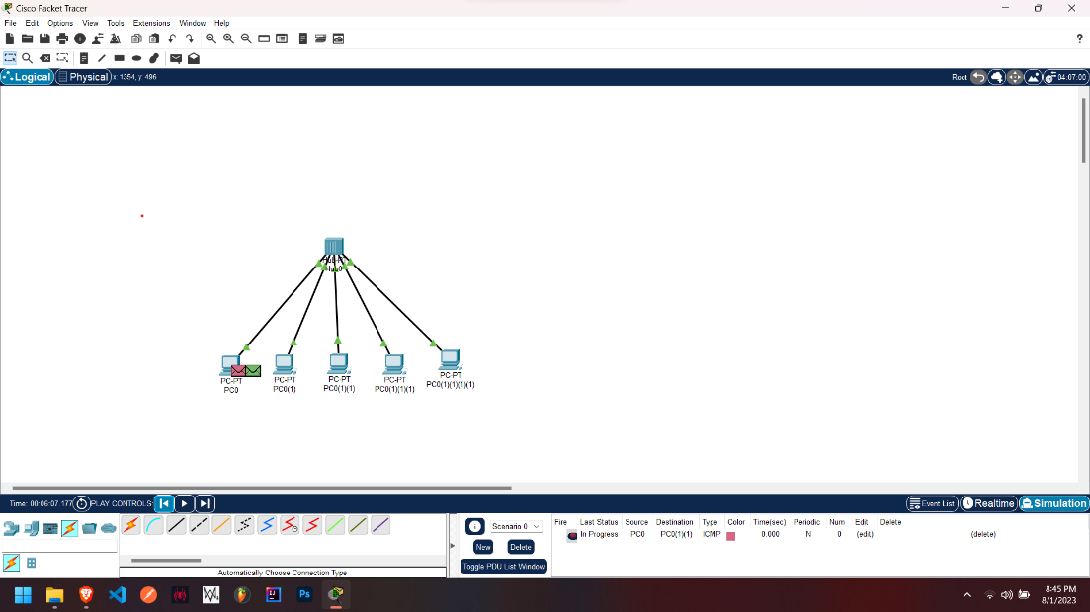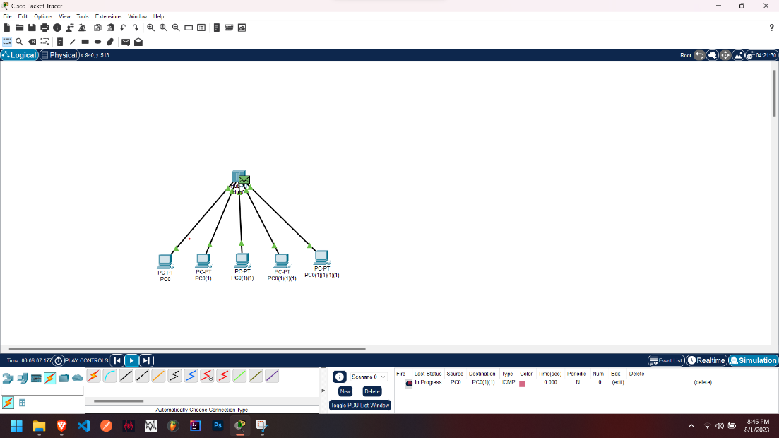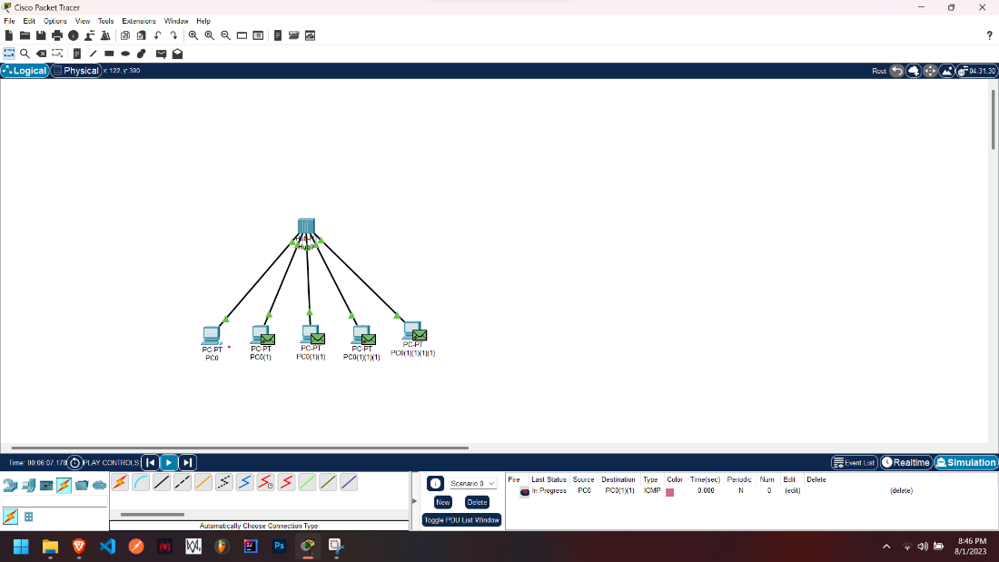

1. **PACKAGE TRACING USING SWITCH** 
   1. Select a switch from the available options in the networking devices section, I have selected the 2960 switch
   2. From the end devices section select PC and add 6 PCs to our workplace
   3. Connect the 6 pcs to the switch using the copper straight through wire from Eth 0 of the PC to ethernet 1 of the switch and so on
   4. Next click on the PC and under the desktop option click on the IP configuration option, after that enter the IPV4 address for the PC 1 as 10.0.0.1 then for PC 2 as 10.0.0.2 and so on till the 6th PC
   5. Next click on the simulation option and click on add simple PDU
   6. Add the PDU on the PCs you want to send the package to, here I am sending from PC 1 to PC 3
   7. Click on the play button and you will witness how the packet transfer occurs

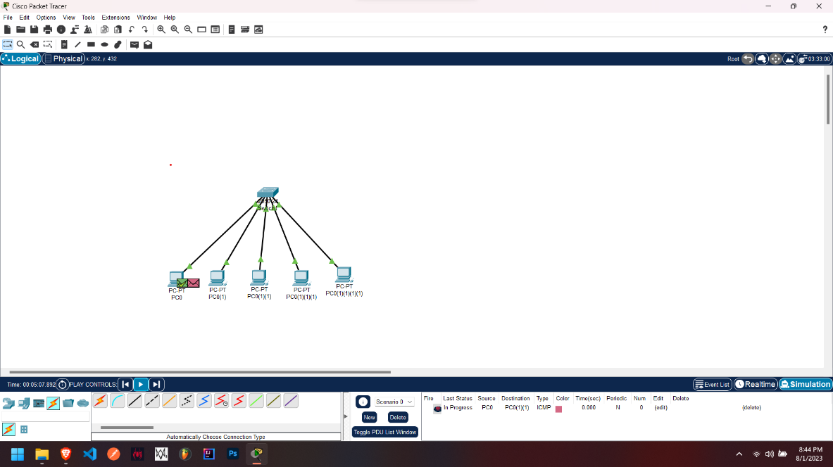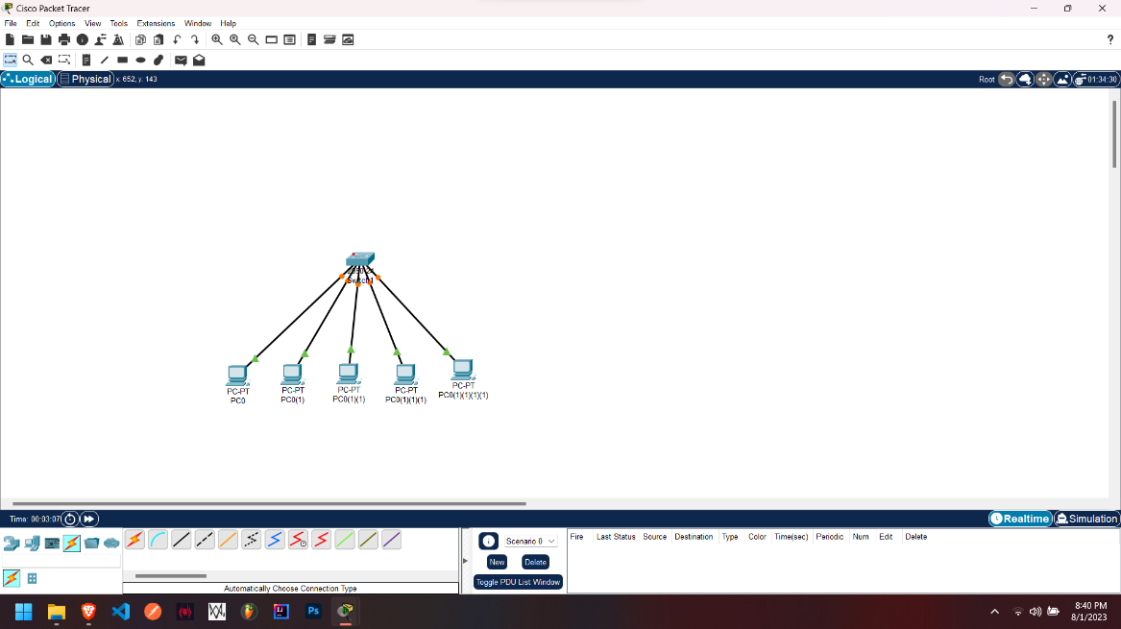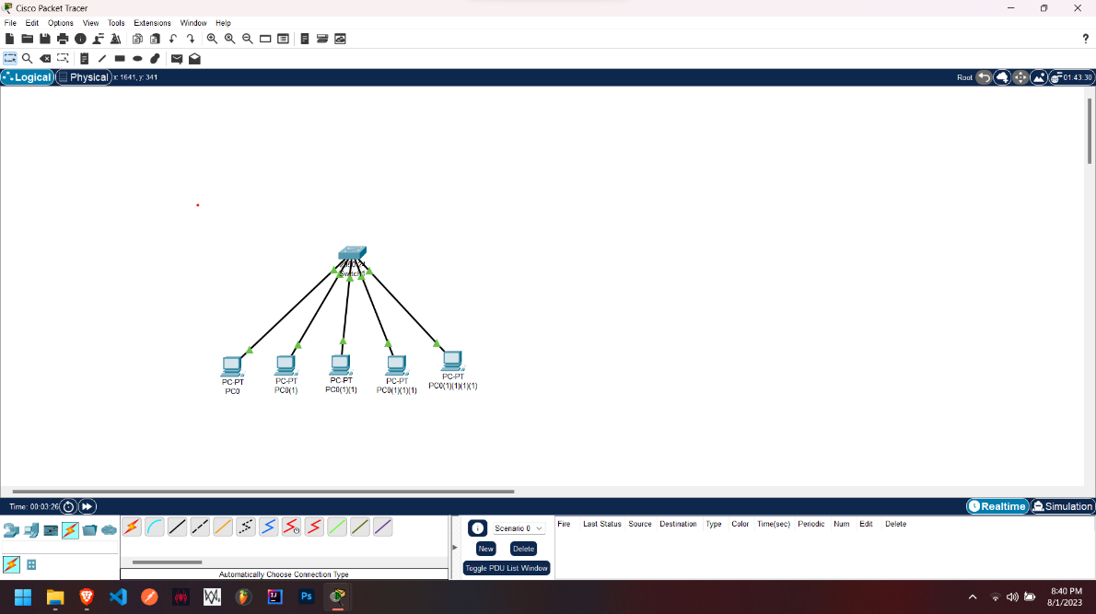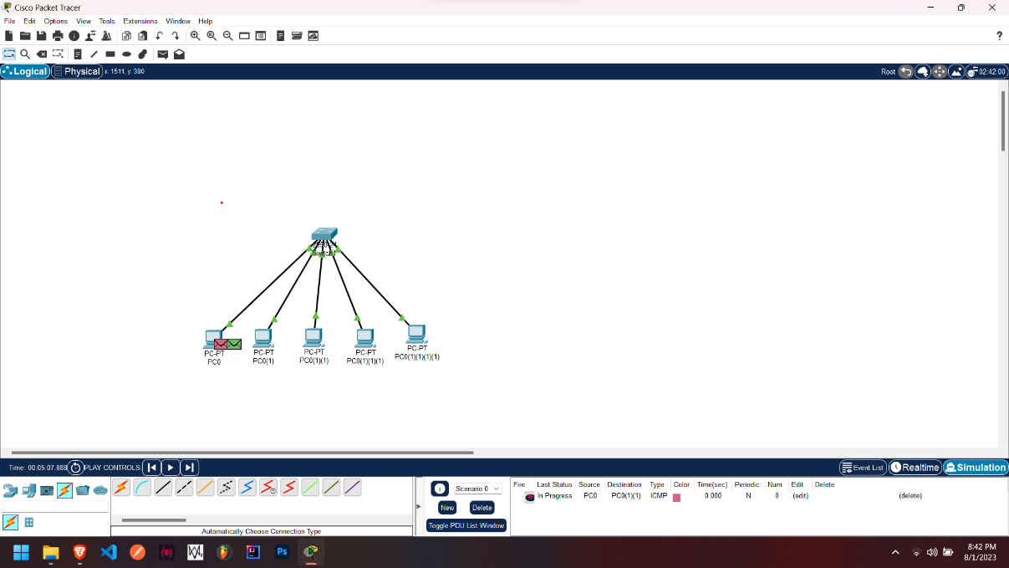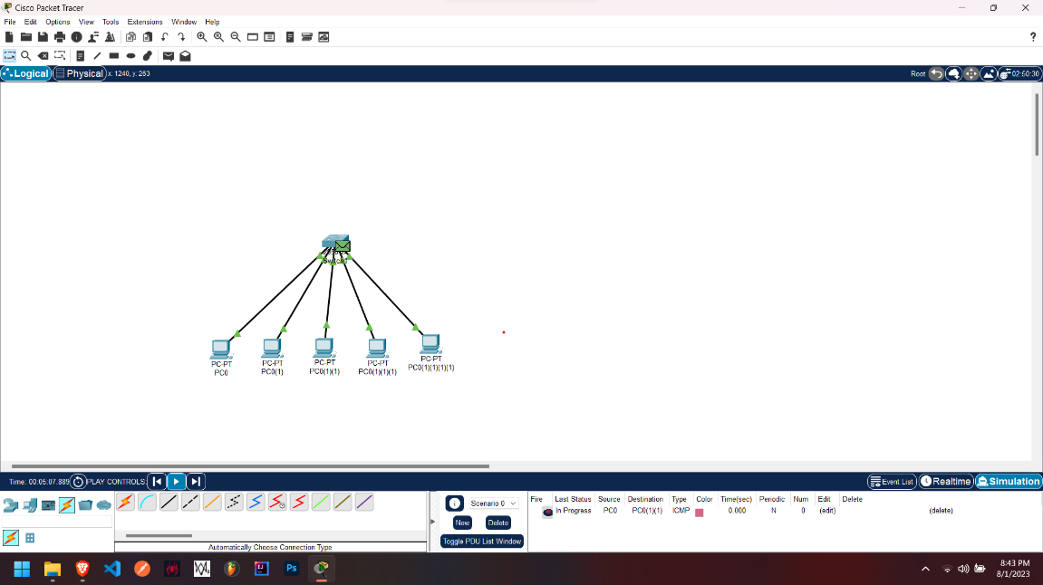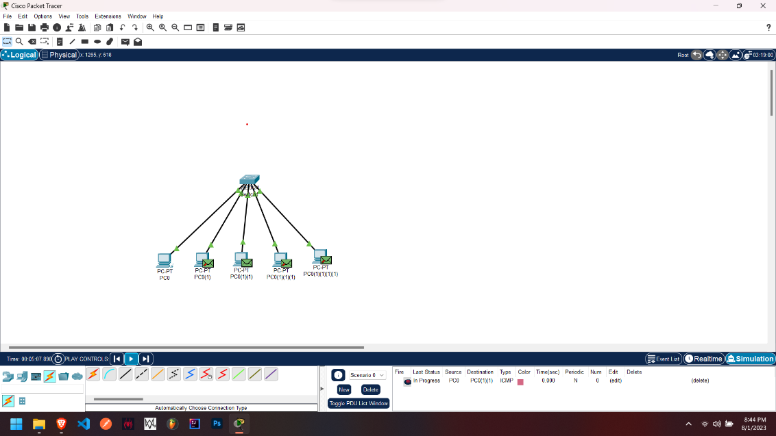

1. **PACKAGE TRACING USING ROUTER** 
   1. Select two switches from the available options in the networking devices section, I have selected the 2960 switches

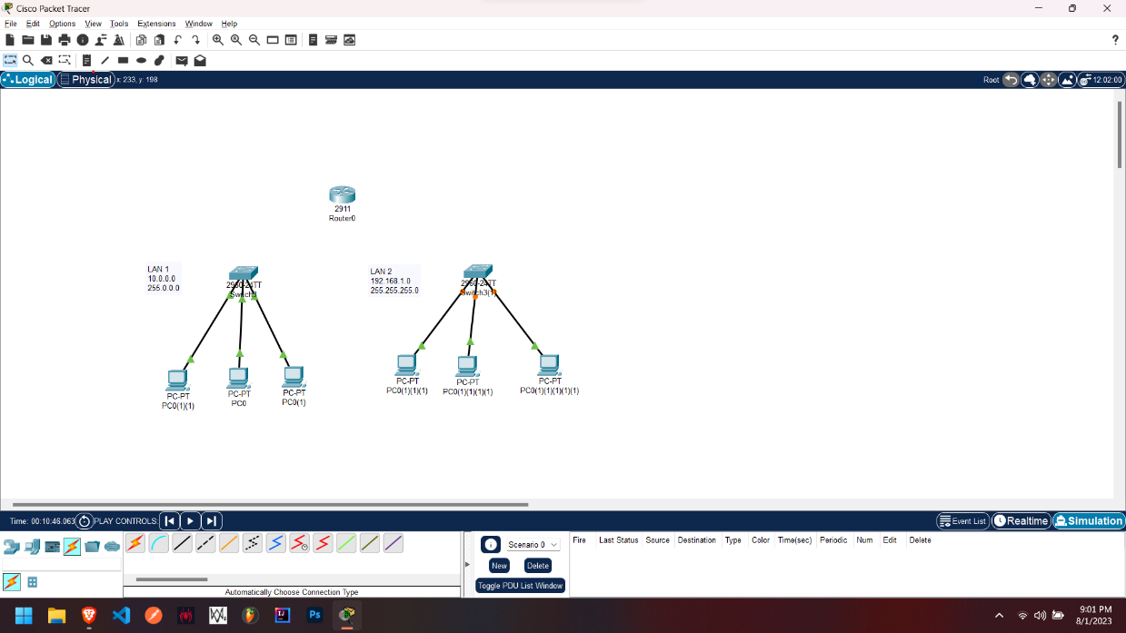

* 1. From the end devices section select PC and add 3 PCs to each of our switch In the workplace
  2. Connect the 3 pcs to the switch using the copper straight through wire from eth 0 of the pc to ethernet 1 of the hub and so on

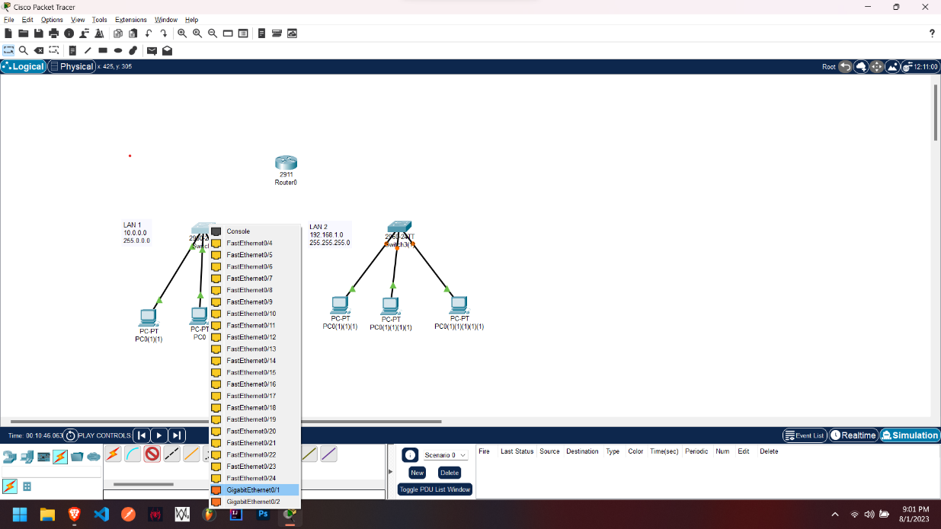

* 1. Next click on the PCs of switch 1 and under the desktop option click on the IP configuration option, after that enter the IPV4 address for the PC 1 as 10.0.0.1 then for PC 2 as 10.0.0.2 and so on till the 3rd PC
  2. Next click on the PCs of switch 2 and under the desktop option click on the IP configuration option, after that enter the IPV4 address for the PC 1 as 198.168.1.1 then for PC 2 as 198.168.1.2 and so on till the 3rd PC
  3. Next, we add a router to the workplace, I have selected the 2911 router as it has 3 GigaBit ethernet connection ports

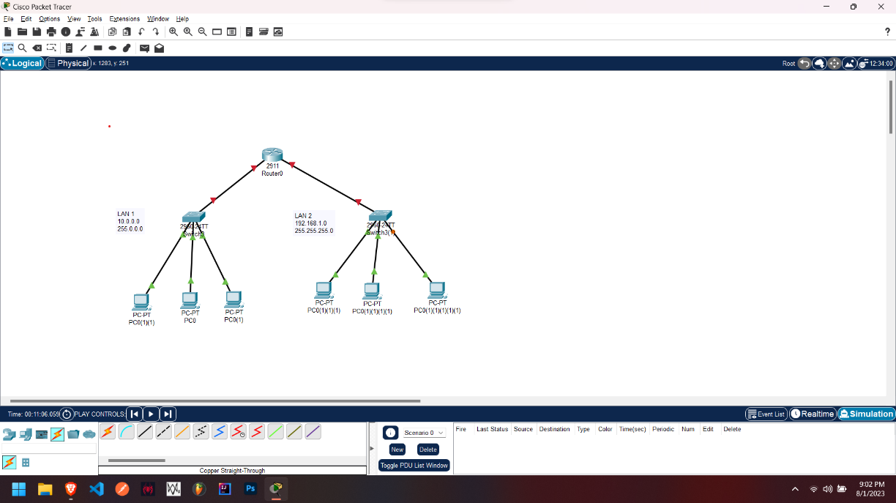

* 1. Now we connect both of the switches to the GigaBit ethernet ports of the router, we use a copper straight through and attach it from switch 1’s GigaBit 0/1 to GigaBit 0/0 of the router and a copper straight through and attach it from switch 2’s GigaBit 0/1 to GigaBit 0/1 of the router
  2. Next, we click on the router and go to the config option, we click on GigaBit0/0 and add IPV4 address as 10.0.0.4

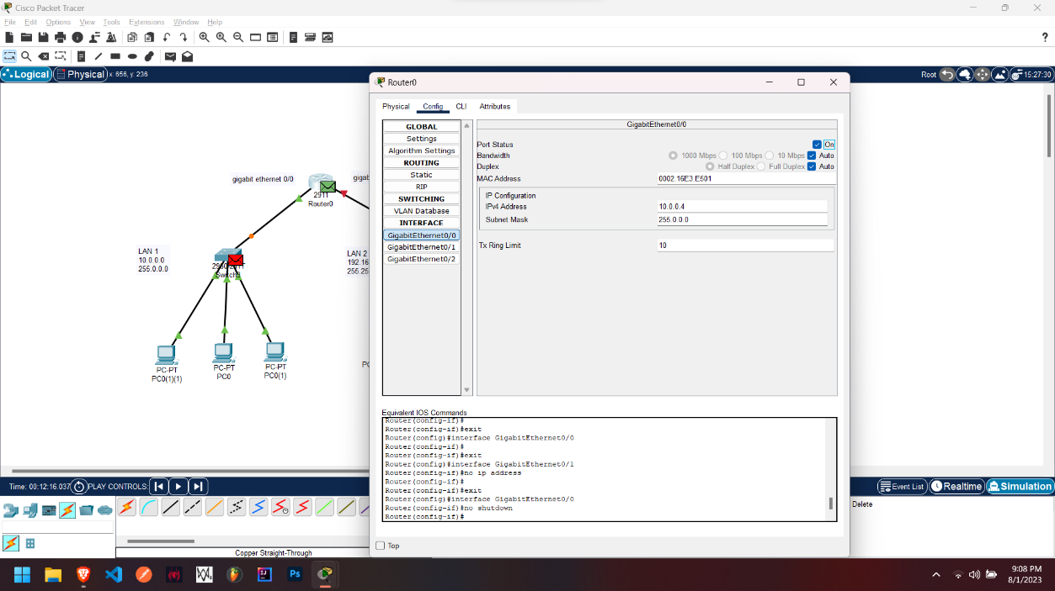

* 1. Next, we click on the router and go to the config option, we click on GigaBit0/1 and add IPV4 address as 198.162.1.4

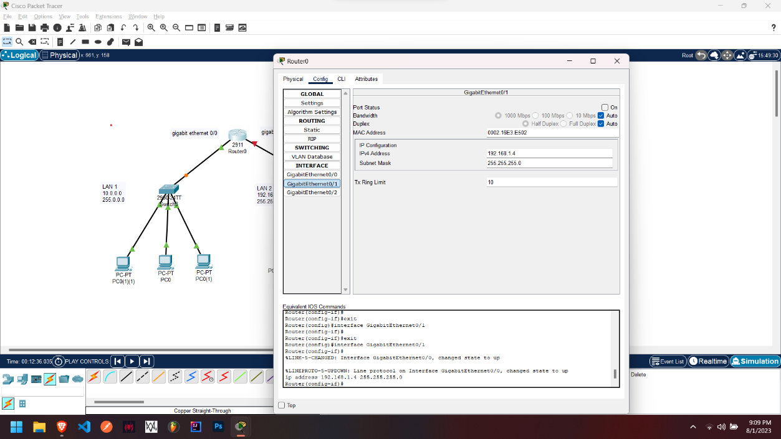

* 1. Next click on the simulation option and click on add simple PDU
  2. Add the PDU on the PCs you want to send the package to, here I am sending from PC 1 under switch 1 to PC 2 under switch 2
  3. Click on the play button and you will witness how the packet transfer occurs