Lab 3
Muhammad Jeewani S24109261, Faysal Piyal Hossain S24109508, Moayad Omar S23208845

1.1:
Rain | Hagrid | Dumbledor | KB
F | F | F | F
F | F | T | F
F | T | F | F
F | T | T | F
T | F | F | F
T | F | T | T
T | T | F | F
T | T | T | F

Only one row makes all four facts true: rain = T, hagrid = F, dumbledore = T. Fact (4) forces dumbledore = T; fact (3) then forces hagrid = F (they are not both true); fact (1) says that if it is not raining then Hagrid is there, but Hagrid is not there, so it must be raining. model_check(knowledge, rain) checks every model in which the knowledge base is true and asks whether rain is true in all of them with dumbledor true. There is just one such model and rain is true in it, so the KB entails rain and the program prints True.

1.2:
Mustard and Plum are ruled out by known cards, so only Scarlet is left.
Kitchen and ballroom are ruled out, so only the library is left.
Revolver is ruled out. The unknown card says Scarlet, library and wrench cannot all be true; Scarlet and library are true, so wrench must be false. That leaves the knife
2.1:
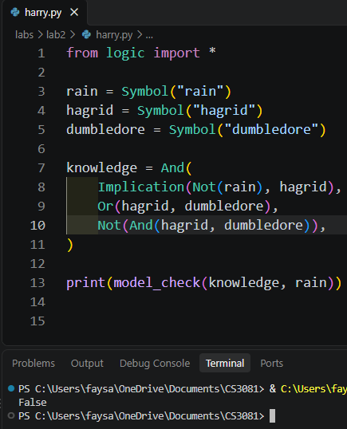
Without fact (4), several models stay possible, and rain will be true in some but not all of them, so the program should print False.From the truth table in Task 1, once the last column is removed three rows satisfy the first three facts:
rain | hagrid | dumbledore | KB true?
T | T | F | TRUE
T | F | T | TRUE
F | T | F | TRUE
Rain is true in two of these models but false in the third (rain = F, hagrid = T, dumbledore = F: no rain, so Hagrid appears). We no longer care if harry is going to dumbledor, its now entailing rain to make the decision. Knowledge Base now cares if harry goes hagrid or dumbledor when it rains but not both. But as default no rain should result harry going to hagrid.

2.2:
After deleting the clue, the remaining clues are: Gilderoy is in Gryffindor or Ravenclaw; Pomona is not in Slytherin. This leaves 8 valid assignments (Gilderoy G: Pomona H or R, then the other two people in either order; Gilderoy R: Pomona G or H, the other two in either order). Every symbol is false in at least one of these 8 models, so model_check returns False for all of them and nothing is printed.
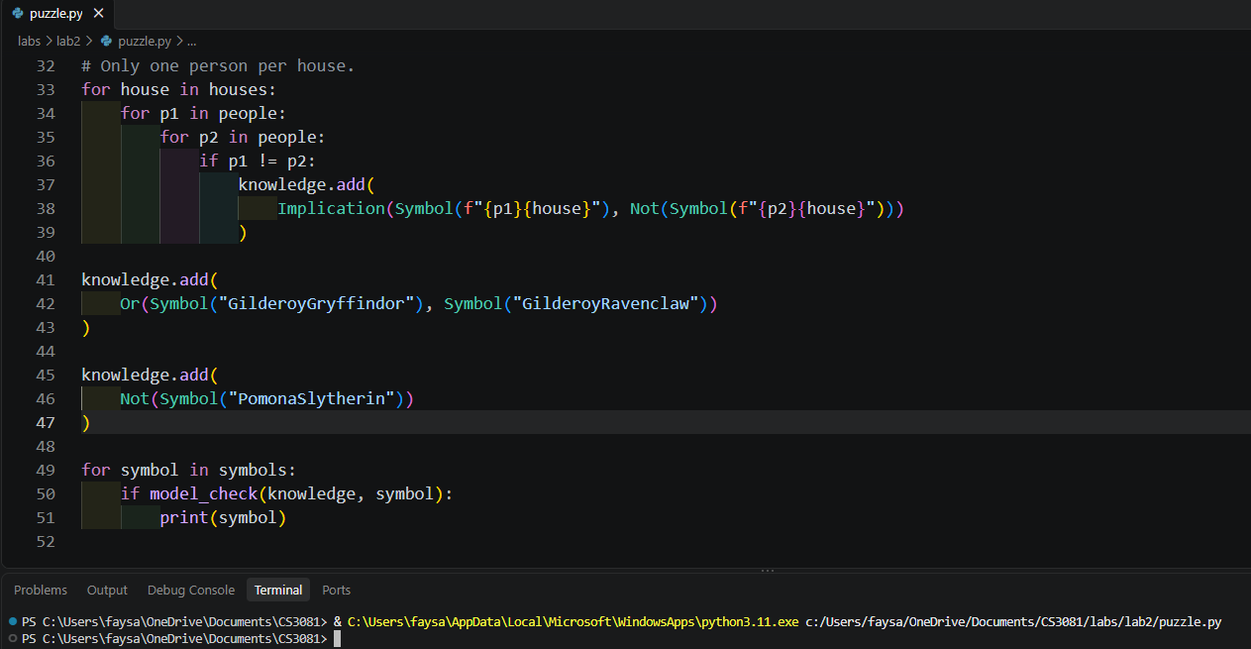

The new clue we can add is Symbol("HoraceGryffindor") (Horace is in Gryffindor). This will make the answer unique again: Horace takes Gryffindor, so Gilderoy (Gryffindor or Ravenclaw) must be Ravenclaw. Pomona cannot be Slytherin, and Gryffindor and Ravenclaw are taken, so Pomona is Hufflepuff. Minerva gets the last house, Slytherin
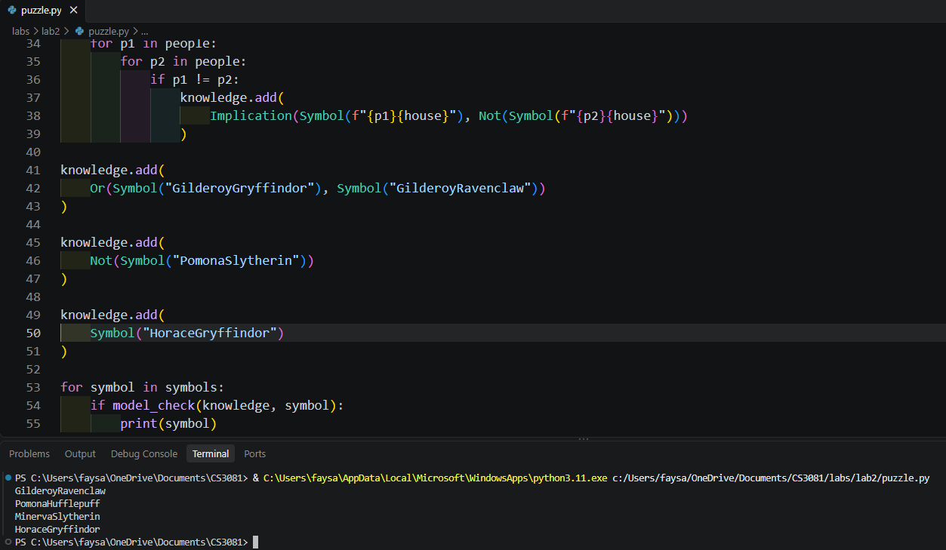

3.1:

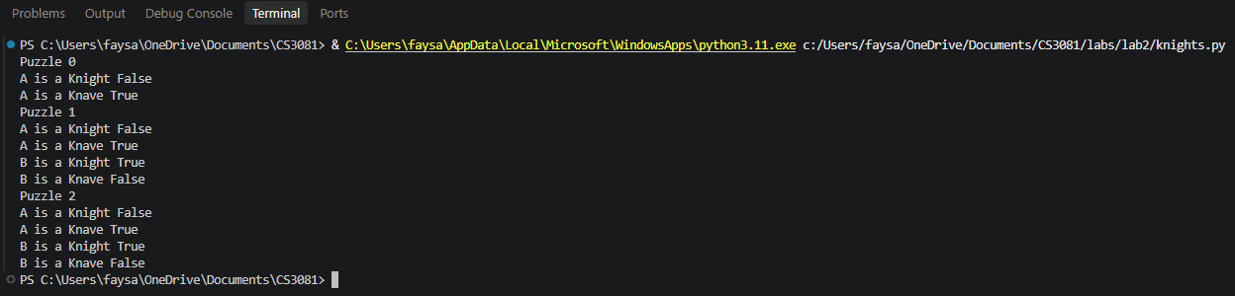
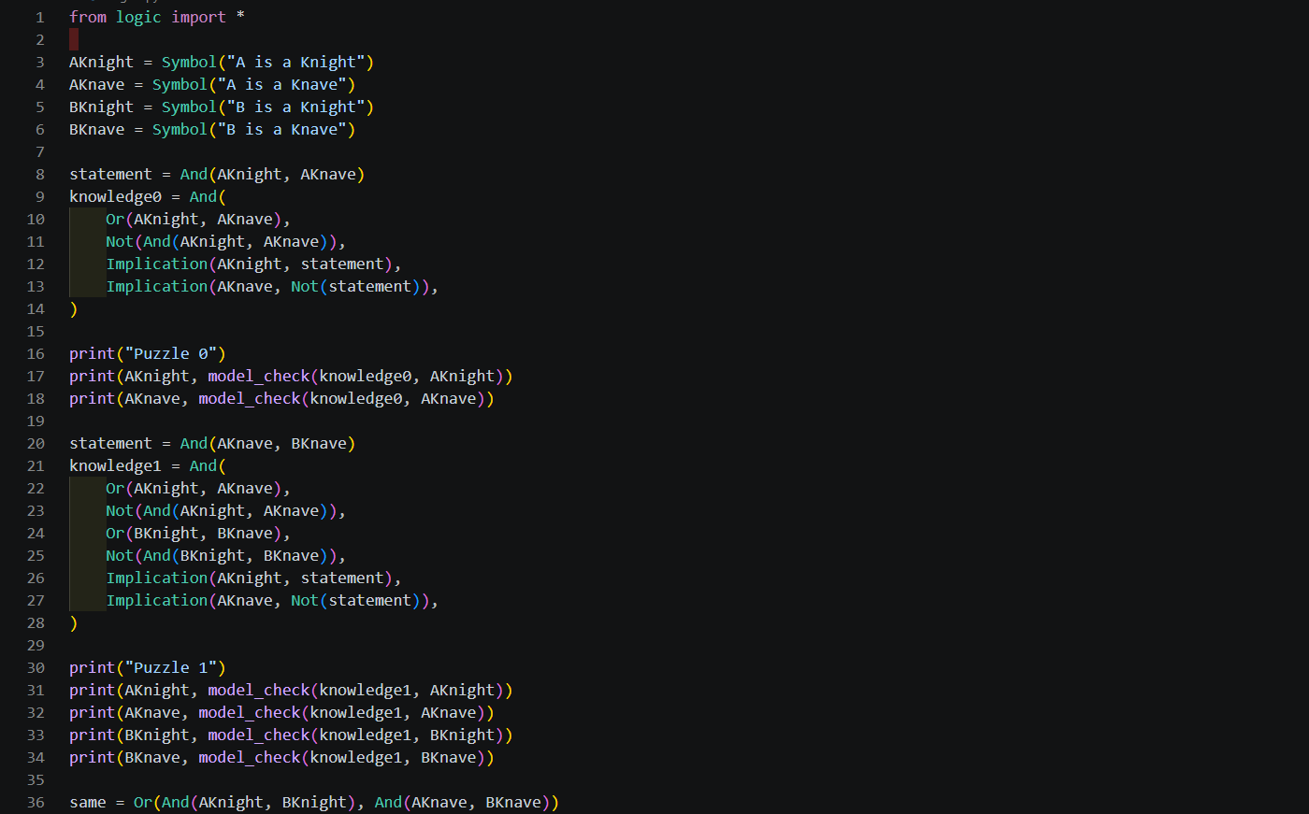
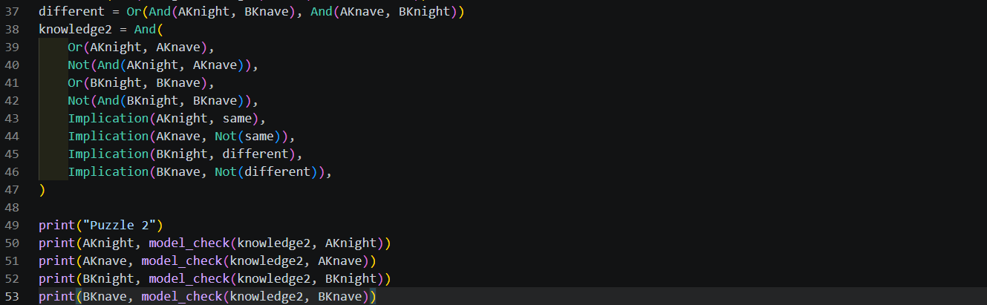

I used claude to generate the code

