Effat University
Engineering College – Computer Science Department
Tawlatna
Requirements Report – Analysis Phase
A Jeddah-based platform that turns café off-peak hours into hosted board-game events.
Course: CS3151 Software Engineering | Section 1
Instructor: Dr. Passent Elkafrawy
Team: Faysal Hossain Piyal, Albaraa Sait, Abdullah Bawazir
Date: 12 October 2026

Contents
1. Problem to be Solved
2. Market Study (Feasibility)
3. Business Model Canvas
4. Personas
5. Requirements and Elicitation Methods
6. Use Case Titles
7. Context Diagram
8. Project Management

1. Problem to be Solved

1.1 Background
Jeddah is full of cafés, but many of them go unnoticed and have slow business. This is not because of poor food or service, but because people have no particular reason to visit them. Tuesday and Wednesday evenings are typically the emptiest, and small cafés cannot afford effective advertising to fill those tables.
At the same time, people who enjoy board games struggle to find organized, social game nights nearby. Planning through WhatsApp groups is messy, and the board-game apps that exist are mostly built outside Saudi Arabia: they let people host events anywhere, which raises safety concerns, and they offer no Arabic support or local presence.

1.2 Problem statement
Local cafés in Jeddah have empty tables during off-peak hours and cannot afford effective advertising, while people who enjoy board games have no reliable, safe and Arabic-friendly way to find and join organized game nights.

1.3 Problems by stakeholder
Stakeholder | Problems they face today
Café owners | Empty tables on slow mid-week evenings; high cost of social media ads; no organized way to host and manage events; manual accounting of revenue.
Casual players | Hard to find organized game nights nearby; messy coordination through WhatsApp group chats; missed reminders and unclear loyalty balances; no guarantee that other players will show up.
Cashiers | Manual logging is slow and error-prone; long queues on event nights; damaged QR codes and internet outages; unclear instructions during peak hours.
Platform operators (Developer / Admin) | Manual verification of partner cafés; data anomalies; difficulty verifying commission accuracy; policy violations by accounts.

1.4 Proposed solution
Tawlatna is an event-management mobile platform that connects cafés seeking more foot traffic with people looking for board-game events:
- Cafés schedule hosted board-game sessions in their off-peak hours; players pay nothing to join.
- Players discover events, reserve up to 4 seats, and receive a QR code linked to their table.
- Cashiers scan the QR code to check players in and log food and beverage (F&B) purchases at the register.
- The platform earns a 15% commission on F&B sales during events only, so cafés take no upfront risk.
- Players earn loyalty points for their purchases and redeem them as rewards; owners and admins get dashboards, commission reports and an audit trail.

1.5 Project goals and scope
- Fill cafés' off-peak tables and raise F&B sales without advertising spend.
- Give players one reliable place to discover and join organized game nights in safe, well-known venues.
- Make check-in and sales logging fast and accurate for café staff.
- Provide a transparent, auditable record of attendance and commission.
In scope: event discovery and reservation, QR check-in, F&B transaction logging, commission calculation, loyalty rewards, owner dashboards and reports, admin audit tools.
Out of scope (this version): letting users host games at any location (Tawlatna is café-only by design) and charging players for seat reservations.

2. Market Study (Feasibility)

2.1 Market overview
The target audience is youth, university students, young professionals, casual board gamers and specialty café operators in Jeddah. The feasibility study estimates the addressable local market at about SAR 180 million per year spent on non-food entertainment, social gatherings and gaming events in Jeddah cafés, with demand for organized social experiences exceeding supply during mid-week hours.
Tawlatna would be the first mover focused on café-hosted board-game events in Jeddah. It starts with 10–15 premier specialty cafés in dense central districts (Al-Zahra, Al-Rawdah, Al-Shati) before expanding city-wide and to other Saudi cities. Likely future competitors are general ticketing apps (Webook, Hala Yalla), dedicated board-game lounges and local meetup organizers.

2.2 Competitor analysis
Most competitors are located outside Saudi Arabia and host events anywhere. Flexible locations may look like an advantage, but they are a safety disadvantage; holding events in well-known cafés gives male and female users a sense of security. None of the board-game competitors offers a loyalty program, so Tawlatna adds coupons and offers on the player's next purchase in the café.
Table 2.1 – Feature comparison
Feature | SeatUp | Meeple Match | OpenTable | Tawlatna
Online booking | ✓ | ✓ | ✓ | ✓
Create own profile | ✓ | ✓ | ✓ | ✓
Events at cafés only | ✕ | ✕ | ✕ | ✓
Loyalty program | ✕ | ✕ | ✓ | ✓
Board games | ✓ | ✓ | ✕ | ✓
Host games anywhere | ✓ | ✓ | ✕ | ✕

Table 2.2 – Detailed comparison
Attribute | SeatUp | OpenTable | Meeple Match | Tawlatna
Core idea | Find or host a board-game table and reserve a seat | Reserve a table at a venue; same "book a seat" service, different industry (restaurants) | Host or join board-game sessions anywhere, not tied to cafés | Book a board-game seat at a partner café in Jeddah
Local / Arabic | No Arabic, no Saudi focus; global and generic | Global platform, not board-game or Saudi-specific | Not Saudi-focused; location-agnostic | Arabic-first, built for the Jeddah market
Café partnerships | Venues can be discovered, but no formal booking or revenue share | Yes: restaurants pay to be listed and take bookings | None: sessions are not tied to partner cafés | Formal onboarding and commission-based revenue share
Loyalty rewards | None | Yes: dining points redeemable for future bookings | None | Points and expiring coupons for attendance
No-show handling | Host adjusts seat count manually; no RSVP confirmation | Reservation reminders | No RSVP confirmation or no-show tracking | RSVP confirmation, auto-release of unconfirmed seats, no-show tracking
Discovery | List of nearby tables, no café map | Map and "near me" search | Online booking with profiles; events not limited to cafés | Filterable map of live sessions by location and time
RSVP: a request for someone to confirm whether they are coming to an event.

2.3 Customer feedback analysis
To find common issues with existing solutions, customer reviews from Google Play, the Apple App Store and tech forums were analyzed.

What users like
- The simple 3-step flow (host or join a game, pick location and time, done), with no more WhatsApp groups.
- Filtering games and sessions by location and time, and browsing partnered board-game cafés on a map.
- Being free to use.

Market gaps and complaints
- No reliable attendance guarantee: Meeple Match itself admits in its FAQ that it cannot guarantee players will show up.
- No regional presence: no dedicated coverage or Arabic language support for the Saudi and Gulf market.
- Little social proof: few public, verifiable reviews, which signals low market penetration and trust.
- Dependence on partner cafés: the café-booking feature only works where a café has already joined.

2.4 Market opportunity and differentiation
- Asset-light café activation: existing coffee shops become temporary social board-game venues without buying inventory or managing events.
- Seamless social discovery: one app to discover, book and join curated game nights across Jeddah neighborhoods.
- Win-win monetization: a performance-based commission on F&B sales gives cafés zero-risk marketing during off-peak hours.

2.5 Feasibility summary
Area | Finding
Technical | Relies on proven technology: Flutter mobile app (iOS and Android), cloud hosting in Saudi-region data centers, payment-gateway integration, and offline-cached QR codes so cafés can validate bookings when connectivity drops. Low technical risk.
Operational | Lean founding team of four growing to nine by the end of Year 1. No venues, inventory or major facilities are needed because the model is asset-light.
Legal and regulatory | Compliance with SDAIA data-protection rules, ZATCA e-invoicing, SAMA guidelines for digital-wallet transactions, and commercial registration and licensing.
Marketing | Instagram and TikTok campaigns, on-table QR standees in partner cafés, micro-influencers and referral incentives: low-cost channels that suit a mobile-first audience.
Financial | Seed funding of SAR 250,000; break-even in Month 10; Year 3 net profit margin above 32%; about 144% return on investment over three years (see Section 8.4).
Recommendation | Proceed with the project. The market study confirms strong demand for accessible, organized social entertainment in Jeddah that pairs coffee culture with board gaming.

3. Business Model Canvas
The canvas below summarizes how Tawlatna creates, delivers and captures value (blocks are numbered in sequence).
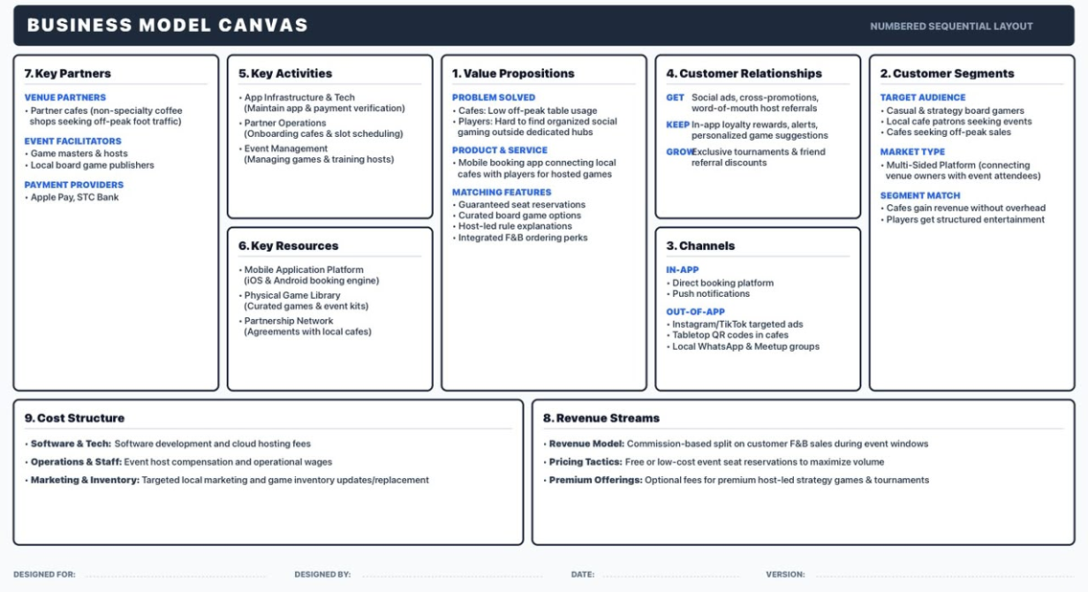
Figure 1 – Tawlatna Business Model Canvas

3.2 How the canvas connects to the requirements
Canvas block | Key content | Where it appears in this report
Customer segments | Casual and strategy board gamers; local café patrons seeking events; cafés seeking off-peak sales | Personas (Section 4)
Value propositions | Guaranteed seat reservations; curated board-game options; host-led rule explanations; integrated F&B perks | UC-1, UC-5; REQ-1 to REQ-5
Channels | In-app booking and push notifications; Instagram/TikTok ads, tabletop QR codes, local WhatsApp and Meetup groups | UC-1, UC-5
Customer relationships | Social ads and referrals to get; in-app loyalty rewards and alerts to keep; exclusive tournaments to grow | UC-5
Revenue streams | Commission on F&B sales during event windows; low-cost seat reservations; optional premium host-led events | UC-4, UC-6
Key activities | App infrastructure; partner operations (onboarding, slot scheduling); event management | UC-2, UC-7
Key partners | Partner cafés; game masters and board-game publishers; payment providers (Apple Pay, STC Bank) | UC-7; Section 7 (boundary note)
Cost structure | Software and cloud hosting; operations and staff; targeted marketing and game inventory | Section 8.4

4. Personas

4.1 User groups
User group | Role in the system | Frequency of use | Technical level
End user (Casual Gamer) | Browse events, reserve seats, order F&B, earn loyalty rewards | 1–3 times per week | Medium to high
Café owner | Book event sessions, monitor attendance, audit F&B transactions, view commission reports | Daily | Low to medium
Cashier | Scan player QR codes to check in, log F&B transaction amounts, apply loyalty points | Daily | Low
Developer / Admin | Manage accounts, audit transaction logs, verify commission calculations, monitor analytics | Daily | High

4.2 Personas
Persona 1: Casual Player – “Omar”
Age | 24
Education | Bachelor's degree in Supply Chain
Role | University graduate
Goals | Find fun, affordable social activities and meet like-minded people who enjoy the same hobby.
Motivations | Exploring aesthetic coffee shops in Jeddah and enjoying casual competition.
Pain points | Organized social game nights are hard to find nearby; coordinating group outings through WhatsApp chats is messy.
Technical skill | High
Usage context | Browsing nearby events on a smartphone between classes or at home.

Persona 2: Café Owner – “Layla”
Age | 36
Education | Bachelor's degree in Business
Role | Local specialty café operator
Goals | Increase foot traffic and drink sales during slow mid-week evenings without paying high advertising costs.
Motivations | Maximizing table occupancy; earning extra revenue through event nights; attracting new customers who may return.
Pain points | Empty tables on Tuesday and Wednesday evenings; high cost of social media ads; no organized way to host and manage events.
Technical skill | Low to medium
Usage context | Checking the partner dashboard on a tablet at the counter; reviewing attendance and commission reports after closing.

Persona 3: Cashier – “Ahmed”
Age | 26
Education | Diploma in Hospitality Management
Role | Cashier / barista
Goals | Check in players quickly with the QR scanner; log F&B transaction amounts accurately; apply loyalty rewards without slowing service.
Motivations | Keeping the line moving on busy event nights; avoiding logging errors; earning shift bonuses for smooth operations.
Pain points | Manual logging is slow and error-prone; unclear instructions during peak hours; customers asking about loyalty points.
Technical skill | Low
Usage context | Using a store tablet at the register to scan QR codes and enter transaction amounts during events.
The Developer / Admin is a fourth user group without a full persona; the role is defined as an actor in Section 6.

4.3 Usage scenarios
Persona | Scenario summary
Omar (Casual Player) | On a Tuesday afternoon Omar filters for events near his neighborhood and finds a “Catan Night” starting at 8:00 PM. He reserves three seats for himself and two friends at no cost and receives one QR code for the table. At the café the cashier scans it to check him in. After ordering a latte and a croissant, the cashier logs the amount and scans the QR again to apply loyalty points. Omar earns points and plans to return.
Layla (Café Owner) | Layla notices her café is nearly empty on Wednesday evenings. From the partner dashboard she schedules a recurring “Board Game Night” every Wednesday, 8:00–10:00 PM, with capacity 16. After an event she sees 14 players attended and generated 42 F&B transactions; the app calculates the 15% commission and her net revenue, and she sees her Wednesday sales rise by 40%.
Ahmed (Cashier) | On a Wednesday event night a player shows a QR code. Ahmed scans it with the tablet and the system confirms the reservation and checks the player in. When the player buys a cappuccino and cake, Ahmed enters 35 SAR and scans the QR again; the app logs the transaction, applies loyalty points and records the 15% commission. The whole process takes less than 30 seconds.

4.4 Persona-to-feature mapping
Persona | Feature needed | Priority
Casual Player | Search for events near the player's area | High
Casual Player | Reserve seats at the café and receive a QR code | High
Casual Player | Rewards for attending multiple events and confirming purchases | High
Casual Player | Push reminder before the event (2 hours prior) | Medium
Casual Player | In-app game rulebooks and quick video guides | Medium
Café Owner | Book event sessions at the café | High
Café Owner | Real-time attendance dashboard for auditing the F&B log and commission reports | High
Café Owner | Analytics dashboard for event attendance and generated revenue | Medium
Cashier | Integrated QR scanner for instant check-in and transaction verification | High
Cashier | Automatic loyalty point application to ease the workflow | High
Developer / Admin | Manage and verify all low-privilege accounts | High
Developer / Admin | Audit the commission trail from the cafés | High

5. Requirements and Elicitation Methods

5.1 Elicitation methods
Requirements were gathered through the following techniques, each building on the previous one:
Method | How it was applied | What it produced
Market and competitor analysis | Compared SeatUp, Meeple Match and OpenTable on features, services and offers (document analysis). | Gaps to fill: café-only venues, loyalty program, no-show handling, Arabic and local focus.
Customer review analysis | Analyzed Google Play, App Store and tech-forum feedback on existing apps. | Pain points (no attendance guarantee, no regional presence) and features worth keeping (3-step booking, filters, map).
Business Model Canvas analysis | Worked through segments, value propositions, channels, key activities and partners. | Core scope: café events, F&B commission model, loyalty rewards.
Stakeholder and persona analysis | Defined user groups and three personas with goals, motivations and pain points (Lab 2). | Four actors and a persona-to-feature mapping.
Scenarios and user stories | Wrote one usage scenario per persona and user stories in Role–Feature–Benefit form; ten core stories selected (Labs 2–3). | Ten core user stories (Section 5.2).
SMART requirement transformation | Converted core stories into Specific, Measurable, Achievable, Relevant, Time-bound requirements (Lab 3). | REQ-1 to REQ-15 (Section 5.3).
Use-case modeling | Derived actors, goals and prioritized use cases; updated the use-case model to seven consolidated use cases and aligned the requirements, rules, and traceability. | Seven use cases, business rules, non-functional requirements and open issues (Sections 5.4 and 6).
Recommended validation not yet performed: short interviews or surveys with partner café owners and cashiers, a prototype walkthrough with players, and peer review of the analysis artifacts.

5.2 Core user stories
ID | Role | Feature | Benefit
S1 | Casual Gamer | Reserve up to 4 seats and receive a QR code | Bring friends and check in quickly without payment
S2 | Cafe Owner | Create recurring events with date, time and capacity | Attract players in slow hours without ad spend
S3 | Cashier | Scan a player's QR code and see reservation details | Fast check-in with no manual entry
S4 | Cashier | Log an F&B transaction by entering the total and scanning the QR | Accurate records, automatic 15% commission, loyalty points applied
S5 | Developer | Audit all F&B transactions and commission calculations | Ensure accuracy and detect anomalies
S6 | Cafe Owner | View a live dashboard of checked-in players and F&B orders | Monitor event performance as it happens
S7 | Casual Gamer | See real-time seat availability | Know whether to join or look for another event
S8 | Cashier | Handle a group payment on one QR code | Log one total and split loyalty points
S9 | Cashier | Process a refund or correct a logged transaction | Keep records accurate; customer not overcharged
S10 | Cashier | Search for a reservation by name or phone number | Check players in even if the QR code is damaged

5.3 Functional requirements (SMART)
Requirements derived from stories S1–S3. Each requirement is specific, measurable, achievable, relevant and time-bound.
ID | Requirement | Measure / time bound
Seat reservation and QR code (S1)
REQ-1 | The system shall allow a casual gamer to reserve up to 4 seats for a selected board game event. | Maximum 4 seats; count enforced per reservation
REQ-2 | The system shall generate a unique QR code linked to the reserved table. | Within 5 seconds of reservation confirmation
REQ-3 | The system shall display the QR code in the player's mobile app and allow offline access. | Available without internet, from the time of reservation
REQ-4 | The system shall send a push notification reminder with directions to the café. | 2 hours before the event
REQ-5 | The system shall allow the player to cancel or modify the reservation. | Up to 1 hour before the event start time
Recurring events (S2)
REQ-6 | The system shall allow the café owner to create a recurring event with a start date, end date and recurrence pattern (e.g., weekly). | Pattern saved on creation
REQ-7 | The system shall allow the café owner to set a maximum event capacity. | Up to 20 seats per event; limit enforced
REQ-8 | The system shall display the event to players after it is created or updated. | Within 1 minute
REQ-9 | The system shall allow the café owner to specify the list of board games available for the event. | Saved at event creation
REQ-10 | The system shall alert the café owner if an event is underbooked. | 24 hours before the event starts
QR code check-in (S3)
REQ-11 | The system shall allow the cashier to scan a player's QR code with the tablet camera. | At check-in
REQ-12 | The system shall display the player's reservation details (name, table number). | Within 3 seconds of scanning
REQ-13 | The system shall validate the QR code and display a valid/invalid confirmation. | At scan
REQ-14 | The system shall work offline and store cached reservations for check-in. | Up to 100 cached reservations
REQ-15 | The system shall alert the cashier if a QR code is already used or invalid. | At scan

5.4 Business rules and non-functional requirements
Taken from the revised use cases UC-1 (Browse and Reservation) and UC-4 (Log F&B Transactions).
ID | Statement | Source
Business rules
BR-1 | A reservation allows a maximum of 4 seats; seats are non-transferable. | UC-1
BR-2 | Cancellation or modification is allowed up to 1 hour before the event starts. | UC-1, REQ-5
BR-3 | Commission is fixed at 15% on F&B sales only; tips are excluded. The platform keeps 15% and the café receives 85% net. | UC-4
BR-4 | Loyalty ratio is 1 point per 1 SAR spent. | UC-4
BR-5 | Refunds reverse the commission and loyalty points proportionally. | UC-4
Non-functional requirements
NFR-1 | Reservation response time shall be under 3 seconds. | UC-1
NFR-2 | System availability shall be at least 99% on event nights. | UC-1
NFR-3 | QR codes shall be unique per reservation. | UC-1, REQ-2
NFR-4 | Transaction logging shall complete in under 20 seconds end to end. | UC-4
NFR-5 | Commission shall be rounded to 2 decimal places. | UC-4
NFR-6 | Offline mode shall store at least 100 cached transactions. | UC-4
NFR-7 | Sync conflicts shall be resolved within 60 seconds of reconnection. | UC-4
NFR-8 | Payment references shall have PCI-like protections. | UC-4

5.5 Open issues
Stories S4–S10 are covered by the use cases and rules above and in Section 6; their SMART requirements will be completed in the next iteration. Issues still to be decided:
- Behavior when the owner cancels an event after reservations are made (automatic notification and refund policy).
- Waitlist behavior when seats are no longer available, and how a waitlist interacts with seat priority.
- Refund flow: how commission and loyalty points are reversed.
- Handling of group payments where several players share one QR code.
- Tax handling in the commission base.

6. Use Case Titles

6.1 Actors
Actor | Description | Goals
Casual Gamer | End user who reserves seats and attends board-game events | Discover a nearby event, reserve a seat, check in with QR, earn and redeem loyalty points
Cafe Owner | Partner who hosts board-game events at their café | Schedule recurring events, fill off-peak tables, track attendance and revenue, receive accurate commission reports
Cashier | Staff member who checks in players and logs F&B transactions | Check players in fast, log transactions correctly, apply loyalty points, handle offline mode
Developer / Admin | Platform operator who manages accounts and audits data | Approve partners, audit transactions, verify the 15% commission, manage accounts, generate analytics
Notification Service (external system) | External service that delivers push and email notifications and receipts | Deliver reminders and receipts requested by the platform

6.2 Use case list (MoSCoW priority)
ID | Use case title | Primary actor | Priority
UC-1 | Browse and Reservation | Casual Gamer | Must
UC-2 | Schedule Board Games | Café Owner | Must
UC-3 | Scan QR code and check-in | Cashier | Must
UC-4 | Log F&B transactions | Cashier | Should
UC-5 | Loyalty Points | Casual Gamer | Must
UC-6 | Generate report and transaction audit | Developer | Must
UC-7 | Manage user accounts | Developer | Should

6.3 Traceability: user stories to use cases
User story / requirement | Use case(s)
Filter events by game and distance | UC-1
Reserve seat and receive QR code | UC-1
Cancel or modify reservation | UC-1
Push reminders | UC-1
Create recurring events | UC-2
Live attendance dashboard | UC-6
End-of-event commission report | UC-6
Scan QR / check-in | UC-3
Log F&B transaction | UC-4
Loyalty points and rewards | UC-5
Audit transactions | UC-6
Verify partner accounts | UC-7
Real-time seat availability (S7) is part of UC-1. Manual reservation search (S10) is handled within UC-3 (Scan QR Code and Check-In) when a QR code is damaged. Group payment (S8) and refunds (S9) remain open issues (Section 5.5).

7. Context Diagram
The context diagram shows Tawlatna as a single system and the external entities that exchange information with it. Details of each data flow are listed in Table 7.1.
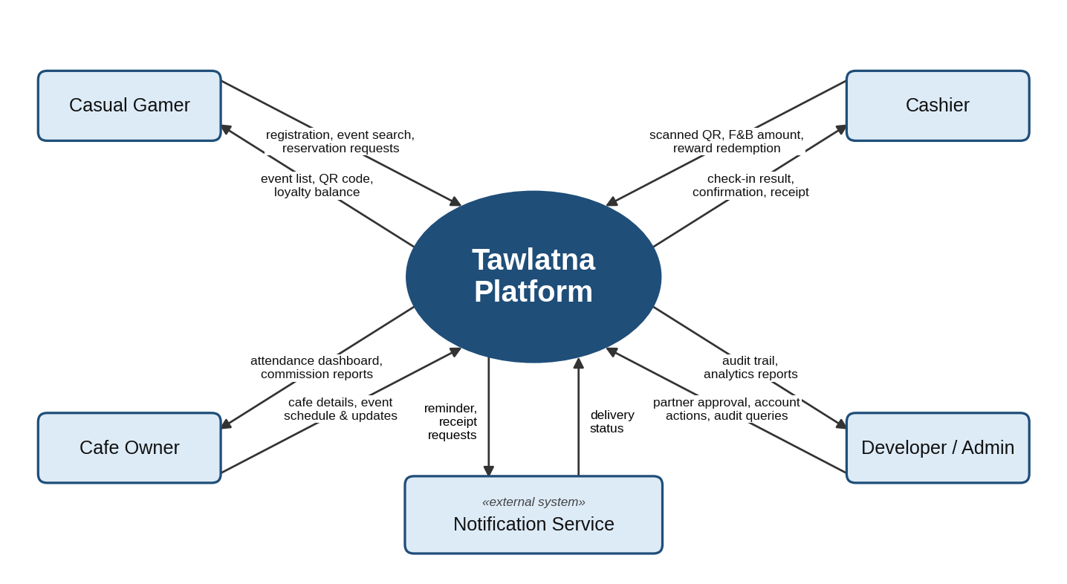
Figure 2 – Context diagram of the Tawlatna platform
Table 7.1 – Data flows at the system boundary
External entity | Sends to Tawlatna | Receives from Tawlatna
Casual Gamer | Registration details; event search filters; seat reservation requests; cancel or modify requests | Event list; real-time seat availability; reservation confirmation and QR code; loyalty balance
Cafe Owner | Café details; event schedule (date, time, capacity, game list, recurrence); event updates or cancellations | Live attendance dashboard; commission reports; underbooked-event alert
Cashier | Scanned QR code; F&B total; reward redemption request; manual reservation search | Reservation details and check-in result; transaction confirmation and new loyalty balance; invalid or already-used QR alerts; receipt
Developer / Admin | Partner approval decisions; account create, suspend or delete actions; audit queries; analytics requests | Partner applications; audit trail; platform analytics
Notification Service (external) | Delivery status | Reminder, notification and receipt requests
Boundary note: Apple Pay and STC Bank appear as key partners in the Business Model Canvas and feasibility study. Seat reservations are paid directly in the app, and the F&B commission is collected from the café register..

8. Project Management

8.1 Development approach
Tawlatna will be built with an Agile, incremental approach. The MoSCoW-prioritized use case list (Section 6.2) acts as the product backlog: Must-have use cases are built first, each increment ends with working software that is reviewed, and the team adapts the plan after every review. All code is committed daily to a company-owned GitHub/GitLab repository with standard documentation, using a modular stack (Flutter front end, Firebase/Node.js back end).
Table 8.1 – Proposed release plan (derived from the MoSCoW priorities and the feasibility milestones)
Increment | Target | Use cases | Goal
1. Core booking and check-in | Month 4 (beta) | UC-1, UC-2, UC-3, UC-7 | Players browse and reserve seats, receive QR codes, cafés schedule board-game sessions, cashiers check players in, and admins manage accounts.
2. Transactions and loyalty | Month 6 (soft launch) | UC-4, UC-5, UC-6 | Cashiers log F&B transactions, loyalty points are recorded, and the platform produces commission reports and transaction audits.
3. Stabilization and refinement | Month 7 and after | Refinement of UC-1 to UC-7 | Improve performance, offline handling, reporting accuracy, and user feedback across the seven consolidated use cases.
The revised use-case model contains seven consolidated use cases; the board-game catalog is not a separate use case in this version.

8.2 Team and roles
Role | Responsibility | Requirements
Managing Director | Overall strategy, legal compliance, profit and loss management | Bachelor's in Business/Management; 5+ years' experience
CTO / Lead Mobile Developer | App architecture, payment-gateway security, portal maintenance | B.Sc. in Computer Science/Software Engineering; mobile-development proficiency
Cafe Partner Manager | Café acquisition, contract negotiation, relationship management | BA in Business/Marketing; strong Jeddah network
Lead Game Master | Curates game kits, localizes rulebooks, schedules hosts | Community-hosting experience; board-game expertise
The founding team oversees all functions for the first three months. Planned additions: a Social Media Specialist and a Customer Support Representative within six months, then two part-time Field Game Masters and a Business Analyst within the first year, for a team of nine by the end of Year 1.

8.3 Schedule
The project runs 7 months from initial setup to public launch in Jeddah. A detailed task-level schedule will be developed by the assigned project team once the project is approved.
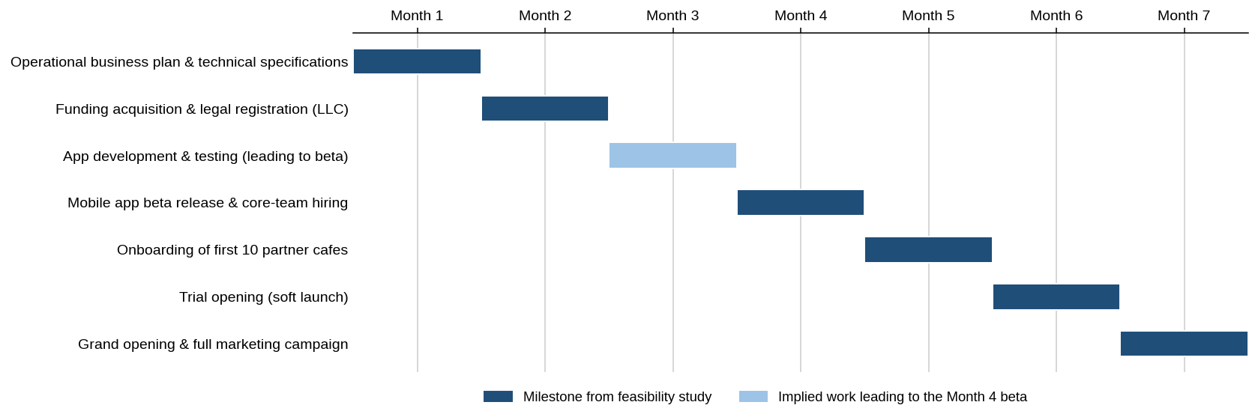
Figure 3 – Project schedule (Months 1–7)

8.4 Budget and financial plan
Initial seed funding is SAR 250,000, financed entirely by equity (SAR 187,500 from the founders and SAR 62,500 from an angel investor or seed grant), with no debt. Break-even is expected in Month 10, requiring about 1,200 active monthly bookings across 15 partner cafés.
Financial summary (SAR) | Year 1 | Year 2 | Year 3
Sales (commissions and booking fees) | 320,000 | 780,000 | 1,450,000
Net profit | 92,625 | 360,750 | 711,750
Total assets | 250,000 | 420,000 | 700,000
Net cash flow | 295,000 | 335,000 | 680,000
Assumptions: the seed funding is secured before Month 1; all milestones are completed on schedule; figures are annual totals with no carry-over of transactions between years. Expected return on investment is about 144% over three years, with dividends starting in Year 2.

8.5 Risk management
Risk | Scenario | Impact / likelihood | Mitigation and contingency
Human resources | The CTO / lead developer leaves mid-project. | High / Medium | Company-owned repository, daily commits, documentation and a modular stack so a replacement developer can start within 48–72 hours.
Café partner operations | Café staff forget or refuse to scan QR codes during busy shifts. | High / High | Single-tap verification on the dashboard; quarterly incentives for baristas based on verified transactions.
Technical | A payment gateway (Apple Pay or STC Bank) is down during peak hours. | High / Low | Offline-cached QR codes on the customer's device; cafés scan and cache checks locally and sync when connectivity returns.
Market / retention | Customers stop booking after 1–2 game nights. | Medium / Medium | Loyalty points and a weekly rotation of featured board-game titles across partner cafés.
Broader risk categories
Category | Risk | Mitigation
Internal | A small team needs multi-disciplinary skills. | Agile practices; outsource non-core administrative tasks.
External market | Low barista adoption or improper QR scanning. | Ultra-simple tablet UI that needs less than one minute of training.
Economic | Inflation in café prices could reduce spending. | Keep the value centered on low-cost social entertainment.
Regulatory | Updates to e-wallet transaction policy. | Strict adherence to SAMA guidelines for digital transactions.

8.6 Legal and regulatory compliance
- SDAIA (Saudi Data & AI Authority) data-protection rules.
- ZATCA e-invoicing requirements.
- SAMA guidelines for digital-wallet transactions.
- Standard commercial registration (CR) and licensing fees.

