ReqSoftware Engineering Lab: From Personas & Requirements to Use Cases & UML
Course: CS3151 Software Engineering
Lab Duration: 2–3 hours (with a 1-week post‑lab)
Context: You already have a Business Model Canvas, initial requirements, and customer personas for your project. In this lab you will transform these into use cases and a consistent set of UML artifacts.

Learning Objectives
By the end of this lab, you will be able to:
1. Identify actors and user goals from personas and requirements.
2. Define and prioritize a use case list; write both brief and fully dressed use cases.
3. Draw a Use Case Diagram with correct system boundary, includes/extends, and generalization.
4. Elaborate behavior with Activity and Sequence Diagrams for key scenarios.
5. Extract a Domain Model (Class Diagram) from the problem domain (not the database schema).
6. Check consistency across artifacts and run a structured peer review.

Deliverables (What to Submit)
Upload a single PDF named TeamName_UML_Lab.pdf containing: -
• D1. Use Case List (prioritized with MoSCoW or similar) and Actor definitions
• D2. Two fully dressed Use Case specifications (one primary, one alternate/edge)
• D3. Use Case Diagram
• D4. Activity Diagram for the most complex use case
• D5. Sequence Diagram for the main success scenario
• D6. Domain Model (Class Diagram)
• D7. Consistency checklist + Peer-review sheet
(Optionally, include PlantUML source in an appendix.)

Tooling (Choose any)
- Draw.io/diagrams.net, StarUML, PlantUML, Lucidchart, Visual Paradigm
- If using PlantUML, keep code blocks in your appendix for reproducibility.

Lab Steps & Activities

Step 0 — Warm‑up (10 min)
Quickly re‑read your personas and top 10 user stories/requirements. Highlight verbs (actions) and nouns (entities). Keep these highlights visible.
Personas (from Lab 2): Casual Gamer (Omar), Cafe Owner (Layla), Cashier (Ahmed), Developer/Admin.
Key Verbs (Actions): browse, filter, reserve, cancel, check in, scan, log, apply, redeem, schedule, audit, verify, notify, calculate.
Key Nouns (Entities): Cafe, Event, Reservation, Seat, QR Code, Casual Gamer, Cashier, Cafe Owner, Transaction, F&B Item, Loyalty Account, Loyalty Point, Reward, Commission, Audit Log, Notification.

Step 1 — Identify Actors & Goals (25 min)
- List all external actors (human roles, systems, devices, timers).
- For each persona, map to one or more actors.
- Derive user goals (what success looks like for each actor).
Template: Actor Card
Actor | Description | Triggers/Interests | Challenges | Notes
Casual Gamer | End user who reserves seats and attends board game events | Wants to find events quickly, reserve seats, earn loyalty points | Messy coordination, missing reminders, unclear loyalty balances
Cafe Owner | Partner who hosts board game events at their cafe | Wants more foot traffic, higher F&B revenue, transparent commission reports | Empty off-peak hours, expensive ads, manual accounting
Cashier | Staff member who checks in players and logs F&B transactions | Fast check-in, accurate transaction logging, loyalty application | Long queues, damaged QR codes, internet outages
Developer / Admin | Platform operator who manages accounts and audits data | Platform integrity, commission accuracy, fraud detection | Manual verification, data anomalies, policy violations
Persona → Actor Mapping
Persona | Actor(s)
Casual Gamer | Casual Gamer
Cafe Owner | Cafe Owner
Cashier | Cashier
Developer / Admin | Developer / Admin
User Goals
- Casual Gamer: Discover a nearby board game event, reserve a seat, check in with QR, earn loyalty points, redeem rewards.
- Cafe Owner: Schedule recurring events, fill off-peak tables, track attendance and revenue, receive accurate commission reports.
- Cashier: Check players in fast, log F&B transactions correctly, apply loyalty points, handle offline mode.
- Developer / Admin: Approve partners, audit transactions, verify 15% commission, manage accounts, generate platform analytics.

Step 2 — Draft the Use Case List (20 min)
Create a candidate list of use cases (goal‑level). Avoid UI details; think outcomes.
Checklist: -
- Named as Verb + Noun (e.g., Place Order, Schedule Pickup)
- Scope is the system, not a single page/button
- Prioritize with MoSCoW (Must, Should, Could, Won’t for now)
Template: Use Case List
ID | Use Case Name | Primary Actor | Goal/Outcome | Priority (M/S/C/W)
UC-1 | Place Order | Customer | Order submitted and paid | M
Traceability matrix.
ID | Use Case Name | Primary Actor | Goal / Outcome | Priority (M/S/C/W)
UC-1 | Register Account | Casual Gamer / Cafe Owner | Account created and verified | M
UC-2 | Browse Board Game Events | Casual Gamer | Events displayed based on filters | M
UC-3 | Reserve Seat | Casual Gamer | Seat reserved; QR code issued | M
UC-4 | Cancel Reservation | Casual Gamer | Reservation cancelled; seat released | S
UC-5 | Receive Event Notification | Casual Gamer | Reminder pushed before event | M
UC-6 | Schedule Board Game Event | Cafe Owner | Event session created and published | M
UC-7 | Manage Event Session | Cafe Owner | Event updated, paused, or cancelled | S
UC-8 | Scan QR Code & Check-In Player | Cashier | Player validated and checked in | M
UC-9 | Log F&B Transaction | Cashier | Transaction recorded; commission calculated | M
UC-10 | Apply Loyalty Points | Cashier | Points credited to player's account | M
UC-11 | Redeem Loyalty Reward | Cashier | Reward applied; points deducted | S
UC-12 | View Attendance Dashboard | Cafe Owner | Live attendance and orders displayed | S
UC-13 | Generate Commission Report | Cafe Owner | End-of-event financial summary produced | M
UC-14 | Audit Transactions | Developer | Transactions and commissions verified | M
UC-15 | Manage User Accounts | Developer | Accounts created, suspended, or deleted | S
UC-16 | Approve Cafe Partner | Developer | Cafe partner verified and activated | M
UC-17 | Generate Platform Analytics | Developer | Platform-wide metrics produced | C
UC-18 | Manage Board Game Catalog | Developer | Game categories and metadata updated | W
Traceability Matrix
User Story (Lab 2) | Use Case(s)
Filter events by game/distance | UC-2
Reserve seat + QR | UC-3
Cancel/modify reservation | UC-4
Push reminders | UC-5
Create recurring events | UC-6
Live attendance dashboard | UC-12
End-of-event commission report | UC-13
Scan QR / check-in | UC-8
Log F&B transaction | UC-9
Loyalty points | UC-10, UC-11
Audit transactions | UC-14
Verify partner accounts | UC-16

Step 3 — Write Use Case Specifications (35 min)
Select two use cases: one core (happy path) and one complex/edge.
A. Brief (for all use cases)
Use Case | Primary Actor | Pre-conditions | Post-conditions | Main Success Scenario (1–2 lines)
UC-1 Register Account | Casual Gamer / Cafe Owner | User has valid email/phone | Account created and verified | User submits details → system validates → account activated
UC-2 Browse Events | Casual Gamer | User is on app | Filtered event list displayed | User applies filters → system returns matching events
UC-3 Reserve Seat | Casual Gamer | User authenticated; event has available seats | Reservation confirmed; QR issued | User selects seats → system confirms → QR generated
UC-4 Cancel Reservation | Casual Gamer | Reservation exists and event starts in more than 1 hour | Seat released; QR invalidated | User requests cancel or modify → system updates availability
UC-5 Receive Notification | Casual Gamer | Reservation confirmed | Push/email delivered | System schedules reminder → sends 2h before event
UC-6 Schedule Event | Cafe Owner | Owner authenticated; cafe approved | Event published to players | Owner sets date/time/capacity, game list and recurrence pattern → system publishes
UC-7 Manage Event | Cafe Owner | Event exists | Event updated or cancelled | Owner edits or cancels → players notified
UC-8 Check-In Player | Cashier | Player QR present | Player checked in | Cashier scans QR → system validates (alerts cashier if QR is invalid or already used) → status updated
UC-9 Log F&B Transaction | Cashier | Player checked in | Transaction logged; 15% commission recorded | Cashier enters amount → scans QR → system logs
UC-10 Apply Loyalty Points | Cashier | Transaction logged | Points credited | System calculates points → updates player account
UC-11 Redeem Reward | Cashier | Player has enough points | Reward applied; points deducted | Cashier selects reward → system deducts points
UC-12 View Dashboard | Cafe Owner | Event in progress | Live data displayed | System streams attendance and orders
UC-13 Commission Report | Cafe Owner | Event ended | Report generated and downloadable | System aggregates F&B data → applies 15% → report
UC-14 Audit Transactions | Developer | Transactions exist | Audit trail produced | Developer filters transactions → system returns log
UC-15 Manage Accounts | Developer | Account exists | Account updated | Developer creates/suspends/deletes → audit logged
UC-16 Approve Partner | Developer | Partner application received | Partner activated | Developer verifies documents → activates account
UC-17 Platform Analytics | Developer | Data available | Analytics produced | System aggregates KPIs
UC-18 Manage Game Catalog | Developer | Authenticated | Catalog updated | Developer adds/edits categories

B. Fully Dressed (for 2 selected cases)
Each activity in the UC
Field | Content
Use Case | UC-3: Reserve Seat
Primary Actor | Casual Gamer
Stakeholders & Interests | Casual Gamer (fast, hassle-free reservation); Cafe Owner (accurate capacity); Tawlatna (fair seat allocation, accurate attendance)
Preconditions | User is registered and authenticated; selected event has at least one available seat; event not yet started
Postconditions | Reservation recorded; seat count decremented; QR code issued and stored in user's account; confirmation notification queued
Main Success Scenario (Flow of Control) | 1) User opens event detail page  2) System displays real-time seat availability  3) User selects number of seats (1–4)  4) System validates availability  5) System creates reservation and reserves seats  6) System generates unique QR code linked to the table  7) System displays confirmation and QR code  8) System schedules reminder notification for 2h before event
Extensions (Alternatives) | 3a) User requests >4 seats → system caps at 4 and informs user  4a) Seats no longer available → offer waitlist or suggest alternative events  6a) QR generation fails → reservation stored; QR retried and pushed on next sync  7a) User is offline → reservation cached; sync on reconnect
Special Requirements (NFRs) | Reservation response time < 3 seconds; QR code generated < 3 seconds; system availability ≥ 99% on event nights; QR codes must be unique per reservation
Business Rules | Max 4 seats per reservation; seats are non-transferable; QR expires 30 minutes after event ends; cancellation or modification allowed up to 1 hour before event
Open Issues | Behavior when owner cancels event after reservations are made (auto-notify and refund policy?); interaction with waitlist priority
Field | Content
Use Case | UC-9: Log F&B Transaction
Primary Actor | Cashier
Stakeholders & Interests | Cashier (fast, error-free entry); Casual Gamer (accurate loyalty points); Cafe Owner (reliable revenue log); Tawlatna (accurate 15% commission and audit trail); Developer (auditable records)
Preconditions | Player is checked in (UC-8 complete); cashier authenticated; tablet connected (or offline mode active)
Postconditions | Transaction recorded with timestamp, amount, player QR ID, cafe ID; 15% commission computed; loyalty points credited to player; receipt offered to player; audit log entry created
Main Success Scenario (Flow of Control) | 1) Cashier opens transaction mode  2) Cashier enters total F&B amount (or selects items)  3) Cashier scans player's QR code  4) System retrieves player and reservation  5) System validates QR is valid and belongs to a checked-in player  6) System records transaction with timestamp and amount  7) System calculates 15% commission (platform) and 85% net (cafe)  8) System credits loyalty points (1 point per 1 SAR) to player  9) System displays updated balance and confirmation  10) System offers receipt (print/email)  11) System writes entry to audit log
Extensions (Alternatives) | 3a) QR invalid → display error, offer manual search by name/phone  5a) Player not checked in → prompt cashier to check in first (link to UC-8)  6a) Offline mode → store transaction locally (up to 100); auto-sync when online  7a) Transaction marked as tip → tip excluded from 15% commission  8a) Loyalty redemption requested → invoke UC-11; then credit remaining  10a) Receipt printing fails → retry; log error
Special Requirements (NFRs) | Transaction logging < 20 seconds end-to-end; 15% commission rounded to 2 decimals; offline storage supports ≥ 100 cached transactions; sync conflict resolution within 60 seconds of reconnect; PCI-like protections for any payment references
Business Rules | Commission fixed at 15% on F&B only; tips excluded; loyalty ratio 1 point per 1 SAR; refunds reverse commission and loyalty proportionally
Open Issues | Refund flow behavior (commission and loyalty reversal); handling multi-player group payments; tax handling in commission base

Step 4 — Draw the Use Case Diagram (20 min)
Include system boundary, actors, associations, and use relationships («include», «extend», generalization when justified.

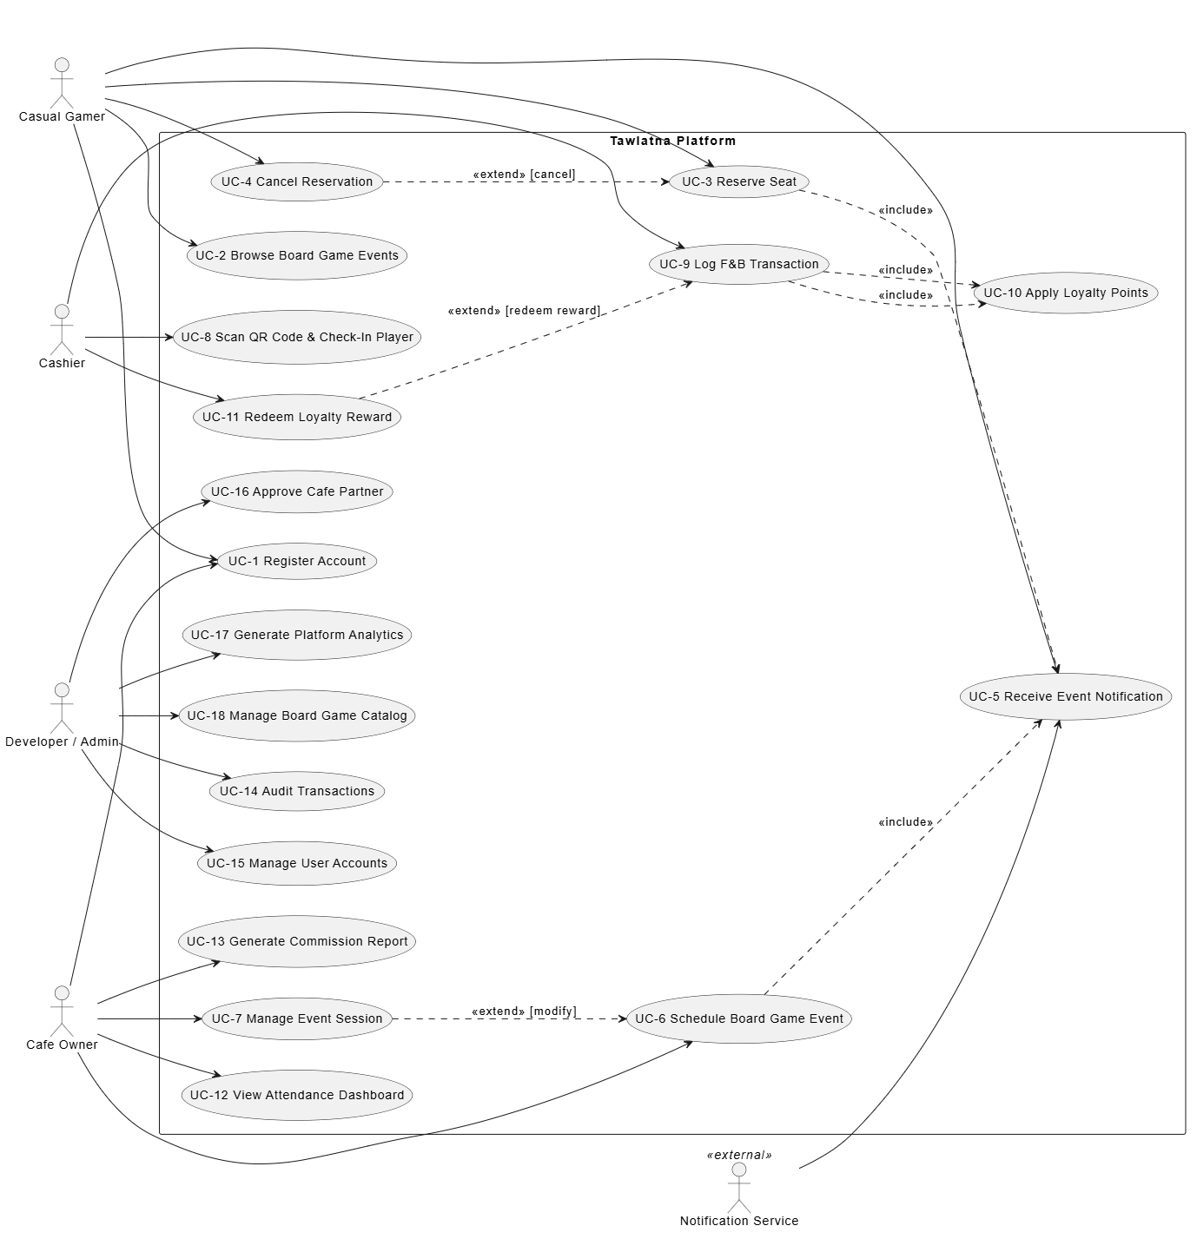

Step 5 — Elaborate Behavior
5A. Activity Diagram for the Complex Case (25 min) Model the workflow including decisions, parallelism (fork/join), and guards.
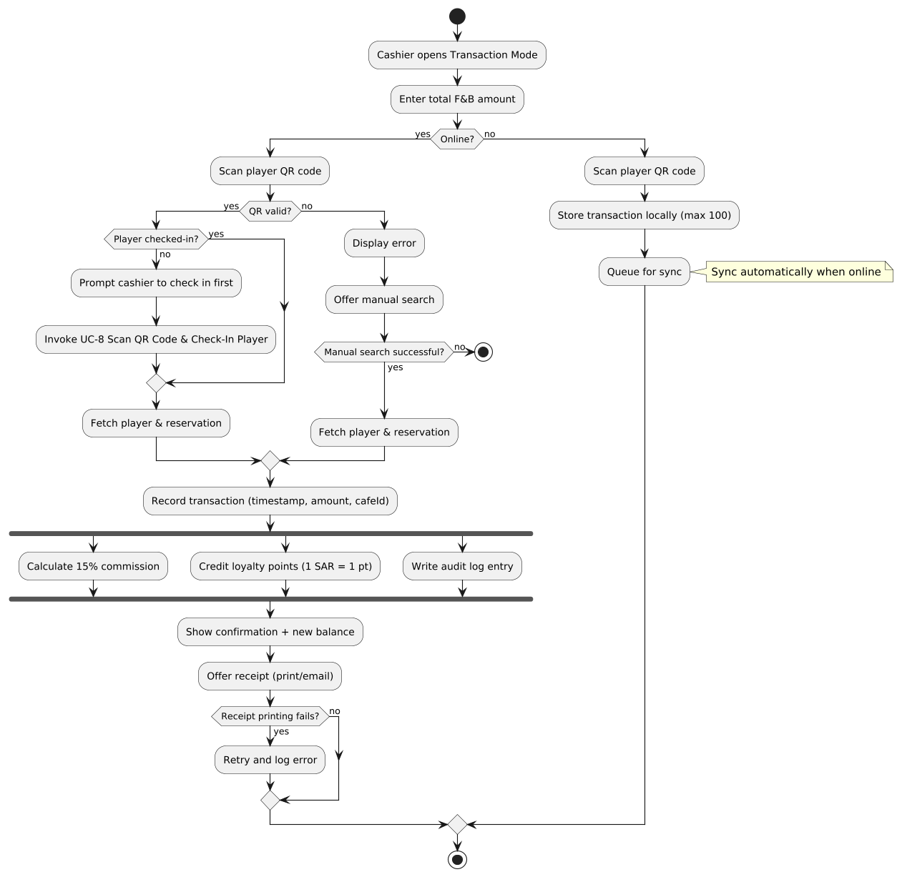

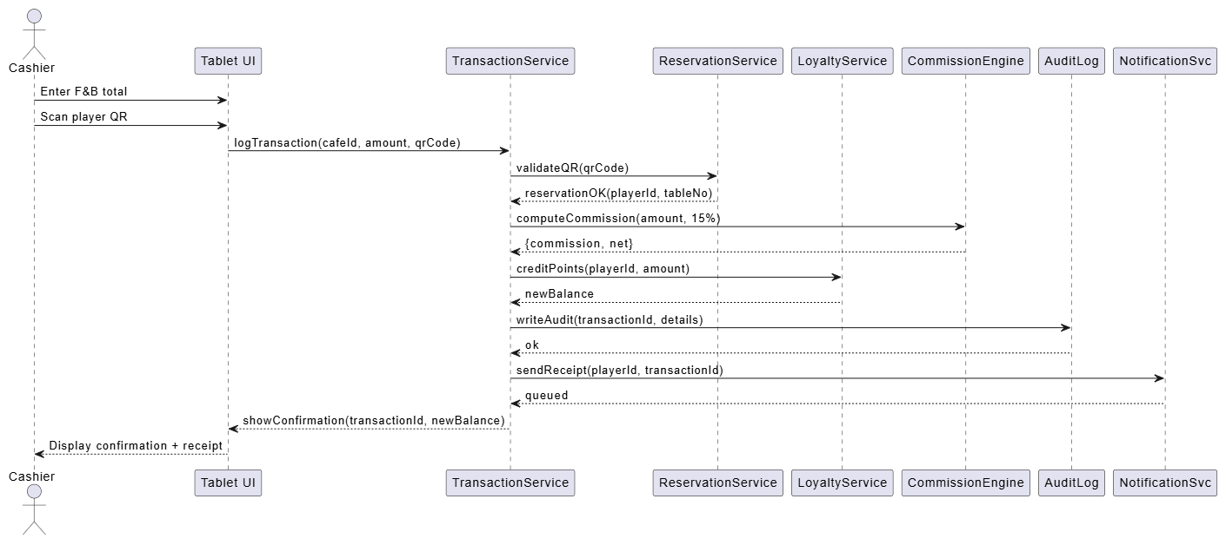
5B. Sequence Diagram for Main Success (25 min) Capture object interactions and lifelines.

Step 6 — Domain Model (Class Diagram) (30 min)
Extract domain concepts (nouns) and relationships (associations, multiplicities, composition) from your requirements and use cases. Avoid technical/database details.

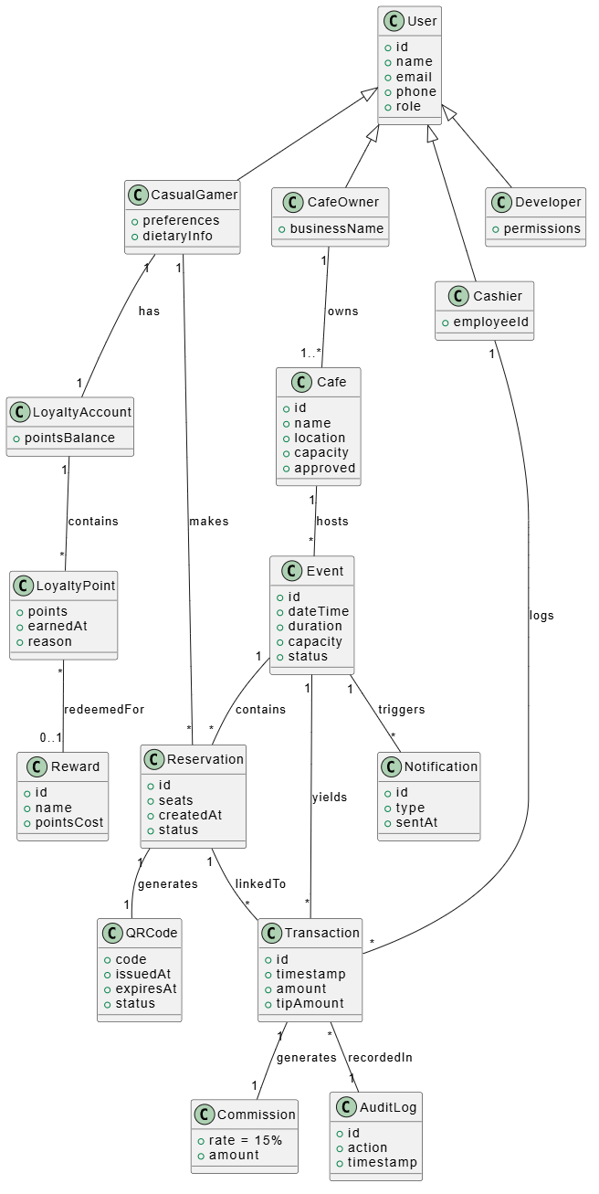
tableNo

Step 7 — Consistency Checks (10 min)
- Every use case is traceable to at least one actor and appears in the Use Case Diagram.
- The Sequence Diagram messages align with the Main Success Scenario steps.
- The Activity Diagram branches match Extensions/guards in the use case.
- All domain classes appear in at least one use case/sequence; names consistent.
- Non‑functional constraints in the use case appear as notes/stereotypes where relevant.

Step 8 — Peer Review (15 min)
Swap with another team and complete the checklist below.
Peer‑Review Checklist –
[ ] Actors cover all personas and external systems –
[ ] Use case names are goal‑level and unambiguous –
[ ] Includes/extends used sparingly and correctly –
[ ] Activity/Sequence diagrams match narratives –
[ ] Class diagram avoids UI/DB details; multiplicities make sense –
[ ] Clear pre/post‑conditions and success guarantees –
[ ] Consistency across all artifacts –
[ ] Clarity, readability, and professional style

Grading Rubric (100 pts)
Component | Criteria | Pts
Actors & Use Case List | Complete, prioritized, correct scoping | 15
Fully Dressed Use Cases (×2) | Preconditions, MSS, extensions, NFRs | 25
Use Case Diagram | Correct notation, relationships, boundary | 15
Activity Diagram | Flow accuracy, guards, concurrency | 15
Sequence Diagram | Lifelines, messages align with MSS | 15
Domain Model | Correct concepts/relations, multiplicities | 10
Consistency + Peer Review | Checklist evidence, coherence | 5

Submission & Naming
- File: TeamName_UML_Lab.pdf. If using PlantUML, append a ZIP with .puml sources.

Extension (Optional, for +5 pts each)
Extension A — State Machine Diagram: Reservation Lifecycle
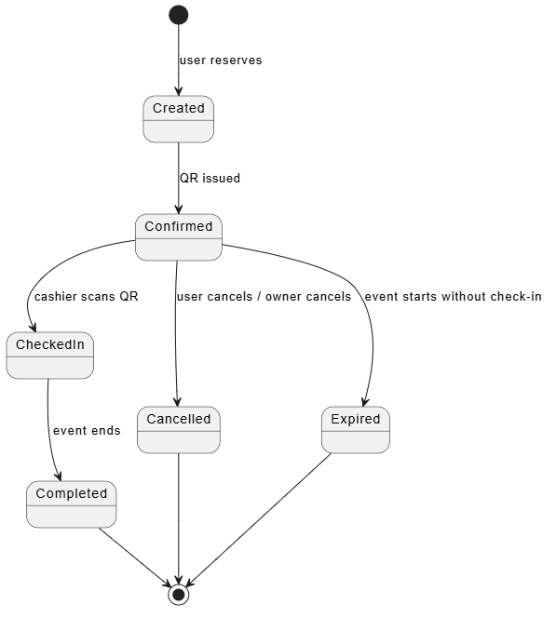
Extension B — System Sequence Diagram: Offline Sync (Alternative Flow of UC-9)
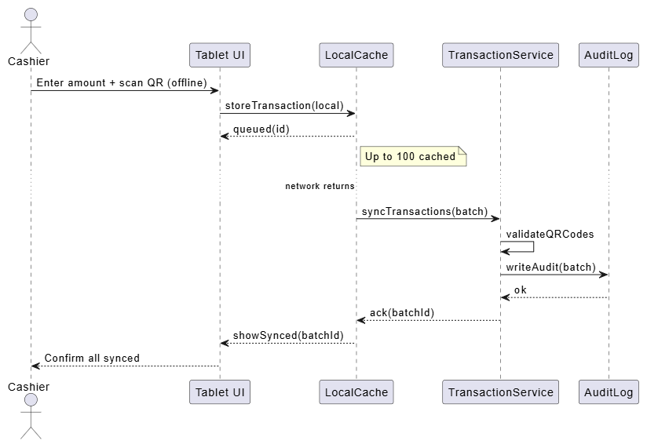

Quick Reference — When to Use Which UML
- Use Case Diagram: scope & goals from user perspective
- Activity Diagram: end‑to‑end workflow with decisions/parallelism
- Sequence Diagram: object interactions over time for a scenario
- Class Diagram: static domain structure and relationships
- State Machine: lifecycle of a complex entity
Tip: Start from personas → goals → use cases; only then elaborate behavior and structure. Keep names consistent across all artifacts.

