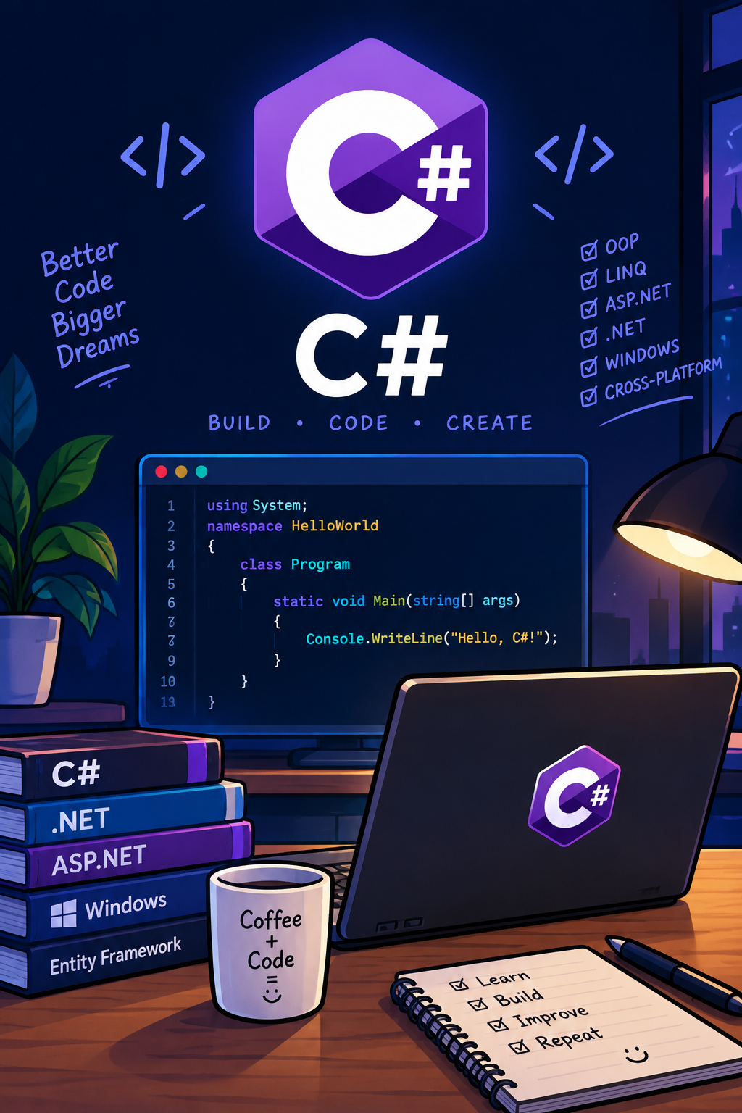  prog6212  POE Part 1 Section B | Abstract  Tables representing API Endpoint plan  Fayyaadh Davies  API ENDPOINT PLAN

Authentication
HTTP Method | Route | Description | Role Requirements | Request body | Expected response
POST | /api/auth/register | Register a new participant | Public | Name, email, hashed password | 201 created
POST | /api/auth/login | Authenticate user | Public | Email, password | JWT token + user detail+ role
POST | /api/auth/logout | Logout | Authenticated | None | 200 OK

User Profile
HTTP Method | Route | Description | Role Requirements | Request body | Expected response
GET | /api/users/me | View own profile | Authenticated | None | User profile
PUT | /api/users/me | Edit own profile | Authenticated | Updated profile | Updated profile
DELETE | /api/user/me | Delete own account | Authenticated | None | 204 no content
GET | /api/user/{id} | View user | Admin/Organiser | None | User details

Events
HTTP Method | Route | Description | Role Requirements | Request body | Expected response
GET | /api/events | View all upcoming events | public | None | Event list
GET | /api/events/{id} | View events  information | public | None | event
POST | /api/events/ | Create event | Admin/Organiser | Event details | 201Created
PUT | /api/events/{id} | Edit event | Admin/Organiser | Event details | 200 OK
DELETE | /api/events/{id} | Delete event | Admin/Organiser | None | 204 no content

Categories
HTTP Method | Route | Description | Role Requirements | Request body | Expected response
GET | /api/categories | View categories | public | None | Category list
GET | /api/categories /{id} | View category | public | None | Category
POST | /api/categories | Create category | Admin/Organiser | Category details | 201Created
PUT | /api/categories /{id} | Edit category | Admin/Organiser | Category details | 200 OK
DELETE | /api/categories /{id} | Delete category | Admin/Organiser | None | 204 no content

Event Enrolment
HTTP Method | Route | Description | Role Requirements | Request body | Expected response
POST | /api/enrolments | Enter an event | Participant | EventID, CategoryID | 201 created
GET | /api/enrolments /me | View own enrolments | Participant | None | Enrolment list
GET | /api/events/{id}/enrolments | View event enrolments | Admin/Organiser | None | Participant list
GET | /api/enrolments/{id} | View enrolment | Participant/Organiser | None | Enrolment
DELETE | /api/enrolments/{id} | Cancel enrolment | Participant | None | 204 no content

Results
HTTP Method | Route | Description | Role Requirements | Request body | Expected response
POST | /api/results | Capture participant results | Admin/Organiser | EnrolmentID,finish time, position | 201 created
PUT | /api/results/{id} | Update result | Admin/Organiser | Result detail | 200 OK
GET | /api/results/{id} | View result | Participants/Organiser | None | Result
GET | /api/participants/me/results | View personal performance history | Participant | None | Result history
GET | /api/events/{id}/results | View event results | Public/Organiser | None | Result list

Route And Weather Information
HTTP Method | Route | Description | Role Requirements | Request body | Expected response
GET | /api/events/{id}/route | View race route | Public | None | Route information
POST | /api/events/{id}/route | Add route | Admin/Organiser | Route details | 201 created
PUT | /api/events/{id}/route | Update route | Admin/Organiser | Route details | 200 OK
GET | /api/events/{id}/weather | View current weather | Public | None | Weather information
GET | /api/events/{id}/enviro nment | View current environment | Public | None | Environment information

