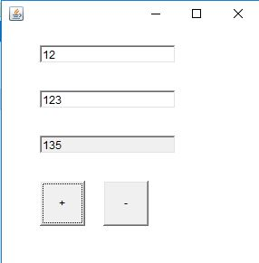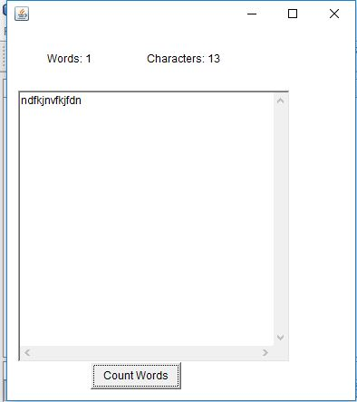

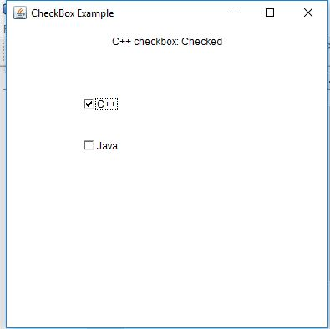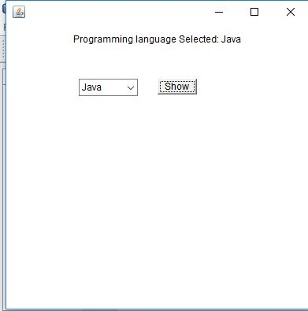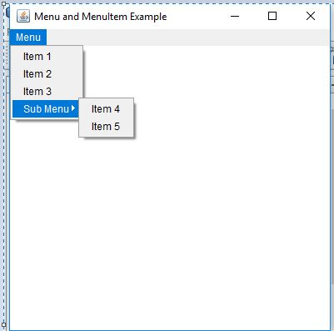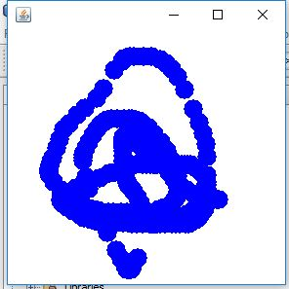

Sound beep event.

GUIs generate events when the user interacts with GUI. For example,

— Clicking a button

— Moving the mouse

— Closing Window etc.

Both AWT and swing components (not all) generate even

— java.awt.event.*;

— javax.swing.event.*;

These objects tells us about event and its source. Examples are:

— ActionEvent (Clicking a button)

— WindowEvent (Doing something with window e.g. closing , minimizing)

**Event Handling Steps**

For a programmer the event Handling is a three step process in terms of code

– **Step 1:** Create components which can generate events (Event Generators)

– **Step 2:** Build component (objects) that can handle events (Event Handlers)

– **Step 3:** Register handlers with generators

**Event Handling Process**

**Step 1: Event Generators**

The first step is that you create an event generator. You have already seen a lot of event generators like:

– Buttons

– Mouse

– Key

– Window etc

Most of GUI components can be created by calling their constructors. For example

JButton b1 = new JButton(“Hello”);

Now b1 can generate events

**Note:** We do not create Mouse/Keys etc as they are system components

**Step 2: Event Handlers/ Event Listener**

The second step is that you build components that can handle events

First Technique - *By Implementing Listener Interfaces*

– Java defines interfaces for every event type

– If a class needs to handle an event. It needs to implement the corresponding listener interface

– To handle “ActionEvent” a class needs to implement “ActionListener”

– To handle “KeyEvent” a class needs to implement “KeyListener”

– To handle “MouseEvent” a class needs to implement “MouseListener” and so on

**Step 3: Registering Handler with Generator**

The event generator is told about the object which can handle its events

Event Generators have a method

— addXXXListener(_reference to the object of Handler class_)

For example, if b1 is JButton then

— b1.addActionListener(this); // if listener and generator are same class

**Event Handling Example**

1. import java.awt.*;

2. import javax.swing.*;

**3. import java.awt.event.*;**

/* Implementing the interface according to the type of the event, i.e. creating event handlpart of step 2 of our process) */

4. public class ActionEventTest

**implements ActionListner{**

5. JFrame frame;

6. JButton hello;

// setting layout components

7. public void initGUI ( ) {

8. frame = new JFrame();

9. Container cont = frame.getContentPane();

10. cont.setLayout(new FlowLayout());

//Creating event generator step-1 of our process

11.**hello = new JButton("Hello");**

/* Registering event handler with event generator.

Since event handler is in same object that contains

button, we have used this to pass the reference.(step

3 of the process) */

12.**hello.addActionListener(this);**

13. cont.add(hello);

14. frame.setDefaultCloseOperation(JFrame.EXIT_ON_CLOSE);

15. frame.setSize(150, 150);

16. frame.setVisible(true);

17. }

//constructor

18. public ActionEventTest ( ) {

19. initGUI();

20. }

/* Override actionPerformed method of ActionListener’s

interfacemethod of which will be called when event

takes place (second part of step 2 of our process) */

**21. public void actionPerformed(ActionEvent event) {**

**22. JOptionPane.showMessageDialog(null,"Hello is pressed");**

**23. }**

24. public static void main(String args[]) {

25. ActionEventTest aeTest = new ActionEventTest();

26. }

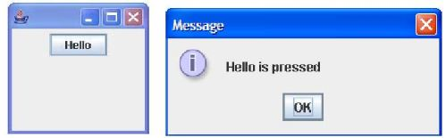27.} // end class