Project title: Developing a sustainable and decarbonized energy management system in the Nordic Green Transition
Acronym: NORDIC-EMS

Project webpage: https://fayzulsaimun.github.io/nordic-ems-site/

Kick-off meeting –September 25th 2026

Venue – Østfold University of Applied Sciences,
Fredrikstad –Building H, Room H-232

Time | Activity | Speaker
9.30-10.00 | Welcome & Coffee
10-10.15 | Opening session | Vice - Dean
10.15-10.45 | Project objectives, WPs, Milestones | Project Manager, Lucian MIHET  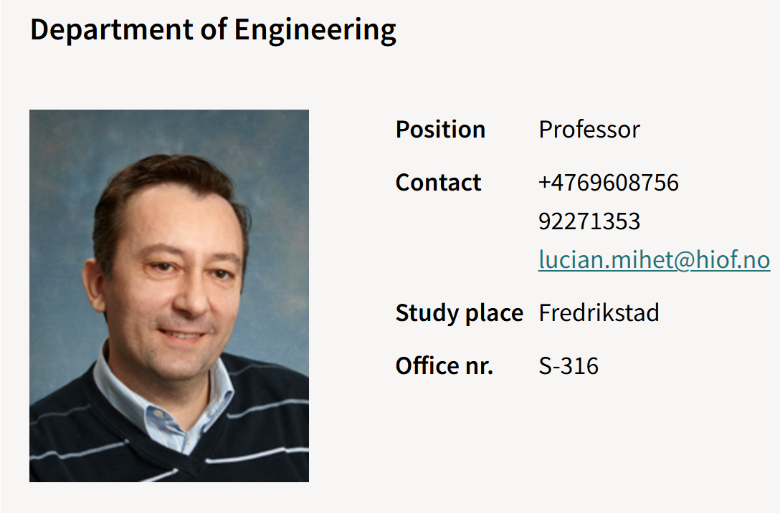
10.45-11.15 | Project partners, Observers and Research groups | All
11.15-11.45 | Mobility tracks, activities, key targets/outputs | Lucian/All
11.45-12.15 | Coffee & Tea Break | All
12.15-13.00 | Budget & Expenses categories | Lucian/Project finance officer
13.00-14.00 | Lunch time | All
14.00-15.00 | Round table discussion | All

