**EX:No.3 221501031**

**07/01/25**

**IMPLEMENTING LINEAR REGRESSION MODEL USING TIME SERIES DATASET**

**AIM:**

To implement linear regression model using time series dataset.

**PROCESS:**

**#Importing libraries**

import numpy as np

import pandas as pd

import matplotlib.pyplot as plt

from sklearn.model_selection import train_test_split

from sklearn.linear_model import LinearRegression

from sklearn.metrics import mean_squared_error

**# Step 1: Generate Synthetic Time Series Data**

np.random.seed(42)

n = 100 # Number of data points

time = np.arange(n) # Time steps

trend = 0.5 * time # Linear trend

noise = np.random.normal(0, 5, n) # Gaussian noise

y = trend + noise # Synthetic target variable

**# Create a DataFrame**

df = pd.DataFrame({'Time': time, 'Value': y})

**# Step 2: Split Data into Training and Testing Sets**

X = df[['Time']]

y = df['Value']

X_train, X_test, y_train, y_test = train_test_split(X, y, test_size=0.2, shuffle=False)

**# Step 3: Train a Linear Regression Model**

model = LinearRegression()

model.fit(X_train, y_train)

**# Step 4: Predict and Evaluate**

y_pred = model.predict(X)

mse = mean_squared_error(y_test, model.predict(X_test))

rmse = np.sqrt(mse)

**# Print Model Performance**

print(f'RMSE: {rmse:.2f}')

**# Plot Results**

plt.figure(figsize=(10, 5))

plt.scatter(X.values, y, label='Actual Data', color='blue', alpha=0.5)

plt.plot(X.values, y_pred, label='Linear Regression Prediction', color='red', linewidth=2)

plt.xlabel('Time')

plt.ylabel('Value')

plt.legend()

plt.title('Linear Regression on Synthetic Time Series Data')

plt.show()

**OUTPUT:**

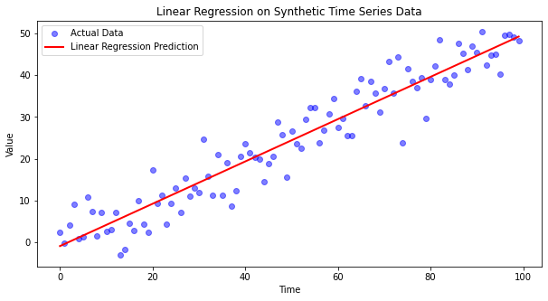

**RESULT:**

The program to implement linear regression is created and executed successfully.