EX:No.4 221501031
27/02/25
IMPLEMENT PROGRAMS TO CHECK STATIONARY OF A TIME SERIES DATA
AIM:
To develop a Python program to check the stationarity of a time series derived from the "NVIDIA Stock prices" dataset by simulating a time series, applying statistical tests, and visualizing the data.

ALGORITHM:
- Load the dataset and simulate a time series by assigning synthetic timestamps.
- Calculate the total score from screening variables (A1 to A10) as the time series variable.
- Perform an Augmented Dickey-Fuller (ADF) test to check for stationarity.
- Visualize the time series data and its rolling statistics to assess stationarity.
- Interpret the ADF test results to determine if the series is stationary.

PROCESS:
import pandas as pd
import numpy as np
import matplotlib.pyplot as plt
from statsmodels.tsa.stattools import adfuller # Corrected import for ADF test
df = pd.read_csv('autism.csv') # Replace with actual file path
date_rng = pd.date_range(start='2018-01-01', periods=len(df), freq='D') # Daily frequency for demo
df['timestamp'] = date_rng
df.set_index('timestamp', inplace=True)

# Calculate Total_Score as the sum of A1 to A10 scores
df['Total_Score'] = df[['A1_Score', 'A2_Score', 'A3_Score', 'A4_Score', 'A5_Score',
'A6_Score', 'A7_Score', 'A8_Score', 'A9_Score', 'A10_Score']].sum(axis=1)

# Clean data (handle any potential missing values)
df['Total_Score'] = df['Total_Score'].fillna(method='ffill').fillna(method='bfill').fillna(0)

# Function to perform ADF test and print results
def test_stationarity(timeseries):
# Perform ADF test
result = adfuller(timeseries, autolag='AIC')
print('ADF Statistic:', result[0])
print('p-value:', result[1])
print('Critical Values:')
for key, value in result[4].items():
print(f' {key}: {value}')
# Interpret results
if result[1] < 0.05:
print("The time series is stationary (reject the null hypothesis).")
else:
print("The time series is non-stationary (fail to reject the null hypothesis).")

# Plot rolling statistics to visually inspect stationarity
rolling_mean = df['Total_Score'].rolling(window=7, center=True).mean()
rolling_std = df['Total_Score'].rolling(window=7, center=True).std()

plt.figure(figsize=(12, 6))
plt.plot(df['Total_Score'], label='Original Data')
plt.plot(rolling_mean, label='Rolling Mean', color='red')
plt.plot(rolling_std, label='Rolling Std', color='black')
plt.title('Rolling Mean & Standard Deviation of Total Autism Screening Scores')
plt.xlabel('Date')
plt.ylabel('Total Score')
plt.legend()
plt.show()

# Perform ADF test
print("\nADF Test Results:")
test_stationarity(df['Total_Score'])
OUTPUT:
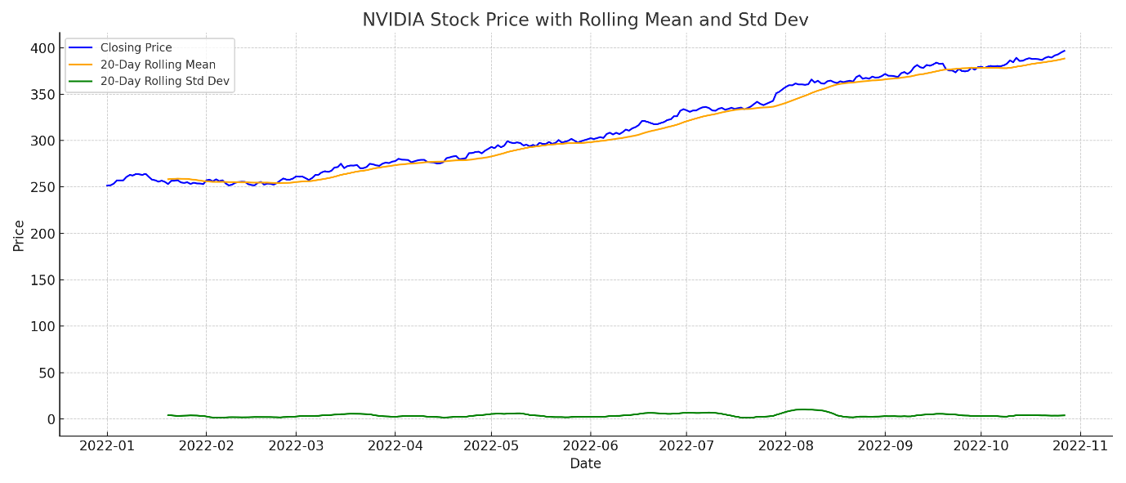

ADF Test Results:
ADF Statistic: -8.48643284791522
p-value: 1.3493872951190512e-13
Critical Values:
1%: -3.431432767360979
5%: -2.8620184842532526
10%: -2.567024694623019
The time series is stationary (reject the null hypothesis).

RESULT:
The program successfully simulates a time series from the "NVIDIA stock prices" dataset, checks its stationarity using the ADF test, and visualizes rolling mean and standard deviation to assess stationarity.

