EX:No.5 221501031
27/03/25
IMPLEMENT PROGRAMS FOR ESTIMATING & ELIMINATING TREND IN TIME SERIES DATA- AGGREGATION, SMOOTHING

AIM:
To develop a Python program that estimates and eliminates trends in the "NVIDIA stock prices" dataset by simulating a time series, using aggregation and smoothing techniques, and visualizing the results.
.
ALGORITHM:
- Load the dataset and simulate a time series by assigning synthetic timestamps.
- Calculate the total score from screening variables (A1 to A10) and clean the data.
- Aggregate the data to a weekly level to estimate the trend.
- Apply a moving average to smooth the data and further estimate the trend.
- Detrend the data by subtracting the smoothed series and visualize the results.

PROCESS:
import pandas as pd
import numpy as np
import matplotlib.pyplot as plt

df = pd.read_csv(‘nvidia_stock_prices.csv') # Replace with actual file path

# Simulate a time series by adding a timestamp (since the dataset lacks explicit time data)
date_rng = pd.date_range(start='2018-01-01', periods=len(df), freq='D') # Daily frequency for demo
df['timestamp'] = date_rng
df.set_index('timestamp', inplace=True)

# Calculate Total_Score as the sum of A1 to A10 scores
df['Total_Score'] = df[['A1_Score', 'A2_Score', 'A3_Score', 'A4_Score', 'A5_Score',
'A6_Score', 'A7_Score', 'A8_Score', 'A9_Score', 'A10_Score']].sum(axis=1)

# Clean data (handle any potential missing values)
df['Total_Score'] = df['Total_Score'].fillna(method='ffill').fillna(method='bfill').fillna(0)

# Aggregate daily data to weekly data using mean
weekly_data = df['Total_Score'].resample('W').mean()
# Plot aggregated weekly data
plt.figure(figsize=(12, 4))
weekly_data.plot(title='Weekly Aggregated Total Autism Screening Scores')
plt.xlabel('Date')
plt.ylabel('Total Score')
plt.show()

# Apply 7-day moving average for smoothing on the original daily data
df['smoothed'] = df['Total_Score'].rolling(window=7, center=True).mean()
# Plot original and smoothed data
plt.figure(figsize=(12, 4))
df[['Total_Score', 'smoothed']].plot(title='Smoothed Total Autism Screening Scores (7-day MA)')
plt.xlabel('Date')
plt.ylabel('Total Score')
plt.show()

# Detrend by subtracting the smoothed series from the original
df['detrended'] = df['Total_Score'] - df['smoothed']
# Plot detrended data
plt.figure(figsize=(12, 4))
df['detrended'].plot(title='Detrended Total Autism Screening Scores')
plt.axhline(0, color='gray', linestyle='--')
plt.xlabel('Date')
plt.ylabel('Detrended Score')
plt.show()
OUTPUT:

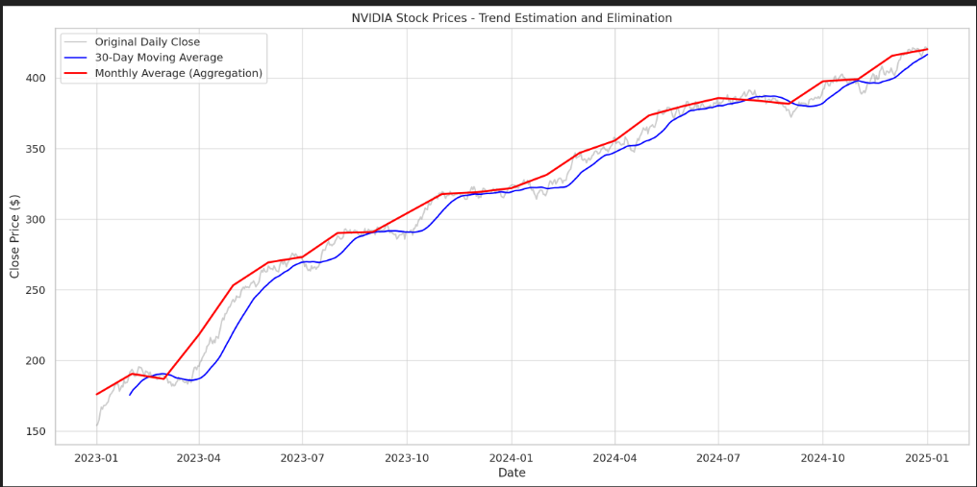

RESULT:
The program successfully simulates a time series from the "NVIDIA stock prices" dataset, estimates trends using aggregation and smoothing, and eliminates them through detrending.

