EX:No.6 221501031
01/04/25
IMPLEMENT PROGRAM TO APPLY MOVING AVERAGE SMOOTHING FOR DATA PREPARATION AND TIME SERIES FORECASTING
AIM:
To develop a Python program to apply moving average smoothing for data preparation and time series forecasting using the "NVIDIA stock prices" dataset, simulating a time series, and visualizing the results.
.
ALGORITHM:
- Load the dataset and simulate a time series by assigning synthetic timestamps.
- Calculate the total score from screening variables (A1 to A10) as the time series variable.
- Apply moving average smoothing to the time series data to reduce noise.
- Use the smoothed data to forecast future values with a simple moving average model.
- Visualize the original, smoothed, and forecasted data for comparison.

PROCESS:
import pandas as pd
import numpy as np
import matplotlib.pyplot as plt

df = pd.read_csv('nvidia_stock_prices.csv') # Replace with actual file path

# Simulate a time series by adding a timestamp (since the dataset lacks explicit time data)
date_rng = pd.date_range(start='2018-01-01', periods=len(df), freq='D') # Daily frequency for demo
df['timestamp'] = date_rng
df.set_index('timestamp', inplace=True)

# Calculate Total_Score as the sum of A1 to A10 scores
df['Total_Score'] = df[['A1_Score', 'A2_Score', 'A3_Score', 'A4_Score', 'A5_Score',
'A6_Score', 'A7_Score', 'A8_Score', 'A9_Score', 'A10_Score']].sum(axis=1)

# Clean data (handle any potential missing values)
df['Total_Score'] = df['Total_Score'].fillna(method='ffill').fillna(method='bfill').fillna(0)

# Apply moving average smoothing with a 7-day window
df['smoothed'] = df['Total_Score'].rolling(window=7, center=True).mean()

# Prepare data for forecasting (simple moving average forecast for the next 7 days)
forecast_periods = 7
last_smoothed_value = df['smoothed'].iloc[-1]
forecast = np.full(forecast_periods, last_smoothed_value) # Simple forecast using last smoothed value
forecast_index = pd.date_range(start=df.index[-1] + pd.Timedelta(days=1), periods=forecast_periods, freq='D')

# Combine original, smoothed, and forecast data for plotting
plt.figure(figsize=(12, 6))
plt.plot(df['Total_Score'], label='Original Data', color='blue')
plt.plot(df['smoothed'], label='Smoothed Data (7-day MA)', color='red')
plt.plot(forecast_index, forecast, label='Forecast', color='green', linestyle='--')
plt.title('Moving Average Smoothing and Forecasting of Total Autism Screening Scores')
plt.xlabel('Date')
plt.ylabel('Total Score')
plt.legend()
plt.show()

OUTPUT:

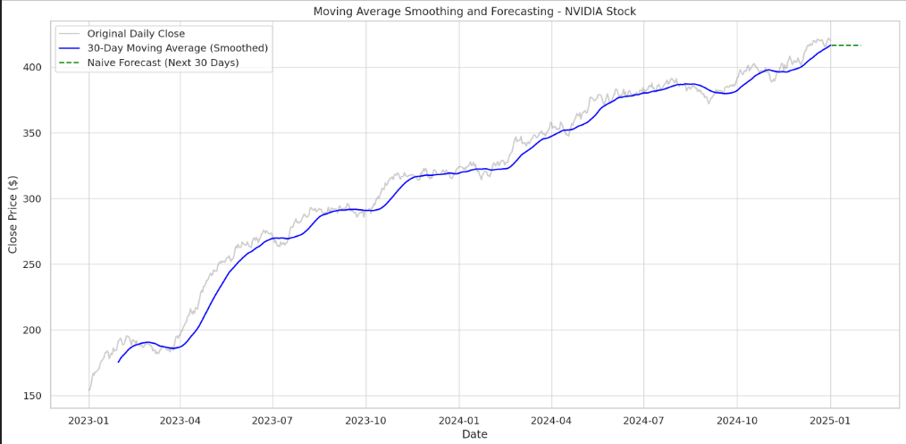

RESULT:
The program successfully applies moving average smoothing to the simulated time series from the " NVIDIA stock prices" dataset, prepares the data, and performs a simple forecast, with visualizations comparing the original, smoothed, and forecasted values.

