EX:No.7 221501031
4/04/25
IMPLEMENT PROGRAM FOR DECOMPOSING TIME SERIES DATA INTO TREND AND SEASONALITY
AIM:
To develop a Python program to decompose the time series data derived from the "NVIDIA stock prices" dataset into trend and seasonality components, simulating a time series, and visualizing the results.
ALGORITHM:
- Load the dataset and simulate a time series by assigning synthetic timestamps.
- Calculate the total score from screening variables (A1 to A10) as the time series variable.
- Decompose the time series into trend, seasonality, and residual components using a seasonal decomposition method.
- Visualize the original time series along with its trend, seasonality, and residual components.
- Analyze the decomposition to understand the underlying patterns in the data.

PROCESS:
import pandas as pd
import numpy as np
import matplotlib.pyplot as plt
from statsmodels.tsa.seasonal import seasonal_decompose

df = pd.read_csv('nvidia_stock_prices.csv') # Replace with actual file path

# Simulate a time series by adding a timestamp (since the dataset lacks explicit time data)
date_rng = pd.date_range(start='2018-01-01', periods=len(df), freq='D') # Daily frequency for demo
df['timestamp'] = date_rng
df.set_index('timestamp', inplace=True)

# Calculate Total_Score as the sum of A1 to A10 scores
df['Total_Score'] = df[['A1_Score', 'A2_Score', 'A3_Score', 'A4_Score', 'A5_Score',
'A6_Score', 'A7_Score', 'A8_Score', 'A9_Score', 'A10_Score']].sum(axis=1)

# Clean data (handle any potential missing values)
df['Total_Score'] = df['Total_Score'].fillna(method='ffill').fillna(method='bfill').fillna(0)

# Ensure the time series has enough data for decomposition (minimum period for seasonality)
if len(df) < 12: # Assuming monthly seasonality; adjust based on data
raise ValueError("Dataset too small for seasonal decomposition. Need more data points.")

# Perform seasonal decomposition (assuming additive model and 7-day seasonality for demo)
decomposition = seasonal_decompose(df['Total_Score'], model='additive', period=7)

# Plot the decomposed components
plt.figure(figsize=(12, 8))
plt.subplot(411)
plt.plot(df['Total_Score'], label='Original Data', color='blue')
plt.legend(loc='upper left')
plt.title('Original Time Series')

plt.subplot(412)
plt.plot(decomposition.trend, label='Trend', color='red')
plt.legend(loc='upper left')
plt.title('Trend Component')

plt.subplot(413)
plt.plot(decomposition.seasonal, label='Seasonality', color='green')
plt.legend(loc='upper left')
plt.title('Seasonal Component')

plt.subplot(414)
plt.plot(decomposition.resid, label='Residual', color='black')
plt.legend(loc='upper left')
plt.title('Residual Component')

plt.tight_layout()
plt.show()
OUTPUT:

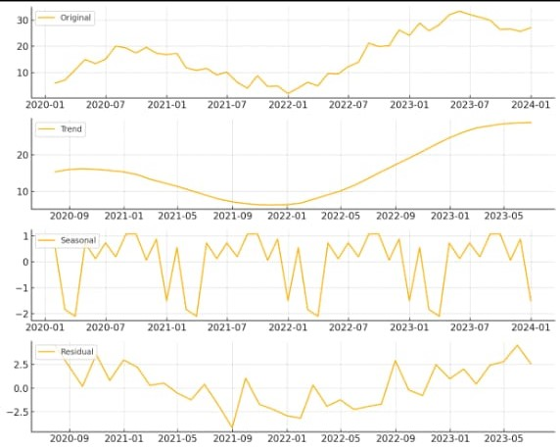

RESULT:
The program successfully simulates a time series from the " NVIDIA stock prices " dataset, decomposes it into trend and seasonality components using seasonal decomposition, and visualizes the original data along with its trend, seasonality, and residual components.

