Exp no: 8 Create an ARIMA model for time series forecasting. 221501031
Date: 8/4/25

Aim:
The aim of this project is to develop a time series forecasting model using the ARIMA (AutoRegressive Integrated Moving Average) technique to accurately predict future nvidia stock prices based on historical monthly data.
Objectives:
The objectives of this project revolve around understanding and modeling the temporal structure of the data. This includes loading and preprocessing the NVDIA stock prices dataset, visualizing trends and seasonal patterns, and checking for stationarity to ensure the dataset meets the assumptions required for ARIMA modeling. The project also focuses on selecting optimal ARIMA parameters, training the model, validating its performance using forecasting metrics, and ultimately generating forecasts for future time periods.
Background/Scope:
Time series forecasting plays a crucial role in sectors where planning and resource allocation are dependent on future demand. The NVDIA stock prices dataset, which records monthly totals of international airline passengers from 1949 to 1960, serves as a standard benchmark for time series analysis. ARIMA, a popular forecasting method, is effective for univariate time series data with trends and seasonality. This project focuses on implementing ARIMA to capture these temporal patterns and generate reliable forecasts.
Steps for Time Series Sales Data Preprocessing:
Step 1: Load and Prepare the Data

Import required libraries, load the dataset, convert the 'Month' column to datetime format, and set it as the index to structure it for time series analysis. This step ensures that the data is properly formatted for temporal operations and modeling.
import pandas as pd
import matplotlib.pyplot as plt
from statsmodels.tsa.arima.model import ARIMA
from pandas.plotting import autocorrelation_plot
from statsmodels.tsa.stattools import adfuller
path = '/content/NVDIA stock pricesm.csv'
df = pd.read_csv(path)
df['Month'] = pd.to_datetime(df['Month'])
df.set_index('Month', inplace=True)

Step 2: Check for Stationarity
Use the Augmented Dickey-Fuller (ADF) test to statistically check if the time series is stationary. Stationarity is a crucial assumption for ARIMA modeling to work effectively.

result = adfuller(df['#Passengers'])
print(f'ADF Statistic: {result[0]}')
print(f'p-value: {result[1]}')
Output:
ADF Statistic: 0.8153688792060498
p-value: 0.991880243437641

Step 3: Make the Series Stationary
If the series is not stationary (p-value > 0.05), apply differencing.

df_diff = df['#Passengers'].diff().dropna()
# Optional: plot autocorrelation to decide on ARIMA parameters
autocorrelation_plot(df_diff)
plt.title("Autocorrelation Plot")
plt.show()
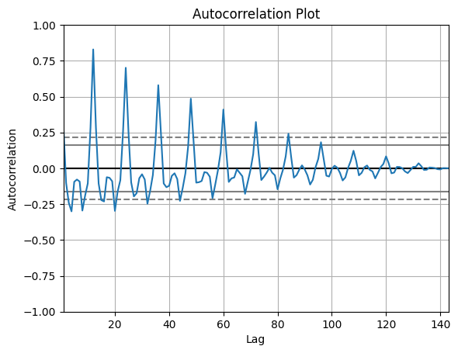

Step 4: Build and Train the ARIMA Model
Fit an ARIMA model to the time series using specified (p, d, q) values (e.g., (2, 1, 2)).
The model learns from the past values and their relationships to forecast future points.

model = ARIMA(df['#Passengers'], order=(2, 1, 2))
model_fit = model.fit()
print(model_fit.summary())

Step 5: Forecast and Visualize Results
Forecast future values (e.g., next 12 months) and visualize them along with the original series. This helps to compare predicted values with historical data and assess the forecast's quality.
forecast = model_fit.forecast(steps=12)
print("Forecasted values:")
print(forecast)
plt.figure(figsize=(10, 5))
plt.plot(df, label='Original')
plt.plot(forecast.index, forecast, label='Forecast', color='red')
plt.title('Air Passengers Forecast')
plt.legend()
plt.show()

Output:
Forecasted values:
1961-01-01 439.854513
1961-02-01 465.296054
1961-03-01 500.665761
1961-04-01 535.971659
1961-05-01 561.690109
1961-06-01 571.314405
1961-07-01 562.974263
1961-08-01 539.731146
1961-09-01 508.529538
1961-10-01 478.147818
1961-11-01 456.746809
1961-12-01 449.695642
Freq: MS, Name: predicted_mean, dtype: float64

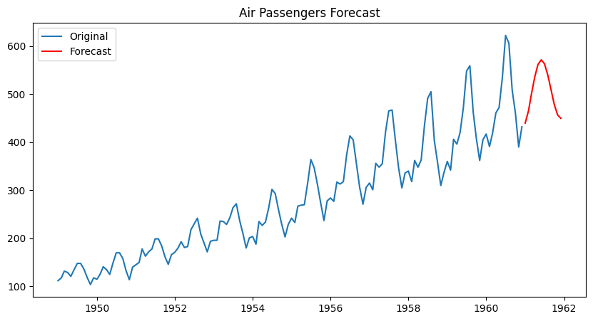

Result:
The ARIMA(2,1,2) model effectively forecasted the next 12 months of NVIDIA stock prices showing a continuing upward trend in numbers.

