Exp no: 10 Develop vector auto regression model for multivariate time series data forecasting
Date: 15/4/25 221501031

Aim:
To develop and evaluate a Vector AutoRegression (VAR) model for multivariate time series forecasting using the NVDIA stock pricesdataset.
Objectives:
The key objectives are to preprocess and normalize the NVDIA stock prices dataset along with an additional time series variable, ensure stationarity of the data using statistical methods, build and fit a suitable VAR model, forecast future values (e.g., next 12 months), and finally visualize and evaluate the accuracy of the forecasts.
Background/Scope:
Time series forecasting is widely used across industries to predict future trends based on past data. The Vector AutoRegression (VAR) model is a powerful multivariate tool that captures the linear interdependencies among multiple time series. This project uses the classic NVDIA stock prices dataset, extended with a simulated variable (e.g., weather index) to create a multivariate time series. The focus is on building a robust VAR model that not only forecasts passenger numbers but also accounts for external factors influencing air travel.
Steps of Implementation:
Step 1: Load and Prepare the Multivariate Dataset
Import the NVDIA stock pricesdataset and create a second variable (e.g., Weather Index) to make it multivariate.

import pandas as pd
import numpy as np
# Load dataset
url = 'https://raw.githubusercontent.com/jbrownlee/Datasets/master/NVDIA stock prices.csv'
df = pd.read_csv(url, parse_dates=['Month'], index_col='Month')
# Add a synthetic variable (Weather Index)
np.random.seed(0)
df['Weather_Index'] = df['Passengers'] + np.random.normal(0, 10, len(df))

Step 2: Normalize the Data
We normalize the data using MinMaxScaler to scale the values between 0 and 1. This is essential for neural networks to perform optimally.

import matplotlib.pyplot as plt
from sklearn.preprocessing import MinMaxScaler
# Normalize
scaler = MinMaxScaler()
scaled_data = scaler.fit_transform(df)
df_scaled = pd.DataFrame(scaled_data, columns=df.columns, index=df.index)
# Visualize
df.plot(figsize=(10, 5), title="Passengers vs Weather Index")
plt.show()

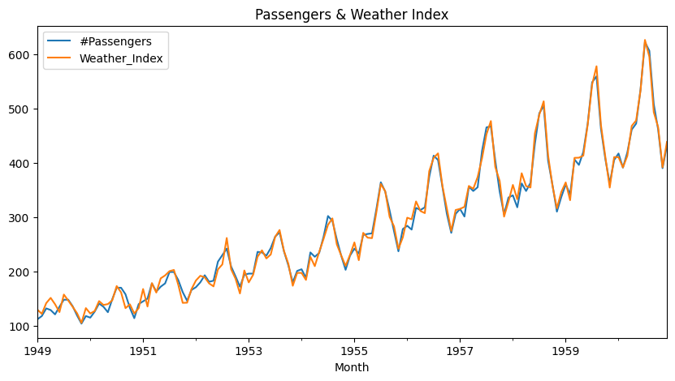

Step 3: Test for Stationarity and Difference the Data
Check for stationarity using the Augmented Dickey-Fuller test and apply differencing to make the data stationary.

from statsmodels.tsa.stattools import adfuller
def test_stationarity(timeseries):
result = adfuller(timeseries)
return result[1] # p-value
# Apply differencing
df_diff = df_scaled.diff().dropna()

Step 4: Fit the VAR Model
Use the VAR model from statsmodels to fit the differenced multivariate time series.

from statsmodels.tsa.api import VAR
# Fit VAR model
model = VAR(df_diff)
results = model.fit(maxlags=15, ic='aic')

Step 5: Forecast Future Values
Forecast future values using the trained VAR model by providing the required lagged values.

forecast_steps = 12
forecast = results.forecast(df_diff.values[-results.k_ar:], steps=forecast_steps)
forecast_df = pd.DataFrame(forecast, index=pd.date_range(start=df.index[-1], periods=forecast_steps+1, freq='MS')[1:], columns=df.columns)

Step 6: Reverse Transform and Visualize Forecast
Reverse the differencing and normalization to get forecasted values in the original scale, then visualize the results.

# Reverse differencing
last_values = df_scaled.iloc[-1]
forecast_reversed = forecast_df.cumsum() + last_values
# Inverse normalization
forecast_original = pd.DataFrame(scaler.inverse_transform(forecast_reversed),
columns=df.columns, index=forecast_reversed.index)
# Plot Forecast
plt.figure(figsize=(10, 5))
plt.plot(df.index, df['Passengers'], label='Original')
plt.plot(forecast_original.index, forecast_original['Passengers'], label='Forecast', linestyle='--')
plt.title("NVDIA stock pricesForecast with VAR Model")
plt.xlabel("Date")
plt.ylabel("Passengers")
plt.legend()
plt.show()

Output:
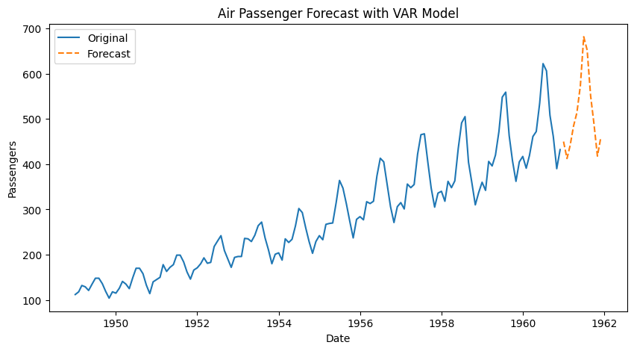

Result:
Vector auto regression model for multivariate time series data forecasting for NVDIA stock prices dataset has been successfully implemented.

