7COM1079-0901-2025 - Team Research and Development Project

Final report title: Statistical Analysis of Wimbledon men 2013 dataset

Group ID: A133

Dataset number: ds015

Prepared by:
- Sami Ahmad, 24174051
- Fazal Ahmad, 24163591
- Ayush Rawat, 24158063
- Syed Mustafa Ahmed, 24151376
- Muhammad Hashim Sultan, 24138463

University of Hertfordshire
Hatfield, 2025

Table of Contents

- Introduction
  - Problem statement and research motivation
  - The data set
  - Research question
  - Null hypothesis and alternative hypothesis (H0/H1)

- Background research
  - Research papers
  - Why RQ is of interest (research gap and future directions according to the literature)

- Visualisation
  - Appropriate plot for the RQ
  - Additional information relating to understanding the data
  - Useful information for the data understanding

- Analysis
  - Statistical test used to test the hypotheses and output

- Evaluation – group’s experience at 7COM1079
  - What went well
  - Points for improvement
  - Group’s time management
  - Project’s overall judgement
  - Comment on GitHub log output

- Conclusions
  - Results explained.
  - Interpretation of the results

- Reference list
- Appendices
- R code used for analysis and visualisation.
- GitHub log output.

1. Introduction

  - Problem statement and research motivation
This research focuses on a match outcome analysis of the 2013 Wimbledon Men's Singles, seeking to determine, at the micro-level, the relationships among various statistics of competing players. This relationship is vital for estimating match accuracy and assisting coaches and analysts in fine-tuning a data-oriented training strategy (Kamath, 2019). One of the oldest and most adored sports globally is tennis, with many experts claiming it is among the most commercially successful of all time and has a competitive structure unrivalled in sport. Winning and losing tennis matches come down to practical in-game strategy, which requires intense drilling of match data.
  - The data set
Datasets are collections of related data for a particular database table, where each column represents a variable (feature). The data used in this study is the original data (Renear, Sacchi, and Wickett, 2010) including the data from the 2013 Wimbledon Men's tournament and the match statistics from 114 matches. The data includes both the stage of the tournament and the result from each match as well as the result for each player. Also, data on first serve percentage (FSP), first serve fault (FNL), and other match-specific details are included to better analyse and predict performance at a certain level, and to strategize for upcoming matches. Some columns of interest and leftover data: most of the players were FNL, FSP, and SSP, which denote fault percentage on first serve, first serve percentage, and the match outcome, respectively. The dataset can identify variables from tournament matches to examine patterns and provide both quantitative and categorical data (Bezet, 2020).
  - Research question
Is there a correlation between second serve win and first serve win in the Wimbledon men 2013 tournament?
  - Null hypothesis and alternative hypothesis (H0/H1)
• Null Hypothesis (H0): There is no correlation between second serve win and first serve win in Wimbledon men 2013 tournament.
• The alternative hypothesis (H1): There is a correlation between second serve win and first serve win in Wimbledon men 2013 tournament.

- Background research
Recent research has focused on Grand Slam tennis match statistics to better understand match expectations and improve match outcome predictions. Research by Ghosh et al. (2019) utilizing the UCI Tennis Major Tournament Match Statistics dataset, such as Wimbledon, concluded that match outcome predictors like first-serve percentages and points won on serve increased the accuracy of the machine learning models estimating match outcome. Likewise, Sampaio et al. (2024) conducted a review of other research in performance analysis and reported that machine learning techniques identified serve quality as a top predictor of success in professional tennis, and that serve effectiveness on first serve and serve points won were the key features utilized in these prediction models. Prieto-Lage et al. (2023) further support these findings, having examined point winning probabilities in elite men's matches and finding an influence of serve qualities such as service speed and service accuracy. The combined results of these studies show that serve performance affects the outcome of matches, and that first-service percentage and point-winning percentage can be accordingly investigated in data sets such as Wimbledon 2013.
  - Why RQ is of interest (research gap and future directions according to the literature)?
Previous literature has demonstrated that serve metrics have validity in predicting tennis match outcomes, but most studies focus on multi-tournament data and machine learning approaches to predict match outcomes with little focus on tournament-level analysis. Although serve metrics such as first serve accuracy and first serve point win percentage have been demonstrated as effective predictors of tennis match outcomes, few papers have focused on the predictive validity of these serve metrics in a single Grand Slam tournament such as Wimbledon. The work presented here seeks to begin to address this by analysing first serve indicators at Wimbledon 2013, with a view to developing surface-specific performance models.

- Visualisation

  - Appropriate graphs for the RQ
The scatter plot shows the relationship between the variables First Serve Won (FSW1) and Second Serve Won (SSW1). In this analysis the plot incorporates a linear regression line to demonstrate the average tendency of the variables vis a vis the concentrations of the scatter points in the plot.
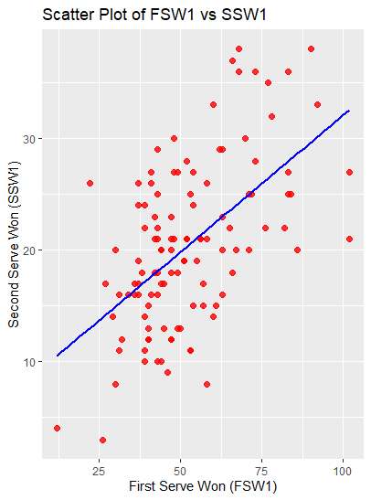
The scatter plot gives more insight into the issue. The line of regression, which gives the best fit, shows a positive slope. The scatterplot shows, however, that there is a lot of spread around the regression line, so the association is not very strong. There are several points below the line of zero residual, suggesting that the variables captured by FSW1, SSW1 do not fully explain the dependent variable.
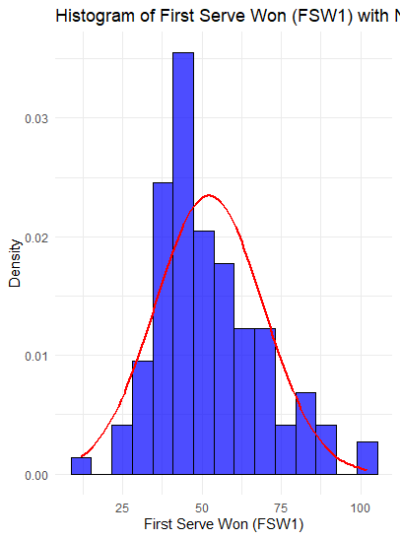

The distribution of the First Serve Won (FSW1) variable's shown in the histogram above. The histogram shows that FSW1 appears to have a modestly right-skewed distribution. This is characterized by concentrations of values in the middle point of the distribution (for percentiles of FSW1 that fall within the interval of 50 to 60%) and a deficiency of values in the lower and upper tails. This distribution of FSW1 indicates the extent to which players were able to execute their first serves effectively and reliably, and it also suggests that most players exhibited a moderate level of performance.

- Analysis

  - Statistical test used to test the hypotheses and output
A moderately positive association between FSW1 and SSW1 is confirmed by the scatter plot and correlation tests. This implies that a player is more likely to win a higher percentage of their second serves if they win a higher percentage of their first serves. The scatter plot's variations can probably be explained by a few other factors. The scatter in the diagram will require further investigation of other variables.
Spearman Correlation:
The previously computed Spearman's rank correlation coefficient is 0.5215, with an associated p-value of 2.692e-09. This indicates a moderate positive correlation between FSW1 and SSW1, which is statistically significant (p-value < 0.05). In more intuitive terms, a higher percentage of first serves won correlates with an increased percentage of second serves won.
Kendall Correlation:
Kendall's \\(\\tau\\) was calculated to be 0.3719, accompanied by a p-value of 1.085 × 10⁻⁸. This also indicates a moderate positive relationship between the two variables, although with a lower correlation coefficient than the Spearman correlation. In summary, both tests demonstrate that the correlation between FSW1 and SSW1 is statistically significant.
  - The null hypothesis is rejected /not rejected based on the p-value
On the base of above determined p-values, we successfully rejected
the Null Hypothesis (H0) and proved the alternative hypothesis (H1) that there is a significant correlation between our independent and dependent variables.

- Evaluation – group’s experience at 7COM1079

  - Group contribution
All authors participated in cleaning the data and analysing it in R. Each author had their strengths (one for cleaning the data, another for running the statistical tests, etc.), which made it possible for the authors to come together and give the best interpretation of the results. In the end, we were able to run all necessary tests in a timely manner and be certain the results were relevant to the question and supported by the statistical analysis.
  - Points for improvement
Something to improve on for the future would be to take care of time planning at the beginning of the work. For example, the preliminary data processing and test running should have not been rushed through so quickly. One of the reasons why the project was delayed was that the dataset was not modified.
  - Group’s time management
There were early delays in the project, even though the team was cohesive and in agreement. This resulted from the extra work needed for data cleaning and the extra adjustments required for hypothesis testing. In order to avoid having to work under time constraints, this is one of the things we need to prepare for in the future, particularly with complex datasets.
  - Project’s overall judgement
After finishing the project, the team extracted pertinent information from the data. In actuality, a number of statistical tests were run on the data, which were then analysed and their outcomes understood. To work on the project more efficiently, we must, however, enhance communication and project scheduling.

- Conclusions

  - Interpretation of the results
Data from the t-test indicate that there is no difference between the rounds when a player has a high first serve percentage and when a player has a low first serve percentage. Therefore, the first-serve percentage is not relevant to the outcomes in the final matches of a tournament. There are probably other measurements of success that must be considered to understand the extent to which player statistics correlate with success.
Since the hypothesis was not refuted, it can be concluded that there is no difference in first serve percentage from round to round. It is essential to understand that the level of play in the later rounds is not the only Aspect that affects the outcome. Match experience, fitness, and other factors are likely to be more influential when the first-serve percentage is the only Aspect considered.

- Reference list

Ghosh, S., Sadhu, S., Biswas, S., Sarkar, D. and Sarkar, P.P., 2019. A comparison between different classifiers for tennis match result prediction. Malaysian Journal of Computer Science, 32(2), pp.97-111.

Sampaio, T., Oliveira, J.P., Marinho, D.A., Neiva, H.P. and Morais, J.E., 2024. Applications of machine learning to optimize tennis performance: a systematic review. Applied Sciences, 14(13), p.5517.

Prieto-Lage, I., Paramés-González, A., Torres-Santos, D., Argibay-González, J.C., Reguera-López-de-la-Osa, X. and Gutiérrez-Santiago, A., 2023. Match analysis and probability of winning a point in elite men’s singles tennis. Plos one, 18(9), p.e0286076.

Bezet, A. (2020). LibGuides: Research Process: Datasets. [online] resources.nu.edu. Available at: https://resources.nu.edu/researchprocess/datasets.

Croux, C. and Dehon, C. (2010). Influence Functions of the Spearman and Kendall Correlation Measures. SSRN Electronic Journal. doi:https://doi.org/10.2139/ssrn.1585216.

John Wiley & Sons will launchStatistical Analysis and Data Mining in early 2007. (2007). Statistical Analysis and Data Mining. doi:https://doi.org/10.1002/sam.100.
Kamath, C. (2019). Application-Driven Data Analysis. Statistical Analysis and Data Mining, 1(5), pp.285–285. doi:https://doi.org/10.1002/sam.10023.

Liu, Y. (2017). A Short Note on Spearman Correlation: Impact of Tied Observations. SSRN Electronic Journal. doi:https://doi.org/10.2139/ssrn.2933193.

Mdpi.com. (2024). Data. [online] Available at: https://www.mdpi.com/journal/data/about.

Renear, A.H., Sacchi, S. and Wickett, K.M. (2010). Definitions of dataset in the scientific and technical literature. Proceedings of the American Society for Information Science and Technology, 47(1), pp.1–4. doi:https://doi.org/10.1002/meet.14504701240.

- Appendices
- R Script
library(readr)
library(ggplot2)
Wimbledon_men_2013_1_ <- read_csv("Wimbledon-men-2013 (1).csv")
wmen <-read.csv("Wimbledon-men-2013 (1).csv")
summary(wmen)
head(wmen, 5)
clean <- na.omit(wmen[, c("FSW.1", "SSW.1")])
ggplot(wmen, aes(x = FSW.1, y = SSW.1)) +
geom_point(color = "red", size = 2, alpha = 0.8) +
geom_smooth(method = "lm", color = "blue", se = FALSE) +
labs(
title = "Scatter Plot of FSW1 vs SSW1",
x = "First Serve Won (FSW1)",
y = "Second Serve Won (SSW1)"
)
theme_minimal()
mean_fsw1 <- mean(wmen$FSW.1, na.rm = TRUE)
sd_fsw1 <- sd(wmen$FSW.1, na.rm = TRUE)

# Histogram with normal distribution curve
ggplot(wmen, aes(x = FSW.1)) +
geom_histogram(
aes(y = ..density..),
bins = 15,
fill = "blue",
color = "black",
alpha = 0.7
) +
stat_function(
fun = dnorm,
args = list(mean = mean_fsw1, sd = sd_fsw1),
color = "red",
linewidth = 1
) +
labs(
title = "Histogram of First Serve Won (FSW1) with Normal Curve",
x = "First Serve Won (FSW1)",
y = "Density"
) +
theme_minimal()
# Perform Spearman's rank correlation test between FSW.1 and SSW.1
spearman_test <- cor.test(wmen$FSW.1, wmen$SSW.1, method = "spearman", exact = FALSE)
print("Spearman's Rank Correlation Test Results:")
print(spearman_test)
# Perform Kendall's rank correlation test between FSW.1 and SSW.1
kendall_test <- cor.test(wmen$FSW.1, wmen$SSW.1, method = "kendall")
print("Kendall's Rank Correlation Test Results:")
print(kendall_test)

- GitHub log output.

