Group 7: Farrel Azhar, Adam Rosario, Payton Morlock, Sibo Zheng

GPGN 490: Global Macroeconomic Data Analysis for Public Policy

June 9, 2024

**Refugee Tab Memo**

The Refugee Tab utilizes the Refugee Population Statistics Database published by the Office of The United Nations High Commissioner for Refugees (UNHCR).[1] The data is maintained and updated annually and semi-annually by the Expert Group on Refugee and IDP Statistics (EGRIS) and the Inter-agency Group on Statelessness Estimation, both commissioned by the UN Statistical Commission (UNSC).[2] The data and visualizations discussed herein utilize population and demographic variables within the dataset to highlight valuable trends. While the UNHCR has tracked refugees since 1951, they have yet to do so for each variable.[3] This constraint will impact the historical range of the data.

**Refugees**

As of 2024, half of all refugees are from Syria, Afghanistan, and Ukraine. Other large refugee populations originated from South Sudan, Sudan, Myanmar, the Democratic Republic of Congo, and Somalia. There are over 35 million refugees worldwide and 6 million asylum seekers.[4] Refugees begin as asylum seekers and then obtain refugee status legally by applying to a country of refuge. Asylum seekers are people who leave their country and are seeking protection from persecution, which must be based on race, religion, nationality, political ideology, or identity. There generally needs to be a reasonable indication that others will inflict harm on the asylum seeker in some way for them to flee. As a result, when conflicts, political violence, and protests take place, refugees increase in numbers. There is a causal vector deriving from conflicts and political violence leading to increases in those seeking asylum, and the two cannot be separated.

**Population Data**

The population data on the dashboard shows the number of forcibly displaced and stateless people by year, including refugees and asylum seekers, along with an option for returned refugees. Using Syria as an example, the data shows an increase starting in 2012, which is the start date for the data collection. It peaks in 2016, dips, and then peaks again in 2020, demonstrating two events leading to a rise in refugees. First, the Syrian Civil War resulted in many people fleeing the country out of fear for their safety. Beginning in 2011, protests spread across the country in support of democracy and oppose the Syrian leader at the time, Basshar al-Assad. Initially, this was considered part of the Arab Spring, but by 2012, the Civil War began. At that point in the data, there is a sharp increase in refugees from Syria. In late 2015, the United States intervened in the war, followed by Russia and Turkey in 2016. By the beginning of 2017, the siege of Aleppo had ended, and a ceasefire had been declared. The data shows that the refugee population ticks down slightly with the ceasefire but remains steady overall. In 2020, it ticks back up. Syria began experiencing an economic crisis, likely also contributing to the refugee population increasing at the time. It should be noted that the population of asylum seekers appears steady in the data–and almost at zero. This has to do with the scale of the data. Generally, asylum seekers apply for refugee status, whether granted or not. As a result, the status of "asylum seekers" is temporary and exists as a brief transitionary period before becoming a refugee.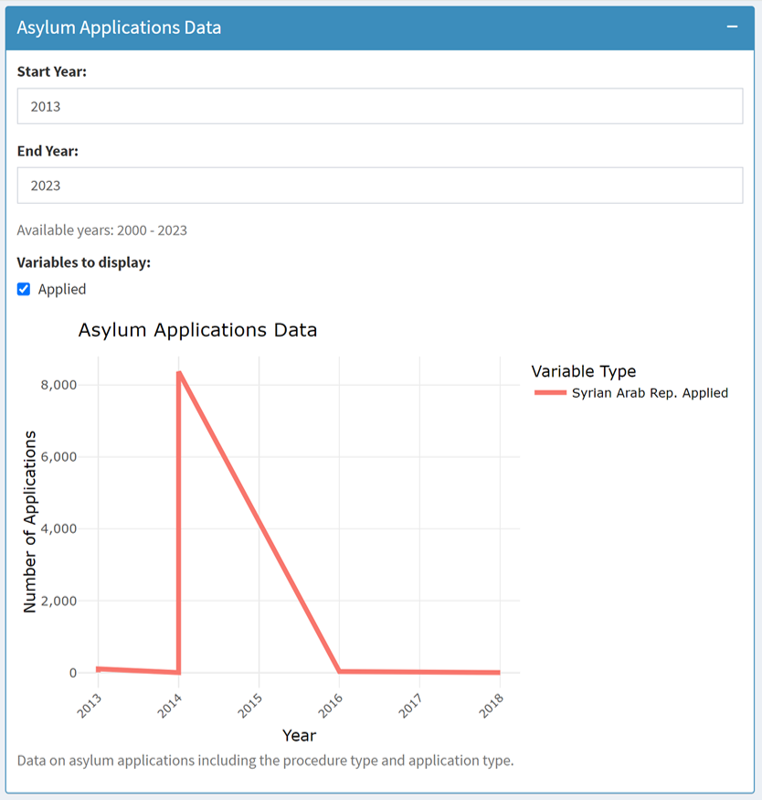

**Asylum Applications Data**

The Asylum Applications Data shows the number of applications from those seeking asylum from different countries. Again, using Syria as an example, there is a considerable increase from 2014 to 2016, falling in line with some of the most deadly parts of the Syrian Civil War. With the application's data, there is also a scaling issue at first glance, as the number of asylum applications is zero from 2014 to 2016. This is not the case; the number of applications was so great in that period that the other periods looked insignificant. To solve this scale issue, the dashboard can change the timeline, giving more in-depth insight into specific time periods. In contrast, the examples here show the aggregate of all the collected data for that country. Note, for Syria, the data cuts off before 2020, but it may also be possible to see an uptick in the number of refugees in this data. However, given the nature of the asylum seekers' status, the number of refugees depends on the number of asylum applications and approvals. The data shows the number of applications in each year, not cumulative. This is similar to the structure of the graph for Population Data; it is not cumulative. The country of origin and arrival are changed at the top of the dashboard. Countries that generally take in the most refugees are Iran, Turkey, and Germany. The graph in the example shows the number of refugee applicants to the United States.

**Asylum Decisions Data**

The Asylum Decisions Data shows the total number of decisions on applications to asylum seekers. The data can be toggled to include the total number of rejected applications, "other," and those that resulted in administrative closures for whatever reason. In the case of Syrian asylum applicants, the data shows spikes in applications going to the destination country over time. In the example, the destination is the United States, so around 2012, the number of applications was high, then peaked around 2015 and 2016 and gradually declined afterward. One of the dashboard's features is hovering over the graph and seeing the exact number at a given time. Applying this to the Asylum Decisions Data, the data shows that in 2015, 777 decisions were made on asylum applications from Syria going into the United States, of which 27 were rejected. Please note that "other" will not include applications accepted; instead, to calculate the number of applications received, one should subtract the sum of "closed," "other," and "rejected" from the total.

**Demographics Data**

The Demographics Data shows the number of female and male refugees from origin to destination countries. When available, the data will include disaggregation by age and sex. Using this part of the dashboard, comparing the ages or sexes of refugees from two selected countries becomes very simple. Not all countries have every year with this data, so it just depends on the data available from UNHCR that can be displayed on the dashboard.

**Solutions Data**

The Solutions Data shows the ultimate solution taken for the refugees recorded. This graph shows the number of returned refugees, resettled refugees, naturalized refugees, and the number of returned internally displaced persons (IDPs). The displayed data shows what is available from the country of origin and the solution the destination country took. In the Syrian refugee example, the United States' solution for the majority of refugees from Syria was resettlement, whereas in Turkey, several refugees were naturalized. However, an even more significant number of refugees were returned.

**Flows Data**

The Flows Data shows the number of people forced to flee during each recorded year, broken down into refugees, asylum seekers, and returned refugees. Gaps in the graphs suggest that data was not recorded on that specific population sub-group for that period.

**IDMC Data**

The IDMC Data comes from the Internal Displacement Monitoring Centre rather than the UNHCR. It measures the number of internally displaced persons (IDPs) who differ from refugees in that they do not leave their country of origin. The selected country of origin will be displayed in the IDMC Data graph.

**UNRWA Data**

The UNRWA Data focuses specifically on Palestinian refugees in the Middle East. This data only displays when the origin is selected as "Palestinian," and the destination is "Jordan," "Lebanon," "Syrian Arab Rep." and "State of Palestine." When viewing this data, it is necessary to narrow the focus to Palestinian refugees and not refugees from other nations, as the other sections, aside from the UNRWA Data section and the Demographics Data section, will not display data at that time.

**Data Bibliography and Sourcing:**

Galal, Hisham, and Ahmadou Dicko. (2023). UNHCR Refugee Population Statistics Database (2023.6.0) [Dataset]. The Office of The United Nations High Commissioner for Refugees (UNHCR).<https://cran.r-project.org/web/packages/refugees/index.html>

1. The Office of The United Nations High Commissioner for Refugees (UNHCR). “Refugee Data Finder.” United Nations. Undated. <https://www.unhcr.org/refugee-statistics/methodology/>. See “Methodology”
2. ibid
3. ibid, see “Summary Spreadsheet”
4. International Organization for Migration. (n.d.). *Migration and Migrants: A Global Overview*. Chapter 2, Refugees and Asylum-Seekers. https://worldmigrationreport.iom.int/what-we-do/world-migration-report-2024-chapter-2/refugees-and-asylum-seekers