Freight Rate Prediction
Technical Report

Spotter ML Engineer Assessment
August 18, 2026

1. Overview
This report documents the modeling approach used to predict freight load rates from operational and market features. The solution was trained on labeled historical loads and evaluated using a forward-looking holdout before generating the required submission predictions.

2. Data Used
Dataset | Rows | Date range | Purpose
train_test.csv | 48,000 | Jan 2025 – Oct 2025 | Model development with posted_rate
validation.csv | 12,000 | Nov 2025 – Dec 2025 | Final prediction set (labels hidden)
december_chart_inputs.csv | 31 | Dec 2025 | Fixed-lane daily forecast scenario

3. Train / Validation Split Approach
The labeled development file spans January through October 2025. Because the final prediction set begins in November, a random split would not reflect how the model would be used in practice. I therefore used a chronological split:
Partition | Period | Rows | Role
Training | 2025-01-01 to 2025-09-30 | 43,147 | Fit the model
Holdout validation | 2025-10-01 to 2025-10-31 | 4,853 | Estimate out-of-time performance

October 2025 was held out as a proxy for the unseen submission period. This avoids temporal leakage, keeps recent market conditions in the validation window, and provides a realistic estimate of error before predicting the 12,000 submission loads.
No rows from validation.csv were used during model selection. That file was reserved exclusively for the final prediction output.

4. Holdout Results (October 2025)
Metric | Value | Interpretation
MAE | $129.76 | Average absolute dollar error
Median AE | $43.20 | Typical error for most loads
RMSE | $652.37 | Penalizes larger misses more heavily
MAPE | 6.23% | Average percentage error
R² | 0.818 | Share of variance explained
Mean actual rate | $2,379.05 | Context for dollar errors

The model performs strongly on typical loads, with a median absolute error of $43.20 against a mean October rate of $2,379.05. The higher RMSE indicates a smaller set of larger misses, which is common in freight rate data where long-haul and specialty equipment loads have wider rate dispersion.

5. December Fixed-Lane Forecast
The assessment also requires daily predictions for a fixed scenario: Lexington to Fort Wayne, 360 miles, Dry Van, 32,000 lb. Only the calendar date changes across the 31 December rows. City coordinates were mapped from training-data medians, and daily market_index / quote_signal values were taken from December medians in the validation feature set so the forecast reflects date-level market movement.
The chart below was generated from the completed december_chart_inputs.csv file after running the project prediction pipeline.
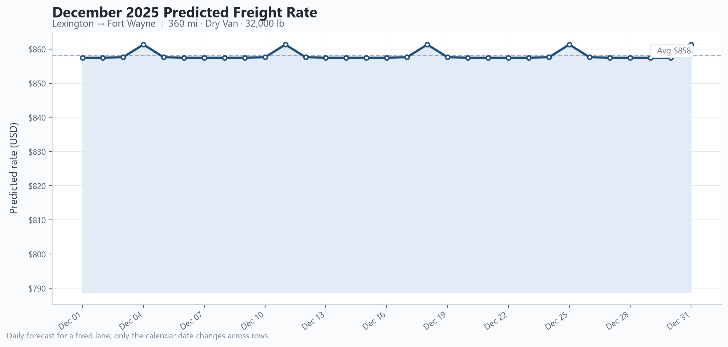
Figure 1. December 2025 predicted rate trend for the fixed assessment lane.

6. Reproducibility
From the project root:
python src/train_model.py
python src/predict.py
python generate_december_chart.py
python score.py --predictions validation_predictions.csv --december-predictions data/december_chart_inputs.csv
python generate_report_docx.py

