**PF-LAB-10-ASSIGNMENT**

**PROBLEM:1**

**PROBLEM:2**

**PROBLEM:3**

**PROBLEM:4**

**PROBLEM:5**

**PROBLEM:7**

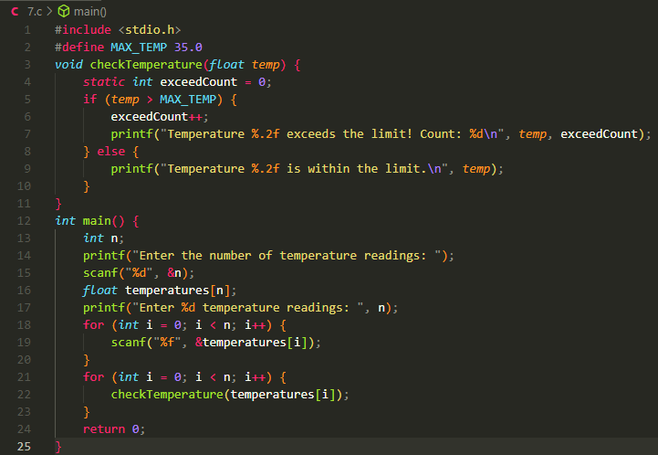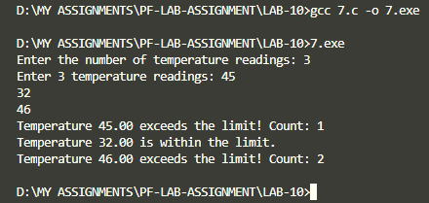

**PROBLEM:8**

**PROBLEM:9**

**PROBLEM:10**

**PROBLEM:11**

**PROBLEM:12**

