**PF -LAB-3-ASSIGNMENTS**

**Q-1**

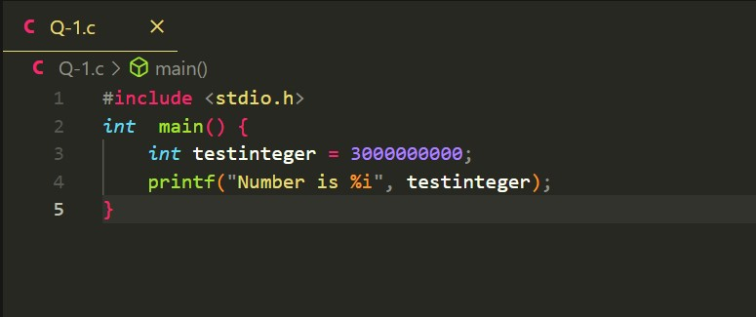

Ans: Because integer datatype can only store value up to 2147483647, & output is greater than that.

**Q-2**

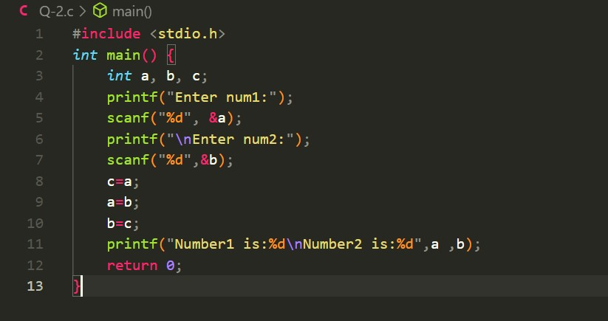

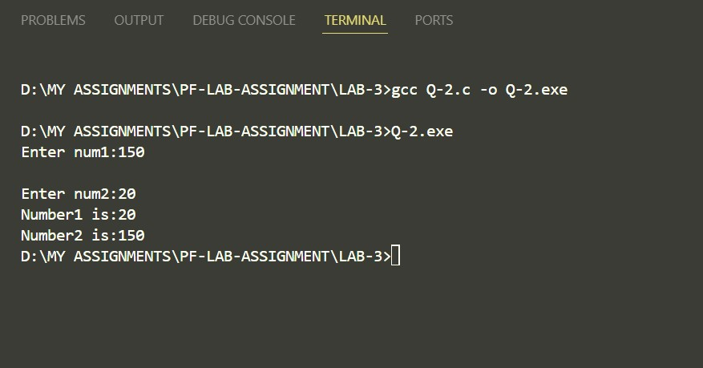

**Q-3**

**Q-4**

**Q-5**

**Q-6**

