**PF-LAB-4**

**1**

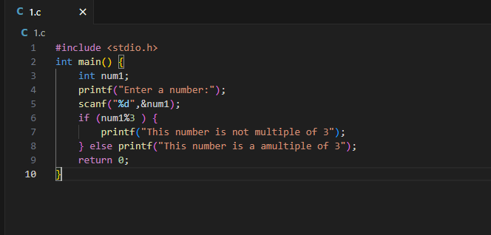

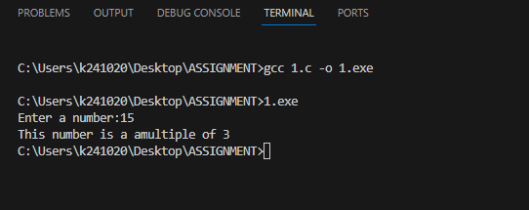

**2**

**3**

**4**

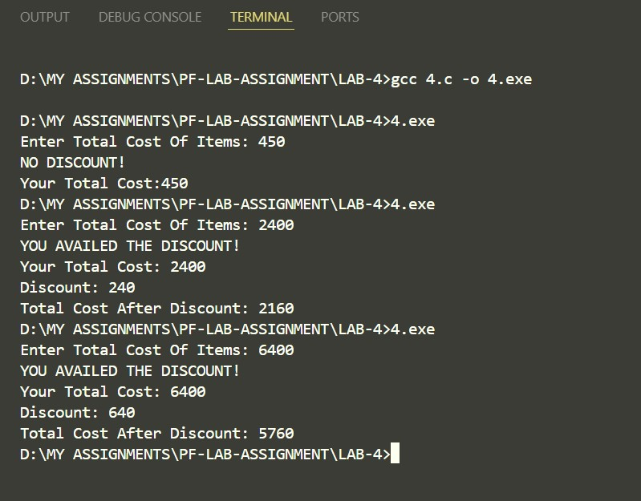

**5**

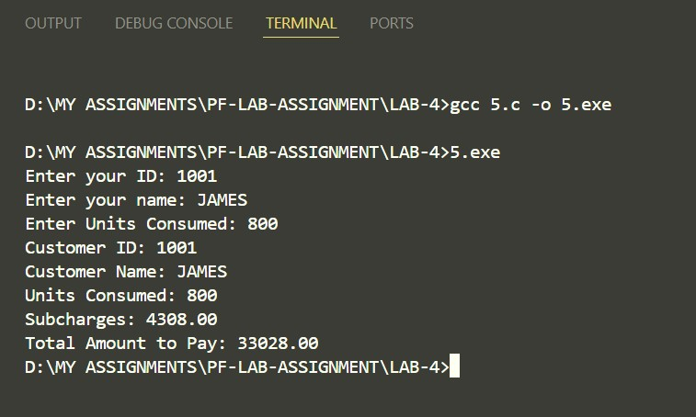

**6**

