**PF-LAB-5-ASSIGNMENT**

**PROBLEM-1**

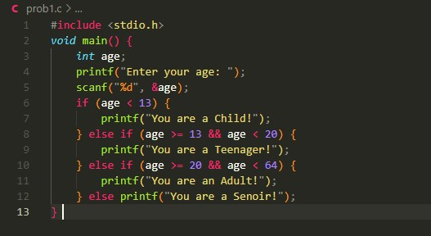

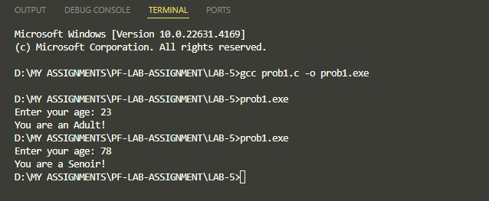

**PROBLEM-2**

**PROBLEM-3**

**PROBLEM-4**

**PROBLEM-5**

**PROBLEM-6**

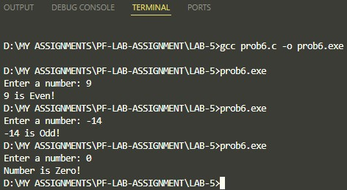

**PROBLEM-7**

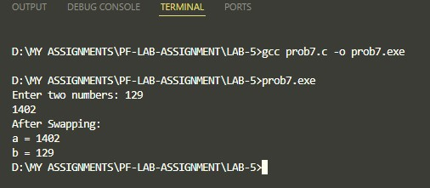

**PROBLEM-9**

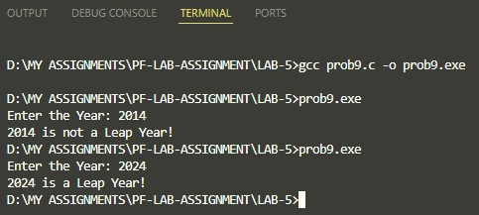

**PROBLEM-11**

**PROBLEM-12**

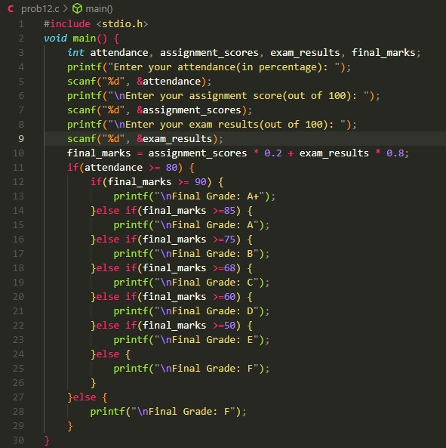

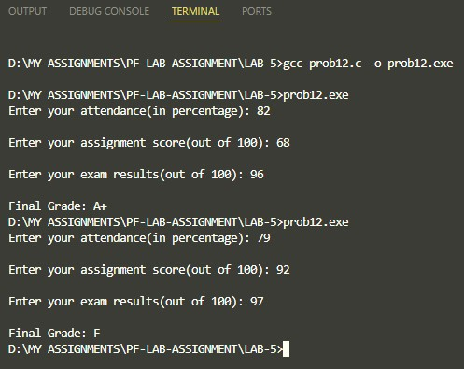

**PROBLEM-13**

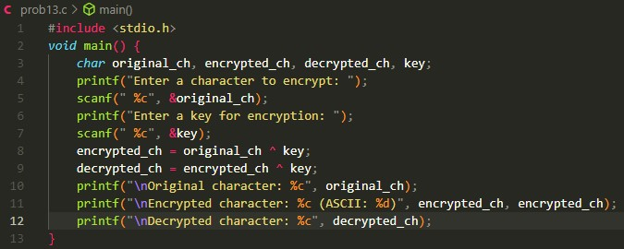

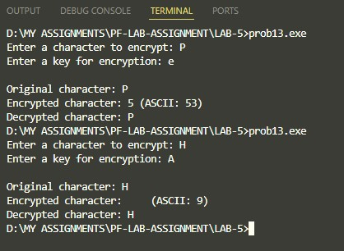

**PROBLEM-14**

