**PF-LAB-6-ASSIGNMENT**

**PROBLEM:2**

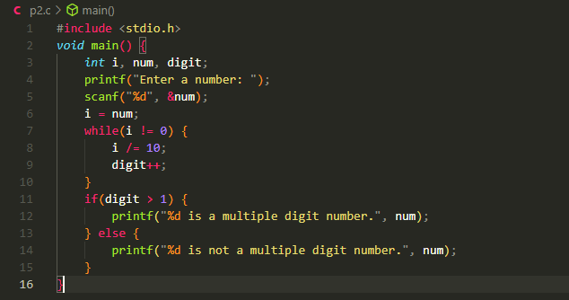

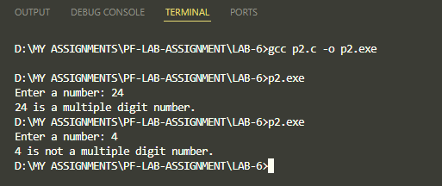

**PROBLEM:3**

**PROBLEM:4**

**PROBLEM:5**

**PROBLEM:6**

