**PF-LAB-7-ASSIGNMENT**

**PROBLEM:1**

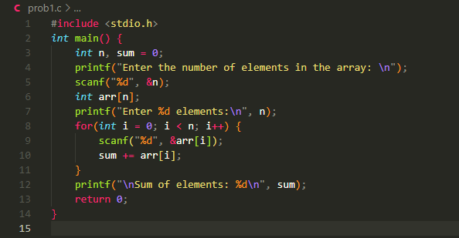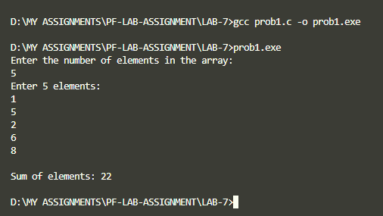

**PROBLEM:2**

**PROBLEM:3**

**PROBLEM:4**

