**PF-LAB-9-ASSIGNMENT**

**PROBLEM:1**

**PROBLEM:2**

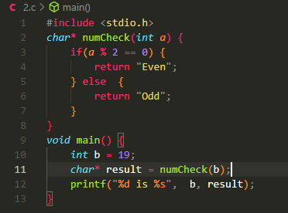

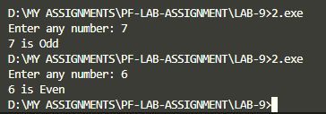

**PROBLEM:3**

**PROBLEM:4**

**PROBLEM:5**

**PROBLEM:6**

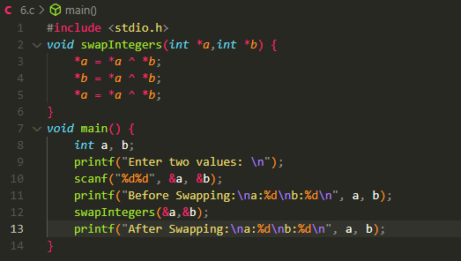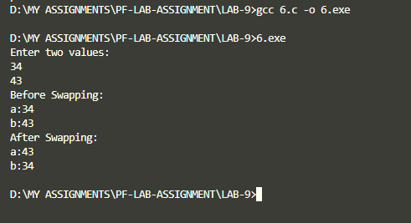

**PROBLEM:7**

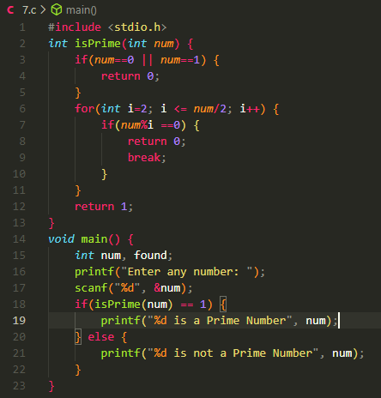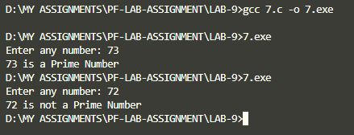

**PROBLEM:8**

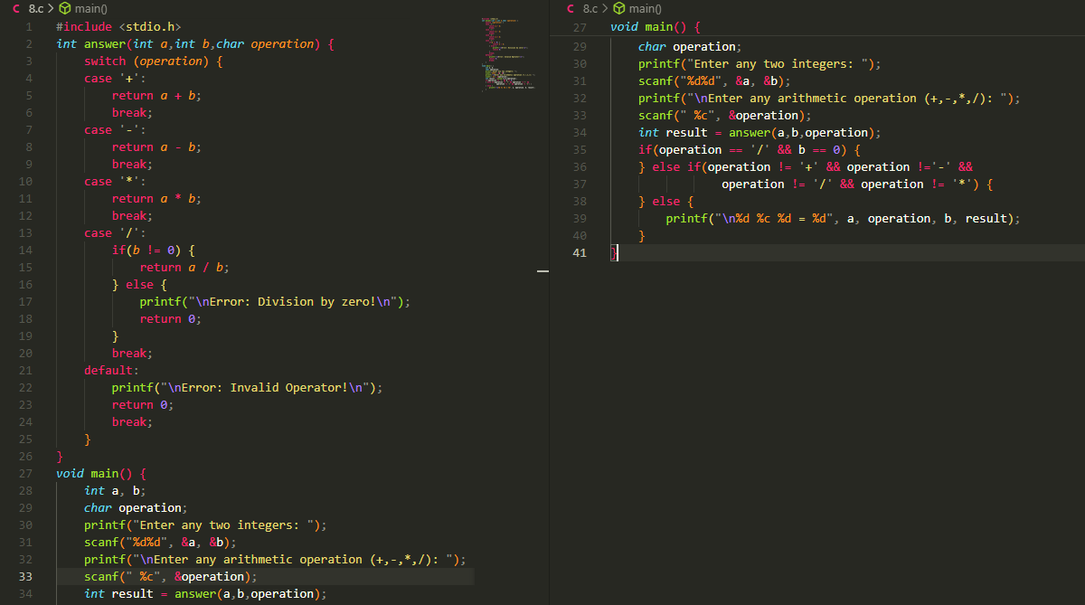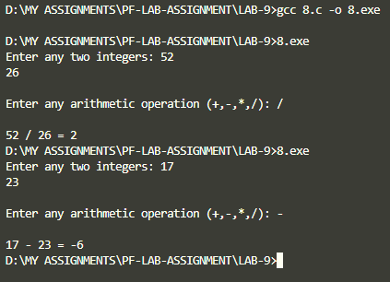

**PROBLEM:9**



