Name: Muhammad Faizan
Batch: 3
Instructor: Akbar Ali
Organization: Hunarmand Punjab
Subject: Artificial Intelligence
Final Project: Question 1

Customer Churn Prediction System

1. Introduction
Churn means a customer leaves a service. Keeping a customer usually costs a company less than finding a new one, so it helps to know early who is likely to leave. The company can then offer those customers a reason to stay.
The aim of this project is to predict whether a telecom customer will churn (Yes or No). This is a classification problem because the answer is a category. I trained two models, Logistic Regression and K-Nearest Neighbours (KNN), and compared them.

2. Dataset
I used the IBM Telco Customer Churn dataset. It has 7,043 customers and 21 columns, covering customer details, the services they use, their contract and their charges. The Churn column is the value to predict.
1,869 customers churned (26.5%) and 5,174 stayed (73.5%). The classes are imbalanced, which affects how the models must be judged.

3. Exploratory Data Analysis

Contract type
Contract type made the biggest difference. 42.7% of month-to-month customers left, compared to 11.3% on a one year contract and only 2.8% on a two year contract.
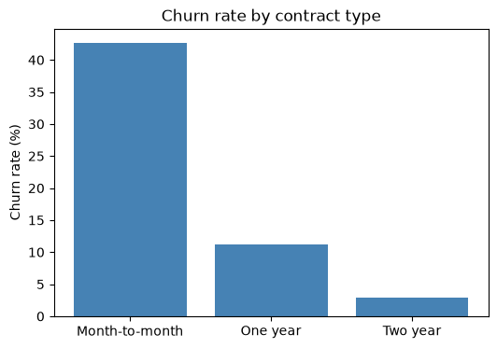
Figure 1: Churn rate by contract type

Tenure
The typical customer who left had been with the company for 10 months, while the typical customer who stayed had 38 months. The first year is the risky time.
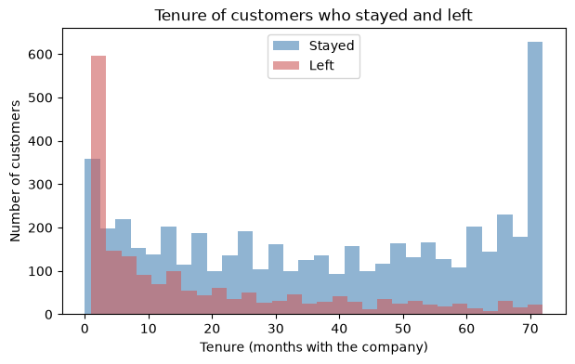
Figure 2: Tenure of customers who stayed and left

Monthly charges and correlation
Customers who left paid more per month on average (74.44 compared to 61.27). Tenure had the strongest relation with churn (-0.35). TotalCharges and tenure are strongly related to each other (0.83), because total charges grow every month.
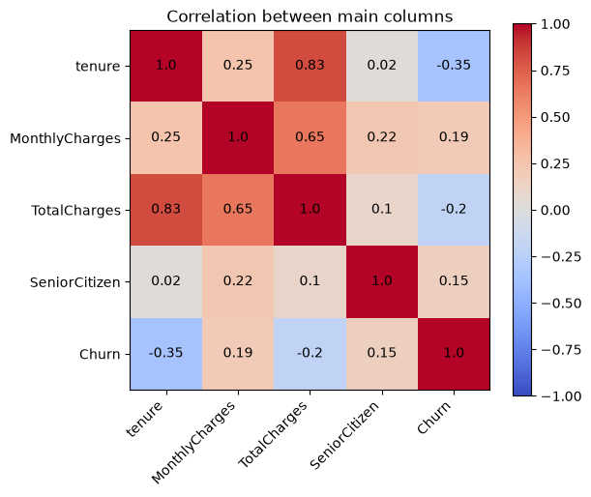
Figure 3: Correlation between main columns

4. Data Preprocessing

Missing values
isnull() reported no missing values, but TotalCharges had been read as text instead of a number. 11 cells contained only a blank space, which pandas does not count as missing. I converted the column with pd.to_numeric and errors="coerce" to reveal them.
All 11 customers had a tenure of 0, so they had not been billed yet. Filling with the median (1,397.48) would give a new customer a bill they never paid, so I dropped these rows. This left 7,032 customers.

Encoding
- customerID was removed because it says nothing about behaviour.
- Label encoding was used for columns with two values, such as Partner and Churn.
- One-hot encoding was used for columns with more than two values, such as Contract, because numbers like 0, 1, 2 would suggest an order that does not exist.

Train/test split and scaling
The data was split into 80% training (5,625 customers) and 20% testing (1,407 customers), keeping the same churn rate in both. I scaled tenure, MonthlyCharges and TotalCharges with StandardScaler because KNN uses distance, and large numbers would otherwise dominate. The scaler was fitted on the training data only to avoid data leakage.

5. Models
Logistic Regression calculates the probability that a customer will churn using the sigmoid function, and predicts churn when the probability is 0.5 or more.
KNN looks at the K most similar customers and takes a majority vote. I chose K with 5-fold cross validation on the training data, using F1-score, so the test set stayed unseen. K=35 scored highest, although the score was almost flat after about K=20.
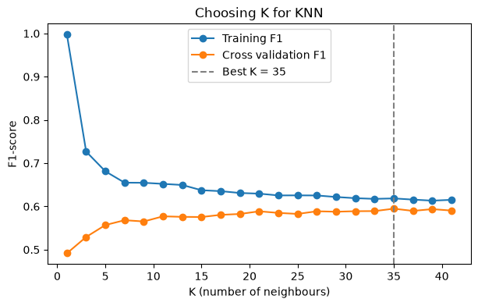
Figure 4: Choosing K for KNN

6. Results
A baseline that always says "No churn" was added for comparison. It gets 73.4% accuracy while finding no churners, which shows why accuracy alone is not enough on imbalanced data.
Model | Accuracy | Precision | Recall | F1-score
Baseline (always No) | 0.734 | 0.000 | 0.000 | 0.000
Logistic Regression | 0.805 | 0.650 | 0.572 | 0.609
KNN (K=35) | 0.797 | 0.626 | 0.586 | 0.605
Table 1: Evaluation summary on the test set
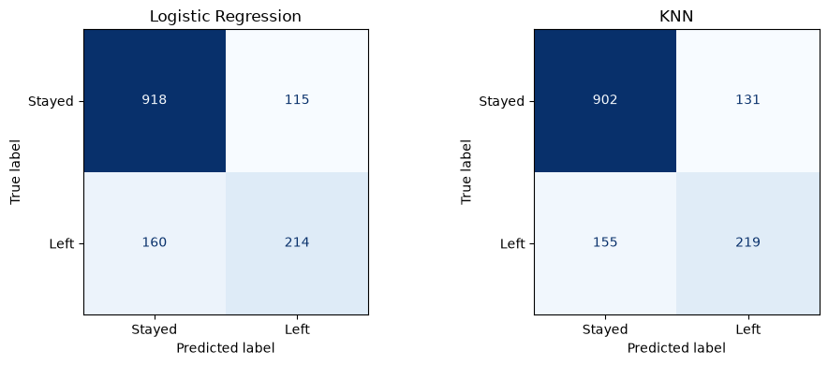
Figure 5: Confusion matrices
There were 374 churners in the test set. Logistic Regression found 214 of them with 115 false alarms. KNN found 219 with 131 false alarms. So KNN found 5 more churners but gave 16 more false alarms. The two models are very close.

7. Overfitting vs Underfitting
Overfitting means the model memorises the training data, so the training score is high but the test score is much lower. Underfitting means the model is too simple, so both scores are low. KNN shows both, because K controls how simple the model is.
Model | Train F1 | Test F1 | Gap | Result
KNN (K=1) | 0.997 | 0.519 | 0.478 | Overfitting
KNN (K=35) | 0.618 | 0.605 | 0.013 | Good fit
Logistic Regression | 0.600 | 0.609 | -0.009 | Good fit
KNN (K=3001) | 0.000 | 0.000 | 0.000 | Underfitting
Table 2: Training and test scores
With K=1 each training customer is its own nearest neighbour, so the model has memorised the data. With K=3001 the vote covers more than half of the training set. There are only 1,495 churners in it, so churn can never get the 1,501 votes it needs and the model says "No" for everyone.

8. Which Columns Matter
The Logistic Regression weights show that tenure and longer contracts push most strongly towards staying, and fiber optic internet pushes most strongly towards churn.
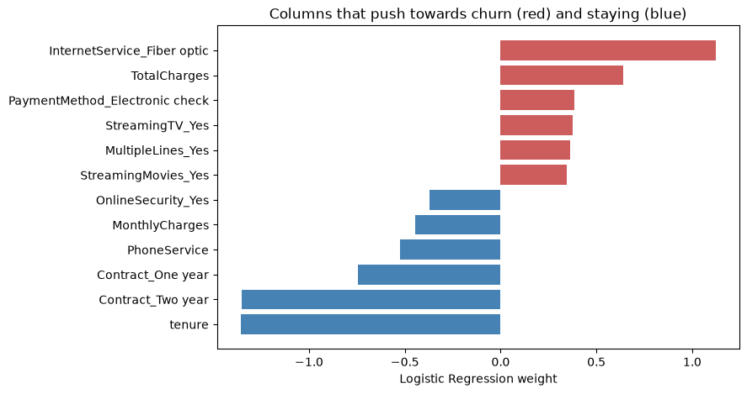
Figure 6: Logistic Regression weights
These weights show what the model uses, not what causes churn. MonthlyCharges has a negative weight even though customers who left paid more on average. This happens because the columns overlap: monthly charges depend on the services a customer has, and TotalCharges is close to tenure multiplied by monthly charges. The model shares the effect between them, so the sign of one column can be misleading.

9. Conclusion
I chose Logistic Regression as the final model, with 80.5% accuracy and an F1-score of 0.609. KNN was very close at 79.7% and 0.605, so the choice is based on Logistic Regression being simpler, faster when predicting, and easier to explain.
The main limit is recall of 0.572, which means the model still misses about 4 in 10 churners. Giving more importance to the churn class during training, or lowering the 0.5 cut-off, would find more churners but also give more false alarms.

Advice for the company
- Offer month-to-month customers a good deal to move to a one or two year contract.
- Give extra attention to customers in their first year.
- Find out why fiber optic customers leave, as 41.9% of them churned compared to 19.0% on DSL.

