KEEPR
The AI-powered receipt & warranty vault
Product Requirements Document (PRD)
Functional, non-functional, product and domain requirements, architecture and system sequence diagrams
Item | Detail
Product | Keepr: receipt & warranty vault with AI extraction
Document version | 1.0
Status | Draft for review
Date | 2 October 2026
Target platforms | Android, iOS and Web from one Flutter codebase
Architecture | Clean Architecture (3 layers: Presentation, Domain, Data) · MVP pattern (Model-View-Presenter) · Riverpod
Backend | Supabase (Auth, Postgres with RLS, Storage, Edge Functions)

Document control

Revision history
Version | Date | Author | Change summary
0.1 | 25 Sep 2026 | Product owner | Problem statement, personas and initial scope
0.5 | 29 Sep 2026 | Product + engineering | Functional/non-functional requirements, domain model
1.0 | 2 Oct 2026 | Product + engineering | Architecture, sequence diagrams, data design, release plan

How to read this document
Requirements carry stable IDs so they can be referenced from tickets, commits and tests: FR- functional, NFR- non-functional, BR- business (domain) rule, US- user story. Priorities use MoSCoW: Must, Should, Could, Won’t (this release).
Two meanings of “MVP”. This document uses the acronym in two senses. MVP pattern means Model-View-Presenter, the presentation pattern used in the Presentation layer. MVP release means Minimum Viable Product, the first public release (v1.0). The word is always qualified to avoid confusion.

Contents

If the table of contents is empty, right-click it in Word and choose Update Field.

1. Introduction

1.1 Purpose
This PRD defines what Keepr must do, how well it must do it, the domain rules it enforces and the architecture it is built on. It is the single source of truth for product, design, engineering and QA from the MVP release (v1.0) through v2.0.

1.2 Product scope
Keepr is a cross-platform app (Android, iOS, Web) that lets people photograph receipts, uses on-device OCR plus an AI model to turn them into structured records, tracks return windows and warranty end dates, sends reminders before deadlines and produces a ready-to-send warranty claim pack. Households can share one vault. Data works offline and syncs to the cloud.

1.3 Intended audience
- Product owner: scope, priorities, success metrics.
- Flutter engineers: architecture, layers, contracts, sequence flows.
- Backend engineer: schema, RLS, Edge Functions.
- UI/UX designer: personas, journeys, screen inventory.
- QA: acceptance criteria, NFR targets, test strategy.
- Clients and reviewers (portfolio): a concise, professional view of how the product is designed.

1.4 Definitions and acronyms
Term | Meaning
Receipt | Proof of purchase captured as an image plus structured fields (merchant, date, items, total).
Warranty | Manufacturer or seller guarantee attached to a purchased item for a period of months.
Return window | Number of days after purchase during which the store accepts returns.
Claim pack | Generated PDF bundling receipt, product photos, serial number and a claim letter.
Household | A shared vault owned by one user with invited members.
OCR | Optical Character Recognition: converting an image of text into machine-readable text.
LLM | Large Language Model used to structure raw OCR text into fields.
Clean Architecture | Layered architecture where source dependencies point inward to the Domain layer.
MVP pattern | Model-View-Presenter: View renders state, Presenter holds presentation logic, Model is domain.
MVP release | Minimum Viable Product: the smallest release that delivers the core value (v1.0).
Riverpod | Flutter state-management and dependency-injection library used for presenters and wiring.
RLS | Row-Level Security in Postgres: per-row access rules enforced by the database.
Outbox | Local queue of pending writes that the sync service pushes to the server when online.
SSD | System Sequence Diagram: the ordered messages exchanged to complete a scenario.

1.5 References
- Flutter documentation (flutter.dev) and Dart 3 language guide.
- Riverpod documentation (riverpod.dev).
- Supabase documentation: Auth, Row-Level Security, Storage, Edge Functions.
- Robert C. Martin, “Clean Architecture” (2017).
- Material Design 3 guidelines; WCAG 2.1 accessibility guidelines.
- Google Play and Apple App Store data-safety and privacy requirements.

2. Product overview

2.1 Problem statement
People buy dozens of items with warranties every year, but proof of purchase is fragile and deadlines are invisible:
- Receipts disappear. Thermal-paper receipts fade within months; paper is lost in drawers, wallets and email inboxes.
- Deadlines are missed. Return windows (often 7–30 days) and warranty end dates are not tracked anywhere, so people discover them too late.
- Claims fail for lack of proof. When an appliance or phone breaks, shops ask for the original receipt and serial number, which the customer cannot find. People pay for repairs that were covered.
- Manual tracking is tedious. Spreadsheets and note apps require typing every field, so nobody keeps them up to date.
- Families buy separately. Household purchases are spread across several people and phones with no shared record.

2.2 Product vision
Vision. “Never lose a receipt or miss a warranty again.” Snap a photo, and Keepr remembers everything, reminds you at the right time and gives you the proof the moment you need it.

2.3 Goals and non-goals
Goals (v1.0 to v2.0) | Non-goals
Capture a receipt in under 20 seconds with minimal typing. | Full accounting or bookkeeping (ledgers, tax filing).
Extract key fields automatically with high accuracy. | Corporate expense-report approval workflows.
Never let a tracked return or warranty deadline pass silently. | Price comparison or shopping recommendations.
Produce a claim-ready document in one tap. | Filing claims directly with manufacturers (v1.x).
Work fully offline and stay in sync across devices. | Bank-account or card-transaction syncing.
Share a vault with family members safely. | Social or public sharing of receipts.

2.4 Success metrics
Metric | Definition | Target (90 days after launch)
Activation | New users who save their first receipt within 24 h of sign-up | ≥ 60%
Extraction accuracy | Merchant, date and total correct without user edit | ≥ 85%
Time to save | Median time from capture to saved receipt | ≤ 20 s
D30 retention | Users active on day 30 after sign-up | ≥ 25%
Reminder engagement | Reminder notifications opened | ≥ 40%
Stability | Crash-free sessions | ≥ 99.5%
Monetisation | Free-to-Premium conversion | ≥ 3%
Store rating | Average rating on Google Play / App Store | ≥ 4.5

2.5 Target users and personas
Persona | Context | Pain points | What Keepr gives them
Ayesha, 29  Working professional | Buys electronics and clothes online and in malls; busy schedule. | Paper receipts fade; misses return windows; cannot find invoice for phone repair. | Fast scan, automatic return/warranty reminders, instant search by product.
Hamza, 41  Family manager | Manages household appliances bought by different family members. | No single place for receipts; does not know which fridge is still under warranty. | Shared household vault, roles, warranty status at a glance, claim pack.
Sara, 34  Freelancer / small business | Buys equipment for work; needs records at tax time. | Scattered receipts across email and paper; manual spreadsheets. | Categories, insights, CSV/PDF export, cloud backup.

2.6 Competitive landscape
Alternative | Strength | Gap Keepr fills
Phone gallery / cloud photos | Free and always available | No structure, search, deadlines or reminders.
Corporate expense apps | Strong OCR and reporting | Built for business expense reports, not personal warranties and returns.
Note and spreadsheet apps | Flexible | Fully manual; no reminders; nobody keeps them current.
Dedicated warranty trackers | Track warranty dates | Mostly manual entry, no AI extraction, no claim pack, weak family sharing.

2.7 Value proposition
- Zero-typing capture: OCR + AI fills the form; the user only confirms.
- Proactive protection: reminders before return and warranty deadlines.
- Proof on demand: one-tap, professional claim pack PDF.
- Works everywhere: Android, iOS and Web; offline-first with sync.
- Built for families: a shared vault with roles.

2.8 Assumptions, constraints and dependencies
Type | Statement
Assumption | Most target users own a smartphone with a camera of 8 MP or more and have intermittent internet.
Assumption | Users will accept cloud backup if data is encrypted in transit and at rest and deletable on request.
Constraint | Single codebase in Flutter (Dart 3) for Android, iOS and Web.
Constraint | Architecture must follow Clean Architecture (3 layers) with the MVP pattern and Riverpod.
Constraint | Running cost for the MVP release must stay within free tiers plus about US$25/month of AI usage.
Constraint | LLM and service keys must never ship inside the client app.
Dependency | Supabase (Auth, Postgres, Storage, Edge Functions), Google ML Kit, an LLM API, RevenueCat, Firebase Cloud Messaging.

3. Scope and release plan

3.1 MVP release (v1.0) scope
The MVP release delivers the core loop: capture, extract, confirm, remind, prove.
- Email and Google sign-in; profile with currency and locale.
- Receipt capture from camera or gallery, with crop and compression.
- On-device OCR (mobile) and AI extraction through an Edge Function.
- Review and edit form with low-confidence highlighting.
- Vault list with search, filters (category, date, warranty status) and detail view.
- Warranty and return tracking with automatic local reminders.
- Claim pack PDF generation and sharing.
- Offline-first local storage with background sync.
- Free plan limits and Premium subscription.
- Settings: theme, notification preferences, data export (CSV), account deletion.

3.2 Feature roadmap
Feature | v1.0 MVP release | v1.1 | v2.0
Auth (email, Google) | ✓ | Apple sign-in | Passkeys
Scan + AI extraction | ✓ | Multi-page receipts | Email receipt import
Vault, search, filters | ✓ | Saved filters | Natural-language search
Warranty / return reminders | Local notifications | Server push (FCM) + email | Smart reminders by product type
Claim pack PDF | ✓ | Custom claim letter templates | Direct submission to partners
Household sharing | Invite + roles | Realtime updates | Multiple households
Insights | Monthly spend by category | Trends + export | Budgets
Platforms | Android + Web | iOS App Store | Desktop (macOS/Windows)
Languages | English | Urdu (RTL) | Arabic, more

3.3 Out of scope (all releases in this PRD)
- Bank or card transaction import.
- Tax filing and accounting ledgers.
- Marketplace or reselling of items.
- Insurance products.

4. User stories
Stories are grouped by persona need and prioritised with MoSCoW. Each story maps to functional requirements in section 5 and to the traceability matrix in Appendix A.
ID | As a… | I want to… | So that… | Priority
US-01 | new user | sign up with email or Google | my receipts are backed up to my account | Must
US-02 | shopper | photograph a receipt right after paying | I never lose proof of purchase | Must
US-03 | shopper | have merchant, date, items and total filled automatically | I do not have to type | Must
US-04 | shopper | see which fields the AI is unsure about | I can correct only those | Must
US-05 | buyer of electronics | set the warranty length for an item | Keepr knows when it ends | Must
US-06 | shopper | be reminded before a return window closes | I can return items in time | Must
US-07 | owner of an appliance | be reminded 30 and 7 days before warranty ends | I can check it while still covered | Must
US-08 | user | search receipts by product, store or amount | I find proof in seconds | Must
US-09 | user with a broken item | create a claim pack PDF and share it | the shop accepts my claim | Must
US-10 | user without internet | scan and save receipts offline | the app works anywhere | Must
US-11 | family manager | invite my spouse to our household vault | we share one record of purchases | Should
US-12 | household owner | give members Editor or Viewer roles | I control who can change data | Should
US-13 | freelancer | see monthly spend by category and export CSV | tax time is easier | Should
US-14 | free user | upgrade to Premium in-app | I get unlimited scans and claim packs | Should
US-15 | user | delete my account and all data | my privacy is respected | Must

4.1 Key acceptance criteria

US-03 / US-04: AI extraction
- Given a clear photo of a printed receipt, when extraction completes, then merchant, purchase date, currency and total are pre-filled within 6 s at p90 on a 4G connection.
- Given a field with confidence below 0.7, when the review form opens, then the field is highlighted and Save requires the user to confirm or edit it.
- Given extraction fails, when the error is returned, then the user sees the form with OCR text available and can complete fields manually.

US-06 / US-07: Reminders
- Given a confirmed receipt with a return window, when it is saved, then a reminder is scheduled 3 days before the deadline at 10:00 local time.
- Given a warranty end date more than 30 days away, when saved, then reminders are scheduled at −30 days and −7 days.
- Given a receipt is deleted or the deadline is edited, when saved, then old reminders are cancelled and new ones are scheduled.

US-09: Claim pack
- Given a receipt with at least one image, when the user taps Create claim pack, then an A4 PDF containing receipt image, item details, serial number, warranty status and a claim letter is generated in under 3 s and the OS share sheet opens.
- Given a free user who has used 3 claim packs this month, when they tap Create claim pack, then the Premium screen is shown.

US-10: Offline
- Given no network, when the user saves a receipt, then it appears in the vault immediately, marked “Waiting to sync”.
- Given connectivity returns, when the sync service runs, then pending changes upload within 60 s and the marker disappears.

5. Functional requirements

5.1 Authentication and profile
ID | Requirement | Priority | Release
FR-AUTH-01 | The system shall allow sign-up and sign-in with email and password (minimum 8 characters, one number). | Must | 1.0
FR-AUTH-02 | The system shall allow sign-in with Google (OAuth); Apple sign-in on iOS. | Must | 1.0 / 1.1
FR-AUTH-03 | The system shall send email verification and support password reset by email link. | Must | 1.0
FR-AUTH-04 | The system shall keep the user signed in using a refreshable session stored securely on device. | Must | 1.0
FR-AUTH-05 | On first sign-in the system shall create a profile and a personal household automatically. | Must | 1.0
FR-AUTH-06 | The user shall be able to set display name, default currency, locale and time zone. | Should | 1.0
FR-AUTH-07 | The system shall sign the user out on all devices on request. | Could | 1.1

5.2 Receipt capture
ID | Requirement | Priority | Release
FR-CAP-01 | The user shall capture a receipt with the device camera, with edge detection guide overlay. | Must | 1.0
FR-CAP-02 | The user shall import a receipt image or PDF from the gallery or file system (Web: file picker / drag-and-drop). | Must | 1.0
FR-CAP-03 | The system shall allow cropping and rotating before processing. | Must | 1.0
FR-CAP-04 | The system shall compress images to at most 1600 px on the long edge and ≤ 600 KB (JPEG/WebP). | Must | 1.0
FR-CAP-05 | The user shall attach additional photos: product, serial-number label, box. | Should | 1.0
FR-CAP-06 | The user shall create a receipt manually without an image. | Must | 1.0
FR-CAP-07 | The system shall support multi-page receipts (stitch up to 5 images). | Could | 1.1

5.3 AI extraction
ID | Requirement | Priority | Release
FR-AI-01 | On Android and iOS, the system shall run OCR on device (ML Kit) before sending text for structuring. | Must | 1.0
FR-AI-02 | On Web, the system shall upload the image to the extraction Edge Function, which uses a vision-capable model. | Must | 1.0
FR-AI-03 | The extraction service shall return merchant, purchase date, currency, total, tax, line items, payment method, suggested category and a confidence score per field, as validated JSON. | Must | 1.0
FR-AI-04 | The system shall suggest warranty length and return window from merchant/category defaults when not printed. | Should | 1.0
FR-AI-05 | The review form shall highlight fields with confidence < 0.7. | Must | 1.0
FR-AI-06 | If extraction fails or times out (15 s), the system shall fall back to manual entry with OCR text visible. | Must | 1.0
FR-AI-07 | When offline, the system shall save the capture as QueuedOffline and extract automatically on reconnect. | Must | 1.0
FR-AI-08 | The system shall enforce the monthly AI-scan quota of the user’s plan on the server. | Must | 1.0

5.4 Receipt vault
ID | Requirement | Priority | Release
FR-VLT-01 | The vault shall list receipts newest first with merchant, date, total, thumbnail and warranty badge. | Must | 1.0
FR-VLT-02 | The user shall search by merchant, item name, serial number, notes and amount. | Must | 1.0
FR-VLT-03 | The user shall filter by category, date range, household member and warranty status (Active, Expiring soon, Expired). | Must | 1.0
FR-VLT-04 | The detail view shall show images (zoomable), fields, line items, warranties, reminders and sync status. | Must | 1.0
FR-VLT-05 | The user shall edit any field; edits re-run domain rules and reschedule reminders. | Must | 1.0
FR-VLT-06 | Deleting a receipt shall move it to Trash for 30 days, then purge permanently. | Should | 1.0
FR-VLT-07 | The system shall warn about likely duplicates (same merchant, date and total). | Should | 1.0
FR-VLT-08 | The list shall paginate/virtualise to remain smooth with 5,000+ receipts. | Must | 1.0

5.5 Warranty and return tracking
ID | Requirement | Priority | Release
FR-WAR-01 | The user shall add a warranty to any line item with period in months and optional provider and extended flag. | Must | 1.0
FR-WAR-02 | The system shall compute warranty end date and status (BR-01, BR-12). | Must | 1.0
FR-WAR-03 | The system shall compute return deadline from return window days (BR-02). | Must | 1.0
FR-WAR-04 | A “Protection” dashboard shall show items with Expiring soon warranties and open return windows. | Should | 1.0

5.6 Reminders and notifications
ID | Requirement | Priority | Release
FR-REM-01 | The system shall schedule default reminders per BR-03 when a receipt is confirmed. | Must | 1.0
FR-REM-02 | The user shall add custom reminders with date, time and note. | Should | 1.0
FR-REM-03 | Tapping a notification shall deep-link to the receipt detail. | Must | 1.0
FR-REM-04 | The user shall configure reminder offsets and quiet hours in settings. | Could | 1.1
FR-REM-05 | The server shall send push and email reminders so reminders reach every signed-in device. | Should | 1.1
FR-REM-06 | A Reminders screen shall list upcoming and past reminders with snooze and dismiss. | Should | 1.0

5.7 Claim pack
ID | Requirement | Priority | Release
FR-CLM-01 | The system shall generate an A4 PDF with cover summary, receipt image(s), item and serial details, warranty status and a claim letter. | Must | 1.0
FR-CLM-02 | The user shall share, save or print the PDF through the OS share sheet (Web: download). | Must | 1.0
FR-CLM-03 | The claim letter shall be pre-filled with user name, merchant, purchase date and issue description entered by the user. | Should | 1.0
FR-CLM-04 | Free plan users are limited per BR-07. | Must | 1.0

5.8 Household sharing
ID | Requirement | Priority | Release
FR-HH-01 | The owner shall invite members by email or share link (valid 7 days). | Should | 1.0
FR-HH-02 | Members shall have roles Owner, Editor or Viewer with permissions per BR-08. | Should | 1.0
FR-HH-03 | Receipts shall show who added them. | Should | 1.0
FR-HH-04 | The owner shall remove members; removed members lose access immediately (enforced by RLS). | Should | 1.0
FR-HH-05 | Household changes shall appear on other members’ devices in real time. | Could | 1.1

5.9 Insights
ID | Requirement | Priority | Release
FR-INS-01 | The system shall show monthly spend by category as a chart for the selected period. | Should | 1.0
FR-INS-02 | The system shall show the total value of items under active warranty (“protected value”). | Could | 1.0
FR-INS-03 | The user shall export receipts as CSV and a ZIP of images. | Should | 1.0

5.10 Offline and sync
ID | Requirement | Priority | Release
FR-SYN-01 | All reads shall be served from the local database; the UI shall never block on the network for viewing data. | Must | 1.0
FR-SYN-02 | All writes shall be stored locally and queued in an outbox for upload. | Must | 1.0
FR-SYN-03 | Sync shall run on connectivity regained, app resume and every 15 minutes in foreground. | Must | 1.0
FR-SYN-04 | Conflicts shall be resolved per BR-13 (last-write-wins per field, images never discarded). | Must | 1.0
FR-SYN-05 | Each receipt shall display its sync state (Synced, Waiting, Failed with retry). | Should | 1.0

5.11 Subscription and entitlements
ID | Requirement | Priority | Release
FR-SUB-01 | The app shall offer Premium monthly and yearly plans through App Store and Google Play billing via RevenueCat. | Should | 1.0
FR-SUB-02 | Entitlements shall be verified server-side (webhook) and cached locally for offline use. | Must | 1.0
FR-SUB-03 | Users shall restore purchases on a new device. | Must | 1.0
FR-SUB-04 | A paywall shall clearly list Free vs Premium limits with no dark patterns. | Must | 1.0

5.12 Settings and data control
ID | Requirement | Priority | Release
FR-SET-01 | Theme (system, light, dark) and text size respecting OS settings. | Must | 1.0
FR-SET-02 | Notification preferences per reminder type. | Should | 1.0
FR-SET-03 | Export all data (CSV + images ZIP) on request. | Should | 1.0
FR-SET-04 | Delete account: removes profile, receipts, images and backups within 30 days; confirmation by password or re-auth. | Must | 1.0
FR-SET-05 | App lock with device biometrics. | Could | 1.1

6. Non-functional requirements
Each quality attribute has a measurable target so it can be verified in testing, monitoring or review. Targets apply to the MVP release unless stated otherwise.
ID | Category | Requirement | Measure / target
NFR-PERF-01 | Performance | Cold start to interactive vault | ≤ 2.5 s on mid-range Android (e.g. 4 GB RAM); ≤ 3 s Web on 4G
NFR-PERF-02 | Performance | Scrolling and animations | 60 fps; no frame > 32 ms in vault list with 5,000 receipts
NFR-PERF-03 | Performance | On-device OCR | ≤ 1.5 s p90 per image
NFR-PERF-04 | Performance | End-to-end extraction | ≤ 6 s p90 on 4G
NFR-PERF-05 | Performance | Local search | ≤ 300 ms for 5,000 receipts
NFR-PERF-06 | Performance | App size | Android release APK per ABI ≤ 30 MB
NFR-REL-01 | Reliability | Crash-free sessions | ≥ 99.5% (Sentry)
NFR-REL-02 | Reliability | No data loss | Zero lost receipts in sync tests (kill app, airplane mode, conflicts)
NFR-REL-03 | Availability | Backend availability | ≥ 99.5% monthly (Supabase SLA)
NFR-OFF-01 | Offline | Core features offline | Capture, view, search, edit, reminders and claim pack work with no network
NFR-SEC-01 | Security | Transport security | TLS 1.2+ for all traffic; certificate validation on
NFR-SEC-02 | Security | Authorization | Postgres RLS on every table; no table readable without a policy
NFR-SEC-03 | Security | Secrets | No LLM/service keys in the client; only the Supabase anon key ships
NFR-SEC-04 | Security | Session storage | Tokens in Keychain/Keystore via secure storage on mobile
NFR-SEC-05 | Security | File access | Private storage buckets; signed URLs valid ≤ 60 min
NFR-SEC-06 | Security | Abuse protection | Rate limit extraction to 30 requests/user/hour; input size ≤ 5 MB
NFR-PRV-01 | Privacy | Data minimisation | LLM receives OCR text or image only, no user identifiers; provider must not train on data
NFR-PRV-02 | Privacy | User rights | Export and delete account in-app; deletion complete ≤ 30 days
NFR-PRV-03 | Privacy | Store compliance | Accurate Google Play Data Safety and Apple privacy labels; privacy policy URL
NFR-PRV-04 | Privacy | Logging | No receipt contents or PII in logs or analytics
NFR-USA-01 | Usability | Learnability | First receipt saved without help by 9 of 10 test users
NFR-ACC-01 | Accessibility | WCAG 2.1 AA | Contrast ≥ 4.5:1, screen-reader labels, tap targets ≥ 48 dp, text scaling to 200%
NFR-L10N-01 | Localisation | i18n ready | All strings in ARB files; locale-aware dates/currency; RTL-ready layouts
NFR-CMP-01 | Compatibility | Supported platforms | Android 8.0+ (API 26), iOS 15+, latest 2 versions of Chrome, Safari, Edge, Firefox
NFR-CMP-02 | Compatibility | Responsive UI | Layouts for phone, tablet and desktop web (breakpoints 600 / 1024 px)
NFR-MNT-01 | Maintainability | Architecture conformance | Domain layer imports no Flutter or data packages (checked by lint rule in CI)
NFR-MNT-02 | Maintainability | Static analysis | Zero analyzer warnings with strict lint set
NFR-MNT-03 | Maintainability | Documentation | README, architecture doc and ADRs for key decisions
NFR-TST-01 | Testability | Coverage | Domain ≥ 90%, presenters ≥ 80%, overall ≥ 70% line coverage
NFR-SCL-01 | Scalability | Growth | Schema and indexes support 100k users × 1,000 receipts without redesign
NFR-OBS-01 | Observability | Monitoring | Crash reporting, performance traces and Edge Function logs with alerting
NFR-COST-01 | Cost | AI cost | Average extraction cost ≤ US$0.002 per receipt; monthly cost alerts

7. Domain model and business rules

7.1 Bounded contexts
Context | Responsibility | Main entities
Identity | Accounts, sessions, profile settings | User
Vault | Receipts, items, attachments, search | Receipt (aggregate root), LineItem, Attachment
Protection | Warranty and return computation, reminders | Warranty, Reminder, ReturnWindow
Sharing | Households, membership and roles | Household, HouseholdMember
Billing | Plans, quotas and entitlements | Entitlement

7.2 Domain model
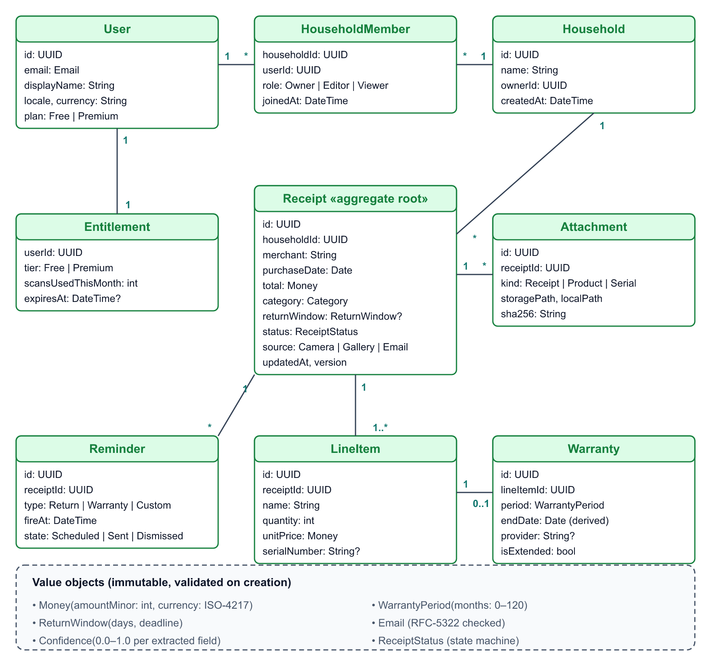
Figure 1. Domain model: entities, relationships and value objects

7.3 Entities and value objects
Element | Kind | Description and invariants
Receipt | Aggregate root | A purchase. Owns line items, attachments and reminders. Must have merchant, purchaseDate and total before it can be Confirmed.
LineItem | Entity | A purchased product. Quantity ≥ 1; unitPrice ≥ 0. May have one Warranty.
Warranty | Entity | Coverage for a line item. endDate is always derived, never stored independently from period.
Reminder | Entity | A scheduled notification tied to a receipt deadline or custom date. fireAt must be in the future when created.
Attachment | Entity | An image or PDF. Identified by SHA-256 to avoid duplicate uploads.
Household / Member | Entities | Sharing boundary. Exactly one Owner per household.
Entitlement | Entity | Plan tier and monthly usage counters; reset on the 1st of each month (UTC).
Money | Value object | Integer minor units + ISO-4217 currency. Never use double for money.
WarrantyPeriod | Value object | Months 0–120. 0 means no warranty.
ReturnWindow | Value object | Days 0–365 and derived deadline.
Confidence | Value object | 0.0–1.0 per extracted field; below 0.7 is “low”.

7.4 Business rules
ID | Rule
BR-01 | Warranty end date = purchase date + warranty months (calendar months). If the day does not exist in the target month, use its last day.
BR-02 | Return deadline = purchase date + return-window days (end of day, user time zone).
BR-03 | Default reminders: return deadline −3 days; warranty end −30 days and −7 days; all at 10:00 local time. Only future reminders are created.
BR-04 | Only Confirmed receipts create reminders and count toward insights.
BR-05 | Purchase date cannot be in the future; total ≥ 0; currency must be a valid ISO-4217 code.
BR-06 | Warranty period must be 0–120 months; return window 0–365 days.
BR-07 | Free plan: 15 AI scans/month (manual entry unlimited), 3 claim packs/month, 1 household with up to 2 members. Premium: unlimited scans and claim packs, household up to 6 members.
BR-08 | Owner: all actions incl. invite/remove members. Editor: create/edit/delete receipts. Viewer: read and generate claim packs only.
BR-09 | Deleting a receipt soft-deletes it for 30 days and cancels all its reminders immediately.
BR-10 | A receipt with the same merchant, date and total in the same household is flagged as a possible duplicate.
BR-11 | Extracted fields with confidence < 0.7 must be confirmed by the user before saving.
BR-12 | Warranty status: Active (> 30 days left), Expiring soon (≤ 30 days), Expired (end date passed).
BR-13 | Sync conflicts: last-write-wins per field using server timestamp; attachments are additive and never deleted by a conflict.

7.5 Receipt lifecycle
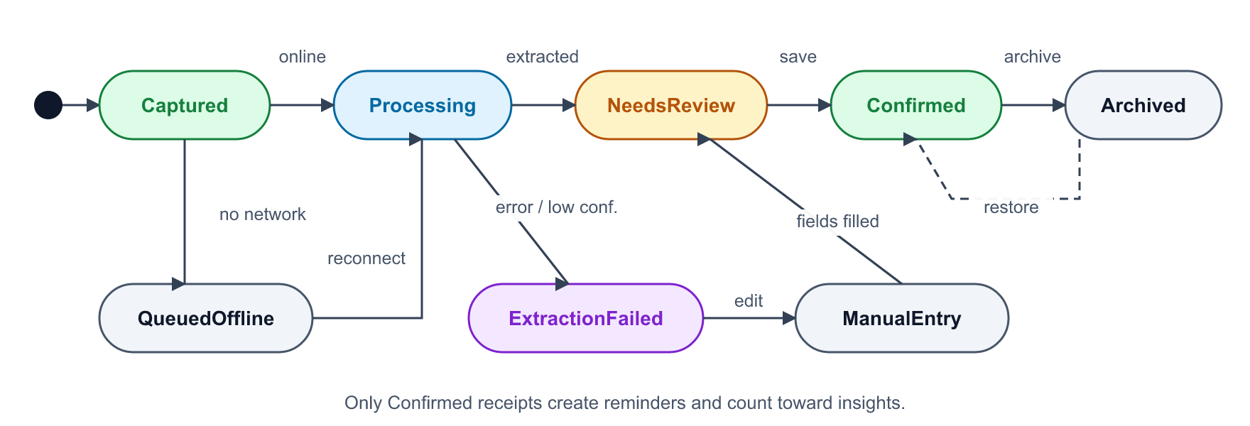
Figure 2. Receipt status state machine
From | Event | To | Guard / side effect
Captured | online | Processing | Quota available (BR-07)
Captured | no network | QueuedOffline | OCR text stored locally
QueuedOffline | reconnect | Processing | Triggered by SyncService
Processing | extracted | NeedsReview | Confidence attached to each field
Processing | error / timeout | ExtractionFailed | Error logged without receipt content
ExtractionFailed | edit | ManualEntry | OCR text shown to help
NeedsReview / ManualEntry | save | Confirmed | BR-05, BR-06, BR-11 pass; reminders scheduled (BR-03)
Confirmed | archive / restore | Archived / Confirmed | Archived receipts keep reminders off

8. System architecture

8.1 Architectural drivers
- Cross-platform: one Flutter codebase for Android, iOS and Web, with platform-specific adapters only in the Data layer.
- Testability: business rules in pure Dart, testable without Flutter, network or database.
- Offline-first: local database is the source of truth for the UI; the network is a sync concern.
- Security: secrets server-side; authorization enforced by the database (RLS).
- Replaceability: swapping Supabase, the LLM provider or the local DB must not touch Domain or Presentation.

8.2 System context
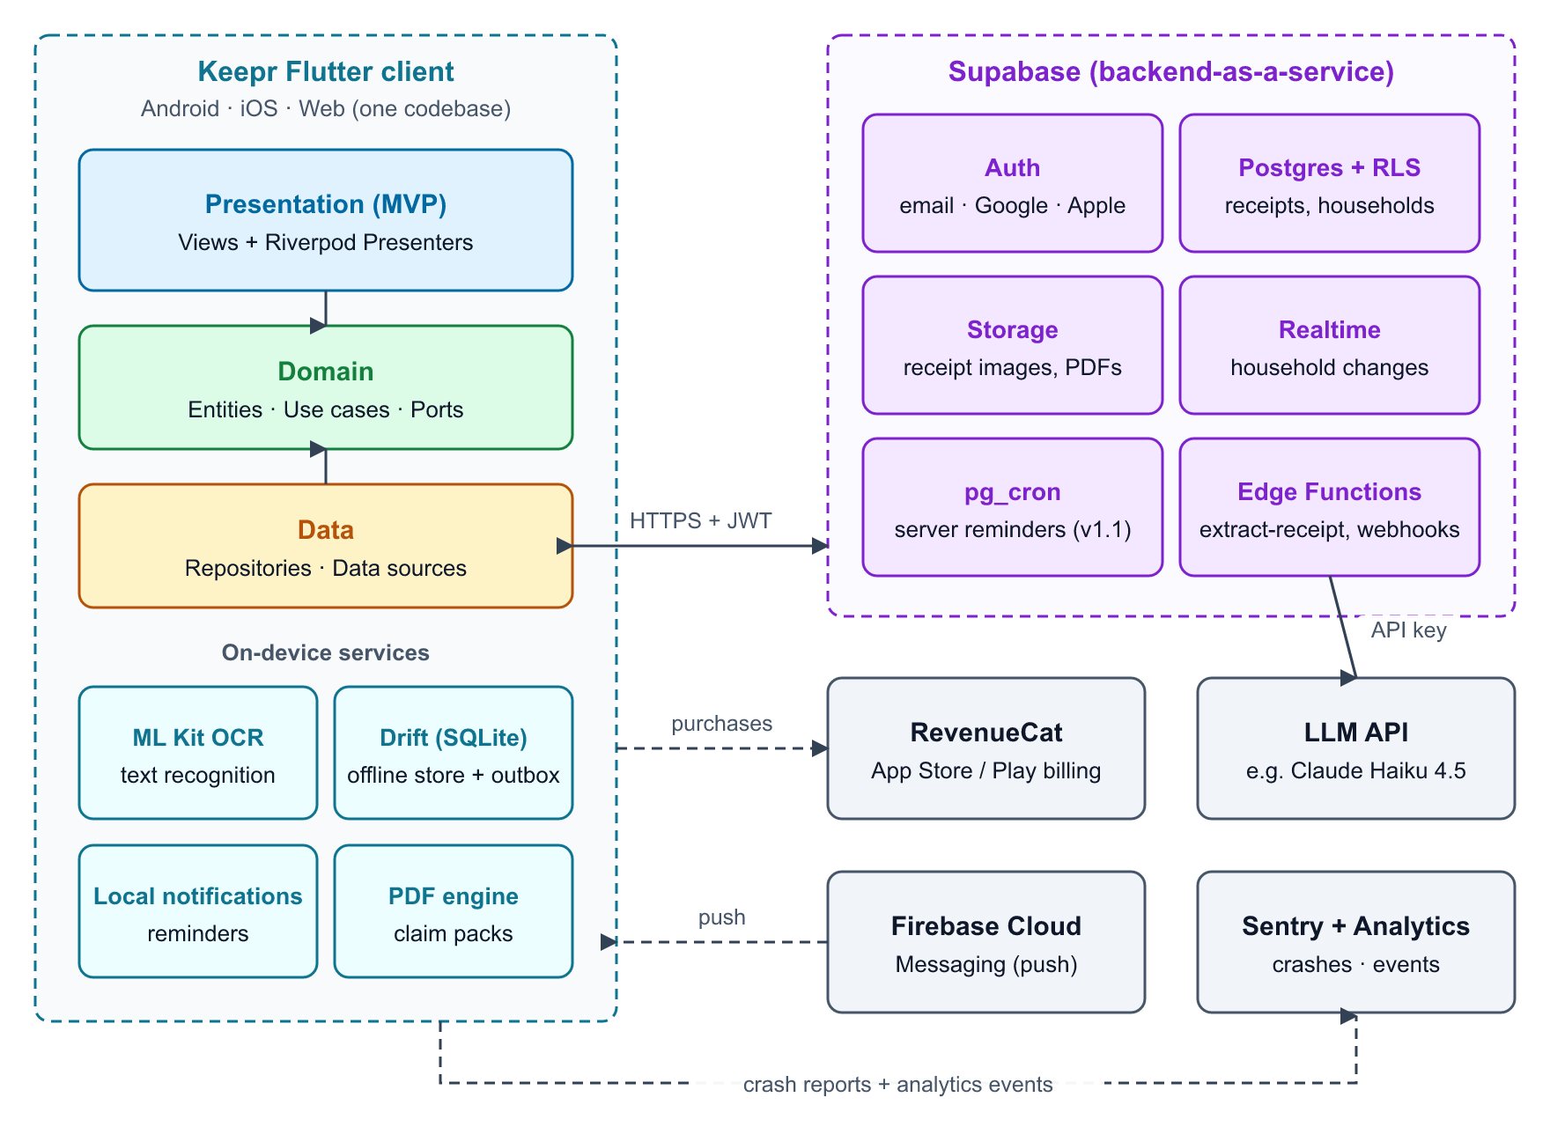
Figure 3. System context: Flutter client, on-device services, Supabase and third parties

8.3 Clean Architecture: the three layers
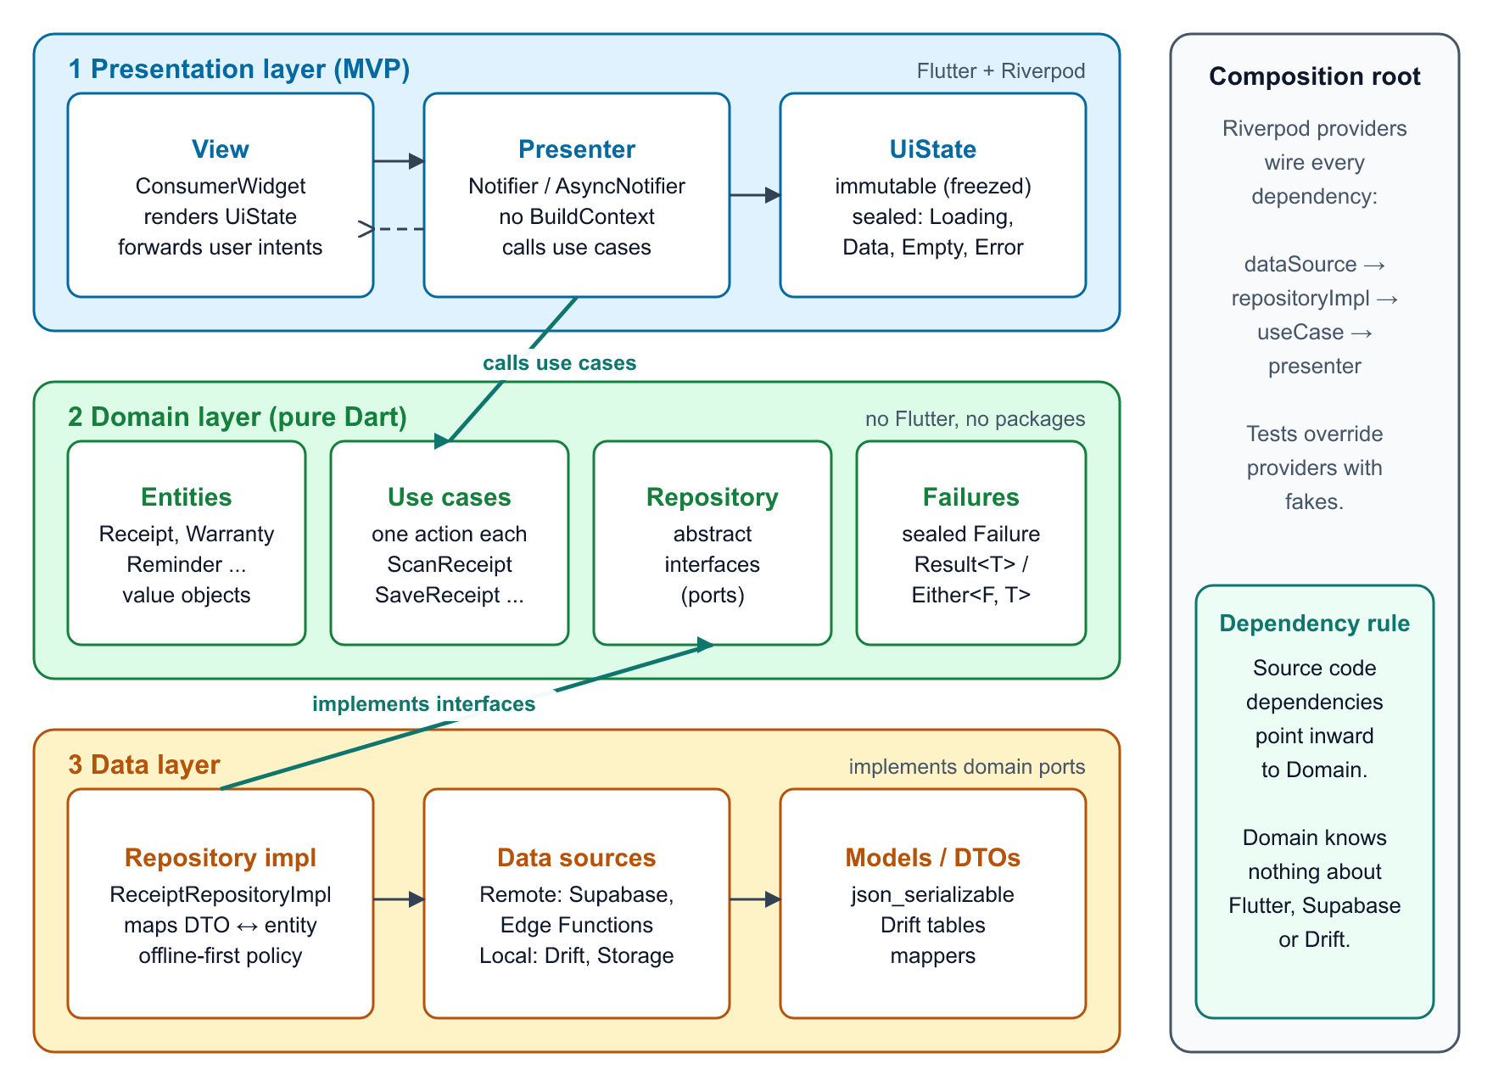
Figure 4. Clean Architecture layers and the dependency rule
Layer | Responsibility | Contains | May depend on | Must not
Presentation | Render UI and translate user intents into use-case calls (MVP pattern). | Views (widgets), Presenters (Riverpod Notifiers), UiState classes, view models, routing | Domain | Call Supabase, Drift or HTTP directly; hold business rules
Domain | Business rules of Keepr. The stable core. | Entities, value objects, use cases, repository interfaces, failures | Nothing (pure Dart) | Import Flutter, Riverpod, Supabase, Drift or JSON packages
Data | Fetch, store and sync data; adapt platforms and services. | Repository implementations, remote/local data sources, DTOs, mappers, platform services (OCR, notifications, PDF) | Domain (implements its interfaces) | Leak DTOs or exceptions upward; contain UI code

8.4 MVP pattern (Model-View-Presenter) with Riverpod
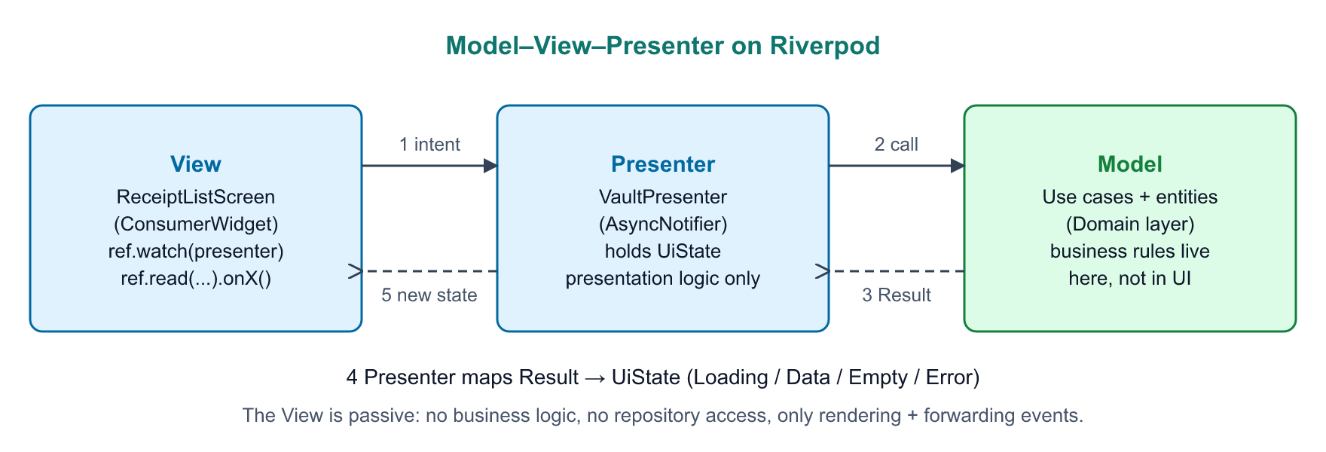
Figure 5. Model-View-Presenter mapped onto Riverpod
MVP role | Keepr implementation | Rules
View | ConsumerWidget / ConsumerStatefulWidget screens and widgets | Passive: renders UiState, forwards intents with ref.read(presenter.notifier).onX(). No business logic, no repositories.
Presenter | Notifier / AsyncNotifier (or StreamNotifier for live lists) per screen | Holds and exposes UiState; calls use cases; maps Result to state; no BuildContext, no widgets; unit-tested with ProviderContainer.
Model | Domain use cases and entities | All business rules; returns Result<T> (Success or Failure), never throws to the presenter.
UiState | Immutable sealed classes (freezed or Dart 3 sealed) | Exhaustive switch in the View guarantees every state (Loading, Data, Empty, Error) is rendered.

Example: Vault screen
// domain/usecases/get_receipts.dart (Model)
class GetReceipts {
const GetReceipts(this._repo);
final ReceiptRepository _repo;
Future<Result<List<Receipt>>> call(ReceiptFilter filter) => _repo.getReceipts(filter);
}

// presentation/vault/vault_state.dart (UiState)
sealed class VaultUiState { const VaultUiState(); }
final class VaultEmpty extends VaultUiState { const VaultEmpty(); }
final class VaultData extends VaultUiState { const VaultData(this.cards); final List<ReceiptCardVm> cards; }
final class VaultError extends VaultUiState { const VaultError(this.message); final String message; }

// presentation/vault/vault_presenter.dart (Presenter)
final vaultPresenterProvider =
AsyncNotifierProvider<VaultPresenter, VaultUiState>(VaultPresenter.new);

class VaultPresenter extends AsyncNotifier<VaultUiState> {
@override
Future<VaultUiState> build() => _load(const ReceiptFilter());

Future<void> onFilterChanged(ReceiptFilter filter) async {
state = const AsyncLoading();
state = await AsyncValue.guard(() => _load(filter));
}

Future<VaultUiState> _load(ReceiptFilter filter) async {
final result = await ref.read(getReceiptsProvider)(filter);
return switch (result) {
Failure(:final failure) => VaultError(failure.userMessage),
Success(:final value) when value.isEmpty => const VaultEmpty(),
Success(:final value) => VaultData(value.map(ReceiptCardVm.fromEntity).toList()),
};
}
}

// presentation/vault/vault_screen.dart (View)
class VaultScreen extends ConsumerWidget {
const VaultScreen({super.key});
@override
Widget build(BuildContext context, WidgetRef ref) {
final presenter = ref.read(vaultPresenterProvider.notifier);
return ref.watch(vaultPresenterProvider).when(
loading: () => const VaultSkeleton(),
error: (e, _) => ErrorView(onRetry: () => ref.invalidate(vaultPresenterProvider)),
data: (ui) => switch (ui) {
VaultEmpty() => const EmptyVault(),
VaultError(:final message) => ErrorView(message: message),
VaultData(:final cards) => ReceiptList(cards: cards, onFilter: presenter.onFilterChanged),
},
);
}
}

8.5 Project structure
Feature-first folders, each split into the three layers. Shared code lives in core/. Tests mirror lib/.
keepr/
├─ lib/
│ ├─ main.dart # bootstrap: env, Supabase.init, ProviderScope
│ ├─ app/ # App widget, go_router, theme, l10n
│ ├─ core/ # Result, AppFailure, Money, utils, shared widgets
│ └─ features/
│ ├─ auth/
│ │ ├─ domain/ # entities/ repositories/ usecases/
│ │ ├─ data/ # datasources/ models/ repositories/
│ │ └─ presentation/ # views/ presenters/ states/ widgets/
│ ├─ receipts/ # scan, review, vault, detail
│ ├─ protection/ # warranties, reminders
│ ├─ claims/ # claim pack
│ ├─ household/
│ ├─ insights/
│ ├─ billing/
│ └─ sync/ # SyncService, outbox, connectivity
├─ test/ # unit + widget tests (mirrors lib/)
├─ integration_test/ # end-to-end flows
├─ supabase/
│ ├─ migrations/ # SQL schema + RLS policies
│ └─ functions/extract-receipt/
└─ .github/workflows/ci.yml

8.6 Technology stack
Concern | Choice | Reason
Framework | Flutter (stable), Dart 3 | One codebase for Android, iOS, Web; sealed classes and pattern matching
State + DI | flutter_riverpod (+ riverpod_generator optional) | Compile-safe providers; presenters as Notifiers; easy overrides in tests
Navigation | go_router | Declarative routes, deep links from notifications, auth redirects, web URLs
Models | freezed, json_serializable | Immutable states and DTOs, generated equality and JSON
Local DB | drift (SQLite; WASM on Web) | Typed queries, reactive streams for the vault, works on all three platforms
Backend | supabase_flutter | Auth, Postgres, Storage, Realtime, Edge Functions in one service
OCR | google_mlkit_text_recognition | Free, fast, private on-device OCR (Android/iOS)
AI structuring | LLM API via Edge Function (e.g. Claude Haiku 4.5) | Accurate JSON extraction at low cost; key kept server-side
Camera / files | camera, image_picker, image_cropper, file_picker | Capture, import and crop on every platform
Notifications | flutter_local_notifications + timezone; firebase_messaging (v1.1) | Offline-capable scheduled reminders; server push later
PDF + share | pdf, printing, share_plus | Generate claim packs on device and share or print
Payments | purchases_flutter (RevenueCat) | Unified App Store / Play billing and server-side entitlements
Charts | fl_chart | Insights charts
Connectivity / secure storage | connectivity_plus, flutter_secure_storage | Sync triggers; token storage in Keychain/Keystore
Quality | very_good_analysis, mocktail, flutter_test, integration_test | Strict lints and a full test pyramid
Monitoring | sentry_flutter, privacy-safe analytics | Crash reports and product metrics
CI/CD | GitHub Actions; Codemagic or fastlane for store builds | Analyze, test, build on each push; signed releases

8.7 Use-case catalogue
Use case | Input | Output | Port (repository)
SignIn / SignUp / SignOut | Credentials | User | AuthRepository
ScanReceipt | Image | ReceiptDraft | ReceiptRepository
SaveReceipt | Receipt | Receipt | ReceiptRepository, ReminderScheduler
GetReceipts / SearchReceipts | ReceiptFilter / query | List<Receipt> | ReceiptRepository
UpdateReceipt / DeleteReceipt | Receipt / id | Receipt / Unit | ReceiptRepository, ReminderScheduler
ScheduleReminders / CancelReminders | Receipt | List<Reminder> | ReminderScheduler
GenerateClaimPack | receiptId, issue text | ClaimPack (file) | ReceiptRepository, ClaimPackRenderer, EntitlementRepository
InviteMember / AcceptInvite / RemoveMember | email / token / memberId | Household | HouseholdRepository
GetInsights | Period | Insights | ReceiptRepository
SyncNow | — | SyncReport | SyncRepository
PurchasePremium / RestorePurchases | Package | Entitlement | EntitlementRepository
ExportData / DeleteAccount | — | File / Unit | AccountRepository

8.8 Dependency injection with Riverpod
Providers form the composition root. Each layer is exposed through a provider, and tests replace any of them with overrides.
// app/di/providers.dart
final supabaseProvider = Provider((ref) => Supabase.instance.client);
final appDatabaseProvider = Provider((ref) => AppDatabase());

final receiptRemoteDsProvider = Provider((ref) => ReceiptRemoteDataSource(ref.watch(supabaseProvider)));
final receiptLocalDsProvider = Provider((ref) => ReceiptLocalDataSource(ref.watch(appDatabaseProvider)));

final receiptRepositoryProvider = Provider<ReceiptRepository>((ref) => ReceiptRepositoryImpl(
remote: ref.watch(receiptRemoteDsProvider),
local: ref.watch(receiptLocalDsProvider),
));

final getReceiptsProvider = Provider((ref) => GetReceipts(ref.watch(receiptRepositoryProvider)));

// test: ProviderContainer(overrides: [receiptRepositoryProvider.overrideWithValue(FakeReceiptRepository())])

8.9 Error handling
Data sources throw platform exceptions; repositories catch them and return a domain Failure; presenters map failures to user-friendly UiState messages. Exceptions never cross a layer boundary.
Failure (domain) | Typical cause | User-facing behaviour
NetworkFailure | Timeout, no connection | Work offline; show “Will sync when online”
AuthFailure | Wrong credentials, expired session | Inline error; redirect to sign-in when session expired
ValidationFailure | Business rule violated (BR-05, BR-06) | Field-level error messages
ExtractionFailure | AI timeout or invalid JSON | Manual entry with OCR text
QuotaExceeded / PaywallRequired | Plan limit reached (BR-07) | Paywall with clear limits
PermissionFailure | Camera/notification permission denied; RLS denial | Explain why and link to settings
UnexpectedFailure | Bug | Generic message; report to Sentry

8.10 Offline-first and sync strategy
- The Drift database is the UI’s single source of truth; presenters watch Drift streams.
- Every write is applied locally inside a transaction that also inserts an outbox row (entity, id, operation, payload, attempts).
- SyncService drains the outbox FIFO with exponential back-off (1 s → 5 min), uploads images first, then rows.
- Pull uses updated_at > lastSyncedAt per household; deletes are tombstones (deleted_at).
- Conflicts follow BR-13. Every row carries version and updated_at set by the server.
- IDs are UUID v4 generated on the client so records can be created offline.

8.11 Cross-platform considerations
Capability | Android | iOS | Web
Capture | camera plugin | camera plugin | image_picker (browser camera / file), drag-and-drop
OCR | ML Kit on device | ML Kit on device | Not available: server-side vision model
Local DB | Drift (SQLite) | Drift (SQLite) | Drift WASM (OPFS / IndexedDB)
Reminders | Local notifications (exact alarms permission) | Local notifications (64 pending limit, rolling schedule) | Email reminders + Web Push (v1.1)
Payments | Play Billing via RevenueCat | StoreKit via RevenueCat | RevenueCat Web Billing / Stripe (v2.0)
Share claim pack | Share sheet | Share sheet | Download / Web Share API
Session storage | Keystore (secure storage) | Keychain (secure storage) | Browser storage managed by Supabase SDK

8.12 Security architecture
- Authentication by Supabase Auth (JWT access token ≈ 1 h, rotating refresh token).
- Authorization by Postgres RLS: a user can access rows only where they are a member of the row’s household (see 10.2).
- Edge Functions verify the JWT, check quota and call the LLM with a server-side key.
- Images stored in a private bucket under householdId/receiptId/; access via short-lived signed URLs.
- Encryption in transit (TLS) and at rest (Supabase managed). Optional SQLCipher for the local DB in v1.1.
- Dependency scanning and secret scanning in CI.

9. System sequence diagrams
The first diagram is a classic black-box system sequence diagram: the whole app is one participant, showing what the user asks of the system. The others open the box to show how each request travels through the three layers (View → Presenter → Use case → Repository → Data source), so they double as an implementation guide.
Diagram | Scenario | Layers shown | Key points
SSD-0 | Core journey (black box) | User, system, external services | Main success scenario from sign-up to claim pack
SSD-1 | Sign in | All three + Supabase Auth | Exceptions become AuthFailure; router reacts to Authenticated state
SSD-2 | Scan receipt and AI extraction | All three + ML Kit + Edge Function | On-device OCR first; offline path queues the draft; web uses vision model
SSD-3 | Confirm, save and schedule reminders | All three + Drift + notifications | Local write + outbox in one transaction; reminders built by domain rules
SSD-4 | Offline-first sync | Data layer + Supabase + presenter stream | Outbox drain, conflict resolution, pull, reactive UI update
SSD-5 | Generate and share claim pack | All three + PDF + OS share | Entitlement check in domain; paywall as a normal state

Notation
- Solid line with filled arrow: a call or request. Dashed line with open arrow: a return value.
- Messages are numbered in time order. A loop arrow on one lifeline is an internal step.
- alt frames show alternative paths (the condition is in brackets); opt is an optional path; loop repeats.
- Colours match the architecture diagrams: blue = Presentation, green = Domain, amber = Data, purple = external services.

9.1 SSD-0: Core journey (black-box system view)
The user’s view of Keepr: sign up, repeatedly scan and confirm receipts, search the vault, receive a deadline reminder and create a claim pack. Internal structure is hidden.
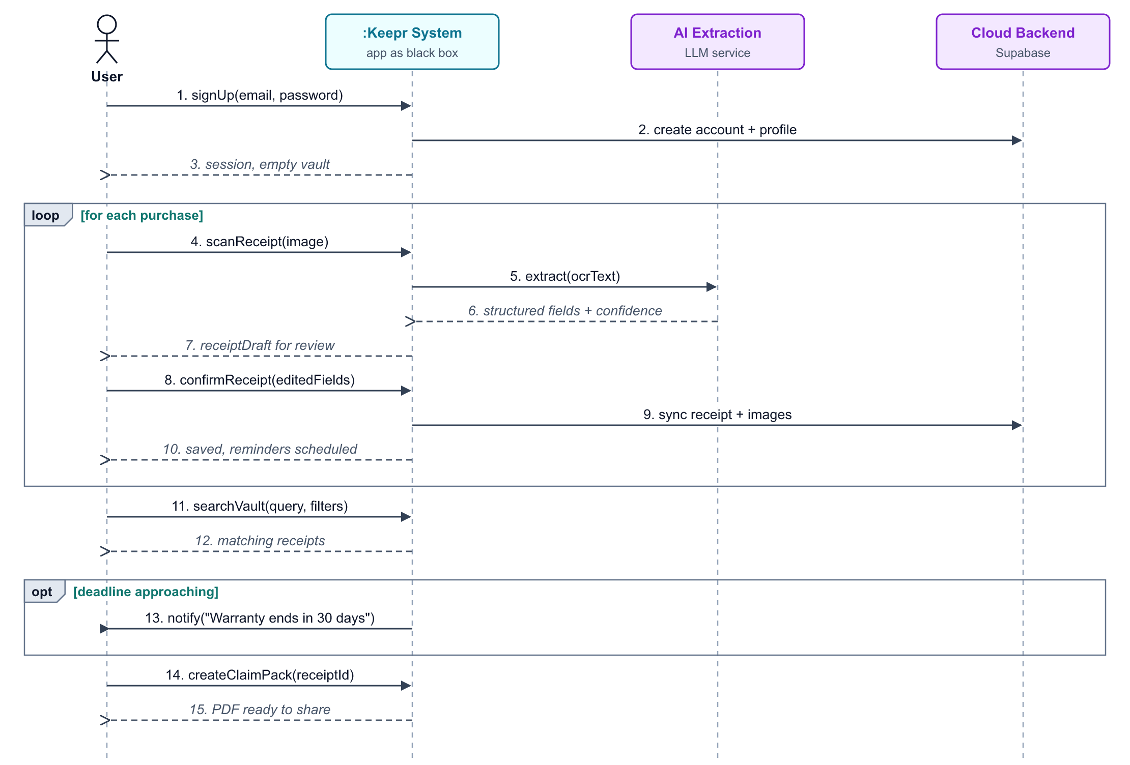
Figure 6. SSD-0: Core journey (black-box system view)

9.2 SSD-1: Sign in
The presenter validates input and moves to Loading; the repository converts Supabase exceptions into domain failures so the View only ever sees Authenticated or Error states.
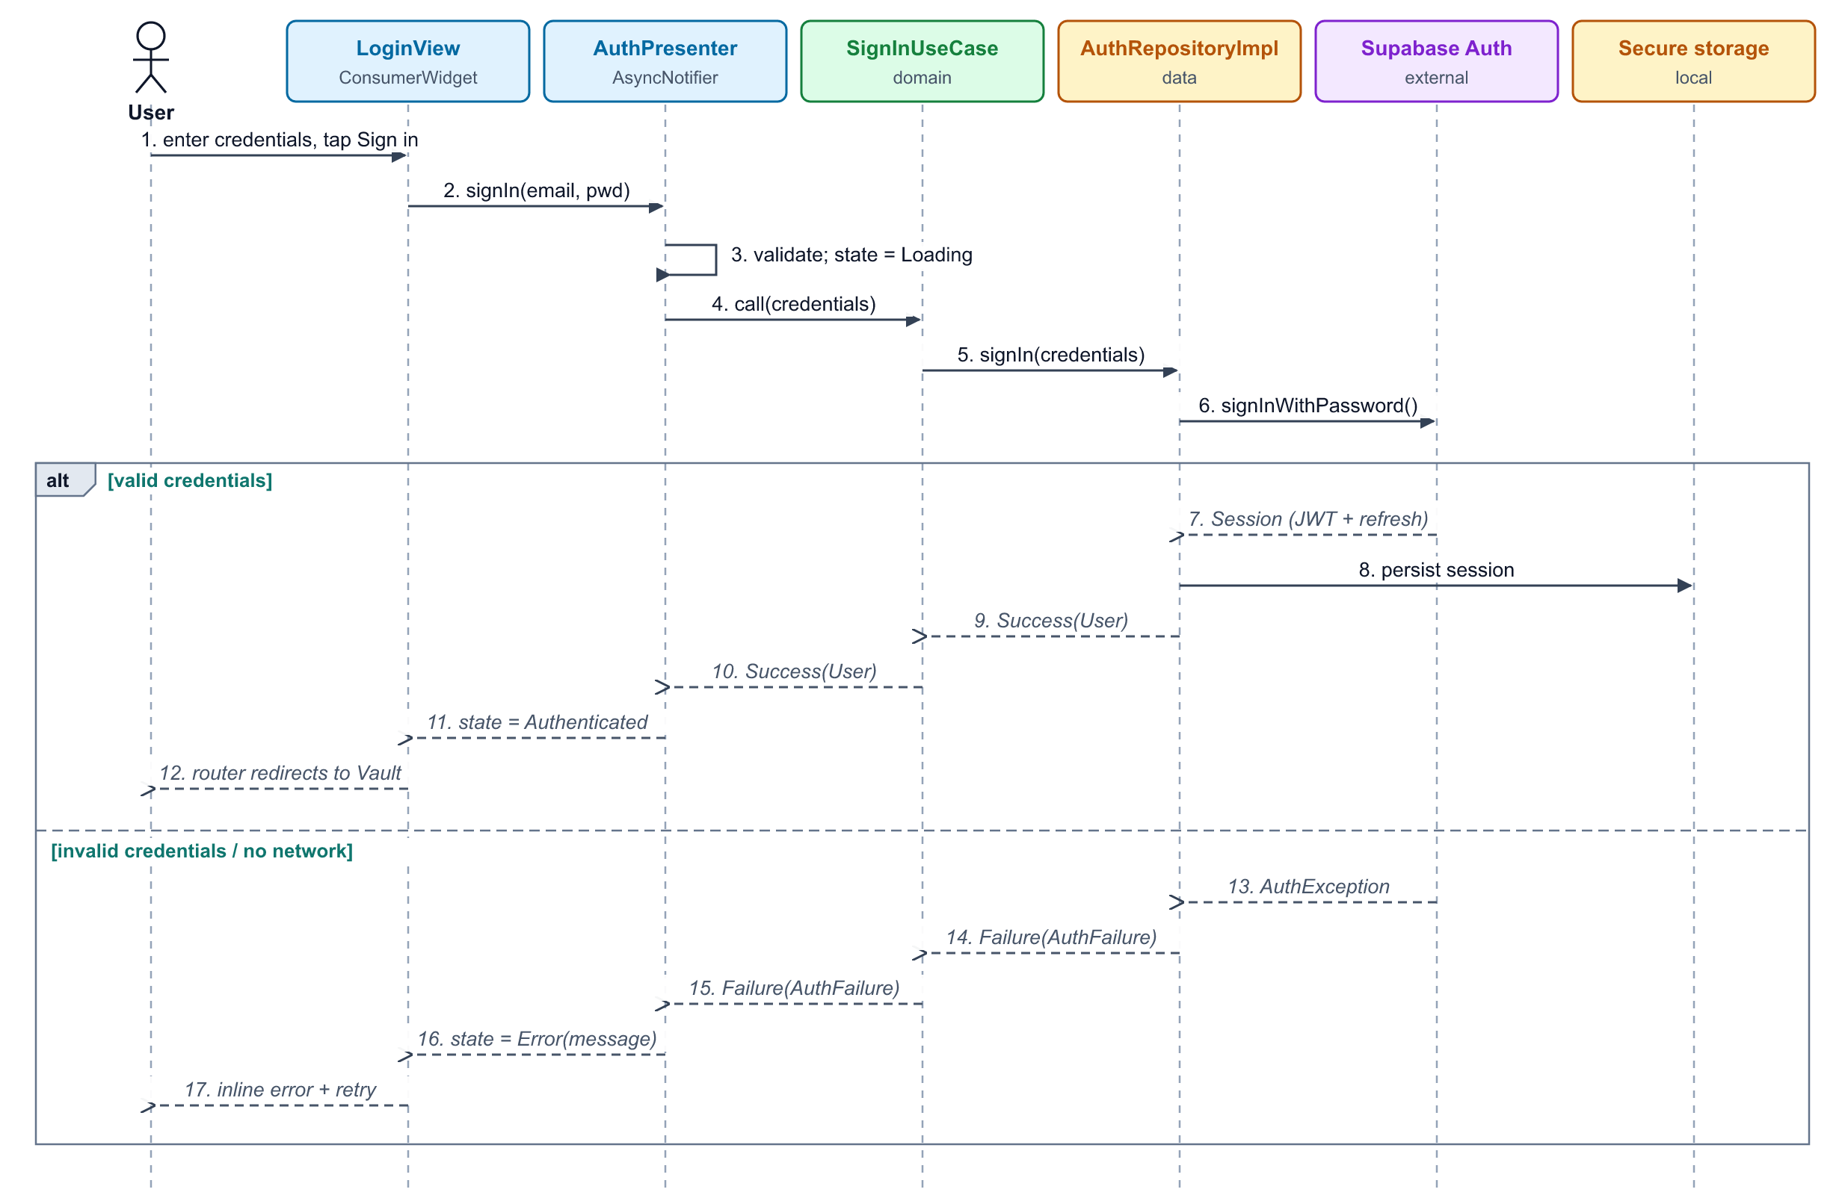
Figure 7. SSD-1: Sign in

9.3 SSD-2: Scan receipt and AI extraction
OCR runs on device; only text is sent to the Edge Function, which calls the LLM with a server-side key and validates the JSON. The use case derives warranty end and return deadline before the review form opens.
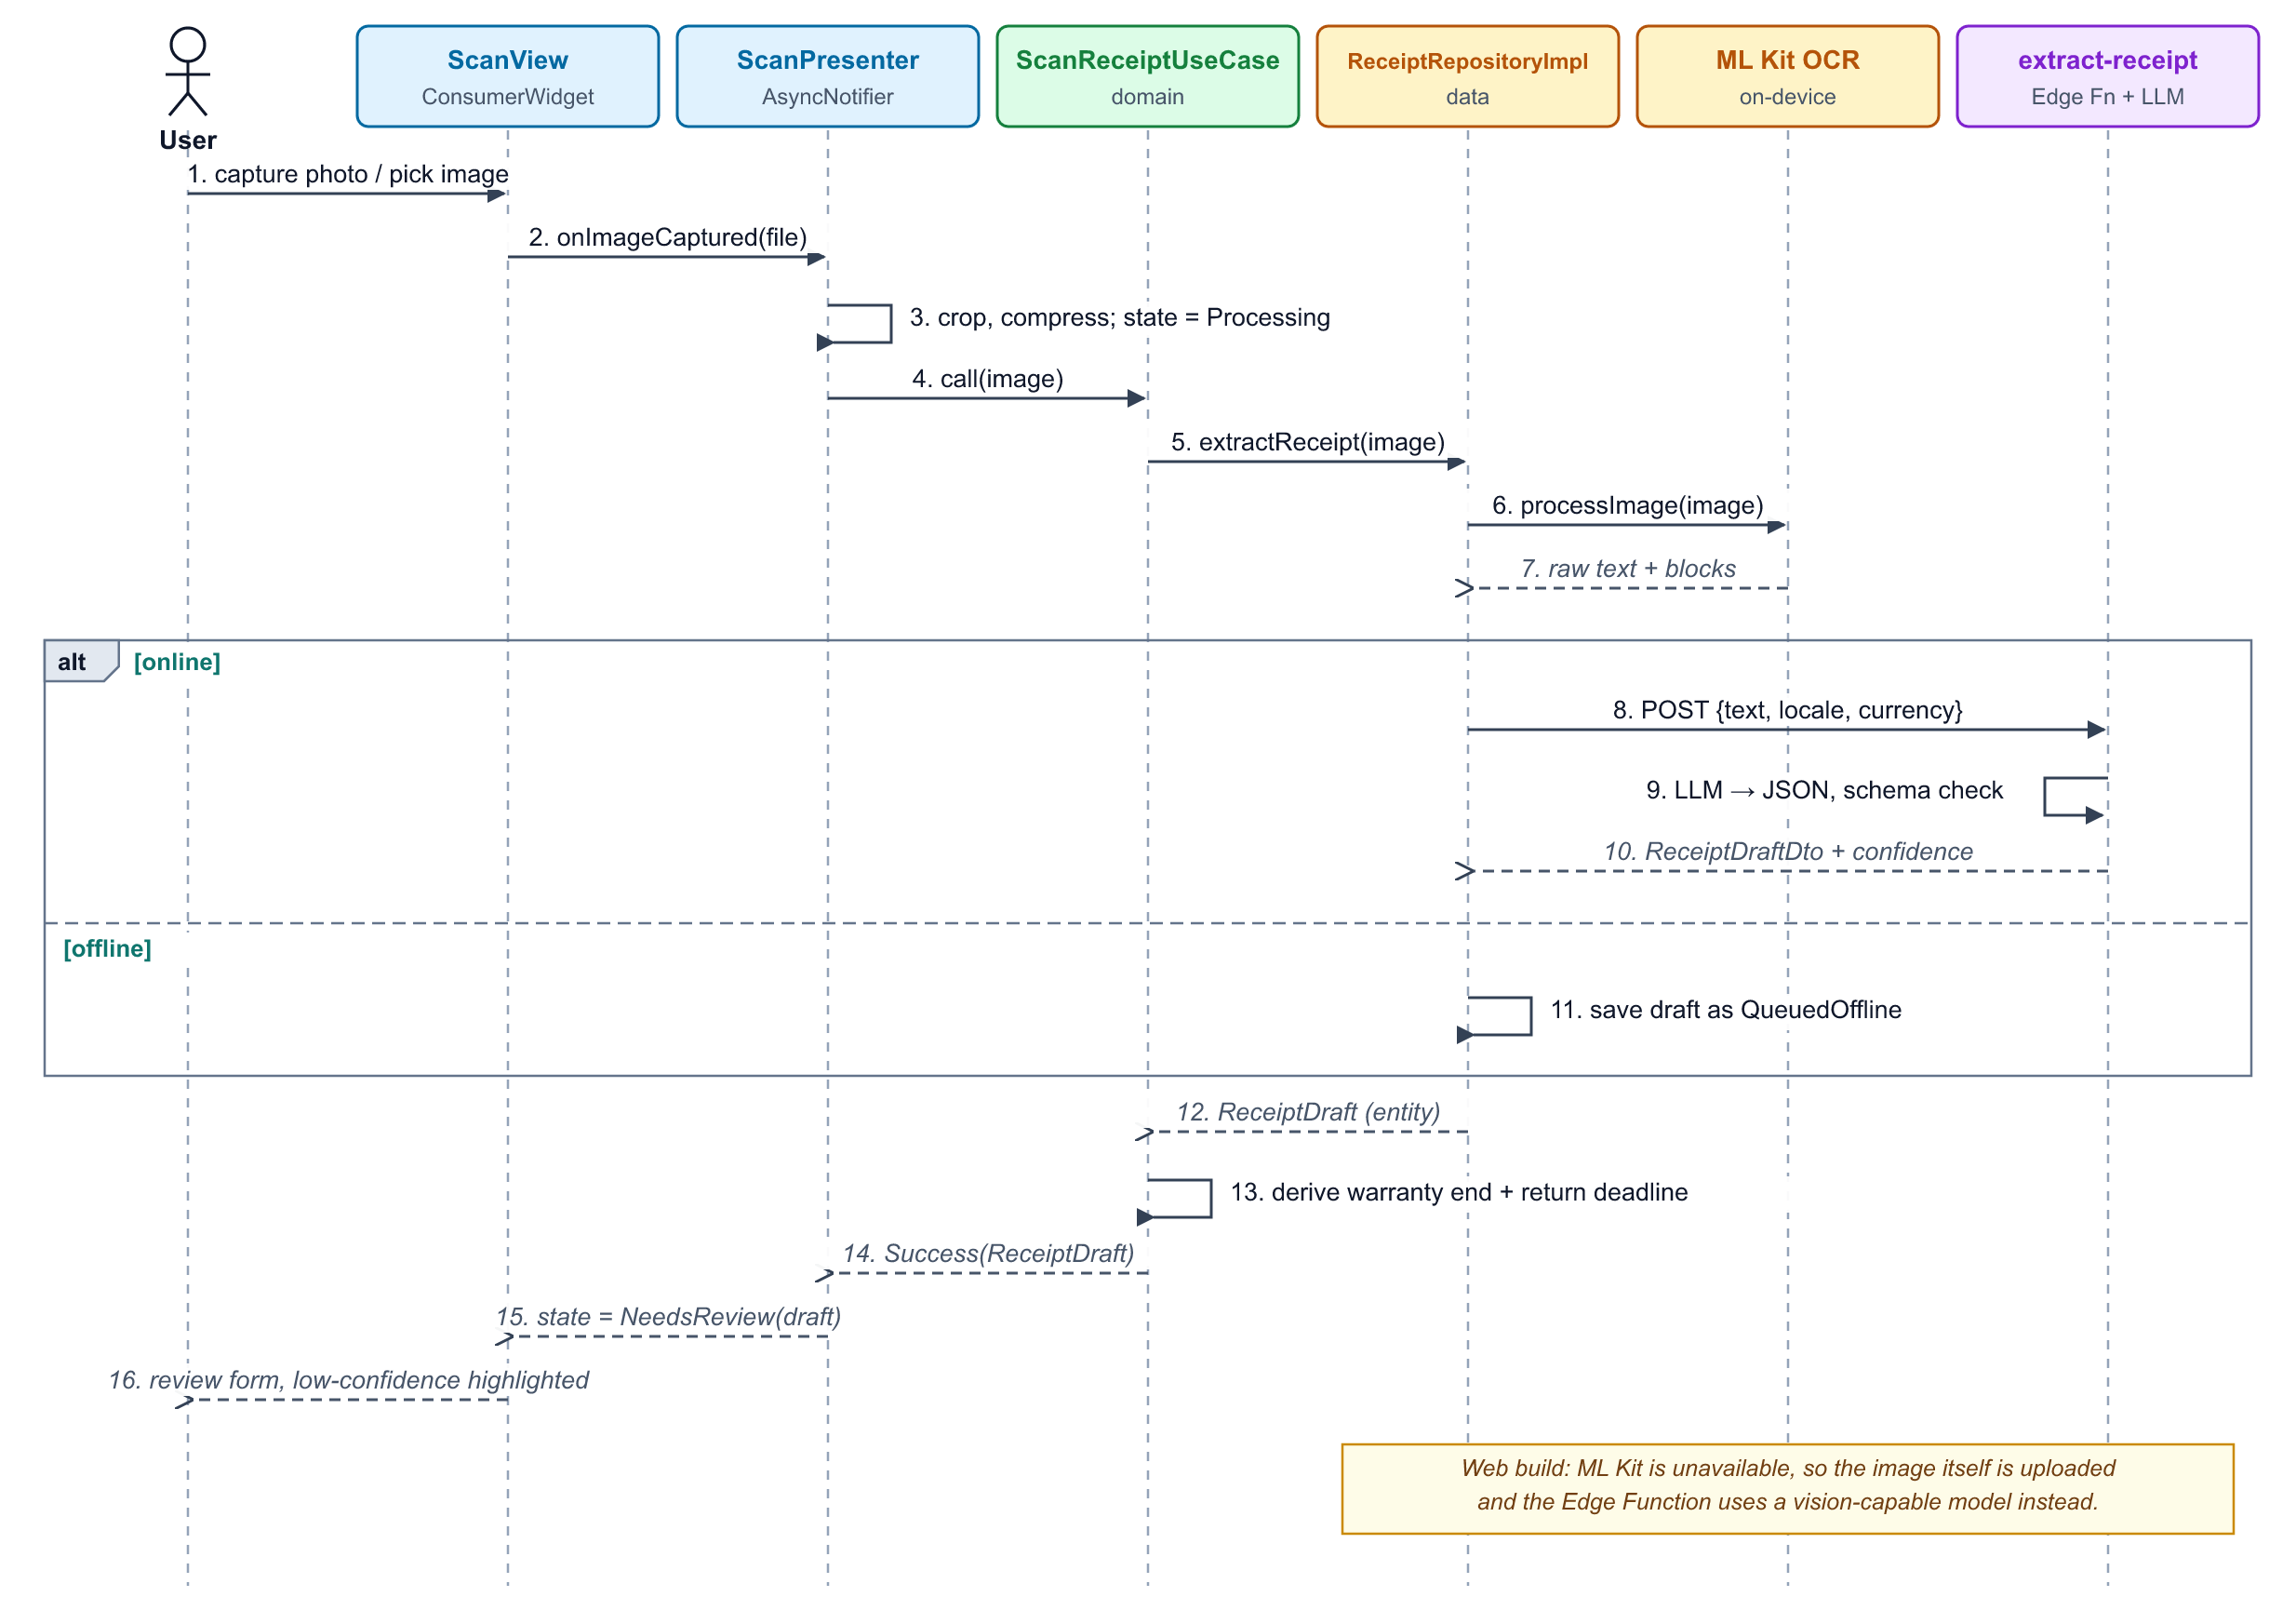
Figure 8. SSD-2: Scan receipt and AI extraction

9.4 SSD-3: Confirm, save and schedule reminders
Saving is local-first: the receipt and an outbox entry are written in one transaction, then the domain builds reminders (BR-03) and the scheduler registers them with the OS.
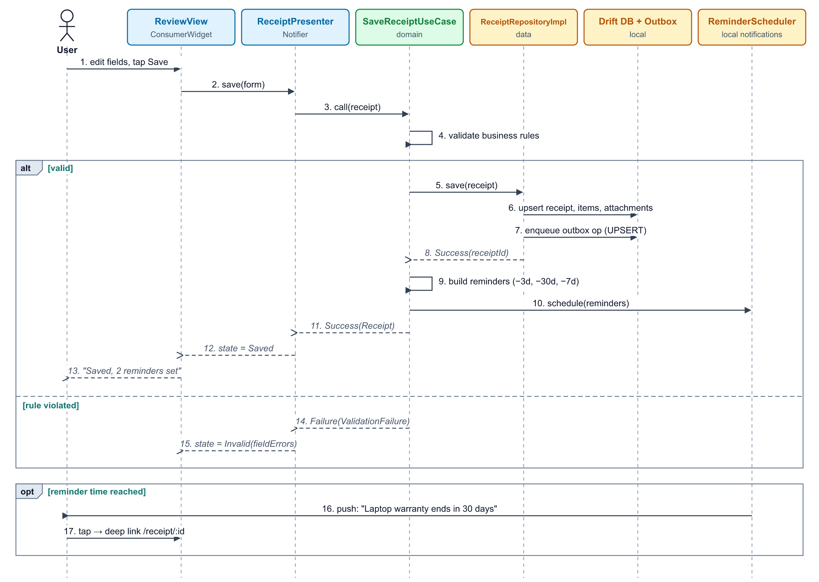
Figure 9. SSD-3: Confirm, save and schedule reminders

9.5 SSD-4: Offline-first synchronisation
Triggered by connectivity, app resume or a timer. Pending operations upload in order, conflicts resolve per BR-13, then remote changes are pulled and the vault updates through its Drift stream.
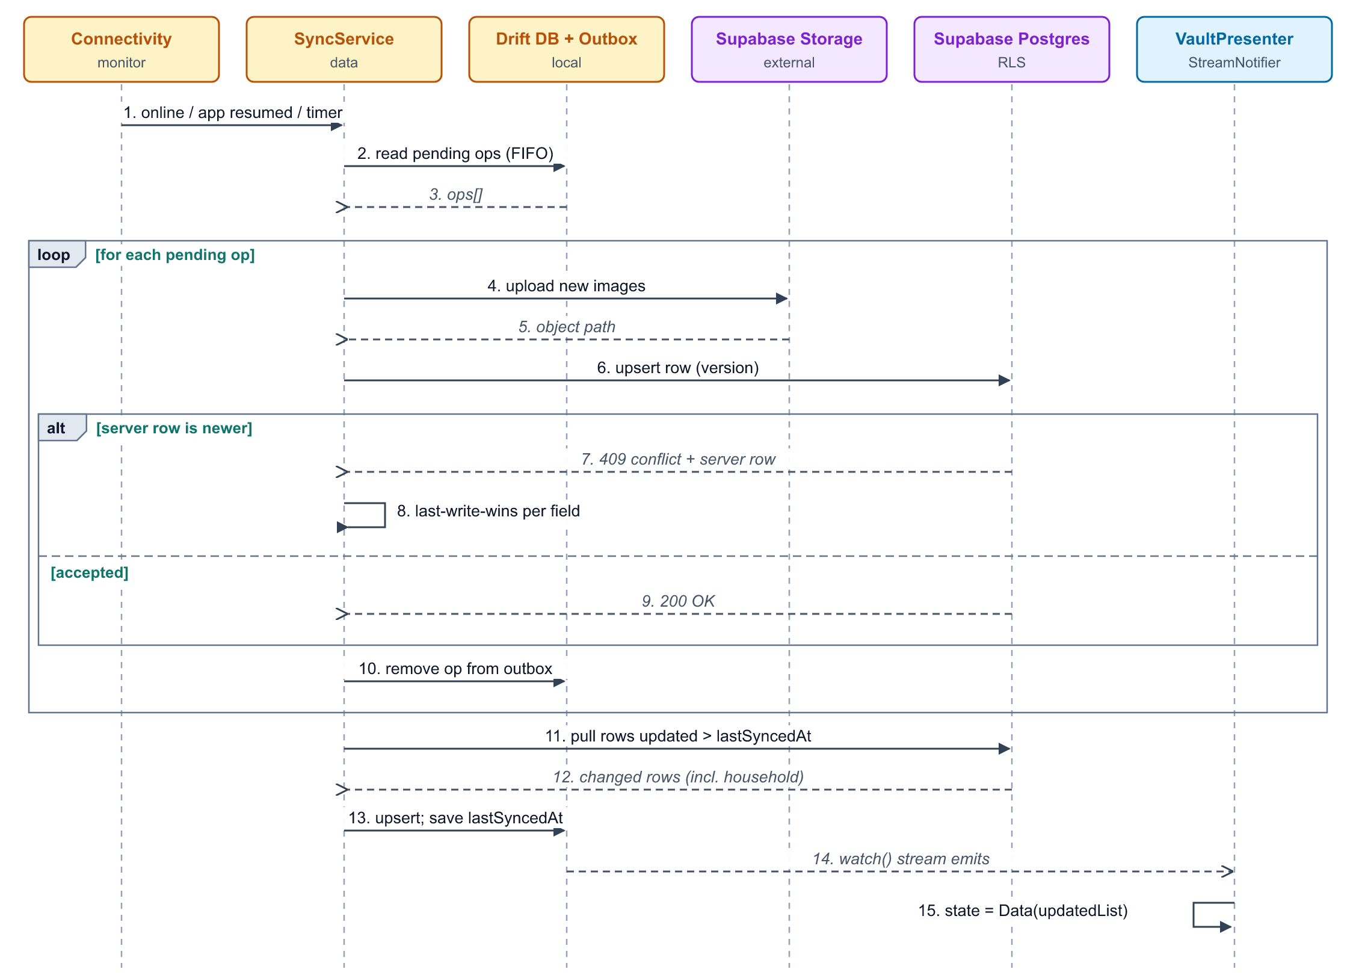
Figure 10. SSD-4: Offline-first synchronisation

9.6 SSD-5: Generate and share a claim pack
The use case checks the user’s entitlement and data completeness. Success produces an A4 PDF shared through the OS; a reached limit is returned as a PaywallRequired failure the presenter turns into a state.
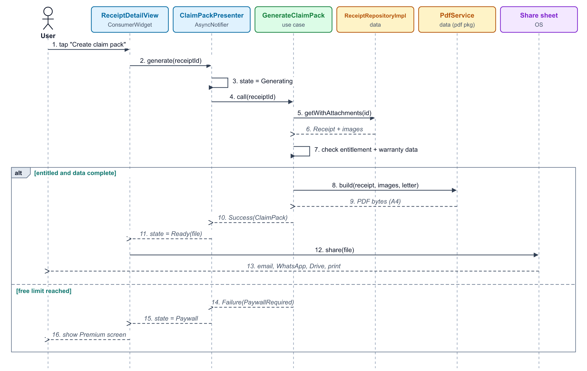
Figure 11. SSD-5: Generate and share a claim pack

10. Data design

10.1 Cloud database schema (Supabase Postgres)
All tables have id uuid primary key, created_at, updated_at (trigger-maintained), version int and deleted_at (tombstone) unless stated.
Table | Key columns | Notes / indexes
profiles | id (= auth.users.id), display_name, currency, locale, time_zone | 1:1 with auth user
households | name, owner_id → profiles | Personal household created on sign-up
household_members | household_id, user_id, role (owner|editor|viewer), joined_at | PK (household_id, user_id)
household_invites | household_id, email, token_hash, role, expires_at, accepted_at | Token valid 7 days
receipts | household_id, created_by, merchant, purchase_date, total_minor, currency, category, return_days, status, source, notes, ocr_text, ai_confidence jsonb | Index (household_id, purchase_date desc); trigram index on merchant
line_items | receipt_id, name, quantity, unit_price_minor, serial_number | Index receipt_id
warranties | line_item_id, months, provider, is_extended, end_date (generated) | Index end_date for reminders
attachments | receipt_id, kind, storage_path, sha256, width, height, bytes | Unique (receipt_id, sha256)
reminders | receipt_id, user_id, type, fire_at, state | Index (fire_at) where state = scheduled
entitlements | user_id, tier, scans_used, claim_packs_used, period_start, expires_at | Updated only by Edge Functions / webhook
ai_usage | user_id, model, input_tokens, output_tokens, latency_ms, success | Cost tracking; no receipt content stored

10.2 Row-Level Security
- RLS is enabled on every table; the default is deny.
- Read receipts and children: exists (select 1 from household_members m where m.household_id = receipts.household_id and m.user_id = auth.uid()).
- Write receipts: same check plus m.role in ('owner', 'editor').
- Members/invites: only the household owner can insert or delete.
- Entitlements and ai_usage: read own row only; writes only by the service role inside Edge Functions.
- Storage bucket receipts uses the same household check on the first path segment.

10.3 Local database (Drift)
- Mirrors the cloud tables needed for offline use (receipts, line_items, warranties, attachments, reminders, households).
- outbox: id, entity, entity_id, op (upsert|delete), payload json, attempts, last_error, created_at.
- sync_state: household_id, last_synced_at.
- local_files: attachment_id, local_path, upload_state.
- Full-text search via SQLite FTS5 virtual table over merchant, items, serials and notes.

11. API and integration contracts

11.1 Edge Function: extract-receipt
POST /functions/v1/extract-receipt with the user’s JWT. Mobile sends OCR text; Web sends a storage path to an uploaded image.
// Request
{ "text": "SUPER ELECTRONICS\nINV# 20931 ... TOTAL 84,999", "imagePath": null,
"locale": "en-PK", "currency": "PKR" }

// 200 Response
{ "merchant": { "value": "Super Electronics", "confidence": 0.96 },
"purchaseDate": { "value": "2026-09-28", "confidence": 0.93 },
"total": { "valueMinor": 8499900, "currency": "PKR", "confidence": 0.98 },
"items": [ { "name": "Wireless earbuds X2", "quantity": 1, "unitPriceMinor": 8499900,
"serialNumber": null, "confidence": 0.81 } ],
"category": { "value": "Electronics", "confidence": 0.88 },
"suggestedWarrantyMonths": 12, "suggestedReturnDays": 7 }

// Errors: 401 unauthenticated · 402 quota exceeded · 413 payload too large
// 422 unreadable receipt · 429 rate limited · 504 model timeout

LLM usage rules
- Strict JSON schema in the prompt; response validated server-side and retried once on schema error.
- Temperature 0; timeout 15 s; maximum input 8,000 characters.
- No user identifiers in the prompt; provider configured not to retain or train on data.
- Token usage written to ai_usage for cost monitoring.

11.2 Other server endpoints
Endpoint | Trigger | Purpose
revenuecat-webhook | RevenueCat event | Verify signature; update entitlements (purchase, renewal, cancel, refund)
invite-member | App (owner) | Create invite token, send email
accept-invite | Deep link | Validate token, add membership
delete-account | App (re-authenticated) | Delete storage objects, rows and auth user; audit log
send-reminders (v1.1) | pg_cron every 15 min | Send due reminders via FCM and email
reset-quotas | pg_cron monthly | Reset scan and claim-pack counters

12. User experience

12.1 Navigation
Bottom navigation on phones (navigation rail on tablet/desktop web): Vault, Protection, a central Scan action, Insights, Settings. Deep links: /receipt/:id, /invite/:token.

12.2 Screen inventory
Screen | Purpose | Key elements | Release
Onboarding | Explain value in 3 cards | Skip, Get started, permission primers | 1.0
Sign in / Sign up | Authentication | Email, password, Google, reset link | 1.0
Vault | Browse receipts | Search bar, filter chips, list/grid, sync badges, empty state | 1.0
Scan | Capture receipt | Camera with edge guide, gallery, flash, multi-photo | 1.0
Review | Confirm extracted data | Image preview, fields with confidence highlights, items, warranty | 1.0
Receipt detail | Everything about one purchase | Images, fields, warranty status, reminders, Create claim pack | 1.0
Claim pack | Generate PDF | Issue description, preview, share | 1.0
Protection | Deadlines at a glance | Expiring soon, open return windows, upcoming reminders | 1.0
Insights | Spending overview | Category chart, protected value, export | 1.0
Household | Sharing | Members, roles, invite | 1.0
Paywall | Upgrade | Free vs Premium table, plans, restore | 1.0
Settings | Preferences and data | Profile, currency, theme, notifications, export, delete account | 1.0

12.3 Design principles
- Material 3 with a custom colour scheme; light and dark themes.
- One primary action per screen; Scan always one tap away.
- Skeleton loaders instead of spinners for lists.
- Every empty and error state explains the next step.
- Respect OS text scaling and reduce-motion settings.

13. Analytics
Privacy-safe product analytics with no receipt content, amounts or merchant names.
Event | Trigger | Properties
sign_up_completed | Account created | method
receipt_captured | Image captured or imported | source, platform
extraction_completed | AI result received | latency_ms, low_confidence_fields, success
receipt_saved | Receipt confirmed | fields_edited_count, has_warranty, offline
reminder_opened | Notification tapped | type, days_before
claim_pack_generated | PDF created | pages, shared_to
paywall_viewed / purchase_completed | Paywall shown / purchase | trigger, plan
sync_failed | Sync error | error_type, pending_ops

14. Quality and testing strategy
Testing follows the layers: most tests target the pure-Dart Domain layer and the presenters, with fewer, slower end-to-end tests on top.
Level | What is tested | Tools | Target
Unit (domain) | Entities, value objects, business rules, use cases | test, mocktail | ≥ 90% coverage
Unit (presenters) | State transitions for each intent | ProviderContainer + overrides | ≥ 80% coverage
Unit (data) | Mappers, repository error mapping, sync/outbox logic | Drift in-memory DB, fakes | All conflict cases
Widget | Views render each UiState correctly | flutter_test, golden tests | Key screens
Integration | Critical journeys: sign in, scan → save, offline → sync, claim pack | integration_test (Android, iOS, Chrome) | Run on every release
Backend | RLS policies and Edge Functions | pgTAP, Deno tests | Every policy has a test
Manual / beta | Real receipts, accessibility, devices | Internal testing tracks, TestFlight | 20 testers, 200 receipts

14.1 CI pipeline
- dart format --set-exit-if-changed and flutter analyze (strict lints, layer import rules).
- Unit and widget tests with coverage gate.
- Build Android App Bundle, iOS (no codesign) and Web.
- Deploy Web preview; upload Android build to the internal testing track on main.
- Supabase migrations and function tests on a preview branch.

14.2 Definition of done
- Acceptance criteria met and demoed on Android and Web (iOS when in scope).
- Code follows layer rules; no business logic in Views.
- Tests written and passing; coverage targets maintained.
- No new analyzer warnings; accessibility labels added.
- Analytics events and error handling in place; docs/ADR updated if architecture changed.

15. Release plan and milestones

15.1 MVP release (6 weeks)
Week | Focus | Deliverables
1 | Foundation | Repo, CI, flavors, theme, go_router, Riverpod DI, Supabase project, schema + RLS, Auth (SSD-1)
2 | Capture + extraction | Scan screen, crop/compress, ML Kit, extract-receipt Edge Function, review form (SSD-2)
3 | Vault + offline | Drift DB, save with outbox (SSD-3), vault list, search, filters, detail, SyncService (SSD-4)
4 | Protection | Warranties, return windows, reminders, Protection screen, deep links
5 | Claim pack + billing | PDF generation and sharing (SSD-5), entitlements, RevenueCat, paywall
6 | Hardening + launch | Household invites, insights, accessibility pass, tests, store listing, Web deploy, beta

15.2 After the MVP release
- v1.1 (+6 weeks): iOS App Store, Apple sign-in, server push/email reminders, realtime household, Urdu, multi-page receipts, biometric lock.
- v2.0 (+3 months): email receipt import, natural-language search, budgets, desktop apps, partner claim submission.

16. Risks and mitigations
Risks are reviewed at the end of every sprint; owners update likelihood and mitigation status.
Risk | Impact | Likelihood | Mitigation
Poor extraction on faded or handwritten receipts | High | Medium | Image pre-processing, confidence highlighting, easy manual edit, collect anonymised failure stats
AI cost grows with usage | Medium | Medium | On-device OCR first, small model, quotas, cost alerts, cache by image hash
iOS limit of 64 pending local notifications | Medium | High | Rolling scheduling of the nearest reminders; server push in v1.1
Sync conflicts or data loss | High | Low | Outbox pattern, tombstones, version column, dedicated sync test suite
Privacy concerns about uploading receipts | High | Medium | Clear privacy policy, on-device OCR, data export/delete, no training on data
Store rejection (billing, privacy labels) | Medium | Low | Follow store guidelines, restore purchases, accurate data-safety forms
Web platform gaps (OCR, notifications) | Low | High | Server-side vision OCR and email reminders on Web

17. Open questions
- Final Premium pricing per region (PKR, USD) and whether to offer a lifetime plan.
- Which LLM model gives the best accuracy per cost on local-language receipts? Run a benchmark on 200 real receipts.
- Should Viewers be allowed to generate claim packs (currently yes)?
- Is email reminders on Web enough for v1.0, or is Web Push required?
- Retention period for ocr_text on the server; can it be kept on device only?

Appendix A. Requirements traceability
Links each feature to its requirements, domain use cases, presenter and sequence diagram.
Feature | Requirements | Use cases | Presenter | Diagram
Sign in | FR-AUTH-01..05 | SignIn, SignUp | AuthPresenter | SSD-1
Scan + AI | FR-CAP-*, FR-AI-* | ScanReceipt | ScanPresenter | SSD-2
Save + reminders | FR-VLT-05, FR-WAR-*, FR-REM-* | SaveReceipt, ScheduleReminders | ReceiptPresenter | SSD-3
Vault | FR-VLT-01..04, 08 | GetReceipts, SearchReceipts | VaultPresenter | SSD-4
Sync | FR-SYN-* | SyncNow | VaultPresenter (stream) | SSD-4
Claim pack | FR-CLM-* | GenerateClaimPack | ClaimPackPresenter | SSD-5
Household | FR-HH-* | InviteMember, AcceptInvite | HouseholdPresenter | SSD-0
Subscription | FR-SUB-* | PurchasePremium, RestorePurchases | PaywallPresenter | SSD-5

Appendix B. Portfolio and freelance deliverables
Keepr is also a showcase project. These deliverables make it work for GitHub, Upwork and Fiverr:
- GitHub README: hero GIF, live Web demo link, Play Store link, feature list, architecture diagrams (Figures 3 and 4), tech stack, how to run, test badge.
- Architecture docs: this PRD (or a summary) and ADRs in /docs.
- Demo video: 90-second walkthrough of scan → reminder → claim pack.
- Upwork case study: problem, solution, your role, stack, screenshots, results (accuracy, time to save).
- Fiverr gig images: device-framed screenshots of Vault, Review and Claim pack screens.
- Clean commit history: small, conventional commits across the 6-week plan.

