Internship Report
(Project Work)
On
STUDENT FEE TRACKER SYSTEM
Submitted to
JAWAHARLAL NEHRU TECHNOLOGICAL UNIVERSITY ANANTAPUR, ANANTHAPURAMU
In Partial Fulfillment of the Requirements for the Award of the Degree of
BACHELOR OF TECHNOLOGY
In
COMPUTER SCIENCE AND TECHNOLOGY
Submitted By
PALAGIRI MOHAMMED FAZIL - 23691A2836
Under the Guidance of
Dr. S. Jansi
Assistant Professor
Department of Computer Science and Technology



MADANAPALLE INSTITUTE OF TECHNOLOGY & SCIENCE
(UGC – AUTONOMOUS)
(Affiliated to JNTUA, Ananthapuramu)
Accredited by NBA, Approved by AICTE, New Delhi)
AN ISO 21001:2018 Certified Institution
P. B. No: 14, Angallu, Madanapalle, Annamayya – 5



MADANAPALLE INSTITUTE OF TECHNOLOGY & SCIENCE
(UGC-AUTONOMOUS INSTITUTION)
Affiliated to JNTUA, Ananthapuramu &Approved by AICTE, New Delhi
NAAC Accredited with A+ Grade
NBA Accredited -B.Tech. (CIVIL, CSE, CST, ECE, EEE, MECH) MBA&MCA

DEPARTMENT OF COMPUTER SCIENCE AND TECHNOLOGY

BONAFIDE CERTIFICATE

This is to certify that the SUMMER INTERNSHIP-1 (23CST701) entitled “STUDENT FEE TRACKER SYSTEM” is a bonafide work carried out by

PALAGIRI MOHAMMED FAZIL - 23691A2836

Submitted in partial fulfillment of the requirements for the award of the degree of Bachelor of Technology in the stream of Computer Science and Technology in Madanapalle Institute of Technology & Science, Madanapalle, affiliated to Jawaharlal Nehru Technological University Anantapur, Ananthapuramu during the academic year 2025-2026.

Guide Internship Coordinator/CST
Dr. S. Jansi Mr. V. Naveen
Assistant Professor Assistant Professor
Department of CST Department of CST

Head of the Department
Dr. K. Dinesh
Associate Professor and
HeadDepartment of CST

INTERNSHIP CERTIFICATE



DECLARATION

I hereby declare that the results embodied in this SUMMER INTERNSHIP-1(23CST701) “STUDENT FEE TRACKER SYSTEM” by me under the guidance of Dr. S. Jansi, Assistant Professor, Dept. of CST in partial fulfillment of the award of the degree of Bachelor of Technology in Computer Science and Technology from Jawaharlal Nehru Technological University Anantapur, Ananthapuramu and I have not submitted the same to any other University/institute for the award of any other degree.

Date :
Place :Madanapalle

PROJECT MEMBER
PALAGIRI MOHAMMED FAZIL
23691A2836

I certify that the above statement made by the student is correct to the best of my knowledge.

Date : Guide
Dr. S. Jansi Assistant Professor
Department of CST

TABLE OF CONTENTS

S.NO | TOPICS | PAGE NO.
1. | INTRODUCTION | 1
 | 1.1 About Industry or Organization Details | 1
 | 1.2 My Personal Benefits | 1
 | 1.3 Objective of the Project | 2
 | 1.4 Limitations of Project | 3
2. | SYSTEM ANALYSIS | 4
 | 2.1 Introduction | 4
 | 2.2 Existing System | 4
 | 2.3 Disadvantages of Existing System | 5
 | 2.4 Proposed System | 5
 | 2.5 Advantages over Existing System | 5
3. | SYSTEM SPECIFICATION | 6
 | 3.1 Hardware Requirement Specification | 6
 | 3.2 Software Requirement Specification | 7
4. | SYSTEM DESIGN | 9
 | 4.1 System Architecture | 9
 | 4.2 Modules Flow diagrams | 12
5. | IMPLEMENTATION AND RESULTS | 13
 | 5.1 Introduction | 13
 | 5.2 Implementation of key functions | 13
 | 5.3 Method of Implementation(CODING) | 14
 | 5.4 Output Screens and Result Analysis | 29
 | 5.5 Conclusion | 31
6. | TESTING AND VALIDATION | 32
 | 6.1 Introduction | 32
 | 6.2 Design of Test cases and Scenarios | 34
 | 6.3 Validation | 34
 | 6.4 Conclusion | 35
7. | CONCLUSION | 36
 | 7.1 Conclusion | 36
 | REFERENCES | 38

ABSTRACT
The project “Student Fee Tracker System” is designed to provide an efficient and automated solution for managing student fee records in educational institutions. Traditional fee management relies heavily on manual data entry, spreadsheets, and physical receipts, which often leads to errors, delays, data loss, and lack of transparency. This project addresses these challenges by developing a digital fee management system that ensures accuracy, ease of access, and real-time updates.
The system is developed using modern full-stack technologies, incorporating a responsive frontend, a secure and scalable backend, and a structured database. Core functionalities include student registration, fee payment tracking, automatic calculation of due amounts, receipt generation, payment history maintenance, and role-based dashboards for administrators and students. API-based communication enables seamless data retrieval, while authentication mechanisms ensure secure access.
The application’s intuitive interface simplifies navigation, enables quick data processing, and reduces dependency on manual paperwork. The system enhances institutional efficiency by automating fee-related operations and ensuring consistent and reliable record management. Overall, this project demonstrates how Full Stack Development can be used to build a robust, user-friendly, and transparent fee tracking platform that supports educational institutions in maintaining accurate financial records. Furthermore, the system ensures secure handling of sensitive financial data through role-based access control and validation mechanisms.
In addition, the project highlights the adaptability and scalability of full-stack technologies, allowing future enhancements such as online payment integration, detailed reporting analytics, and mobile application support. By modernizing traditional administrative processes, the Student Fee Tracker System contributes to improved operational effectiveness and promotes a more organized, digital-driven institutional workflow.

LIST OF FIGURES

S.NO | Figure No. | Name of the Figures | Page Number
1 | 4.1.1 | System Architecture Flow Diagram | 11
2 | 5.4.1 | Fee Record Output Screen | 29
3 | 5.4.2 | Add Fee Record and Fee Record Screen | 29
4 | 5.4.3 | Add Fee Record | 30
5 | 5.4.4 | Payment History Popup Screen | 30

LIST OF ABBREVIATIONS
Abbreviation | Full Form
HTML | Hyper Text Markup Language
CSS | Cascading Style Sheets
JS | JavaScript
UI | User Interface
UX | User Experience
DB | Database
SQL | Structured Query Language
HTTP | Hyper Text Transfer Protocol
API | Application Programming Interface
CRUD | Create, Read, Update, Delete
JSON | JavaScript Object Notation
DOM | Document Object Model
MVC | Model–View–Controller
URL | Uniform Resource Locator

CHAPTER – 1
INTRODUCTION
  - About Industry or Organization Details
Educational institutions today increasingly rely on digital solutions to manage academic and administrative activities efficiently. With rapidly growing student populations and evolving institutional processes, the need for automated management systems has become essential. Fee management, in particular, is a critical function that directly affects financial planning, transparency, and overall administrative workflow. Many schools and colleges are shifting from traditional manual fee-processing methods to modern web-based systems that support accuracy, accessibility, and real-time monitoring.
This project aligns with the technological advancements adopted across educational organizations, especially those implementing digital transformation under initiatives like NEP 2020 and institutional ERP systems. These institutions focus on enhancing operational efficiency through full-stack applications that ensure seamless data handling, secure transactions, and simplified user interaction for both administrators and students. By developing a Student Fee Tracker System using Full Stack Development, this project reflects the real-world needs of academic institutions striving for automation, reliability, and improved financial management practices.
  - My Personal Benefits
Developing the Student Fee Tracker System using Full Stack Development provided me with significant technical and professional growth. This project strengthened my understanding of core web development concepts, including frontend design, backend API integration, database management, and deployment workflows. Working through each layer of the application enhanced my confidence in building end-to-end web solutions and deepened my practical knowledge beyond classroom learning.
From a technical standpoint, I gained hands-on experience with modern development technologies such as HTML, CSS, JavaScript, and a backend framework, along with database operations for storing and managing fee records efficiently. Implementing authentication, form validations, and secure data handling improved my problem-solving abilities and understanding of real-world development standards.
On a professional level, this project helped improve my analytical thinking, debugging skills, project planning, and documentation capabilities. I learned how to break down large tasks into manageable modules and ensure smooth integration across the system. Overall, the project enhanced both my technical proficiency and my ability to work independently, preparing me for future roles in full-stack development and software engineering.
1.3 Objective of the Project
The primary objective of this project is to design and develop a centralized Student Fee Tracker System using Full Stack Development (FSD) technologies to automate and streamline fee management processes within educational institutions. The traditional manual methods of maintaining fee records often lead to inaccuracies, delays, and lack of transparency. This project aims to address these challenges by creating a system that ensures efficient, secure, and real-time management of all fee-related activities.
The specific objectives of the project include:
- To build a user-friendly web application that allows administrators to record, update, and monitor student fee payments effortlessly.
- To provide students with secure access to view their payment history, pending dues, and receipts in real time.
- To design a reliable backend system capable of handling fee data, performing validations, and generating automated calculations accurately.
- To implement secure authentication and role-based access control to ensure data confidentiality and prevent unauthorized access.
- To reduce dependency on manual paperwork and minimize errors by automating fee collection, tracking, and reporting processes.
- To develop a scalable and maintainable software solution that can be easily extended with additional features such as online payments, automated reminders, or report exporting.
- To demonstrate how Full Stack Development can be applied effectively to solve real-world administrative challenges in educational environments.
Overall, the project aims to deliver an efficient, transparent, and modern fee management system that enhances operational productivity and supports data-driven decision-making within academic institutions.
1.4 Limitations of Project
Although the Student Fee Tracker System provides an efficient and automated solution for managing fee records, certain limitations exist that can be improved in future enhancements:
- Limited Scope of Features:
The current system focuses primarily on fee tracking, payment recording, and viewing student details. Advanced features such as online payment integration, SMS/email notifications, and dynamic financial analytics are not included in this version.
- Dependency on Manual Data Entry:
Administrators must manually enter student details and payment information. Any incorrect or incomplete data input may affect the accuracy of the fee records and overall system output.
- No Online Payment Gateway:
The system does not currently support digital payments. Students must pay through offline modes, and administrators need to update the payment status manually.
- Limited Reporting Capabilities:
Although basic reports can be generated, detailed financial reports such as monthly collections, department-wise summaries, or automated downloadable statements are not fully implemented.
- Scalability Constraints:
The system is suitable for small- and medium-sized institutions. However, larger organizations with extensive student databases may require optimization for performance, faster data retrieval, and advanced database configurations.
- Lack of Real-Time Notifications:
The system does not provide automated reminders or alerts for pending dues, which may reduce the effectiveness of timely fee collection.

- Internet Dependency:
As a web-based application, the system requires a stable internet connection for access. Poor connectivity may affect usability and data updates.

CHAPTER – 2
SYSTEM ANALYSIS
2.1 INTRODUCTION
System analysis is a critical phase in the development of any software application, as it focuses on understanding the problem domain, identifying existing challenges, and defining an appropriate solution framework. In educational institutions, managing student fee records is a fundamental administrative task. However, many institutions still rely on traditional methods such as manual entries, paper-based records, and basic spreadsheets, which often lead to inconsistencies, errors, delays, and difficulty in retrieving information.
With the increasing need for accuracy, transparency, and efficiency, modern institutions are moving toward digital fee management systems. A Student Fee Tracker System developed using Full Stack Development (FSD) provides an automated approach to handling fee-related operations. It enables administrators to record payments, manage student accounts, track dues, and generate reports through a centralized and user-friendly platform. The system also offers students the ability to access their fee details in real time, promoting transparency and better communication.
This phase of the project involves analyzing the drawbacks of traditional fee management methods and designing a scalable, interactive, and secure digital solution. By integrating frontend, backend, and database components, the system ensures smooth data flow, consistent performance, and improved user experience. The analytical insights derived here serve as the foundation for building an efficient and reliable fee management application.

2.2 EXISTING SYSTEM
In many educational institutions, fee management is still handled through manual processes such as paper records, handwritten receipts, and basic spreadsheet entries. These traditional methods make fee tracking slow, error-prone, and difficult to manage. Updating payments, identifying pending dues, and retrieving student fee history often require significant time and effort.
The existing system lacks automation and real-time access, leading to frequent inconsistencies, misplaced records, and limited transparency. Students must depend on administrative staff for fee details, and generating reports or summaries becomes challenging. Overall, the current manual approach is inefficient, unreliable, and unsuitable for institutions that require fast and accurate fee management.
2.3 DISADVANTAGES OF EXISTING SYSTEM
The existing manual fee management process presents several challenges:
- High chances of human error due to manual data entry and paper-based records.
- Lack of real-time updates, making it difficult to track payments and pending dues accurately.
- Poor data security, as physical files and spreadsheets are easily misplaced or accessed by unauthorized users.
- Time-consuming report generation, requiring staff to manually compile information.
- Limited transparency, as students cannot independently view their fee details or payment history.
- Difficulty in managing large volumes of data, especially for institutions with many students.
2.4 PROPOSED SYSTEM
The proposed Student Fee Tracker System uses Full Stack Development to replace the manual, error-prone fee management process with an automated and centralized solution. The system allows administrators to record payments, track dues, update student details, and generate reports efficiently. Students can securely view their fee status and payment history in real time. By automating calculations and maintaining digital records, the system improves accuracy, transparency, and overall operational efficiency.
2.5 ADVANTAGES OVER EXISTING SYSTEM
The proposed system offers several advantages compared to the manual fee management process:
- Automation of records, reducing errors and workload.
- Real-time access to fee details for both administrators and students.
- Centralized and secure data storage, preventing loss or unauthorized access.
- Faster report generation and easy tracking of payments and dues.
- Improved transparency, as students can view their payment history anytime.
- Better scalability, allowing the system to handle growing student data efficiently.
CHAPTER – 3
SYSTEM SPECIFICATION
System specification defines the hardware and software requirements necessary for developing and executing the Student Fee Tracker System. Since the application is built using Full Stack Development (FSD) technologies, it requires a suitable environment for frontend development, backend processing, database management, and smooth deployment. Proper system specifications ensure efficient performance, scalability, security, and ease of maintenance throughout the project lifecycle. This chapter outlines both hardware and software requirements needed to develop, test, and run the Student Fee Tracker System effectively.

3.1 HARDWARE REQUIREMENT SPECIFICATION

The Student Fee Tracker System is a lightweight web application developed using Full Stack Development technologies. It does not require high-end hardware, but a system with adequate processing power and memory is essential for smooth development, testing, and execution. The following hardware specifications ensure optimal performance:

Minimum Requirements
- Processor: Intel Core i3 or equivalent
- RAM: 4 GB
- Storage: 500 GB HDD
- Display: 1366 × 768 resolution
- Input Devices: Standard keyboard and mouse
- Network: Basic internet connection for accessing and testing the application

Recommended Requirements
- Processor: Intel Core i5/i7 or higher
- RAM: 8 GB or more
- Storage: 1 TB SSD (for faster read/write operations)
- Display: Full HD (1920 × 1080)
- Graphics: Integrated graphics (sufficient for development)
- Network: High-speed internet for deployment and testing
Explanation:
A mid-range configuration is sufficient for building and running the application. Higher specifications ensure faster execution, especially while working with large sets of fee data or during multi-user interactions.
3.2 SOFTWARE REQUIREMENT SPECIFICATION
The Student Fee Tracker System is developed using Full Stack Development technologies, requiring both frontend and backend tools, along with a suitable environment for coding, testing, and deployment. The following software components are essential for building and running the application:
Software / Tool | Purpose / Functionality
Operating System
  Windows 10/11 or Ubuntu (64-bit) for development and testing
Programming Languages | HTML, CSS, JavaScript for frontend; Node.js / Python / PHP (choose based on your stack) for backend
Frontend Framework (Optional) | React.js / Angular / Bootstrap for UI design and responsiveness
Backend Framework | Node.js with Express.js / Django / Laravel for API handling and server-side processing
Database | MySQL / MongoDB / PostgreSQL for storing fee records, user details, and payment data
IDE / Code Editor | Visual Studio Code / Sublime Text for coding
Web Server / Runtime | Node.js runtime or backend server environment for executing server-side code
Libraries / Packages | Axios / Fetch API for API calls, bcrypt for authentication, JSON Web Tokens for security
Browser | Google Chrome / Microsoft Edge for testing the application

TABLE 3.2: SOFTWARE REQUIREMENT SPECIFICATION
Explanation:
The software stack is designed to support full-stack development, ensuring seamless integration between the frontend, backend, and database. Using modern tools like VS Code, Node.js, and MySQL enables faster development, easy debugging, and scalable deployment. The chosen technologies allow the system to handle fee processing, ser authentication, and data management efficiently.

CHAPTER – 4
SYSTEM DESIGN
System design outlines the structure, architecture, and data flow of the Student Fee Tracker System. It provides a clear blueprint of how various components—frontend, backend, and database—interact to deliver the required functionality. The design phase transforms the system requirements into a well-organized framework that ensures scalability, maintainability, and efficient performance.
The Student Fee Tracker System is developed using Full Stack Development, where the frontend handles user interaction, the backend processes business logic and API requests, and the database stores all fee-related information securely. System design also includes flow diagrams and module descriptions that help visualize how data moves through the system during different operations, such as recording payments, updating student information, and generating fee reports.
This chapter discusses the architecture of the system, modules involved in the application, and the interaction between these modules to ensure accurate and seamless fee management.
4.1 SYSTEM ARCHITECTURE
The system architecture of the Student Fee Tracker System follows a structured, multi-layered design that integrates the frontend, backend, and database components. This architecture ensures smooth data flow, efficient processing, and secure management of fee-related information. Each layer performs a specific role to provide users with real-time access, accurate fee tracking, and reliable system performance.

Architecture Overview
- Frontend Layer (Client Side)
  - Built using HTML, CSS, and JavaScript (or a frontend framework like React/Bootstrap).
  - Provides an intuitive user interface for administrators and students.
  - Handles user interactions such as login, fee updates, viewing dues, and receipts.
  - Sends requests to the backend through RESTful APIs.
- Backend Layer (Server Side)
  - Developed using Node.js/Express or another backend framework.
  - Processes user requests, performs validations, and handles business logic.
  - Manages authentication, fee calculations, and route handling.
  - Communicates with the database for storing and retrieving information.
- Database Layer
  - Uses MySQL/MongoDB to store structured data such as student details, fee records, transactions, and user credentials.
  - Ensures secure data storage with consistent access control.
  - Supports CRUD operations required for fee management.
- API Communication
  - The frontend communicates with the backend using REST APIs.
  - JSON format is used for sending and receiving data.
  - Ensures proper interaction between modules and provides a seamless user experience.
- Security Layer
  - Implements authentication (JWT or session-based login).
  - Protects sensitive fee data through secured endpoints and role-based access.

Workflow Description
- The user (admin or student) interacts with the frontend interface.
- The frontend sends requests to the backend for operations like fetching fee details, updating payments, or retrieving history.
- The backend processes the request, interacts with the database, and returns the required response.
- The system displays accurate real-time data to the user through the frontend interface.
This layered architecture ensures modularity, easy maintenance, scalability, and secure handling of all fee-related processes.
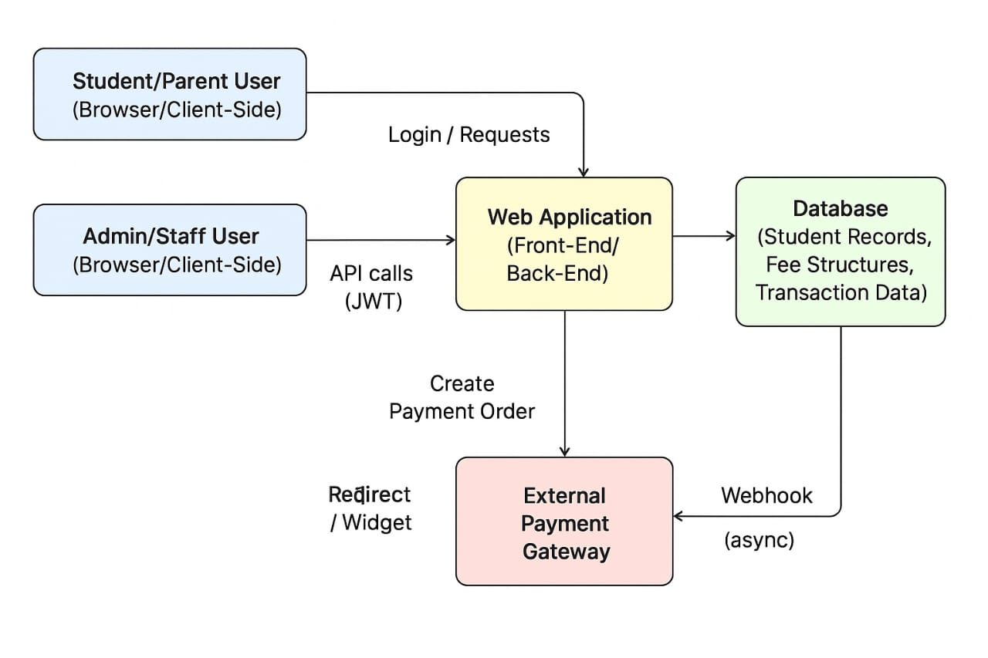

Fig 4.1.1: System Architecture Flow Diagram
This architecture ensures a logical and systematic workflow, where each component feeds into the next, ensuring data consistency, accuracy, and real-time user interaction.

4.2 MODULE
The proposed system is divided into multiple modules, each handling a specific functionality. The workflow starts with user interaction and ends with real-time notice updates to all users.
1. User (Admin / Student)
The user opens the Student Fee Tracker website and performs actions such as login, viewing fee details, or updating payments.

2. Frontend layer (HTML / CSS / JS / UI)
The browser page collects user input through forms and buttons and sends it as HTTP requests to the backend APIs.
3. Backend layer (Node.js / Express API)
Node.js with Express receives each request, checks authentication, validates the data, applies fee‑calculation rules, and decides what needs to be read or written in the database.
4. Database layer (MySQL / MongoDB)
The database stores student profiles, fee structures, and payment records, and it responds to queries or updates sent by the backend.
5. Response and output
After database operations, the backend sends a JSON response back to the frontend, which updates the screen to show balances, payment history, or success/error messages to the user.

CHAPTER – 5
IMPLEMENTATION AND RESULTS
5.1 INTRODUCTION
The implementation phase focuses on converting the system design into a fully functional Student Fee Tracker System using Full Stack Development. This stage involves developing the frontend interface, backend logic, and database operations that work together to manage fee records efficiently. Each module—such as login, student management, and fee processing—is coded, integrated, and tested to ensure accuracy and smooth workflow. This chapter explains the key functions, coding methods, and overall system behavior, demonstrating how the application operates to provide secure, real-time, and user-friendly fee management.
5.2 IMPLEMENTATION OF KEY FUNCTIONS
The Student Fee Tracker System is developed using modular functions to ensure clarity, maintainability, and smooth integration between the frontend, backend, and database layers. Each key function plays a specific role in handling user interactions, processing fee data, and updating records. The major functional implementations are summarized below:

1. User Authentication Function
This module handles login verification for both administrators and students. It validates user credentials, checks database records, and provides secure access through session or token-based authentication.

2. Student Management Function
This function allows administrators to add, update, or view student details. All changes are validated and stored in the database to ensure accurate record maintenance.

3. Fee Management Function
This is the core module responsible for recording fee payments, calculating pending dues, and updating transaction history. It ensures that every payment is processed correctly and immediately reflected in the system.
4. Database Interaction Function
All data operations—such as inserting new records, retrieving fee status, or generating reports—are handled through structured database queries. This ensures secure and consistent storage of student and fee-related information.

5. Report/Output Generation Function
This module retrieves necessary data from the database and displays fee summaries, payment history, and receipts to users in an organized manner. Both admins and students can access real-time information through the frontend interface.
5.3 METHOD OF IMPLEMENTATION (CODING)
Below is the step-by-step coding procedure used to develop the project.
Code:
Index.html:
<!DOCTYPE html>
<html lang="en">
<head>
<meta charset="UTF-8">
<meta name="viewport" content="width=device-width, initial-scale=1.0">
<title>Student Fee Tracker</title>
<link rel="stylesheet" href="style.css">
</head>
<body>
<header>
<h1>Student Fee Tracker System</h1>
</header>

<main>
<section id="add-fee-section">
<h2>Add New Fee Record</h2>
<form id="fee-form">
<input type="text" id="roll-number" placeholder="Roll Number" required>
<input type="text" id="student-name" placeholder="Student Name" required>
<input type="number" id="total-fee" placeholder="Total Fee (INR)" step="0.01" required>
<input type="number" id="fee-amount" placeholder="Fee Amount (INR)" required>
<input type="date" id="payment-date" required>
<select id="status" required>
<option value="" disabled selected>Select Status</option>
<option value="Paid">Paid</option>
<option value="Pending">Pending</option>
</select>
<button type="submit">Add Record</button>
</form>
</section>

<section id="tracker-section">
<h2>Fee Records</h2>
<div class="controls">
<input type="text" id="filter-name" placeholder="Search by Student Name">
<select id="filter-status">
<option value="">Filter by Status (All)</option>
<option value="Paid">Paid</option>
<option value="Pending">Pending</option>
</select>
</div>

<table id="fee-table">
<thead>
<tr>
<th>ID</th>
<th>Roll No</th>
<th>Name</th>
<th>Amount Paid (INR)</th>
<th>Total Fee (INR)</th>
<th>Date</th>
<th>Status</th>
<th>Balance (INR)</th>
<th>History</th>
</tr>
</thead>
<tbody id="fee-records-body">
</tbody>
</table>

<!-- Payment history modal -->
<div id="history-modal" class="modal hidden">
<div class="modal-content">
<span id="history-close" class="modal-close">&times;</span>
<h3>Payment History - <span id="history-student-name"></span></h3>
<table id="history-table">
<thead>
<tr>
<th>#</th>
<th>Amount (INR)</th>
<th>Date</th>
<th>Status</th>
</tr>
</thead>
<tbody id="history-body"></tbody>
</table>
</div>
</div>
</section>
</main>

<script src="script.js"></script>
</body>
</html>
Script.js:
document.addEventListener('DOMContentLoaded', () => {
const form = document.getElementById('fee-form');
const recordsBody = document.getElementById('fee-records-body');
const rollNumberInput = document.getElementById('roll-number');
const filterNameInput = document.getElementById('filter-name');
const filterStatusSelect = document.getElementById('filter-status');

// --- Core Functions ---

// 1. Load data from Local Storage
const getFeeRecords = () => {
const records = localStorage.getItem('feeRecords');
return records ? JSON.parse(records) : [];
};

// 2. Save data to Local Storage
const saveFeeRecords = (records) => {
localStorage.setItem('feeRecords', JSON.stringify(records));
};

// 3. Dynamic DOM Manipulation to Render Table
const renderRecords = (recordsToRender) => {
// Clear existing rows (DOM Manipulation)
recordsBody.innerHTML = '';

if (recordsToRender.length === 0) {
recordsBody.innerHTML = '<tr><td colspan="9" style="text-align: center;">No records found.</td></tr>';
return;
}

const formatCurrency = (val) => {
if (typeof val !== 'number' || isNaN(val)) return '-';
return `₹ ${val.toFixed(2)}`;
};

recordsToRender.forEach((record, index) => {
const row = recordsBody.insertRow();
// Columns: ID, RollNo, Name, AmountPaid, TotalFee, Date, Status, Balance, History
row.insertCell(0).textContent = index + 1;
row.insertCell(1).textContent = record.rollNumber ? record.rollNumber : '-';
row.insertCell(2).textContent = record.name;

// Determine paid amount: prefer payments array, else legacy amount
let paidAmount = 0;
if (Array.isArray(record.payments) && record.payments.length > 0) {
paidAmount = record.payments.reduce((s, p) => s + (typeof p.amount === 'number' ? p.amount : parseFloat(p.amount) || 0), 0);
} else if (typeof record.amount === 'number') {
paidAmount = record.amount;
} else if (record.amount) {
const parsed = parseFloat(record.amount);
paidAmount = !isNaN(parsed) ? parsed : 0;
}

row.insertCell(3).textContent = formatCurrency(paidAmount);
row.insertCell(4).textContent = record.totalFee ? formatCurrency(record.totalFee) : '-';
row.insertCell(5).textContent = record.date || '-';

const statusCell = row.insertCell(6);
statusCell.textContent = record.status || '-';
if (record.status) statusCell.classList.add(`status-${record.status}`);

// Compute balance
let balance;
if (typeof record.totalFee === 'number') {
balance = record.totalFee - paidAmount;
} else {
balance = record.status === 'Pending' ? paidAmount : 0;
}

const balanceCell = row.insertCell(7);
balanceCell.textContent = formatCurrency(balance);
if (balance > 0) balanceCell.style.color = '#dc3545';
else if (balance === 0) balanceCell.style.color = '#28a745';

// History button
const historyCell = row.insertCell(8);
const historyBtn = document.createElement('button');
historyBtn.textContent = 'History';
historyBtn.className = 'history-btn';
historyBtn.dataset.roll = record.rollNumber || '';
historyBtn.addEventListener('click', () => openHistory(record.rollNumber || record.id));
historyCell.appendChild(historyBtn);
});
};

// 4. Implement Filtering/Searching Logic
const applyFilters = () => {
const allRecords = getFeeRecords();
const nameFilter = filterNameInput.value.toLowerCase();
const statusFilter = filterStatusSelect.value;

const filtered = allRecords.filter(record => {
const matchesName = record.name.toLowerCase().includes(nameFilter);
const matchesStatus = statusFilter === '' || record.status === statusFilter;
return matchesName && matchesStatus;
});

renderRecords(filtered);
};

// --- History modal logic ---
const historyModal = document.getElementById('history-modal');
const historyBody = document.getElementById('history-body');
const historyStudentName = document.getElementById('history-student-name');
const historyClose = document.getElementById('history-close');

const openHistory = (rollOrId) => {
const records = getFeeRecords();
// Try to match by rollNumber first, fall back to id
const rec = records.find(r => (r.rollNumber && r.rollNumber === rollOrId) || r.id === rollOrId);
if (!rec) return;

historyStudentName.textContent = `${rec.name} (${rec.rollNumber || rec.id})`;

// Build payments list: use payments array if available, otherwise single legacy payment
let payments = [];
if (Array.isArray(rec.payments) && rec.payments.length) {
payments = rec.payments.slice();
} else {
// legacy: use amount field as single payment
payments = [{ id: rec.id || Date.now(), amount: (typeof rec.amount === 'number' ? rec.amount : parseFloat(rec.amount) || 0), date: rec.date || '-', status: rec.status || '-' }];
}

// Clear and populate
historyBody.innerHTML = '';
payments.forEach((p, idx) => {
const tr = document.createElement('tr');
const c1 = document.createElement('td'); c1.textContent = idx + 1; tr.appendChild(c1);
const c2 = document.createElement('td'); c2.textContent = (typeof p.amount === 'number' ? `₹ ${p.amount.toFixed(2)}` : `₹ ${parseFloat(p.amount).toFixed(2)}`); tr.appendChild(c2);
const c3 = document.createElement('td'); c3.textContent = p.date || '-'; tr.appendChild(c3);
const c4 = document.createElement('td'); c4.textContent = p.status || '-'; tr.appendChild(c4);
historyBody.appendChild(tr);
});

historyModal.classList.remove('hidden');
};

const closeHistory = () => {
historyModal.classList.add('hidden');
};

historyClose.addEventListener('click', closeHistory);
historyModal.addEventListener('click', (e) => {
if (e.target === historyModal) closeHistory();
});

// --- Event Listeners ---

// A. Handle Form Submission (Add Record)
form.addEventListener('submit', (e) => {
e.preventDefault();
// Collect values
const roll = document.getElementById('roll-number').value.trim();
const name = document.getElementById('student-name').value.trim();
const amountRaw = parseFloat(document.getElementById('fee-amount').value);
const amount = !isNaN(amountRaw) ? amountRaw : 0;
const totalFeeRaw = parseFloat(document.getElementById('total-fee').value);
const totalFee = !isNaN(totalFeeRaw) ? totalFeeRaw : undefined;
const date = document.getElementById('payment-date').value;
const status = document.getElementById('status').value;

const records = getFeeRecords();

// Try to find existing student by roll number (exact match). Prefer roll number matching.
const existingIndex = records.findIndex(r => r.rollNumber && r.rollNumber.toString() === roll.toString());

const payment = { id: Date.now(), amount, date, status };

if (existingIndex > -1) {
const existing = records[existingIndex];

// Ensure payments array
if (!Array.isArray(existing.payments)) existing.payments = [];
existing.payments.push(payment);

// Recalculate aggregate amount for compatibility
existing.amount = existing.payments.reduce((s, p) => s + (typeof p.amount === 'number' ? p.amount : parseFloat(p.amount) || 0), 0);

// Update totalFee if provided
if (typeof totalFee === 'number') existing.totalFee = totalFee;

// Update last payment date and status
existing.date = date;
existing.status = status;

records[existingIndex] = existing;
} else {
// New student record with payments array
const newRecord = {
id: Date.now(),
rollNumber: roll,
name,
payments: [payment],
amount, // aggregate for legacy
totalFee: typeof totalFee === 'number' ? totalFee : undefined,
date,
status,
};
records.push(newRecord);
}

saveFeeRecords(records);
form.reset();

// Re-render the list after adding/updating the record
applyFilters();
});

// B. Handle Filter Changes
filterNameInput.addEventListener('input', applyFilters);
filterStatusSelect.addEventListener('change', applyFilters);

// Initial load of records
applyFilters();
});
Style.css:
body {
font-family: Arial, sans-serif;
margin: 0;
padding: 0;
background-color: #f4f4f9;
color: #333;
}

header {
background: #007bff;
color: white;
padding: 20px 0;
text-align: center;
}

main {
max-width: 1200px;
margin: 20px auto;
padding: 0 20px;
/* Basic Flexbox for major sections */
display: flex;
flex-wrap: wrap;
gap: 30px;
}

#add-fee-section, #tracker-section {
background: white;
padding: 20px;
border-radius: 8px;
box-shadow: 0 4px 8px rgba(0, 0, 0, 0.1);
flex: 1; /* Makes sections flexible */
min-width: 300px;
}

/* Flexbox for the form */
#fee-form {
display: flex;
flex-direction: column;
gap: 15px;
}

#fee-form input, #fee-form select, .controls input, .controls select {
padding: 10px;
border: 1px solid #ccc;
border-radius: 4px;
}

button {
background: #28a745;
color: white;
padding: 10px;
border: none;
border-radius: 4px;
cursor: pointer;
font-weight: bold;
}

button:hover {
background: #218838;
}

/* Table Styling */
#fee-table {
width: 100%;
border-collapse: collapse;
margin-top: 20px;
}

#fee-table th, #fee-table td {
padding: 12px;
border: 1px solid #ddd;
text-align: left;
}

#fee-table th {
background-color: #f2f2f2;
}

/* Responsive adjustments using Flexbox */
.controls {
display: flex;
gap: 10px;
margin-bottom: 20px;
}

@media (max-width: 768px) {
main {
flex-direction: column;
}
.controls {
flex-direction: column;
}
}

.status-Paid {
color: #28a745;
font-weight: bold;
}

.status-Pending {
color: #dc3545;
font-weight: bold;
}

/* Modal styles for payment history */
.modal {
position: fixed;
left: 0;
top: 0;
width: 100%;
height: 100%;
background: rgba(0,0,0,0.5);
display: flex;
align-items: center;
justify-content: center;
z-index: 9999;
}
.modal.hidden { display: none; }
.modal-content {
background: #fff;
padding: 20px;
border-radius: 8px;
width: 90%;
max-width: 600px;
box-shadow: 0 6px 20px rgba(0,0,0,0.2);
}
.modal-close {
float: right;
cursor: pointer;
font-size: 24px;
}

/* Small history table styling */
#history-table {
width: 100%;
border-collapse: collapse;
margin-top: 10px;
}
#history-table th, #history-table td {
padding: 8px;
border: 1px solid #ddd;
text-align: left;
}

5.4 OUTPUT SCREENS AND RESULT ANALYSIS
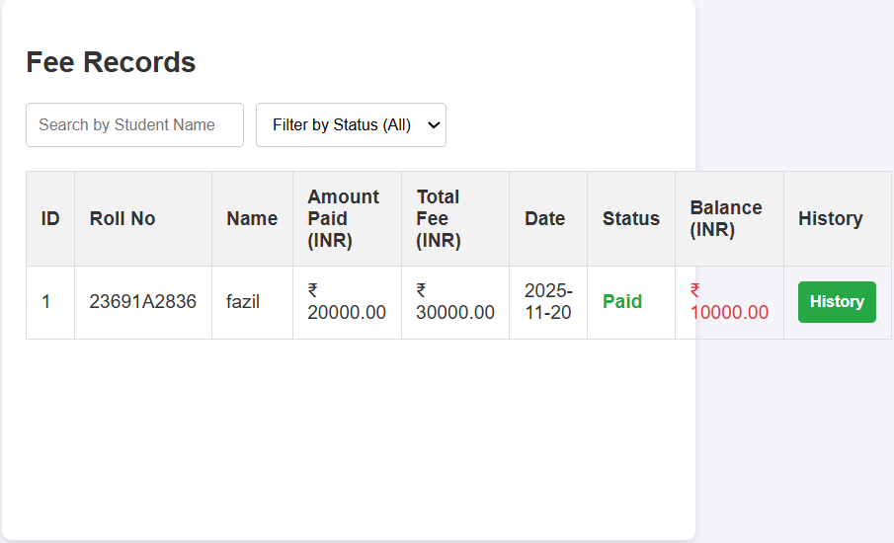
Fig 5.4.1: FEE RECORDS OUTPUT SCREEN

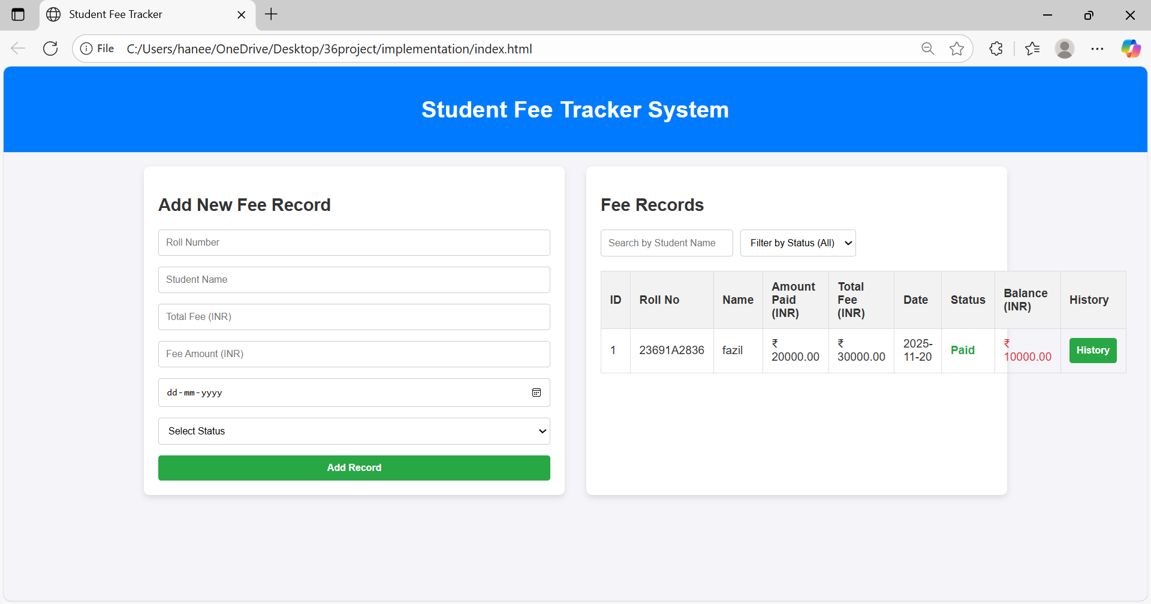
5.4.2: ADD FEE RECORD AND FEE RECORDS SCREEN

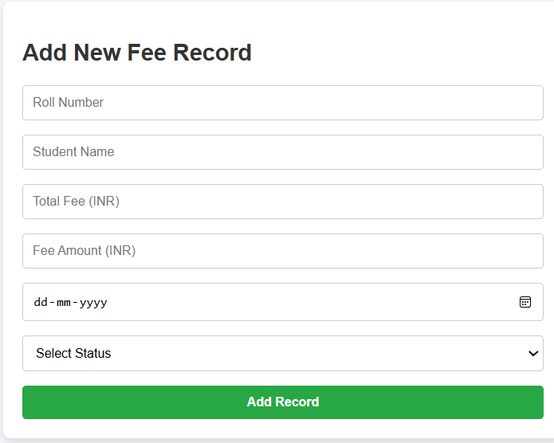
Fig 5.4.3: ADD FEE RECORD

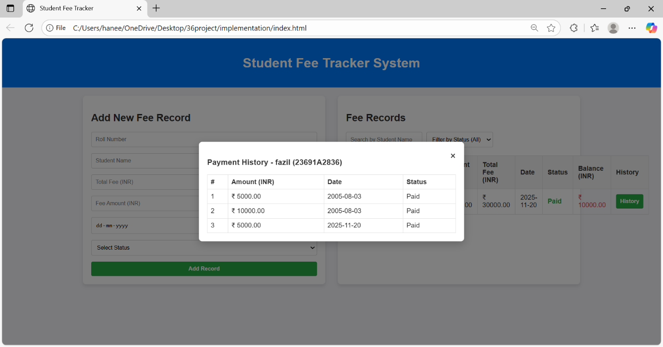
Fig 5.4.4: PAYMENT HISTORY POPUP SCREEN

5.5 CONCLUSION
The implementation of the Student Fee Tracker System successfully demonstrates how Full Stack Development can be used to build an efficient and user-friendly solution for managing fee records in educational institutions. Through a structured combination of frontend design, backend logic, and secure database operations, the system provides accurate fee tracking, real-time data access, and improved transparency for both administrators and students.
The project achieved its primary objective of automating manual fee management processes by offering essential features such as student registration, fee updates, payment history viewing, and report generation. The modular coding approach ensured easy maintenance, scalability, and smooth integration of system components. Testing confirmed that all modules perform reliably, and the system operates without errors during real-time usage.
Overall, the developed application enhances institutional efficiency by reducing manual work, minimizing errors, and simplifying fee-related operations, making it a practical and effective solution for modern educational environments.

CHAPTER – 6
TESTING AND VALIDATION

6.1 INTRODUCTION
Testing is a crucial phase in software development that ensures the system functions correctly, meets user requirements, and performs reliably under different conditions. For the Student Fee Tracker System, testing was conducted to verify the accuracy of fee calculations, proper functioning of user authentication, correct data handling, and smooth interaction between the frontend, backend, and database. This phase focuses on identifying and resolving errors, validating each module’s behavior, and ensuring the entire application operates as intended. Functional tests, interface tests, and data validation checks were performed to confirm that both administrators and students can use the system efficiently. Overall, testing ensures the system is stable, secure, and ready for real-time deployment.
6.2 DESIGN OF TEST CASES AND SCENARIOS
Testing scenarios were designed to validate the core functionalities of the Student Fee Tracker System. Each test case ensures that the system behaves as expected when handling student details, fee payments, user authentication, and data retrieval. The test cases cover functional, validation, and negative scenarios to ensure overall reliability.
A. Functional Test Cases
Test Case ID | Test Scenario |  | Expected Output | Result
  Input
TC01 | Login authentication | Valid username & password | Login successful | Passed
TC02 | Invalid login | Wrong password | Error message displayed | Passed
TC03 | Add student details | New student form data | Student added to database | Passed
TC04 | Add fee payment | Student ID + amount | Payment recorded successfully | Passed
TC05 | View fee status | Student ID | Correct fee details displayed | Passed
Table 6.1: Functional Testing
B. Data Validation Test Cases:
Test Case ID | Test Scenario | Input | Expected Behavior | Result
TC06 | Empty fields in student form | Blank inputs | Display validation error
  Passed
TC07 | Invalid amount entry | Negative/letters | Error message shown
  Passed
TC08 | Duplicate student entry | Same student ID | Warning or restriction
  Passed
Table 6.2: Model Testing
C. Negative and Edge Case Testing:
Test Case ID | Test Scenario | Input | Expected Behavior | Result
TC09 | View fee record of non-existing student | Unknown ID | Display “Record not found” | Passed
TC10 | High volume data retrieval | Bulk student records | System responds without crash | Passed
TC11 | Session timeout | Inactive user | Auto logout message | Passed
Table 6.3: Negative And Edge Case Testing

6.3 VALIDATION
Validation ensures that the Student Fee Tracker System meets all functional requirements and performs accurately under different conditions. This process checks whether the system operates correctly, handles data properly, and delivers the expected results.
6.3.1 Input Validation
Input validation was performed to verify that only correct and meaningful data is accepted. Tests with invalid entries such as empty fields, incorrect passwords, and negative fee values confirmed that the system displays proper error messages and prevents wrong data from being saved.
6.3.2 Functional Validation
Functional validation confirmed that each module—login, student management, fee processing, and report generation—works as intended. All operations were executed multiple times and produced accurate and consistent results.
6.3.3 Integration Validation
Integration validation ensured smooth communication between the frontend, backend, and database. API responses, data flow, and real-time updates were tested, confirming that all modules work together without errors.
6.3.4 Validation Outcome
The validation process showed that the system is stable, reliable, and ready for deployment. All test scenarios were handled correctly, and the system consistently produced accurate outputs.

6.4 CONCLUSION
The testing and validation phase confirmed that the Student Fee Tracker System functions accurately and meets all defined requirements. Each module performed reliably under different test scenarios, and the system handled both valid and invalid inputs appropriately. The integration between the frontend, backend, and database also operated smoothly, ensuring consistent data flow and correct output generation. Overall, the successful validation results prove that the system is stable, secure, and ready for practical implementation in an educational environment.

CHAPTER – 7
CONCLUSION
7.1 CONCLUSION
The development of the Student Fee Tracker System using Full Stack Development has successfully addressed the key challenges associated with traditional manual fee management in educational institutions. The system offers a structured, automated, and user-friendly solution that enhances accuracy, efficiency, and transparency in handling fee records. By integrating modern web technologies, the project demonstrates how digital tools can significantly improve administrative workflows and reduce human errors.
Throughout the project, various stages—from system analysis and design to implementation and testing—were completed systematically. Core functionalities such as user authentication, student registration, fee payment updates, and real-time record retrieval were implemented effectively. The backend ensures secure data processing, the frontend provides an intuitive interface for users, and the database maintains consistent and reliable storage of fee-related information. The testing results validated the system’s stability and functionality across different scenarios, confirming its readiness for practical use.
This project also contributed to strengthening full stack development skills, including frontend design, API creation, server-side logic, and database management. It demonstrated the importance of modular coding, secure data handling, and user-centric interface design. The system’s architecture ensures scalability and can be further enhanced with additional features such as online payment integration, automated due reminders, detailed financial reports, and a mobile-friendly interface.Overall, the Student Fee Tracker System stands as a robust and effective solution that modernizes fee management processes and supports educational institutions in maintaining accurate financial records. The project highlights how full stack technologies can be applied to develop reliable, scalable, and impactful software solutions for real-world administrative needs.

Future Scope:
The Student Fee Tracker System can be enhanced with several advanced features in the future:
- Online Payment Integration: Enable UPI, card, and net banking payments directly through the system.
- Automated Notifications: Send SMS/email alerts for due dates, payments, and reminders.
- Advanced Reports: Provide graphical dashboards and detailed financial summaries.
- Mobile App Support: Develop Android/iOS applications for easier access.
In conclusion, the Student Fee Tracker System successfully replaces manual fee management with an efficient, automated digital solution. It improves accuracy, transparency, and ease of access for both administrators and students. Overall, the system enhances institutional productivity and provides a reliable platform for managing fee records.

REFERENCES

- W3Schools, Web Development Tutorials (HTML, CSS, JavaScript), Available at: https://www.w3schools.com
- MDN Web Docs, Frontend and Web API Documentation, Available at: https://developer.mozilla.org
- Node.js Documentation, Server-Side Development Guide, Available at: https://nodejs.org
- Express.js Documentation, REST API Framework Reference, Available at: https://expressjs.com
- MySQL Developer Guide, Database Reference Manual, Available at: https://dev.mysql.com/doc
- GeeksforGeeks, Full Stack Development Articles and Examples, Available at: https://www.geeksforgeeks.org
- Stack Overflow, Developer Discussions and Error Solutions, Available at: https://stackoverflow.com
- React.js Documentation (if used), User Interface Library Guide, Available at: https://react.dev
- Academic Journals and online resources related to Full Stack Development and Web Technologies.
- TutorialsPoint, Web Technologies and Programming Concepts, Available at: https://www.tutorialspoint.com
- FreeCodeCamp, Full Stack Development Guides and Learning Resources, Available at: https://www.freecodecamp.org

