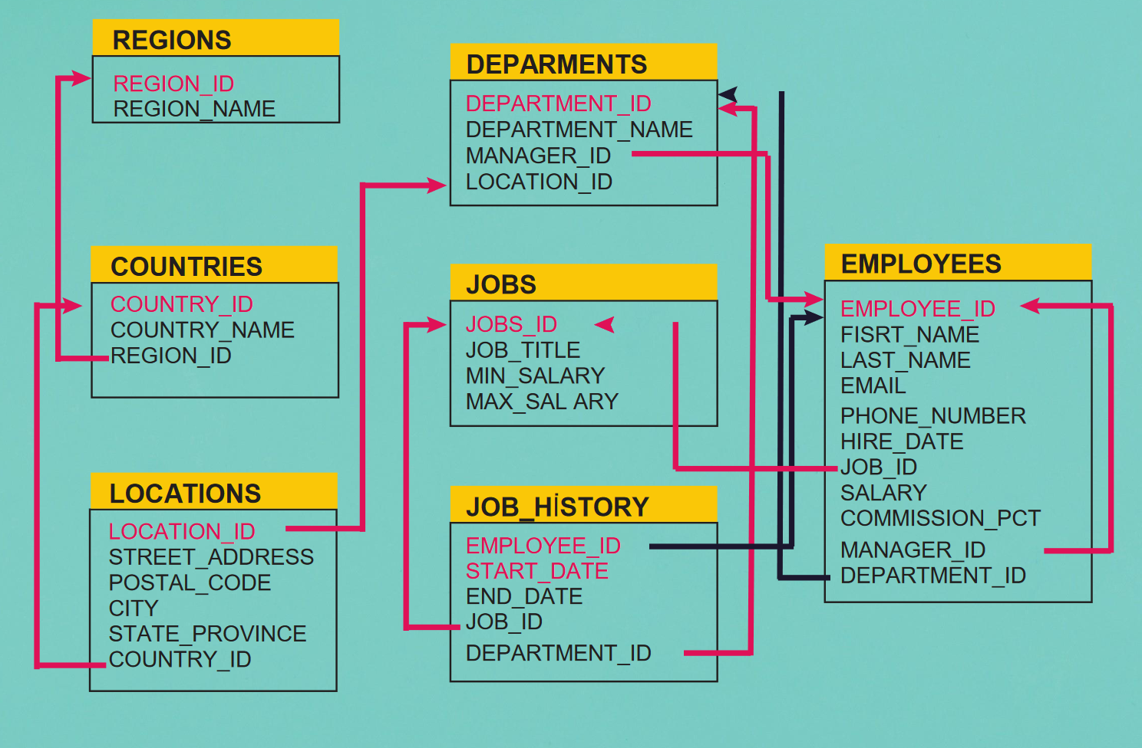

You have been given structure of the tables in Human Resource Schema (HR).

Answer the following questions by writing queries

1) Write a query in SQL to display job Title, the difference between minimum and maximum salaries

for those jobs which max salary within the range 12000 to 18000.

2) Display the details of the employees who have no commission percentage and whose salary is

within the range 7000 to 12000 for those employees who are not working in the departments

50,30 and 80.

3) Write a query in SQL to display the full name (first name and last name), hire date, commission

percentage, email and telephone separated by '-', and salary for those employees whose salary

is above 11000 and make the result set in a descending order by the full name.

4) Write a query in SQL to display the first and last name, and salary for those employees whose first

name is ending with the letter “m” and they have been hired before June 5th, 2005.

5) Write a query in SQL to display all the information about the department Marketing.

6) Write a query to display data from job_history and make the result set in descending order by the

epmloyee_id and ascending order by start date.

7) Write a query to display job_id and salary of employees whose phone number starts with 515 or

590 and was hired after 2003 by sorting hire_date and salary in ascending way.

8) Write a query to display employees who were hired in 2001.

9) Write a query to display employees’ first and last name who were not hired in 2006 and 2007.

10) Write a query to display email, job_id and first name of employees whose hired year was 2007

or hired month was 1.

11) Write a query to display details of employees who was hired after 2007 or salary is less than

10000.