Remove deformed bars and move REINFORCEMENT Bar in the place of Deformed Bars
Remove structural steel sections completely
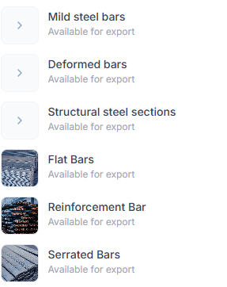

1.Mild Steel Bars 10 mm

Mild Steel Round Bar – 10mm
Specification:
Mild Steel Square Bar, available in various sizes 6 to 32 mm diameter

2) Reinforcement bar
Reinforcement Bar 8 mm
Specification:
Reinforcement Round bar available in various sizes 6 to 32 mm diameter
3) Flat bars
Flat bars 10x 3 mm size
Specification:
Flat bar available in various sizes 10 x 3,13X3 mm,13 X 5 mm, 13 X 6 mm,16x5 mm etc

4) Serrated Bar
Serrated bar 20 mm x 3 mm
Specification:
Serrated bar available various sizes 3mm to 5 mm at various depths of 20mm to 70mm.

Remove Timber instead add white wood & remove Hardwood 1) White Wood 2) Plywood 3) Moisture Resistance MDF 4) Solid Core Chip Board
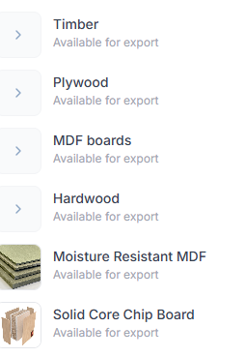

- White Wood Canadian White Wood WXW50
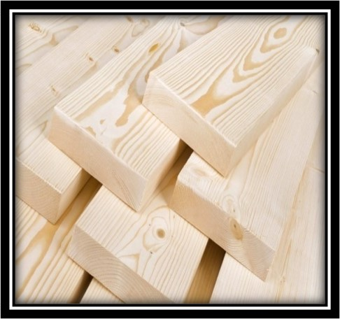
Canadian White Wood WXW50
Specification
Size | 1'' x 2'', 1'' x 4'', 1'' x 6'', 2'' x 2'', 2'' x 3'', 2'' x 4'', 2'' x 12'', 3'' x 3'', 4'' x 4''

2) Plywood
Ply Wood – Hardwood
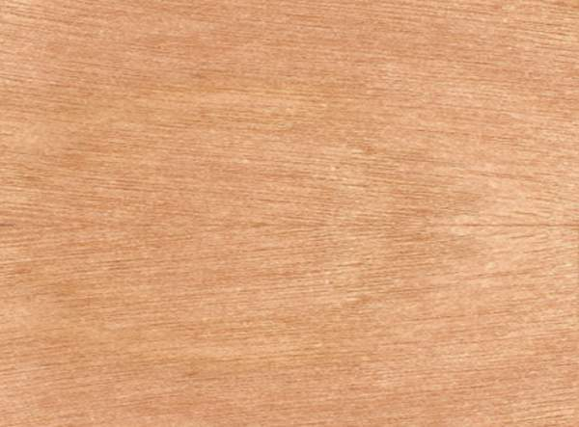

Various type ply wood available – Bendy Plywood, Birch Plywood, Commercial plywood, Film faced plywood, Veneer plywood WBP plywood

- Moisture Resistance MDF
Specification MR MDF No soggy sagas, only style! Secret weapon: water-repelling glue, maybe a waxy dip. Pulped, pressed, prepped, ready to conquer damp.
- Solid Core Chip Board
Solid Core Chip Board 38 mm thickness .size 915 x 2135mm
Solid Core Chipboard is easy to work with and can be finished with laminates, veneers, or paint, providing a versatile solution for various design

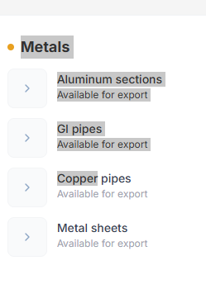

- Aluminum Sectionds
Aluminium 40 x 20 x 1.2 mm Rectangular Hollow 5.95M
Specification: hape Form
Hollow
Shape Profile
Rectangular hollow profile, Rectangular Hollow Section (RHS)
Cross Section Dimensions
0.2 CMT (height)
Length
5.95M
Thickness
Uniform wall thickness
Width
5 CMT
- GI PIPES
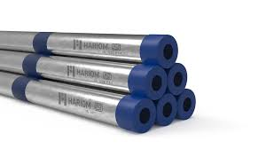
- Strong, tough and corrosion-resistant
- Popular choice in various applications for aesthetic appearances
- Available sizes range from 20NB to 100NB
- Thickness range from 1.2mm to 2.5mm
- Copper Pipes

Copper Pipe/Tube 1/4"-6" Inch Diameter x 1' foot Length

- Metal Sheets
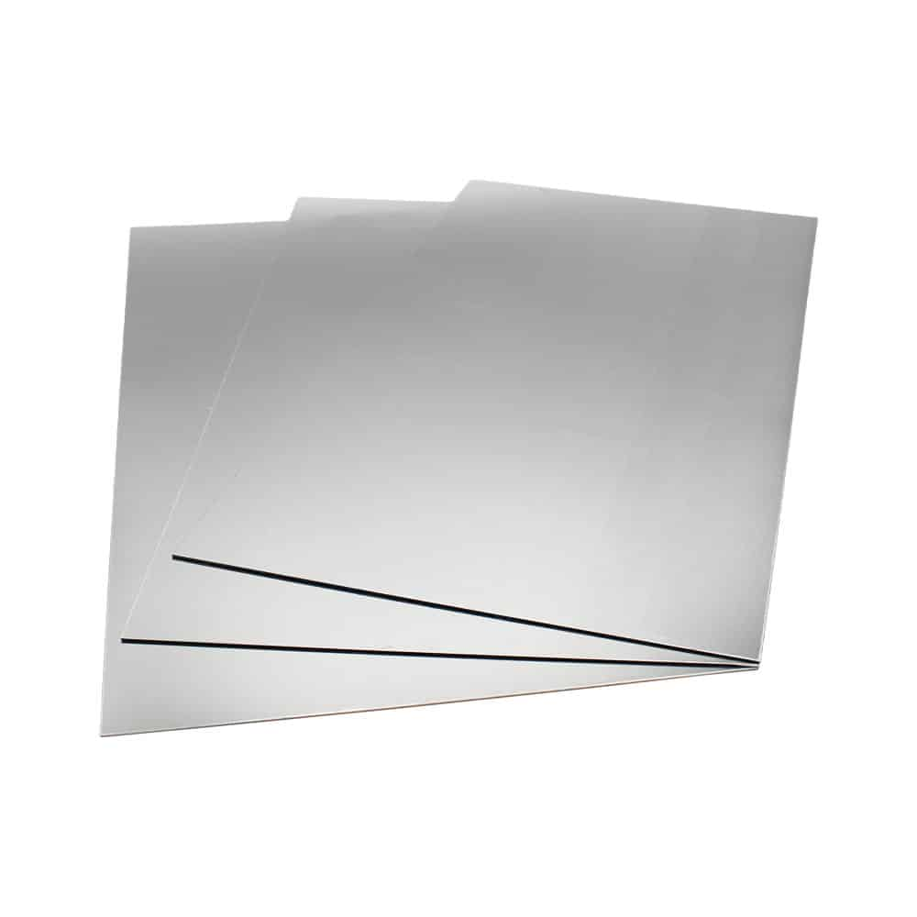

0.8mm Thick Metal Plate 1050 Grade Aluminium Sheets

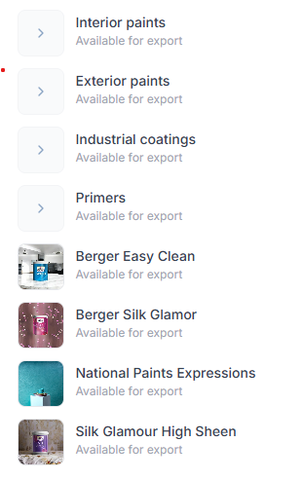
1) keep interior paints 2) exterior paints 3) Industrial Coating 4) Primers
  - Interior paint
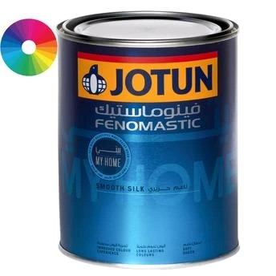
Jotun Fenomastic My Home Smooth Silk Base A (900 ml)
Brand:Jotun
  - Exterior Paint
- 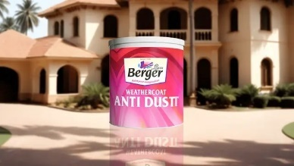
Weathercoat Anti Dustt TT
Brand:BERGER
100% acrylic emulsion exterior wall paint
Unique Dust Guard technology.
3)Industrial Paint
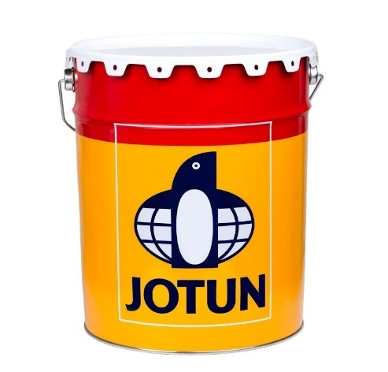
Jotun Penguard Topcoat
Brand : JOTUN
This is a 2 Component Product (A + B),
Both are Included 5L Consists of 4 + 1 Litre
4)primers
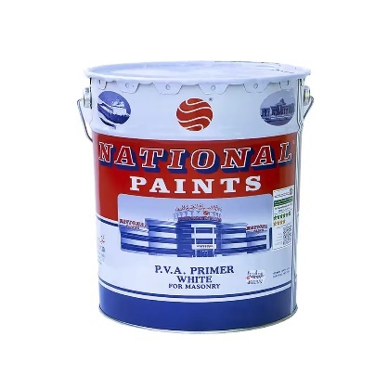
National Paints PVA Primer White
Brand :National Paints
Color :White
Itme Type : PVA Primer

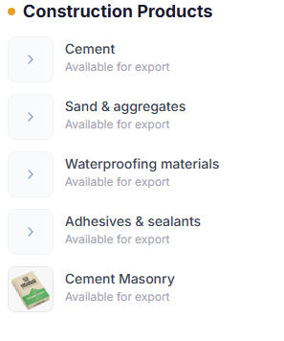
Keep only
1)Waterproofing Materials
2)Adhesives &Sealants

Remove ( Cement, sand and aggregates & Cement Masonry )

  - Water Proofing Materials
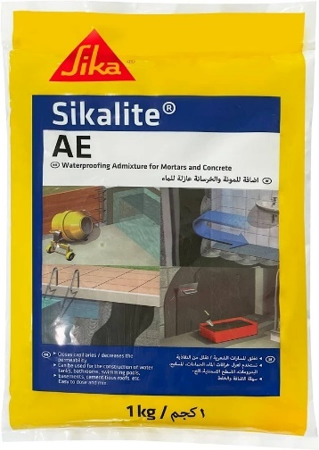
SIKALITE
Ready To Use Powdered Waterproofing
Admixture For Cement/Sand Mortars and Concrete

- 2)Adhesives &Sealants
- 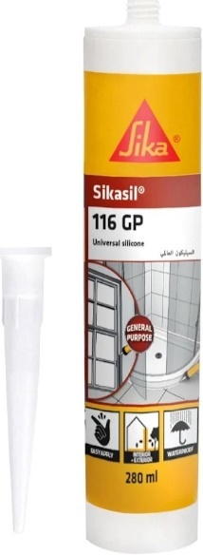

SIKA - Universal Multipurpose Silicone Sealant
For Glazing And Weatherproofing - Sikasil-116 Gp White

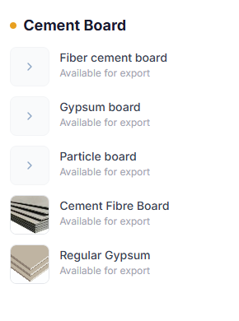

Keep only first two items
1) Fiber Cement Board
2) Gypsum Board

Remove (Particle board, Cement fibre Board , Regular Gypsum ) use the same pictures for first two option.
  - Fiber Cement Board
ideal for cladding, partition walls, ceilings, and facades.
  - Gypsum Board
Standard Gypsum dimensions (1200 x 2400 x 12mm - 15mm)
user-friendly installation features.
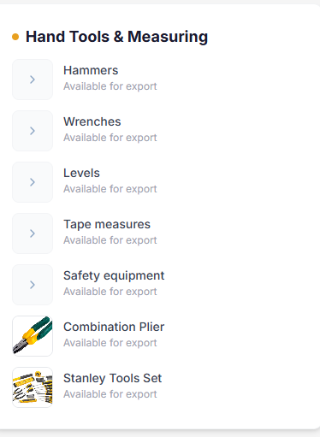
- Hammers
Fibre Glass nail Hammer 450 Gramms
Brand : Stanley
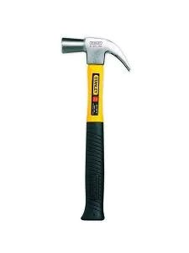

- Wrenches

Combination Wrench Set

- Combination wrench 10 mm
- Combination wrench 12 mm
- Combination Wrench 14 mm

Brand : Stanley
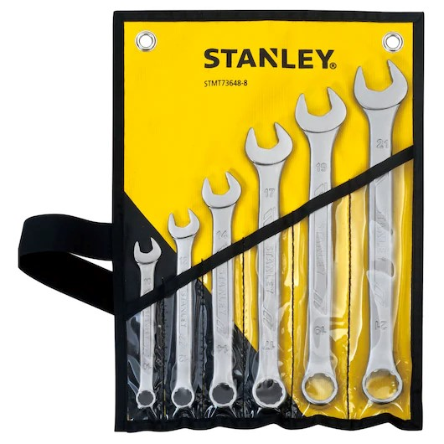
- Spirit Levels

Spirit Level 12" Professional
Brand :UKEN
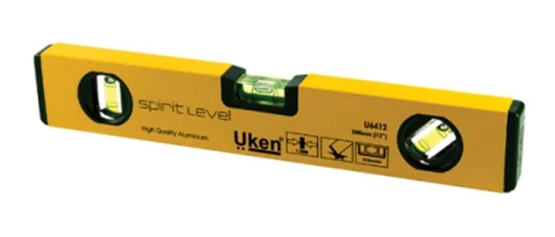
- Measuring Tape

Stanley Measuring Tape 8M Bimaterial
- 8-meter length, suitable for large-scale measurements.
- Bimaterial build for added comfort and durability.
- Clear, accurate markings for precise results.
- Ideal for construction, carpentry, and industrial use.
- Robust Stanley design ensures long-lasting performance.

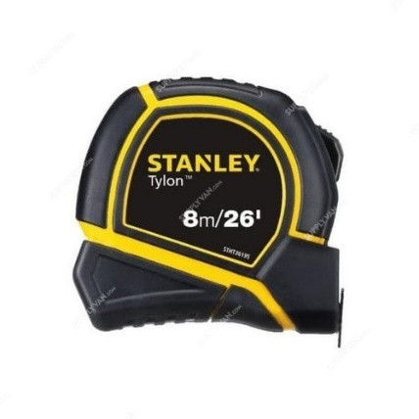
- Safety Equipment

Safety Shoe
Model # 50053-127-44
Brand :DEWALT
PLANE Low Cut Safety Shoes - Size 39-44, Steel Toe, Taupe Suede, SB Rated, Oil Resistant

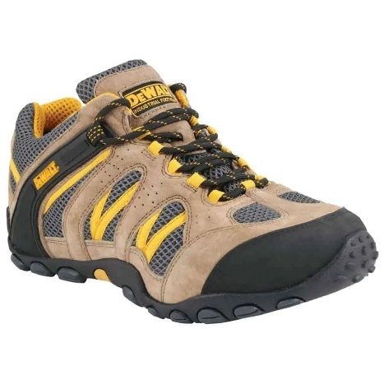
- Combination Pliers
Use same image

Dynagrip Combination Plier 180MM

- Forged carbon steel jaws and handle provides long life
- Heat treated to ensure durability and optimal performance
- For greater reliability, induction hardened at cutting edges,
- Induction hardened for high performance, Ergonomically designed
- Stanley Tools set – REMOVE THE ITEM – NOT REQUIRED

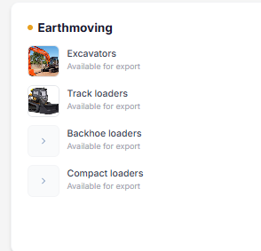

  - Backhoe Loaders
JCB 4CX Super Backhoe Loader

The primary design features of the 4CX-14 SUPER backhoe loader are the four equal-sized tires which provide high ground clearance and traction, and 4-wheel steer capability for enhanced manoeuvrability. Additionally, a host of performance, comfort, safety and efficiency enhancements enable this machine to tackle loading operations like no other.
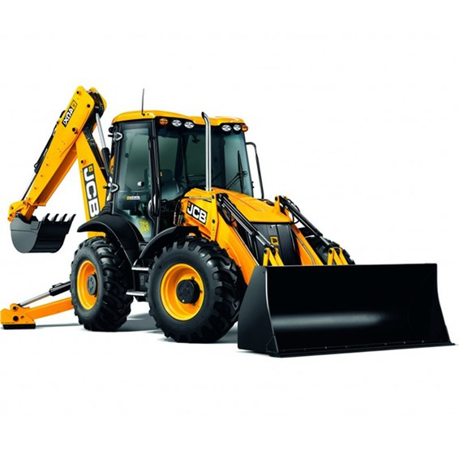

  - Compact Loader ( delete option 4 )

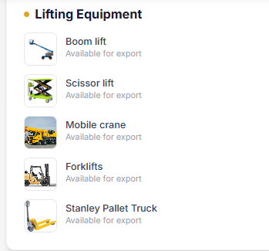



Remove 3rd & 4 th one ( DELETE Tractor Units & Ashok Leyland Truck)



Industrial Mixer

Imer Multi-Mix 350 Mortar/Concrete Mixer w/Steel Drum
Brand : IMER
Drum Capacity :12 Cu ft
Motor Power 1.9 hp

