**Data communications** are the exchange of data between two devices via some form of transmission medium such as a wire cable. For data communications to occur, the communicating devices must be part of a communication system made up of a combination of hardware (physical equipment) and software (programs).

The effectiveness of a data communications system depends on four fundamental characteristics**: delivery, accuracy, timeliness, and jitter**.

**1. Delivery.** The system must deliver data to the correct destination. Data must be received by the intended device or user and only by that device or user.

2 Accuracy. The system must deliver the data accurately. Data that have been altered in transmission and left uncorrected are unusable.

3. Timeliness. The system must deliver data in a timely manner. Data delivered late are useless. In the case of video and audio, timely delivery means delivering data as they are produced, in the same order that they are produced, and without significant delay. This kind of delivery is called real-time transmission.

4. jitter refers to the variation in the time delay between data packets arriving at the receiver end. data packets are expected to arrive in a steady and predictable flow. due to network congestion, poor routing, or other issues, packets may not arrive at regular intervals — this irregularity is called **jitter**.

**Components**

A data communications system has five components.

* **Firstly**, the **message** is the actual data or information that needs to be communicated from sender to receiver.
* **Secondly**, the **sender** is the device that originates the message, such as a computer, phone, or sensor.
* **Thirdly**, the **receiver** is the device that receives the message, like another computer or mobile device.
* **Next**, the **transmission medium** is the physical path through which the message travels, such as cables, fiber optics, or wireless signals.
* **Finally**, the **protocol** is a set of rules that governs how data is transmitted and received, ensuring proper communication between sender and receiver. Without a protocol, two devices may be connected but not communicating.

Data Flow

Data flow defines the direction in which data can travel between two devices. It can be classified into simplex, half-duplex, and full-duplex modes.

**1. Simplex**

* **Firstly**, data travels **in only one direction**.
* **The sender can only send**, and the receiver can only receive.
* **Example**: A traditional keyboard sending input to a computer.

**✅ 2. Half-Duplex**

* **In this mode**, data can travel in **both directions**, but **not at the same time**.
* **At any moment**, one device acts as sender and the other as receiver, then they switch.
* **Example**: Walkie-talkies (you press to talk, then release to listen).

**✅ 3. Full-Duplex**

* **Here**, data flows in **both directions simultaneously**.
* **Both devices can send and receive** data at the same time.
* **Example**: Telephone conversations or modern internet connections.

**NETWORKS**

A network is a set of devices (often referred to as nodes) connected by communication links. A node can be a computer, printer, or any other device capable of sending and/or receiving data generated by other nodes on the network.

For a network to be effective, it must satisfy **three main criteria**:

**1. Performance**

* **Firstly**, performance shows how fast and efficient a network works.
* It can be measured by:
  + **Transit time** → the time taken for data to travel from source to destination.
  + **Response time** → the time taken between a request (inquiry) and a reply (response).

**2. Reliability**

* **Secondly**, reliability refers to how consistently the network works.
* It depends on:
  + Frequency of failures.
  + Recovery time after failure.
  + Robustness during unexpected events or disasters.

**3. Security**

* **Finally**, security protects data and resources in the network.
* It includes:
  + Preventing unauthorized access.
  + Protecting data from damage or corruption.
  + Having recovery policies in case of breaches or data loss.

Physical Structures

It is how devices are connected. This is done through **links**, which are communication pathways. There are **two main types of connections**:

**Point-to-Point Connection**

* Tt provides a **dedicated link** between two devices only.
* The **entire capacity** of the link is used just for those two devices.
* It usually uses cables (like wires or fiber optic), but can also use wireless methods like **microwave** or **satellite**.
* **Example**: Remote control to TV using infrared — it’s only between those two devices.

**2. Multipoint Connection (Shared link)**

* This type connects **more than two devices** using the same link.
* The link is **shared** by all devices in two ways:
  + **At the same time** → called spatial sharing.
  + **One by one (taking turns)** → called time sharing.
* 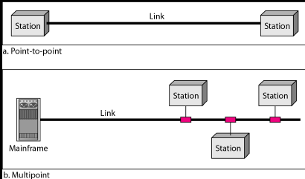**Simple Example**: A classroom projector connected to many students’ laptops through Wi-Fi → all share the same link.

**Topology**

* topology means the **way devices are arranged/connected** in a network.
* **In simple terms**, it shows the **layout or structure** of a network.

**Mesh Topology**

* **Here**, every device is connected to **every other device directly**.
* **Very reliable** → even if one link fails, data can take another path.
* **But** → needs a lot of cables and is expensive.

**Star Topology**

* **All devices are connected to a central device** (like a switch or hub).
* **Easy to manage** → if one computer fails, others still work.
* **But** → if the central hub fails, the whole network goes down.

**Bus Topology**

* **All devices share a single main cable** (called backbone).
* **Cheap and simple** → uses less cable.
* **But** → if the main cable fails, the whole network stops.

**Ring Topology**

* Devices are connected in a **circle (ring)**, and data travels one way around the ring.
* **Equal access** → each device gets its turn.
* **But** → if one link fails, it can affect the entire network.

**Categories of Networks**

**LAN (Local Area Network)**

* **Firstly**, LAN covers a **small area** like a home, school, office, or a single building.
* It usually connects computers, printers, and other devices within that limited area.
* **High speed** and relatively **low cost**.
* **Example**: Wi-Fi network inside your home or a school computer lab.

**MAN (Metropolitan Area Network)**

* **Secondly**, MAN covers a **city or a large campus**.
* It is bigger than LAN but smaller than WAN.
* Often used by governments, universities, or organizations to connect multiple buildings across a city.

**WAN (Wide Area Network)**

* **Finally**, WAN covers a **very large area** like a country or even worldwide.
* It connects multiple LANs and MANs together.
* **Slower speed compared to LAN**, but allows global communication.
* **Example**: The **Internet** itself is the biggest WAN.

**Internet**

* the Internet is a **global network of networks**.
* It connects millions of devices (computers, phones, servers) across the world.
* **In simple words**, it is the system that allows us to share information, communicate, and access services globally.

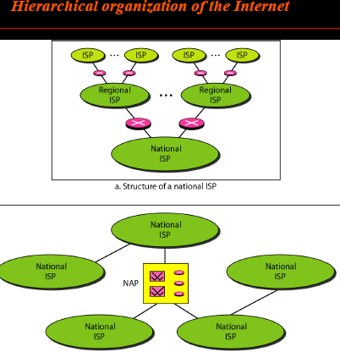**PROTOCOLS**

A protocol is synonymous with rule It consists of a set of rules that govern data communications. It determines what is communicated, how it is communicated and when it is communicated.

**Example**:

* **HTTP/HTTPS** → for web browsing.
* **SMTP** → for sending emails.
* **TCP/IP** → the main Internet protocol suite.

The key elements of a protocol are

**Syntax**

* Syntax means the structure or format of data.
* It decides how data is arranged (the order of bits, fields, and headers).
* **In simple words**: it’s like grammar in a language → if the format is wrong, the receiver won’t understand.

**Semantics**

* **Semantics means the meaning of each part of the data.**
* It ensures both sender and receiver understand **what each field or message means**.
* **In simple words**: it’s like vocabulary → both sides must agree on the meaning of words.
* **Example**: In a request message, a "1" might mean "yes" and a "0" might mean "no".

**Timing**

* **Timing means when data should be sent and how fast it should be delivered.**
* It ensures the sender does not send data **too fast or too slow** for the receiver.
* **In simple words**: it’s like turn-taking in a conversation → if both people talk at once, it creates confusion.