Network models

OSI model

* OSI stands for **Open Systems Interconnection**.
* It is a **conceptual framework** that explains how data moves from one computer to another through a network.
* 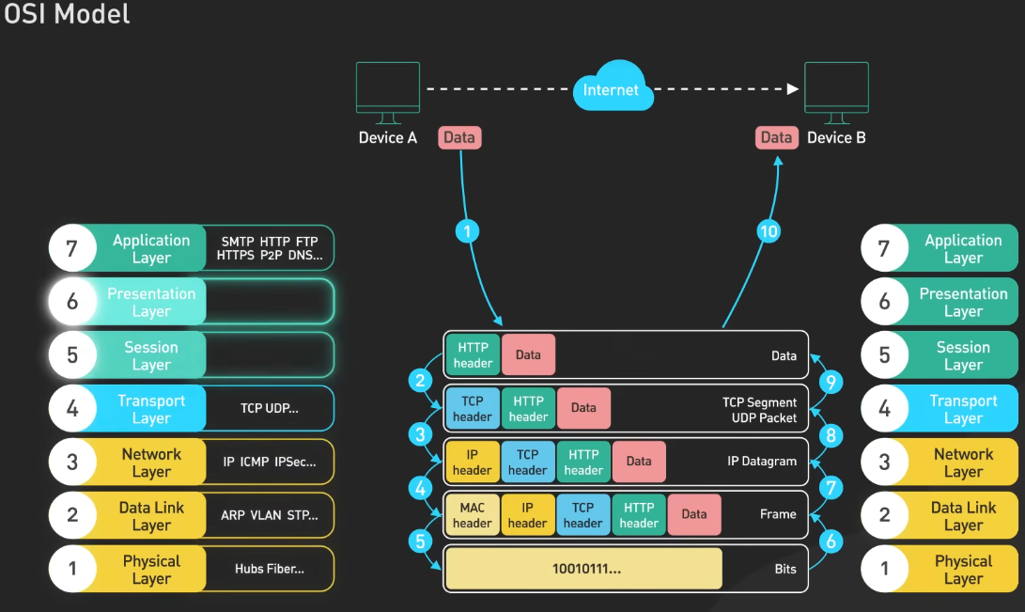**In simple words**: It breaks down communication into **7 layers**, where each layer has a specific job.

**The Seven Layers of the OSI Model:**

1. **Physical Layer**: This foundational layer manages the transmission and reception of raw **bitstreams** over a physical medium. It encompasses hardware elements like cables, switches, and the electrical or optical signals used for data transmission.

Duties:

•Physical characteristics of interfaces and media

•Representation of bits

•Data rate

•Synchronization of bits

•Line configuration

•Physical topology

•Transmission mode

1. **Data Link Layer**: Responsible for node-to-node data transfer, this layer ensures error detection and correction from the Physical Layer. It structures data into **frames** and manages access to the **physical medium (mac address)**, facilitating reliable communication between devices on the same network.
   * Protocols and Technologies:
     1. **Ethernet**: A widely used LAN technology that defines wiring and signaling standards for the physical layer and frame formats for the data link layer.
     2. **Wi-Fi** (IEEE 802.11): A wireless networking technology that operates at the data link layer, managing wireless communication between devices.

Duties:

Framing

•Physical addressing

•Flow control

•Error control

•Access control

1. **Network Layer**: This layer handles the routing of **data packets** across multiple networks. It determines the optimal paths for data transmission and manages logical addressing schemes, **Assigns unique IP addresses** to devices, to ensure data reaches its intended destination.
   * Common Protocols
     1. Internet Protocol (IP)
     2. Internet Control Message Protocol (ICMP)
     3. **Routing Protocols:** Protocols like OSPF and RIP
2. **Transport Layer**: Ensuring complete data transfer, the Transport Layer provides end-to-end communication services. It **manages error detection and recovery, flow control (using the protocol TCP & UDP, TCP is reliable but slower, UDP is faster but less reliable)**, and Segmentation: Large data streams from the application layer are divided into smaller, manageable segments for transmission, ensuring that data is delivered accurately and in sequence using TCP and UDP. **Ports** are used by transport layer protocols, such as TCP and UDP, to identify specific applications or services on a device.
3. **Session Layer**: This layer establishes, **manages, and terminates sessions** between applications. It controls dialogues between computers, managing session initiation, data exchange, and termination, ensuring that sessions remain separate and data streams are **properly synchronized**.
4. **Presentation Layer**: Acting as a translator, the Presentation Layer **formats data** to be presented to the Application Layer. It handles **data encryption, decryption, compression**, and translation between different data formats, ensuring that data from the application layer of one system can be read by the application layer of another.
5. **Application Layer**: The topmost layer, it provides network services directly to **end-user applications**. This includes services like email, file transfer, and web browsing, facilitating user interaction with the network.
   * **Common Protocols Operating at the Application Layer:**
     1. **Hypertext Transfer Protocol (HTTP):** Facilitates the transfer of web pages on the internet.
     2. **File Transfer Protocol (FTP):** Enables the transfer of files between computers.
     3. **Simple Mail Transfer Protocol (SMTP):** Used for sending emails.
     4. **Domain Name System (DNS):** Translates domain names into IP addresses.

Duties:

•Network virtual terminal

•Mail services

•File transfer, access, and management

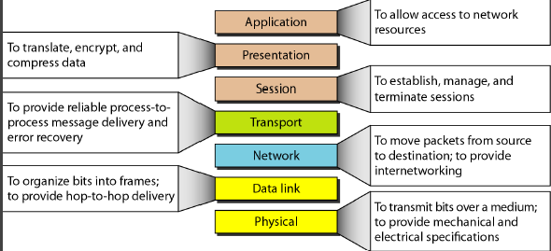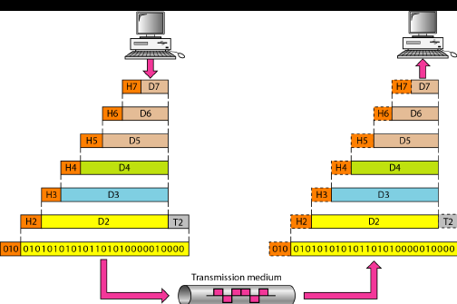•Directory services

**TCP/IP Protocol Suite**

* TCP/IP stands for **Transmission Control Protocol / Internet Protocol**.
* It is the **set of communication protocols** used on the Internet and most modern networks.

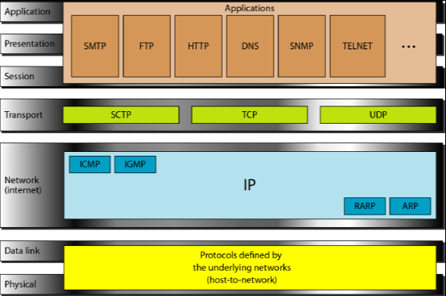Addressing

addressing means **giving a unique identity** to devices on a network so they can communicate.

**Physical (Link) Address**

* Also called **MAC address**.
* It is the **unique hardware address** of a network device.
* Works at the **data link layer**.
* **Example**: A4-5E-60-11-22-33

**Logical (IP / Network) Address**

* Also called **IP address**.
* Assigned **by software** and can change over time.
* Works at the **network layer**.
* IPv4 → 192.168.1.1

**Port Address**

* Identifies a **specific application or service** running on a device.
* Works at the **transport layer**.
* **Purpose**: ensures the right service receives the data.
* **Examples**:
  + Port 80 → HTTP (web)

**Specific / Application Address**

* Also called **user-friendly or service-level address**.
* Often a **domain name or URL** that maps to an IP via DNS.
* Works at the **application layer**.
* 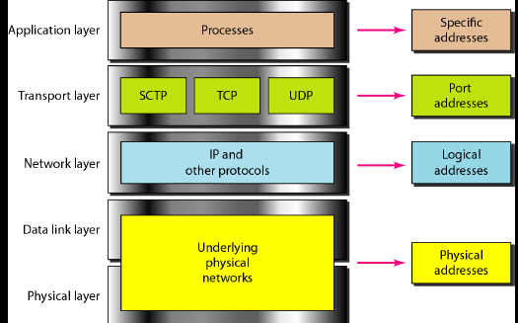**Example**: www.google.com