**SDPM Final Term Project**

**Group-2**

**Section-A**

**Project Title: Donation Funding.**

|  |  |
| --- | --- |
| **NAME** | **ID** |
| **Sarker, Md. Fazley Rabbi** | **19-39444-1** |
| **Muhtasim, Md. Mehedi** | **19-39430-1** |
| **Abu Hasnat Jelani Chand** | **19-39734-1** |
| **Tanvir Samsuzzaman** | **17-35608-3** |

**Under the supervision of**

**Md. Anwarul Kabir**

**Associate Professor**

**1.0 Introduction**: We have started working with the proposed project setting a clear target market or audience. Here, our target is the people who are going to donate and the people who are going to be benefited with the donations. As we can see there are a lot of donations are being raised but not reaching the people who really need it. So, here we are to ensure the donations reaching the actual needy people. With our goals being achieved, donors will get a trustworthy medium to donate and the needy people will get the help that they need.

**2.0 Project Title:** Donation Funding.

**3.0 Objectives:** The use case starts from the Applicant. The Applicant make an application to the Manager. The application is basically whether the Applicant wants to submit a donation, or he will need donation. The Manager then check the application, If the application is for submission of donation, then it will be submitted through the System and if it is for his donation needs then the Manager will check and verify it. If the application is verified, then the Applicant goes to the Donor and gives a registration form for donation. Donor registers and donate through bank transfer, card transfer or mobile banking.

**4.0 Justification:** In our “Donation Funding project is basically helping the poor people. It is defined as a gift in the form of money or kind of contribution given by a person to support. And if we do this then the poor people will get rid of many problems.

**5.0 Stakeholders analysis:**

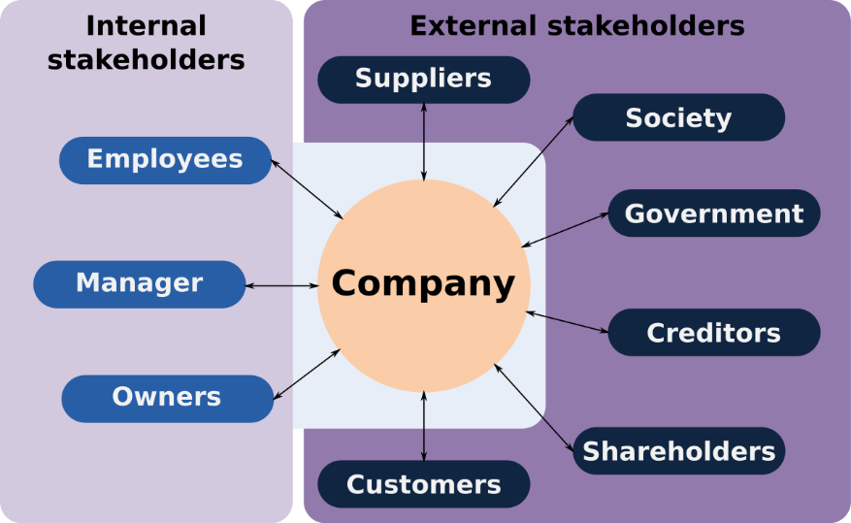

A project is successful when it achieves its objectives and meets or exceeds the expectations of the stake­holders. These stakeholders can include individual donors, corporate charitable givers, foundations, and state or federal agencies that provide funding. Our project stakeholders are:- (Manager, Applicants & Donor). Keeping these stakeholders engaged ensures a consistent inflow of funding. A stakeholder analysis template, also known as a power interest grid, can help you in four key ways:

* **Gathering crucial input:** You don’t know what you don’t know. Often, key stakeholders can deliver valuable insight that can help keep your project on track and successful.
* **Gaining more resources:** If your stakeholder has a full understanding of what it will take to get your project off the ground, they may be able to help you secure the people, tools, and resources you need to make you successful.
* **Building trust:** By consistently engaging and involving stakeholders in your process, you’re building trust that may make them quick to support upcoming projects.
* **Planning ahead:** Consistent feedback from key stakeholders helps you anticipate feedback and requirements on future projects and gain buy-in more quickly.

**6.0 Feasibility study:** A technical feasibility study is an in-depth examination of tech factors related to the intended project. It touches things on our donation funding project like

* Hardware and software components,
* Technical risks and constraints,
* Compatibility with other IT systems, and
* Capabilities of our team.

**Financial Feasibility:**

In our donation funding system this assessment typically involves a cost and benefits analysis of the project, helping organizations determine the viability, cost, and benefits associated with a project before financial resources are allocated. It also serves as an independent project assessment and enhances project credibility—helping decision-makers determine the positive economic benefits to the organization that the proposed project will provide.

**7.0 Systems component:** Below are the components that we aggregated to make the whole system of ours.

**Registration:** Here any donor or applicant can Log In to our website with a valid ID. To make one valid ID the Donor or the Applicant has to complete registration first.

**Make Donation:** One donor can donate any amount of money they want and for doing so the donor can use three medium services which are-

1. **Mobile Banking:** They can make their donation by Bkash, Dauch-bangla, Rocket, Upay, Nagad and Rocket. These are the top mobile banking services currently available in our country so we have given them all the options.
2. **Card Payment:** They can make their donation though card also in our website
3. **Bank Transfer:** We have included bank transfer option also. A donor can donate money through bank transfer.

**Application Option:** Till now we have discussed about how a donor will donate their money in our system but when an applicant applies. Though our application option then our manager will be able to see all the applications. He will verify is it fake or real and then proceed further to transfer the money.

**Transfer Money:** In this option after the manager verified that the application is real our system will transfer the donation to the desired applicant. The applicant will receive their money.

**Update fund balance:** Here our system will calculate the donation that comes to our system and the donation that has been already given to our applicant so that we know how much we have with us.

8.0 **Efforts estimation:** Our project is to develop an application named “Donation Funding.”. Here after analysis all the components we are assuming that the SLOC (Source Lines of Code) we need is

=10000.

As our Software project type is organic that’s why values of Coefficient<Effort Factor> = 2.4

Project Complexity, P= 1.05.

SLOC-Dependent coefficient, T= 0.38. Now we will calculate the values,

**PM=** Coefficient<Effort Factor> *(SLOC/1000)^p

=2.4*(10000/1000)^1.05

=26.93

**Development Time = DM =** 2.5*(PM)^T

=2.5*(26.93)^0.38

= 8.74 = 9 [In months]

Required number of peoples = ST

**=**PM/DM

= (26.93/8.74)

= 3.08 = 3

**Budget Estimation:**

Duration in weeks = 9*4 = 36 weeks Office days = 5 days

Working hours = 8 Hours

So, per week working hours is = (5*8) hours = 40 hours So Total Working hours is = 40*36= 1440 hours.

Developer salary is = 1000 Taka/ Hour

Total developers Salary = (1000* 1440)

= 1440000 Taka

|  |  |  |
| --- | --- | --- |
| Expanse | Amount | Total Amount |
| Salary for 3 developers |  | 1440000 Taka |
| 9 months office rent | 9*20000 | 180000 Taka |
| Requirement analysis Cost for 3 weeks | 15*8*700 | 84000 Taka |
| 4 months Maintenance  cost | 16*10*1200 | 192000 Taka |
| Travel Cost | 9*2000 | 18000 Taka |
| Total Cost = |  | 1914000 Taka |
| 15% of total cost = |  | 287000 Taka |
| Now total cost is = |  | 2201000 Taka |

10. **Activity Diagram:**

Actor: Donor, Applicant & Manager.

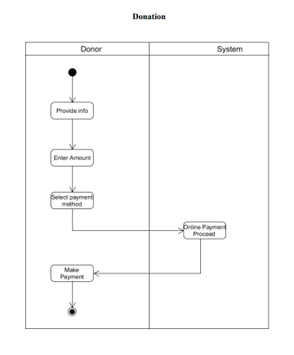

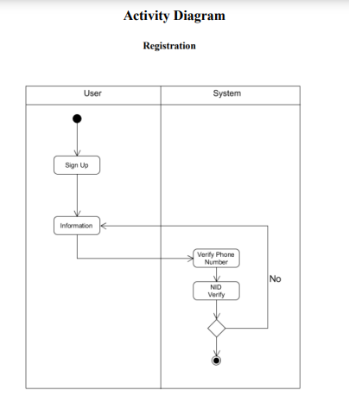

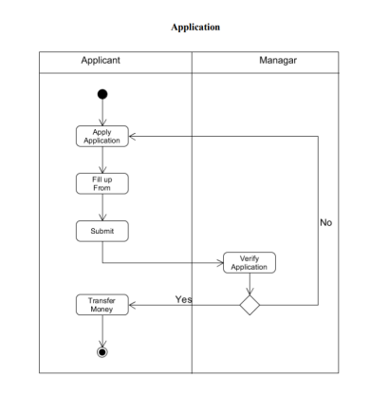

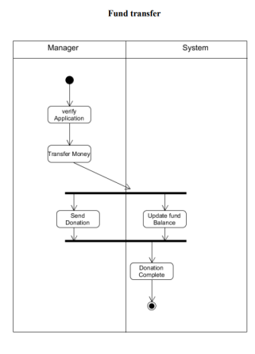

**User Interface:**

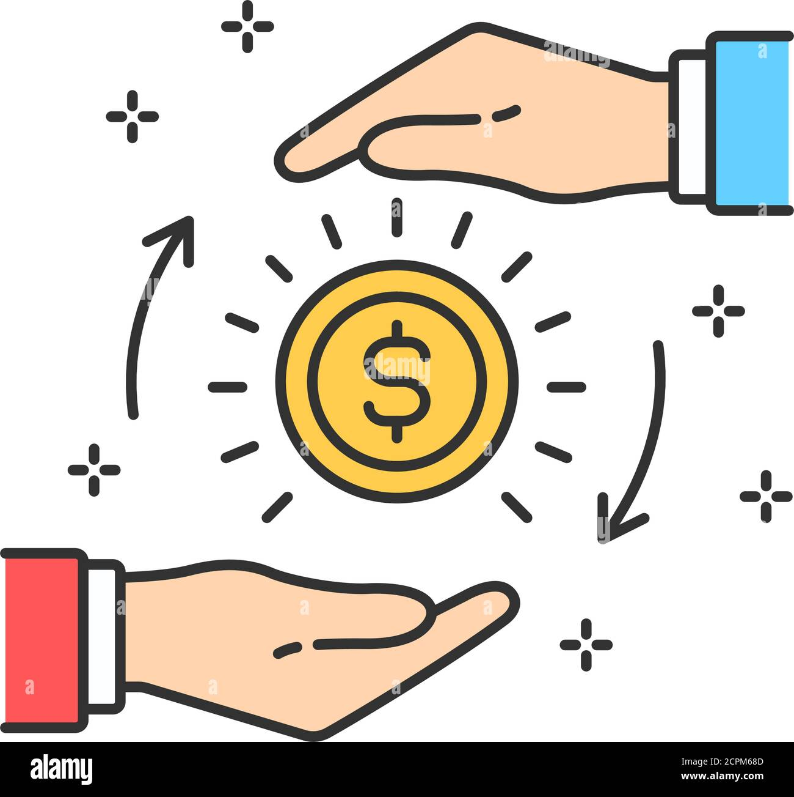

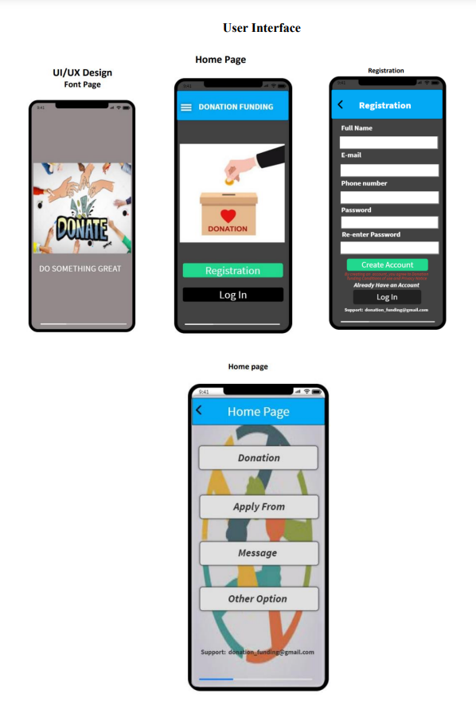

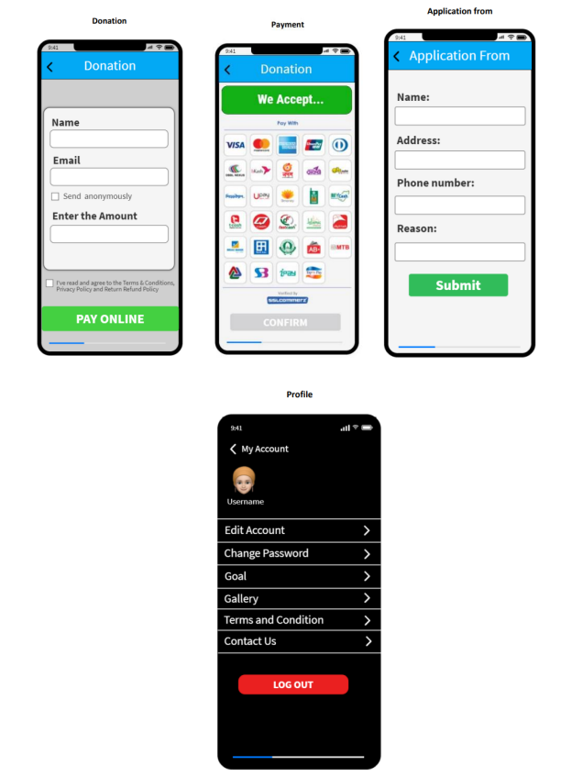

11.0 **Risk Analysis**:

Our project is very helpful for the poor and needy people who really need donation. But it is not totally risk-free. Many obstacles may hamper the activities of the project. As we can see there are a lot of donations are being raised but not reaching the people who really need it. There are so many possible risks of it.

Charity contributions, sponsorships and donations often form an integral part of a company’s social responsibility initiatives. The generosity of companies making donations not only support the company in reaching its internal social responsibility targets, but also spark corporate morale and boosts a company’s public image. It would be naïve to think that all the funds and charities recently established to receive donor funds for the benefit of pandemic relief will reach their intended destination. Globally, the Financial Action Task Force has warned of risks and compliance failures as criminals worldwide have found ways to tap into this new-found, well-intended resource. Donors should be encouraged to be generous in this difficult time. But money-flows for this purpose are no different from those in general commerce where due diligence and proper compliance are required at all times. A proportionate due diligence assessment of the prospective recipient organizations and their personnel allow donor companies the benefit of making a measured, risk-based decision on whether to proceed with the intended contribution and taking appropriate risk avoidance or mitigation measures. In this way, the funds will reach those in need.

Establish or verify whether the prospective recipient:

* Is appropriately registered as a non-profit (or similar) organization.
* Has any political affiliations or links and if so, whether the organization is independently administered.
* Does, or is likely to, interact with public officials.
* Has a sound reputation
* Has been the subject of adverse media reports.
* Has appropriate governance structures in place, and verify the integrity of its board of directors, trustees, senior managers and managers;
* Is appropriately audited
* Is a fund or organization supported by reputable sponsors.
* Is appropriately open and transparent in terms of its financial position and use of funds or contributions.
* Has adequate internal anti-bribery and corruption and governance controls and intends using third parties as part of the services it offers.

**Ignoring Donor Wishes:**

Questions to ask include:

* Is the donor’s request for the use of the donation reasonable given our plans and resources?
* Are we in position to fully comply with the request?
* How will we demonstrate to the donor that the conditions of the gift have been met?
* Who in the organization is responsible for tracking the use of the gift and notifying the donor?

**Lack of Clarity:**

Many donation fundings involve two or more partner organizations. Raising money “together” can be an effective strategy as long as all of the parties participating in the funding campaign take time to clarify their respective roles and responsibilities. A “memorandum of understanding” is a useful tool for clarifying not only who does what but who will benefit in which ways after the campaign. Possible topics to include in such a document include:

* Effective date
* Limitations and responsibilities
* Project timeline and key due dates
* Accounting of expenses and receipts
* Ethical standards
* Cancellation

**Lack of Transparency**:

Today’s donors are savvy, connected and curious. At a minimum, they want to know:

* Who leads your nonprofit;
* How contributed funds are spent; and
* What impact the nonprofit is having in the areas where it works and serves.

Transparency and compliance are two different concepts. Meeting minimum requirements imposed by federal and state regulatory agencies is compliance. Transparency is a choice that leaders of a nonprofit make. To manage the risk that donors will believe you are hiding rather than sharing, ask your donors what they would like to know about your organization and make that information readily available.

12.0 **Conclusion:** Our project aims to help the needy people by providing them the donation and make donation easier and more reliable for the people who are willing to donate. When a person donates money, they don't know that their money is delivered to the right person or not and here our project will come to fill this gap. Our project will focus on solving this issue.